Microsoft Azure Fundamentals (AZ-900) Cert Prep: 1 Cloud Concepts

Course details

The Microsoft Azure Fundamentals certification exam is for anyone looking to begin their professional journey in cloud computing. To pass the AZ-900 exam, you need a high-level knowledge of the cloud, Azure architecture, core security, its basic services, management tools, and governance. This first course in the AZ-900 cert prep series covers the Cloud Concepts part of the exam objectives. Your instructor Kunal D Mehta provides a comprehensive guide toward understanding cloud computing, including the three “as-a-service” models, types of cloud configurations, and the potential benefits that organizations can get by leveraging cloud computing.

Hello, cloud!

[Narrator] The entire world is undergoing a digital transformation. With each day, more IT professionals are realizing the inefficiencies of traditional on-premises environments and discovering how cloud computing can help run their businesses with greater agility than ever before. Cloud enables instant access to computing resources from anywhere at any time, and automatically adjusts the quantity of resources you need. It's also very economical. You can instantly get your business up and running without having to empty your pockets purchasing expensive hardware. Cloud computing also takes modern, cutting edge technologies like artificial intelligence, machine learning, augmented reality, and makes them accessible to the general public like us, so that everyone can be empowered to achieve their vision of the future. With the cloud, the only limitation is our imagination. This is probably why you keep hearing about the cloud so much. I presume that's why you're here, to get a piece of the action. If that's the case, you have picked the perfect course to watch because I'm here to accompany you through your expedition in learning about the cloud and Microsoft Azure. Say the magic words "Hello Cloud!" to begin.

Overview of AZ-900

[Instructor] I'm sure you know this, but for the record, let me just put it out there. AZ-900 is the code for the Microsoft Azure Fundamentals exam. Before you give the exam or even start preparing for it, there are crucial things you need to know. Let me explain what they are. It's a human tendency to resist change. The unpredictability of the change makes us a little uncomfortable, and that's natural. The same sentiments are triggered when you go tell a person, "Hey, there's this new thing called the Cloud. You should totally jump on board." Microsoft's intention with this exam is to make you comfortable with this change so you can embrace the Cloud with confidence. The AZ-900 exam is designed to address four of the most basic concerns anyone can have. That is, what exactly is the Cloud? What services does it offer to start with? What about its security? And how easy or difficult it is to manage the Cloud? If you look at the official AZ-900 exam curriculum, you'll see it perfectly aligns with answers to these four questions. The exam curriculum is sectioned into three parts. First is Describe Cloud Concepts, which weighs around 25 to 30% of the exam. This is designed to ensure you understand exactly what the Cloud is. The second part is Describe Azure Architecture and Services. It weighs a good 35 to 40% of the exam. This is designed to ensure you understand what services and security Azure has to offer. And the third part is Azure Management and Governance. Weighs around 30 to 35% of the exam. This is designed to ensure you understand the manageability aspect of Azure. It is very important to keep in mind that AZ-900 is designed to introduce new learners to Microsoft Azure. It is not intended to make you a super pro max Cloud ninja. Nevertheless, it's certainly going to make you comfortable with Azure and be an excellent first step towards a career as a Cloud professional. In this course, which is the first in the learning path for AZ-900 on LinkedIn Learning, we'll cover the Cloud Concepts part of the exam.

Agenda

[Instructor] Here is the agenda for this course. For simplicity, I've taken the first section of the exam objective and renamed it to match the title of this course. Microsoft Azure Fundamentals AZ-900: Cloud Concepts. I've divided this course into five chapters. The one you're watching right now is the Introduction. The next chapter will be Understand Cloud Service Models. Here you learn what the cloud is, its key characteristics, infrastructure, platform and software as a service offerings, along with the shared responsibility model. After that, we have the chapter Understand Types of Cloud Computing. Here you learn about the different configurations of the cloud: public, private, hybrid, and sovereign clouds. Then we'll move onto the chapter Understand the Benefits of Cloud Computing. Here you learn about the core attributes of the cloud. Things like scalability, elasticity, high availability, and fault tolerance. I'll also give you a high-level overview of the security, management, and governance experience associated with cloud computing. The final chapter will be the Conclusion. Here I'll summarize the key learnings of the course and point you to the next step in the AZ-900 learning path. Point to be noted is that this course is going to be theoretical. There will be no demonstrations in this course because my primary goal here is to first give you a strong foundation of the fundamental concepts before we jump into hands-on action with Azure later on.

Prerequisites

[Instructor] Here are the prerequisites to gain the maximum value out of this course. Let's talk about the target audience. This course is intended for beginners in IT who want to pursue a career in cloud computing or help desk staff who want to upgrade their skills and grow in their IT careers for better designation and pay. Then we also have seasoned infrastructure professionals as well as software developers who are experienced in IT but not necessarily in the cloud domain. So if you're looking to transition into the cloud from something else, this course is fit for you. You could also be a business decision maker in charge to analyze the pros and cons of the cloud. You can watch this course and report your findings to the team, or you could be a part of the higher management wanting to know if cloud is the way to go for your organization. This course can serve you with the perfect executive level briefing on cloud computing. In terms of the required knowledge, since this is an entry level course you don't need to know a lot. A conceptual understanding of compute, networking, storage, and applications is helpful but not mandatory. In terms of the required resources you need three things. One is access to the AZ-900 learning path on LinkedIn Learning, which you already have. And second, a Microsoft Learn account. Both these materials complement each other really well. Microsoft Learn is the formal documentation that you can use for reference. And this learning path for interactive instructor led videos. A combination of these two should be sufficient to pass the exam. When it comes to learning, I'm a little old school. I also recommend you keep a pen ready to jot down the important points. When you're just sitting and watching learning content your participation is usually passive but when you start writing the things you are learning your participation becomes active. It helps you understand and remember the concepts a lot better. I have included a workbook one document in the exercise files of this course for you to take notes. Before we go any further let me take a moment to introduce myself. I'm Kunal D Mehta, an IT consultant who specializes in Microsoft Cloud and data center technologies. When I'm not doing geeky stuff I like to swim, scuba dive, travel, or just relax, watch a movie and eat pizza. I'm absolutely thrilled to be your instructor for this AZ-900 learning path on LinkedIn Learning. For best experience, watch this course on full screen. If you feel I'm speaking too fast or too slow you can use the controls in the video player to adjust the speed for your comfort. All right, without any further ado, let's jump right in.

1. Understand Cloud Service Models

What is cloud computing?

[Instructor] Welcome to the chapter, understand cloud service models. Here, I'll explain what the cloud is, its key characteristics, cloud service models, and the shared responsibility model. Have you ever wondered why it's called Cloud computing? Here's my perspective on it. If you have ever flown in an aircraft high up in the sky, I'm sure you must have noticed a couple of things from your window seat. Firstly, clouds have this distinctive property where smaller pieces of clouds can seamlessly blend into larger clouds and larger chunks of clouds can seamlessly fragment into smaller pieces. If I had to oversimplify it, this is sort of what happens to computing resources in Cloud computing. You can combine computing resources together to provision smaller or larger pieces out of it in Cloud computing. Secondly, you may have also noticed that clouds in the sky always seem to extend beyond the horizon almost as if to infinity. That's again similar to the aggregate of computing resources in Cloud computing, for all practical purposes there's an infinite amount of computing resources for you to provision in Cloud computing and therefore I believe this name makes so much sense. Now let's see what it actually is , at the center of every IT enabled business is an application that is absolutely critical for the organization to function. It keeps the business alive and the revenues coming in. For example, think of the banking application that banks use, the healthcare application that hospitals use, or the ticketing application that airlines use. Can you imagine how they would function without them? It would be borderline impossible for those businesses to survive without their application in today's world. To top that, modern businesses have a global reach, they have users all around the world in different time zones expecting the application to be accessible anywhere at any time, every minute matters. So it's clear that keeping that application up and running is a priority for all businesses. This is where things become a little inconvenient. You need a lot of supporting components to run this business application at a level where it can match those high expectations. Things like expensive server hardware, networking devices, and storage appliances, the wires, cables, and the connections between them. Then these hardware components need redundant power supplies, redundant cooling, and redundant internet to be on and connected. They all need to be redundant in case any one of them fails. For the safe keeping of these components, you need a secure physical space and you know how exorbitant real estate prices are. Then on top of the hardware, you need to install an operating system and potentially bear the cost of its licensing. This operating system needs regular maintenance by applying software patches and hotfixes to keep it up to date. Then the application itself has it direct dependency on frameworks and runtime environments that it requires to run. And finally, there's data that is generated as a result of the use of this application, not to mention you have to secure the whole thing from top to bottom, physically and digitally. Handling all of this can be a daunting challenge, this is called the traditional IT stack and when you build the whole stack yourself in your own corporate location we refer to it as an on-premises environment or simply on-premises, remember the priority of most businesses is the application and its data, not the underlying components. Let me explain using an analogy. Imagine it's raining on a cozy evening, you're snuggled up in a blanket and all you want to do is eat some cake, let's accept it, we've all been there. Now imagine someone tells you, if you want to eat cake you should go to the kitchen, switch on the microwave, mix flour, milk, eggs, butter, sugar, bake the cake yourself and apply the frosting to eat it. Wouldn't you be mad? I would be furious and probably even throw a shoe at them, I know you agree with me but luckily we have a solution for that. Our civilization has evolved enough to have confectionary stores where you can order the cake as a service, sitting comfortably at home. Not only that, but you can also order as many slices of as many flavors you like. That's true freedom in my opinion, the confectionary store in this case becomes the cake service provider. Now, my question to you is if you don't like to bake your own cake, why should you unnecessarily build your own IT stack? Sounds counterproductive, right? That's where Cloud computing comes to the rescue. Cloud is like the confectionary store of the IT world, you can get access to any computing resources you need as a service. The entity providing them is called the Cloud Service Provider or CSP. In the context of AZ-900, Microsoft is the Cloud Service Provider and the name of their cloud is Azure, meaning bright blue skies. Here's a simple definition of the Cloud based on what we just witnessed. Cloud computing is the delivery of any computing resources from the IT stack as a service by a Cloud Service Provider.

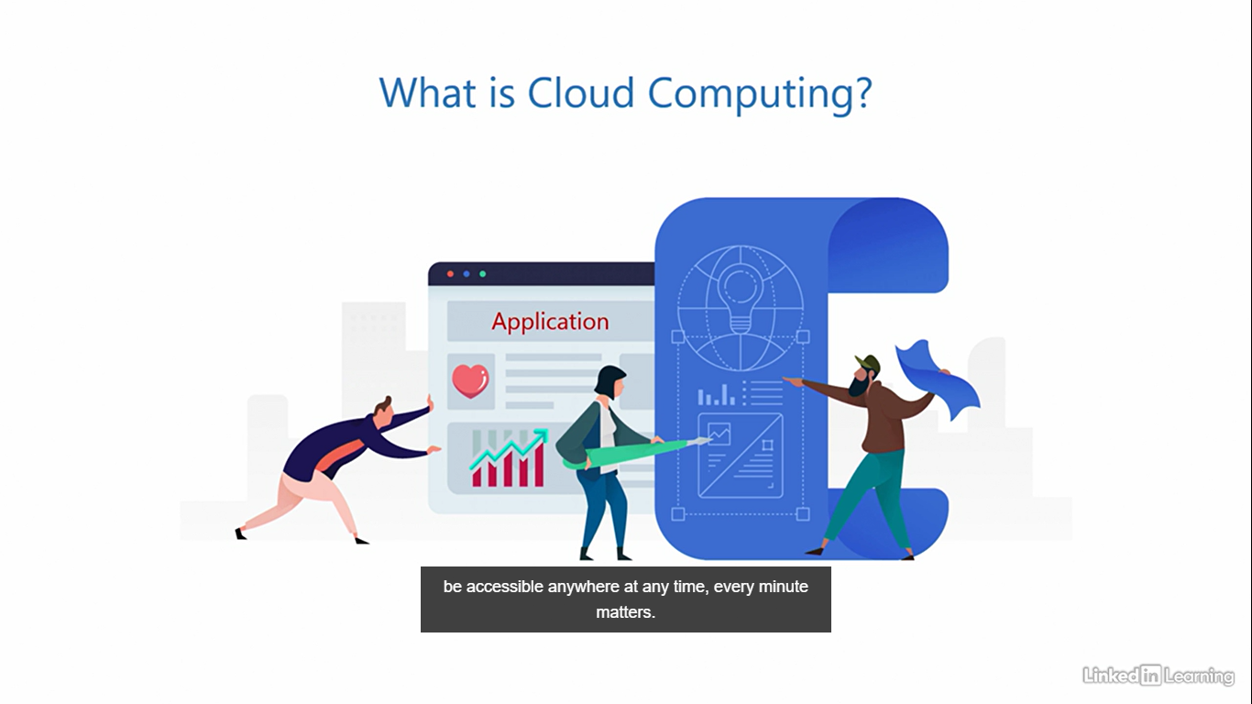

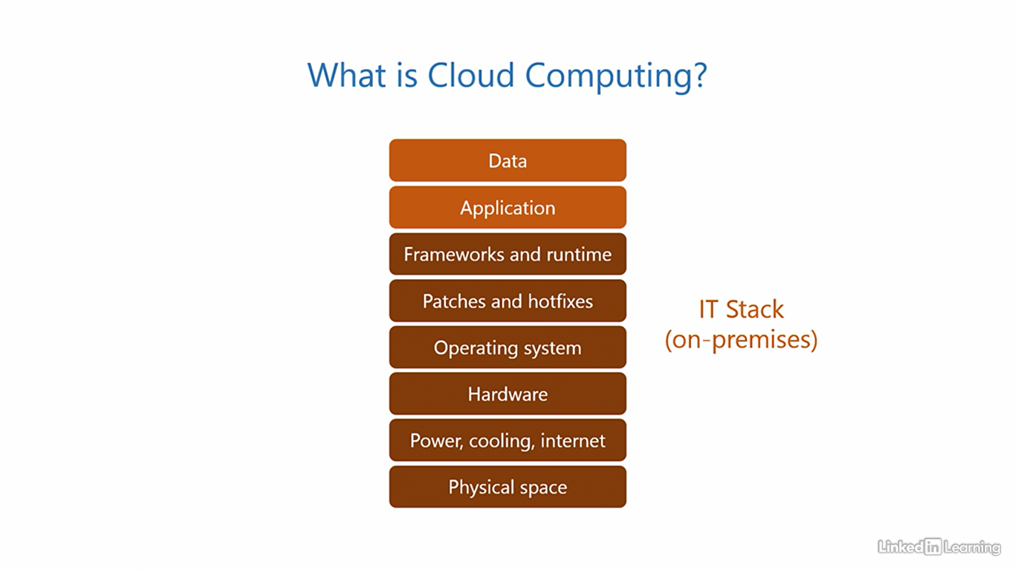

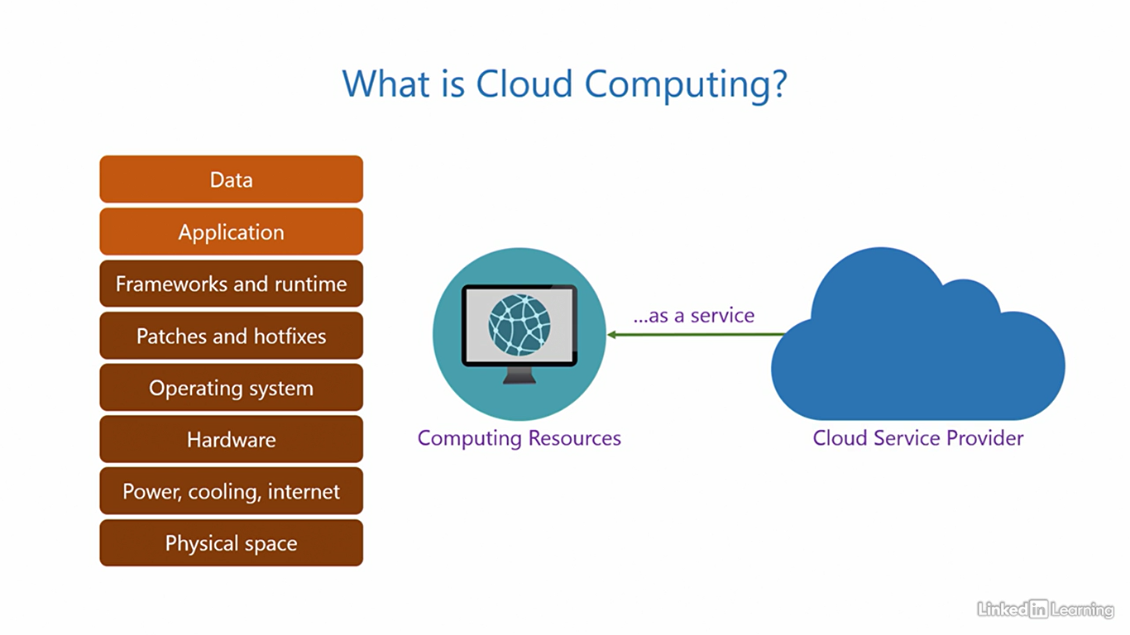

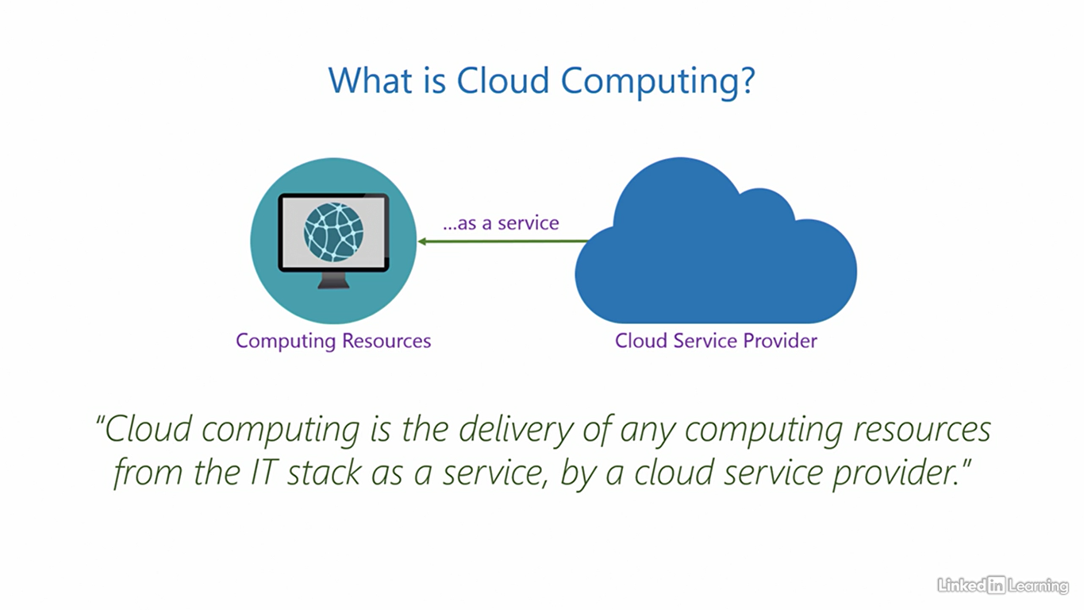

Virtualization is the foundation for cloud

[Instructor] A technology called virtualization is the core foundation for all of cloud computing. Virtualization is what powers the cloud. And without it, the cloud would simply not exist. I'm not going to go too deep into this, but at a high level, here's how. What are the three elementary pieces of a computer system? They are the processor, memory, and the hard disk. All of these are real, physical, tangible objects. So far, so good. Then, the process of virtualization steps in and changes the whole game. It allows you to create software copies of these elementary pieces. So you get a virtual processor, virtual memory, and virtual hard disk. These are not real objects. They're just software copies of the real pieces. But the key being, the virtual pieces function identical to the real pieces. Now, you're probably thinking, "What's the point of doing this?" Fair question. Because these are software pieces, you can provision them over the internet or any network. Remember when I explained cloud computing, I mentioned the delivery of computing resources. This is what makes the delivery possible. You cannot send a real physical processor, memory, or hard disk over a network, but you can provision their virtual counterparts over a network, and they'll behave like the real ones. Virtualization gives mobility to these pieces. This one single capability is what makes the cloud revolutionary. Virtualization also provides isolation between instances of virtualized resources. Any given set of virtualized resources operates independently and confined within its boundaries, completely unaware of other virtualized resources on the system.

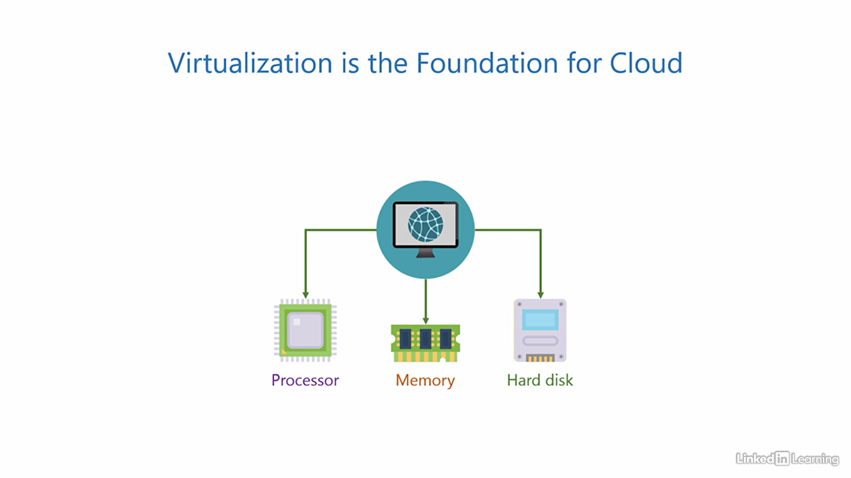

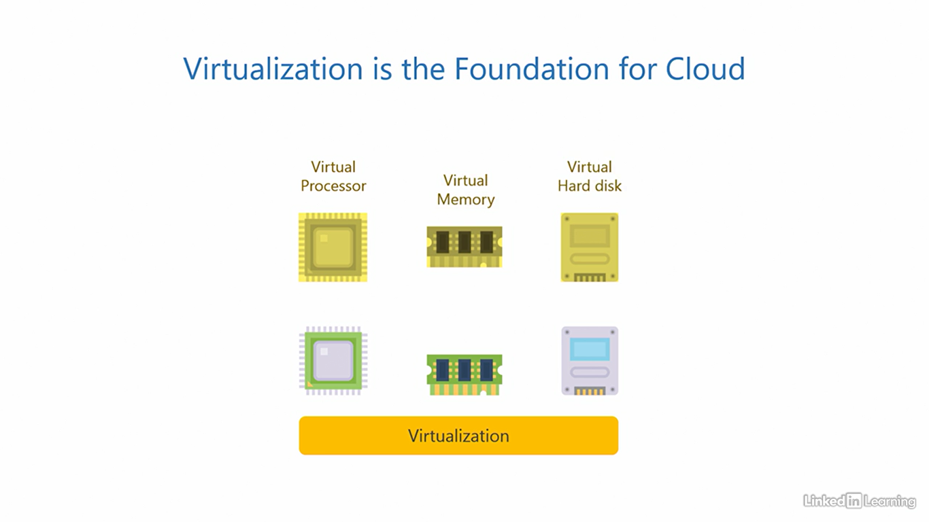

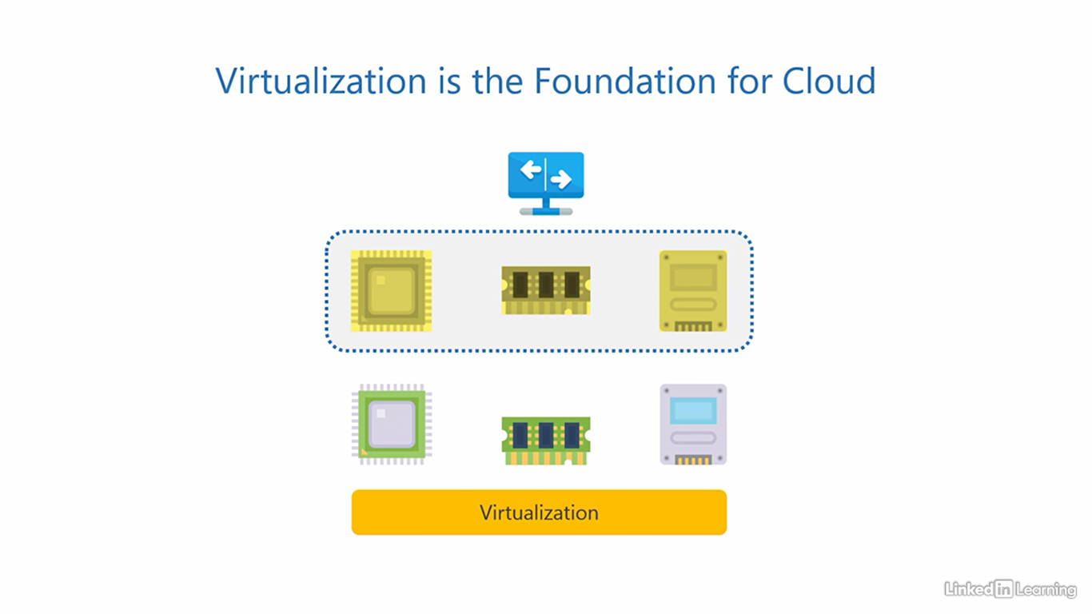

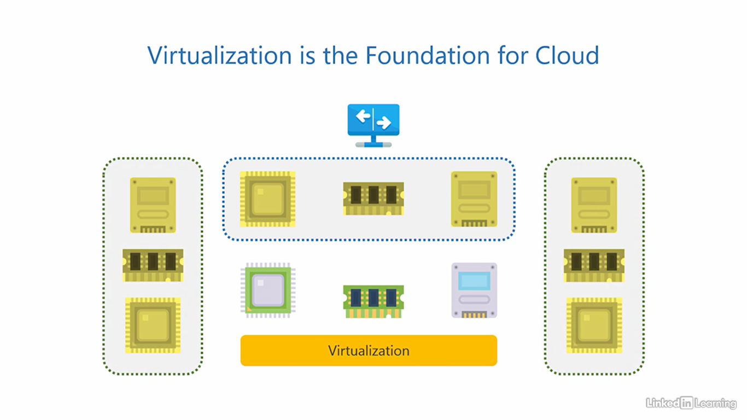

Key characteristics of cloud computing

[Instructor] In the last video, we saw how virtualization is the core foundation for cloud. But just because we have virtualization, does not imply we have a cloud. You need a little more than that. There are four unique key characteristics of cloud computing. Let's see what those are. The first key characteristic is resource pooling. Remember when I mentioned how clouds in the sky blend into larger clouds, or fragment into smaller ones? The technical term we use to describe that in cloud computing is resource pooling. Here, we take a large number of physical computing resources, put them together, and virtualize them. What you get as a result is a large pool of virtualized computing resources. You can now request for these virtualized resources to be provisioned of whatever size you need, a small sized or a large sized resource, depending on your precise requirement. In the diagram on your screen, I'm only illustrating this for the processor, but this actually applies to all three elementary pieces, the processor, memory, and the hard disk. The second key characteristic is elasticity. Remember when I mentioned clouds in the sky look like they extend to infinity? The term we use to describe that is elasticity. Cloud service providers are massive establishments, not small. They usually have hundreds of data centers spread across the world, each with very large capacities. This means the size of the virtualized pool of resources is so huge, that it's practically never ending. You can provision as many extra resources as you need when the workload goes up, and deprovision them when the demand goes down. The third key characteristic is pay per use. In an on-premises environment, you have to bear the huge upfront cost of purchasing expensive computer hardware, irrespective of if you use it or not. But in the cloud, you only pay for the resources you use and the time you use them for. You are not liable to pay for anything else. So if you use two units or one unit, you just pay for that. If you don't use anything, your bill is zero. The fourth key characteristic is automation. All the three characteristics you saw so far, the resource pooling, elasticity, and pay per use billing are all automated. And because everything is automated, it enables you to provision resources on demand and perform self-service on resources, without having to depend on anyone. Neither the cloud service provider, technical support, nor anybody else. Remember, these characteristics apply to all three pieces, the processor, memory, and the hard disk. There you have it, the four key characteristics of cloud computing. It's a real cloud, only if you have, at the very least, resource pooling, elasticity, pay per use, and automation.

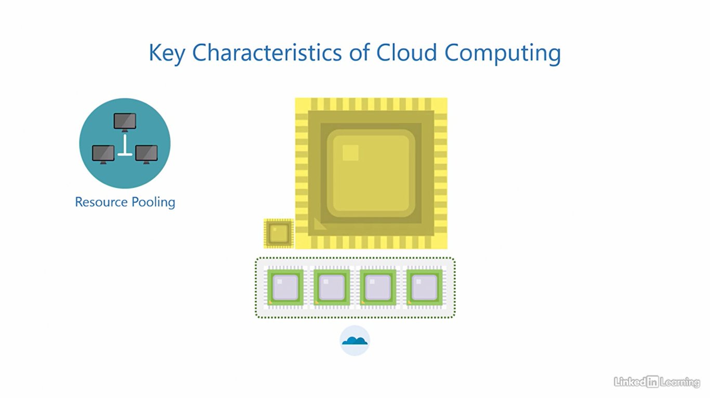 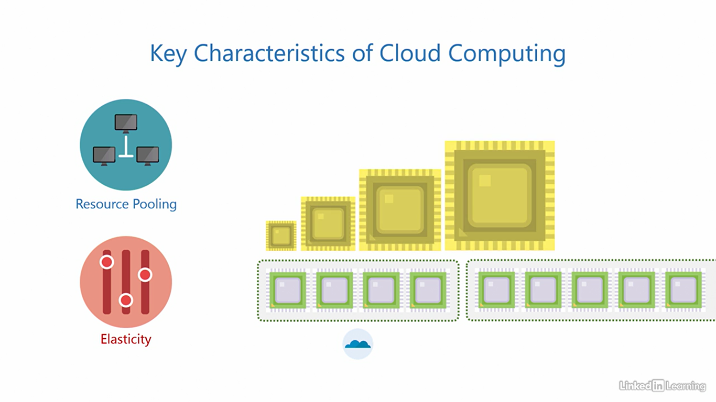

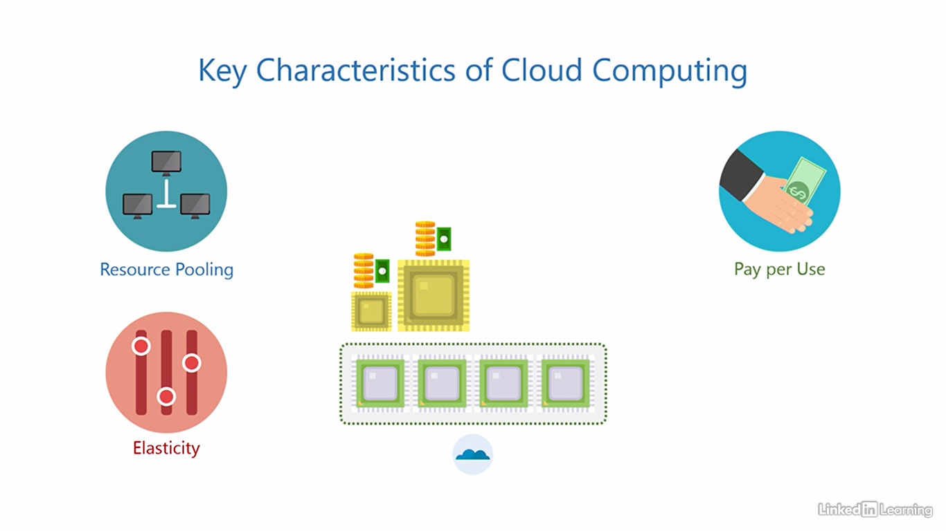

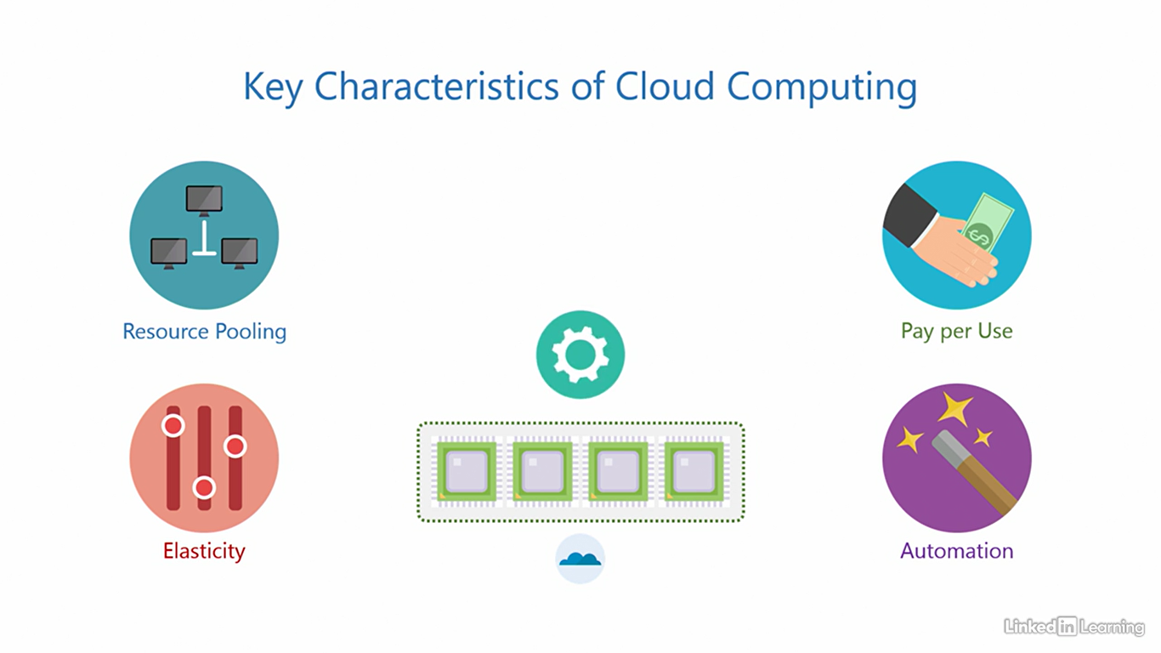

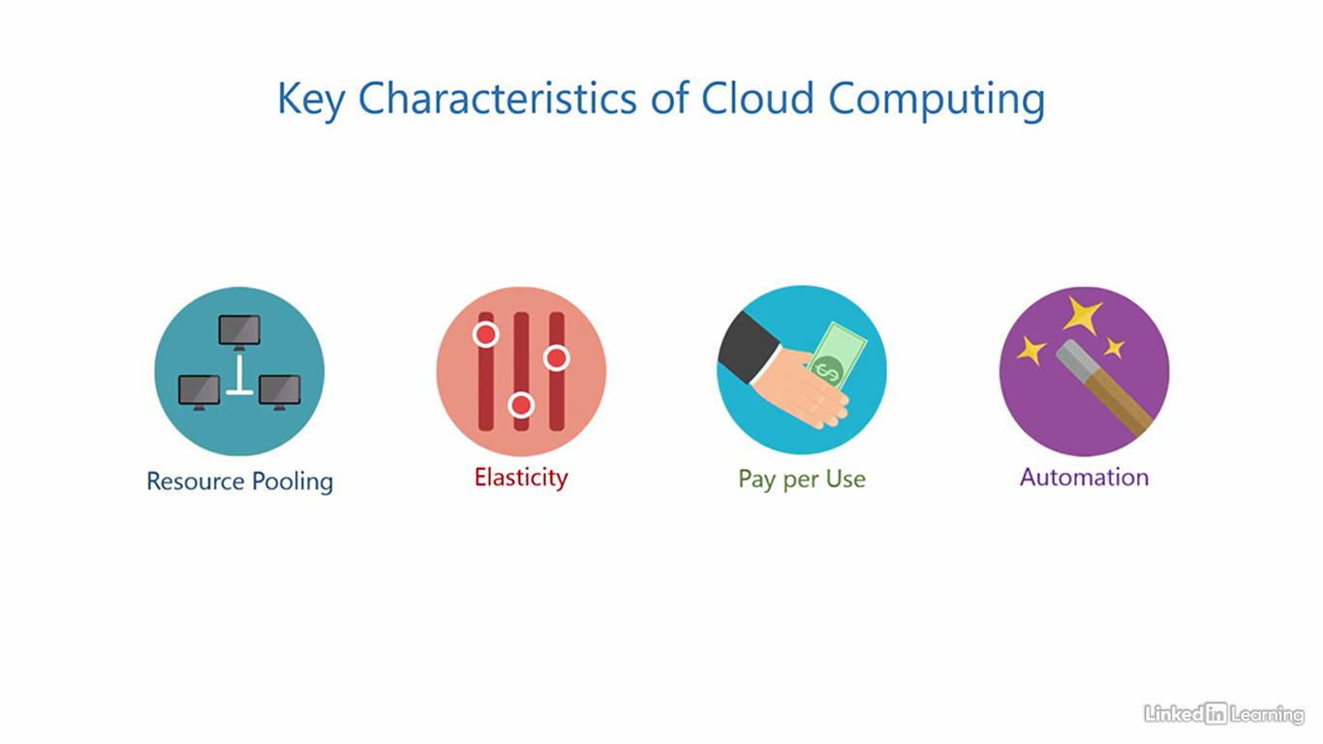

Understand infrastructure as a service (IaaS)

[Instructor] We know that a cloud service provider delivers computing resources from the IT stack as a service. The entity on the other end consuming these resources is a customer organization, or simply a customer. Most enterprise clouds are business to business so the customers are usually startups, small, medium or large companies, and they can choose to consume parts of the IT stack depending on their need. Now you may be wondering, if a customer can get the whole IT stack as a service, why would they choose to avail only parts of it and not the whole stack? I have two words for that, control and customization. Let's go back to the cake example. What if you wanted a cake of a very specific flavor or maybe a very specific brand of whipped cream on top of the icing, and the confectionary store didn't have them. What would you do? You'd take control, source the ingredients and customize the cake yourself. The same theory applies to the cloud. You can choose different pieces of the IT stack when you want more control and customization. There are three cloud service models of how computing resources can be offered to customers. The first one is infrastructure-as-a-service. In this offering, the cloud provides its customers access to virtualized hardware resources. What that means is the cloud service provider procures physical hardware, sets it all up, virtualizes it using virtualization, and then offers these virtualized hardware resources to customers as a service. The cloud service provider also handles the redundant power, cooling, internet connections and the physical space needed to house them. The remaining components above the hardware in the stack are controlled and maintained by the customer. That is the operating system, patches and hotfixes, frameworks and runtime, application and the data. So if there's an application that needs a specific operating system or a feature within the operating system, this offering can be useful. And it's possible because the customer has full control of the operating system and all the competence on top of it. I want you to understand one important point very clearly here. The cloud service provider does not deliver physical hardware. They purchase physical hardware and virtualize it. That's how they're able to serve virtualized computing resources to customers. And the key is, as I mentioned, virtualized computing resources behave identically to their physical counterparts. These three are typically called the infrastructure components. And since the cloud service provider offers them as a service, this model is called infrastructure-as-a-service. Also abbreviated as IAAS, IAAS. The advantage of this offering is that the customer gets maximum control of the application environment, right from the operating system level to the data, the whole upper part of the stack. The disadvantages, there's more work to do because the customer is handling a bigger part of the stack. If you want to determine if IAAS is right for you, think about how much control you need of the environment to run the application and how much work you want to put in.

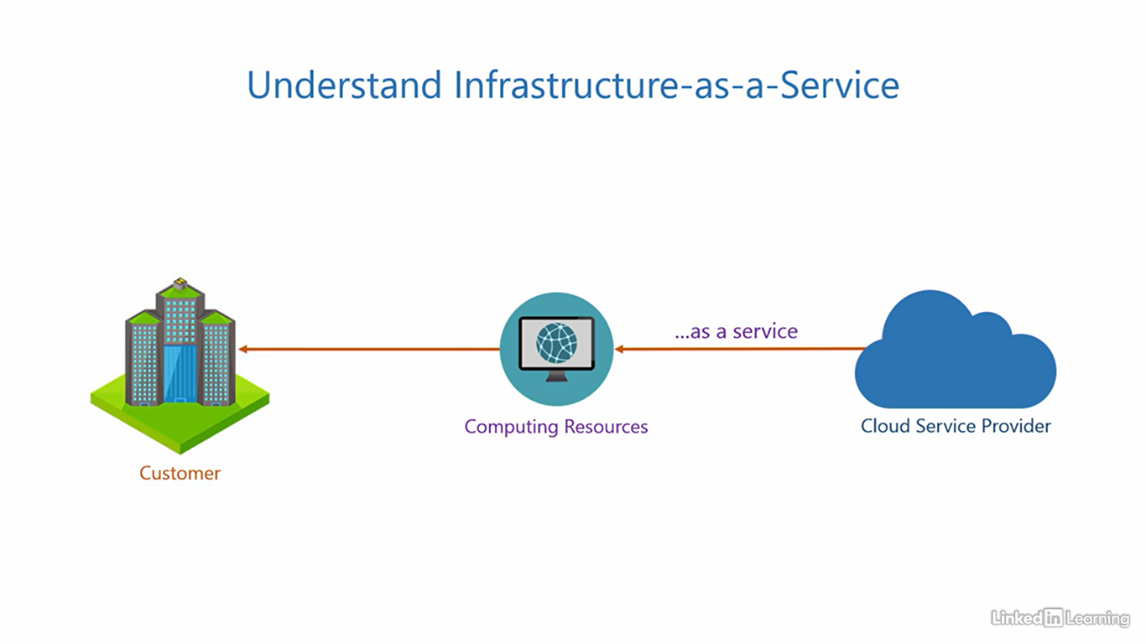

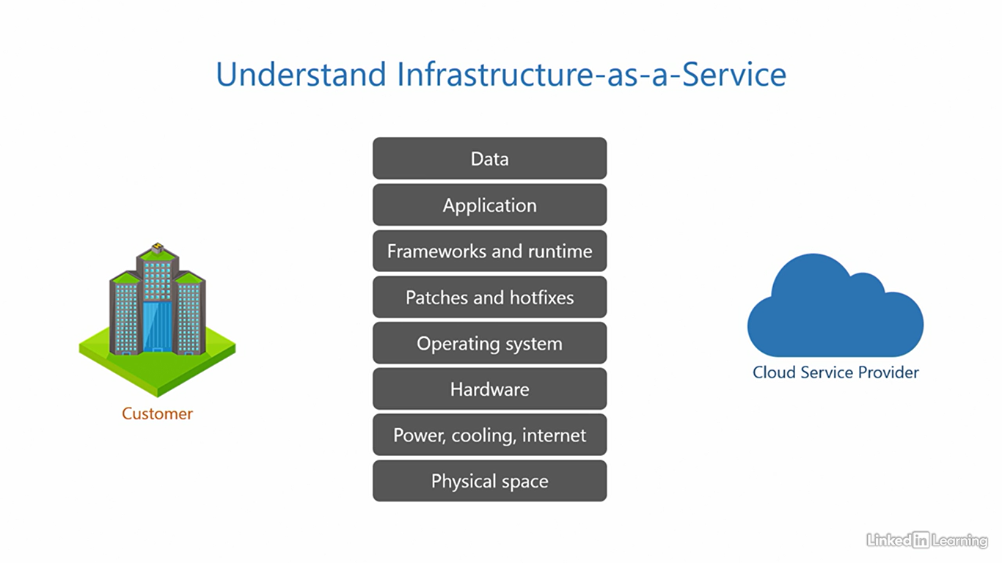

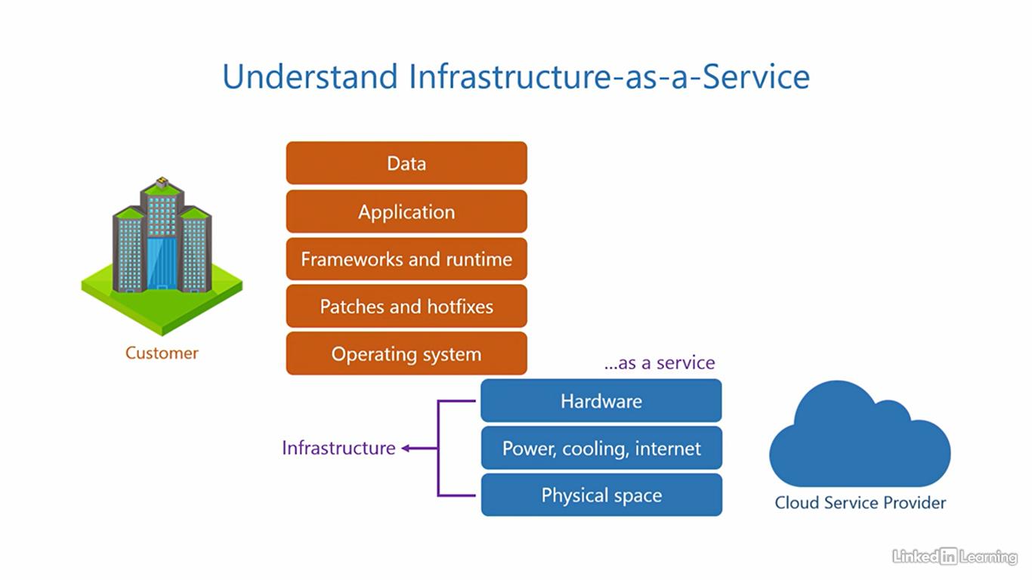

Understand platform as a service (PaaS)

[Narrator] The second service model is platform-as-a-service. In this offering, the cloud provides its customers access to application dependencies. Most significantly, the frameworks and runtime. The cloud service provider sets up the operating system, applies patches and hot fixes to keep it up to date, installs the framework and runtime, and then offers these dependencies to the customers as a service. The application and data are controlled and maintained by the customer. If there's an application developed in-house or purchased from a software vendor that needs to be run, this offering can be useful. The customer will be able to install and run almost any industry standard application using this model without having to configure the underlying dependencies. These three typically contribute to the platform components. And since the cloud service provider offers them as a service, this model is called platform-as-a-service, also abbreviated as PaaS. The advantage of this offering is that the customer can get up and running with their application quickly without having to deal with unnecessary configuration. The disadvantage is a little less control of the environment. In general, this is usually not a problem because most applications run just fine using PaaS. If you want to determine if PaaS is right for you, ask yourself, does the application support PaaS? If yes, then you should consider it. PaaS is the most popular cloud service offering out there among businesses. But if you want more control, IaaS can be a potential alternative.

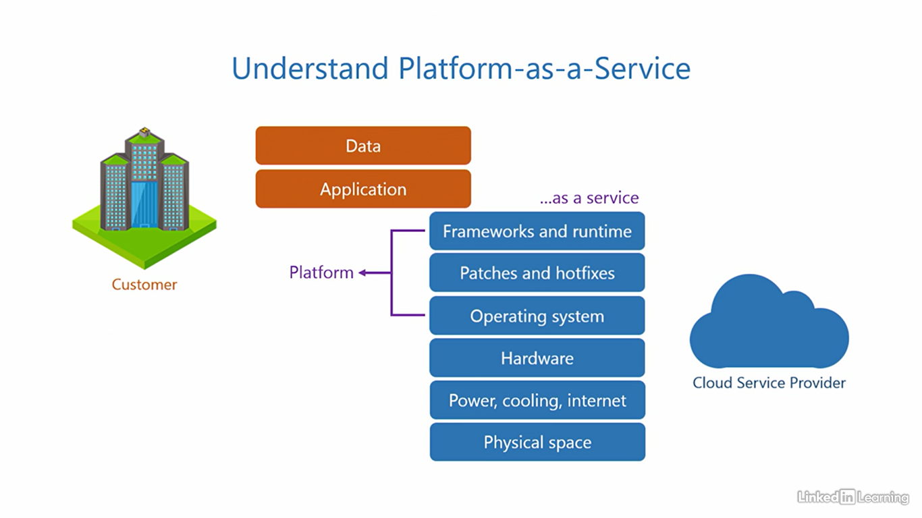

Understand software as a service (SaaS)

[Instructor] The third service model is software-as-a-service. In this offering, the cloud provides its customers with direct access to the application they need. The cloud service provider installs the application in their own environment, configures all the underlying dependencies, and offers instances of the application as a service to its customers, totally ready to use. But, there's a catch here. Cloud service providers only offer popular applications through this service model. Typically those that are high in demand and not just every application that exists out there. If an application you want is available in this model, that's good news. The data generated as a result of using the application is controlled by the customer. Simple and straightforward. Since the cloud service provider directly offers the software you need as a service, this model is called software-as-a-service, also abbreviated as S-a-a-S or SaaS. The advantage of this offering is that the configuration a customer has to make for the application is minimal to none. The application is ready to use. The customer just needs to provide its users access to it, and that is all. The disadvantage is the application a customer needs may not always be available in this offering. If you think about it, kind of makes sense. Cloud service providers want to help you but also want to make money. So they're going to spend their time and effort on popular applications that can bring in greater revenues rather than applications rarely requested by customers. If you want to determine if SaaS is right for you, ask yourself, is the application you need available as a SaaS offering? If yes, then go for it. Or else, you may want to consider PaaS or IaaS alternatives. Microsoft Azure supports all the three cloud service models we discussed, infrastructure-as-a-service, platform-as-a-service, and software-as-a-service.

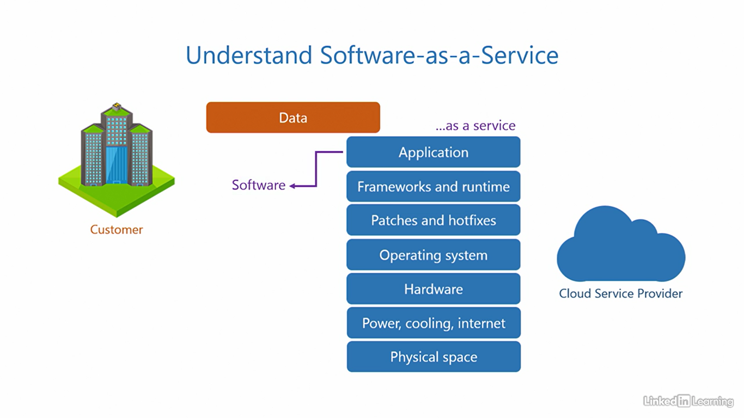

Understand the shared responsibility model

[Instructor] A cycle has two wheels and they work in tandem to give you a smooth ride. Both wheels are responsible for keeping balance and sustaining a comfortable ride. Similarly, both the customer and the cloud service provider are responsible for keeping the application running and secure. In fact, this not just applies to cloud computing but to any place where there are multiple parties and multiple things to do. All parties must have their roles and responsibilities clearly defined for efficiency and to avoid confusion. The cloud is no different. There are two parties here, the customer and the cloud service provider. And they both have a shared responsibility towards application uptime and security. The share of responsibility each of them bears varies depending on the type of service model that is if it is Infrastructure As A Service, Platform As A Service or Software As A Service, let's look at this in a little more detail. Here's the traditional IT stack and for reference and on-premises environment. We use this as a baseline to show the distribution of responsibilities in Infrastructure As A Service Platform As A Service, and Software As A Service. We know that in a on-premises environment, the customer sets up the entire stack in their own data center. They are the only party in this equation. So the responsibility of deploying, controlling and maintaining everything belongs to the customer, end to end, right from acquiring physical space to the data. They're also responsible for the security of the entire IT stack. Now let's see how infrastructure as a service differs. Here, you know the cloud offers infrastructure components as a service. This means the responsibility of these components belongs to the cloud service provider. Acquiring the physical space, redundant power, cooling, internet connections, and hardware, it is also pertinent that if any of these fail, the customer should ideally remain unaffected. So if a server burns out, a disc fails, a network cable disconnects, or anything else happens to these components, it should not impact the customer. That's why cloud service providers try to design their cloud from the ground up, keeping business continuity in mind. They are also responsible for the security of these components, the responsibility of the operating system, and above up to the data belong to the customer, applying patches and hot fixes, making sure the system is up to date, and installing the frameworks and run time. If anything goes wrong in these components and the application goes down, the customer must figure out what's wrong and how to fix it. Not the cloud service provider. The customer is also responsible for the security of these components. Moving on to Platform As A Service. As you may have guessed the load, of responsibilities here shifts a little more towards the cloud service provider. So in addition to the infrastructure, they also become responsible for the platform, including the operating system, patches and hot fixes, frameworks and run time. The cloud service providers do their best to make sure any problems with these components have a minimum impact on the application. They're also responsible for the security of these components. The customer on the other hand is responsible for the application and its data. As long as the customer does not misconfigure the application itself, everything should run smoothly. The customer is also responsible for the security of these two components. Finally, let's look at Software As A Service. In this offering, most of the responsibilities are offloaded onto the cloud service provider, including the application. They need to make sure the application is up and running for the customer no matter what. The customer here is only responsible for the data associated with the application. All service models, Software As A Service, Platform As A Service and Infrastructure As A Service involve two parties, the cloud service provider and the customer. So it's essential to understand who is accountable for which part of the stack. The shared responsibility model that is on your screen is simplified for your understanding. As we progress through the courses, you'll get a better understanding of this. If you observe carefully you'll note, the customer is always responsible for the data.

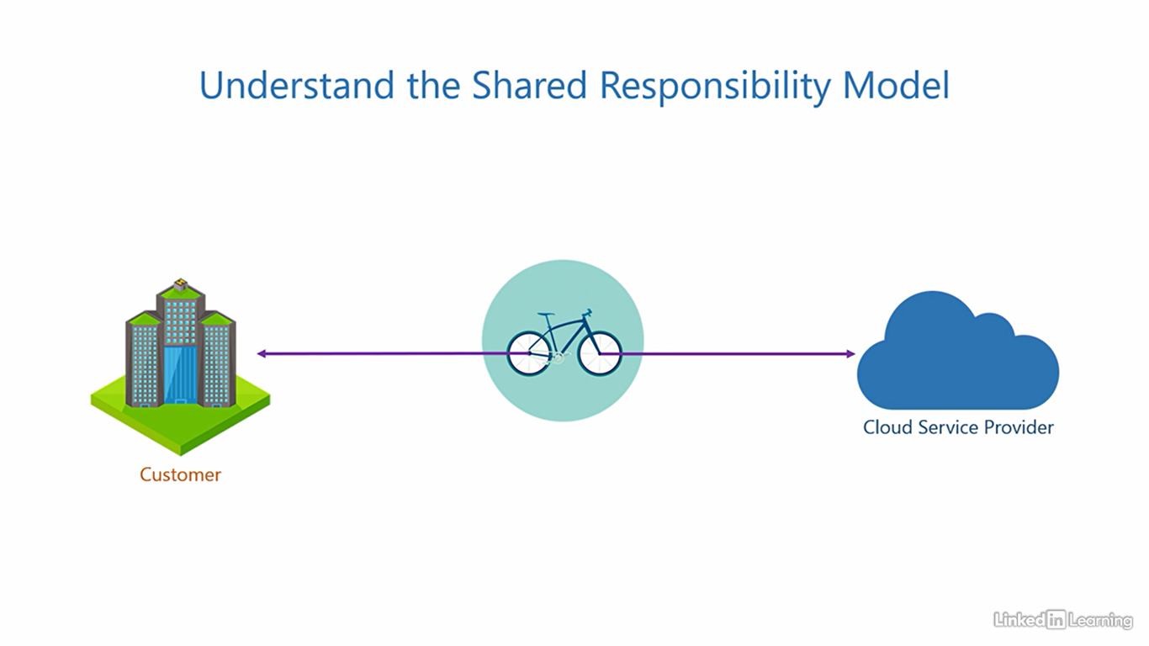 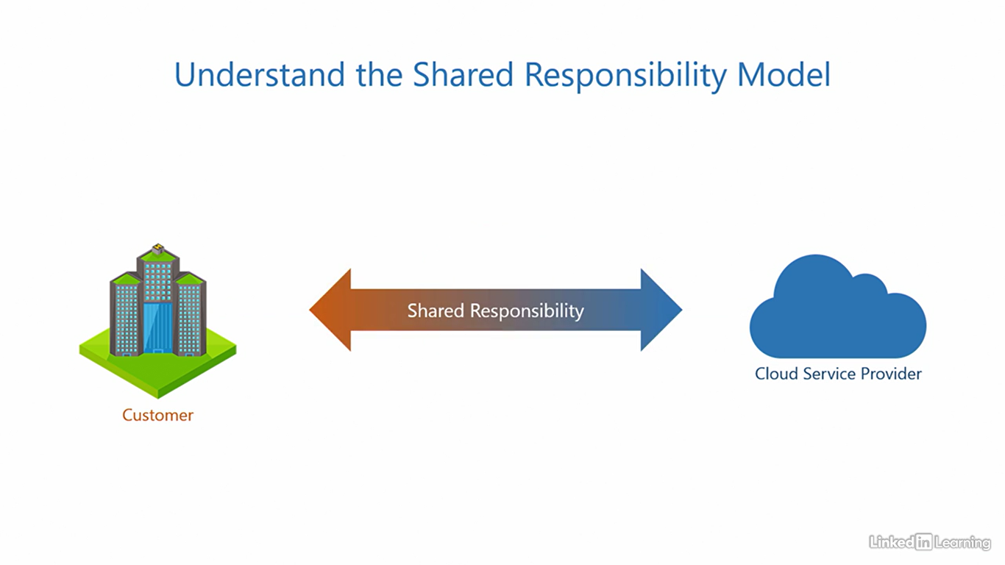

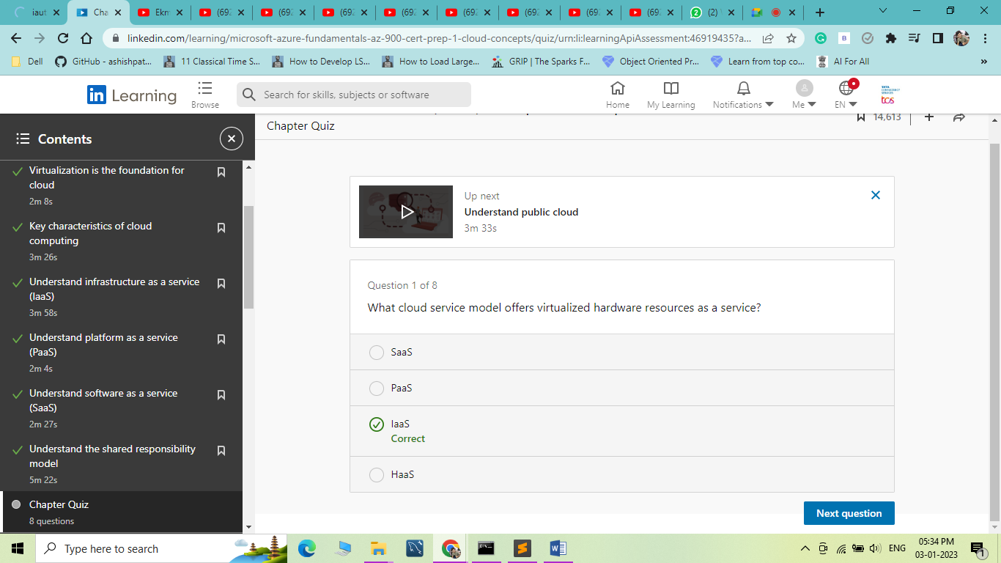

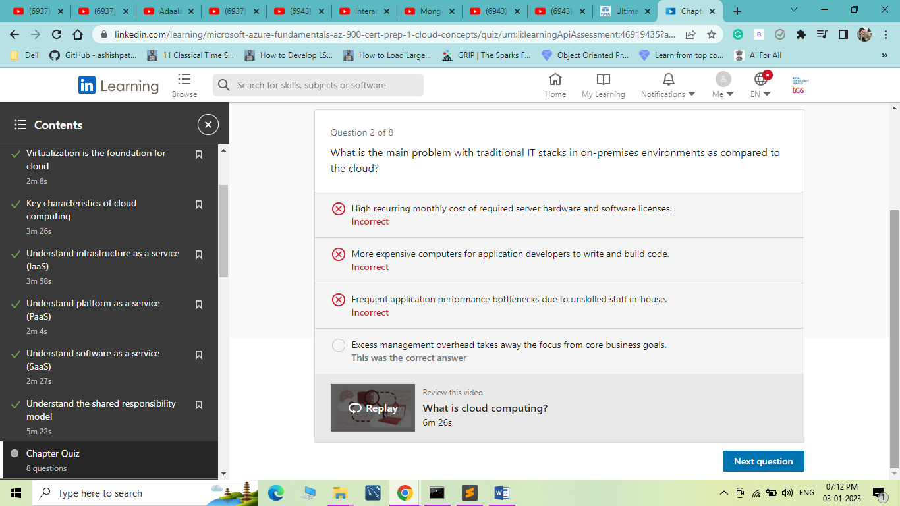

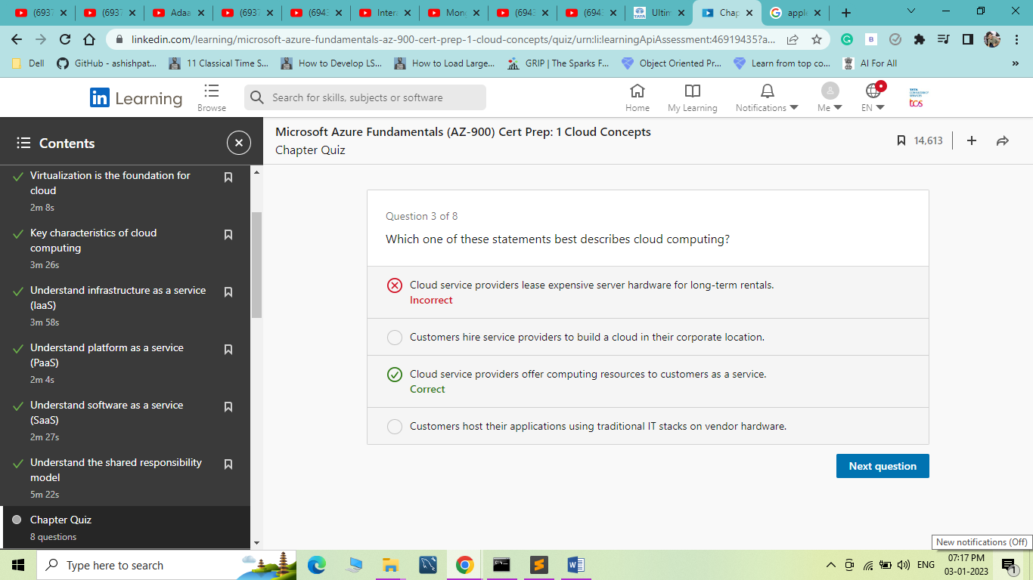

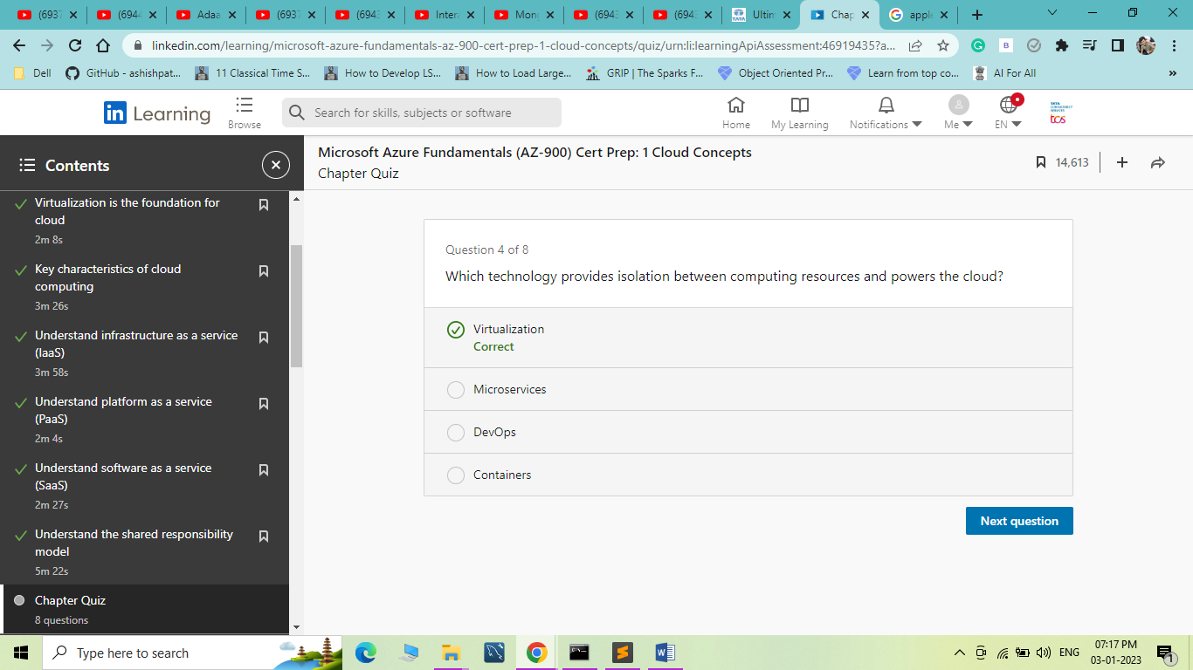

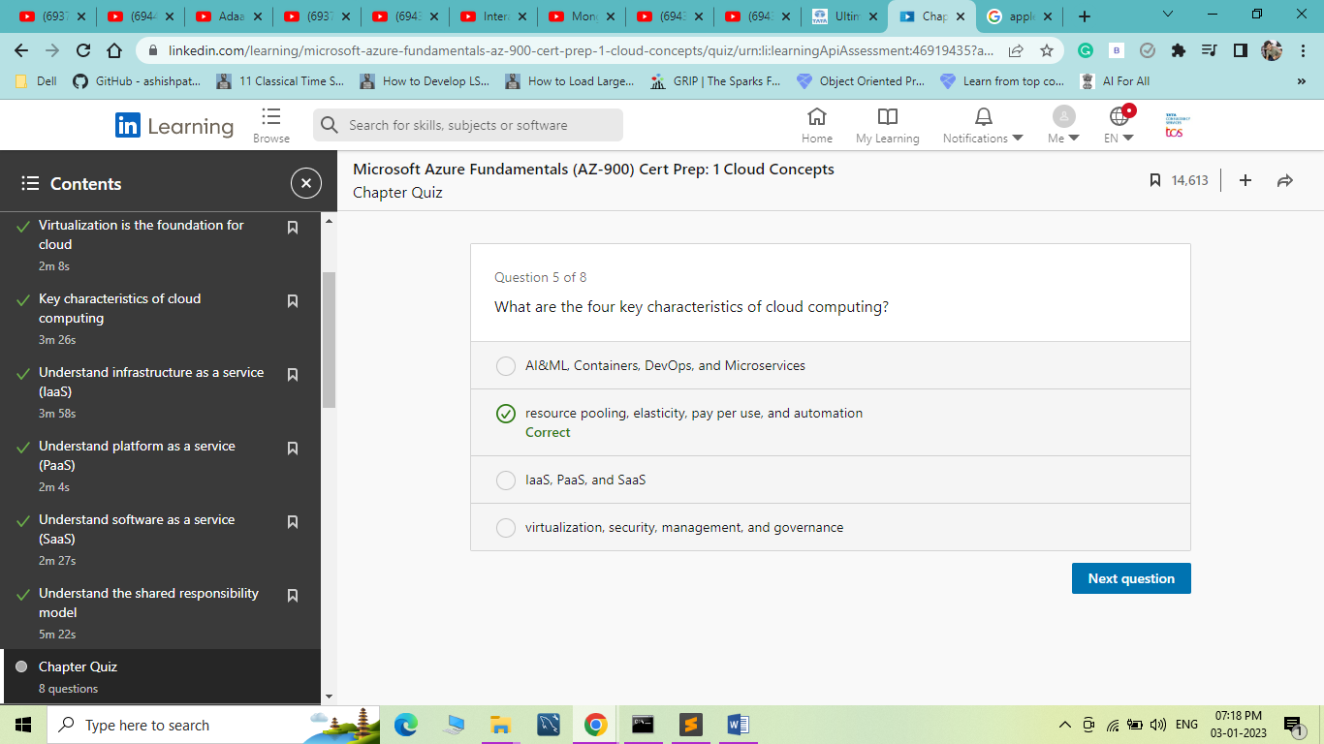

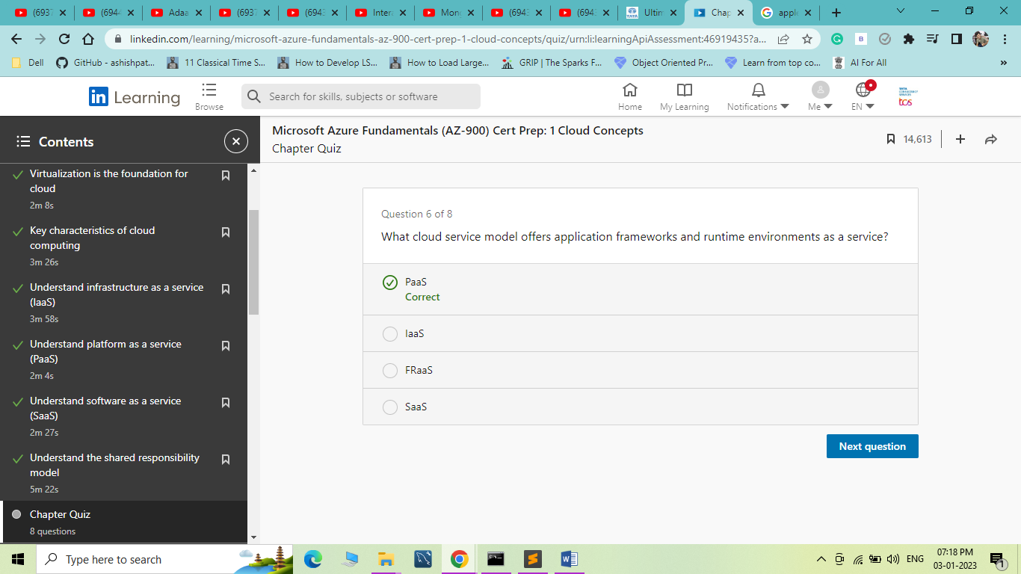

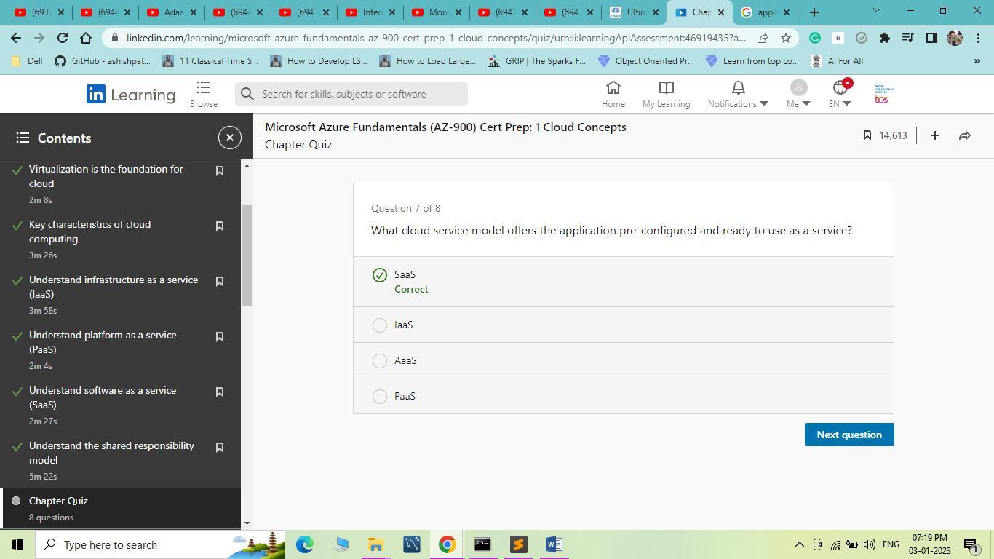

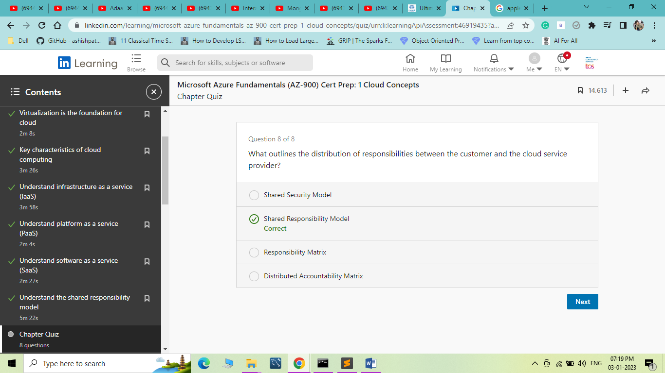

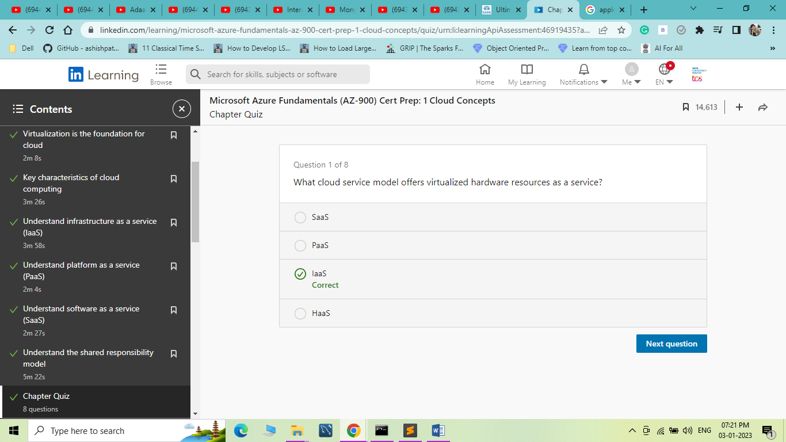

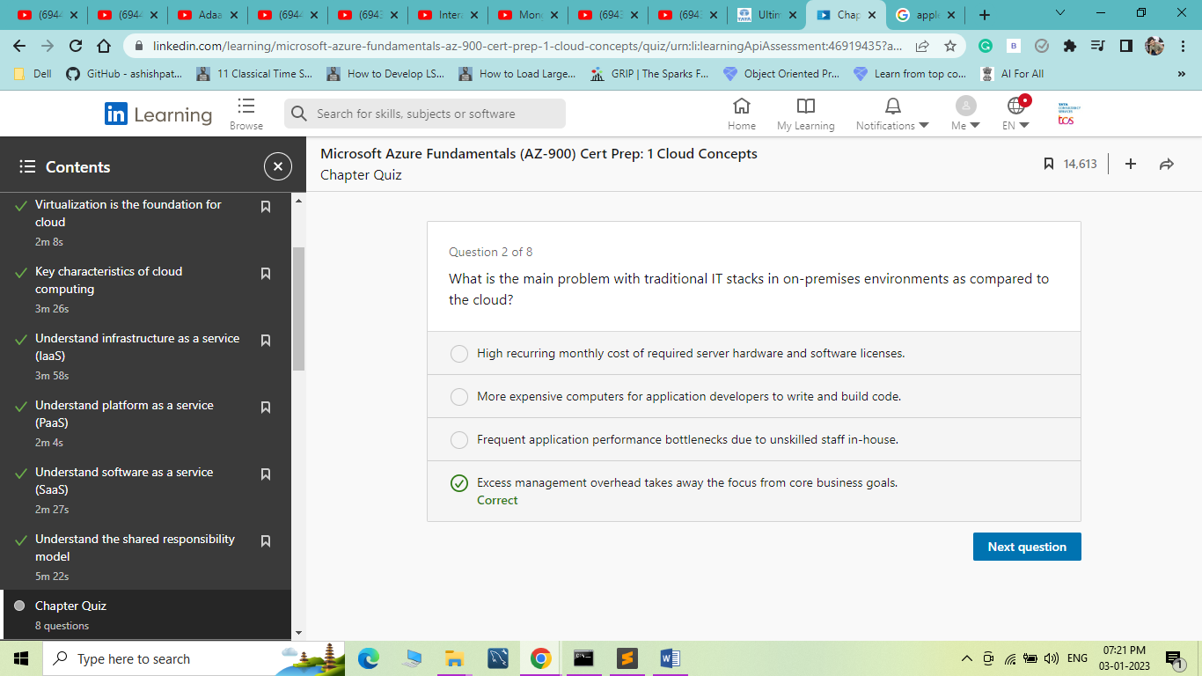

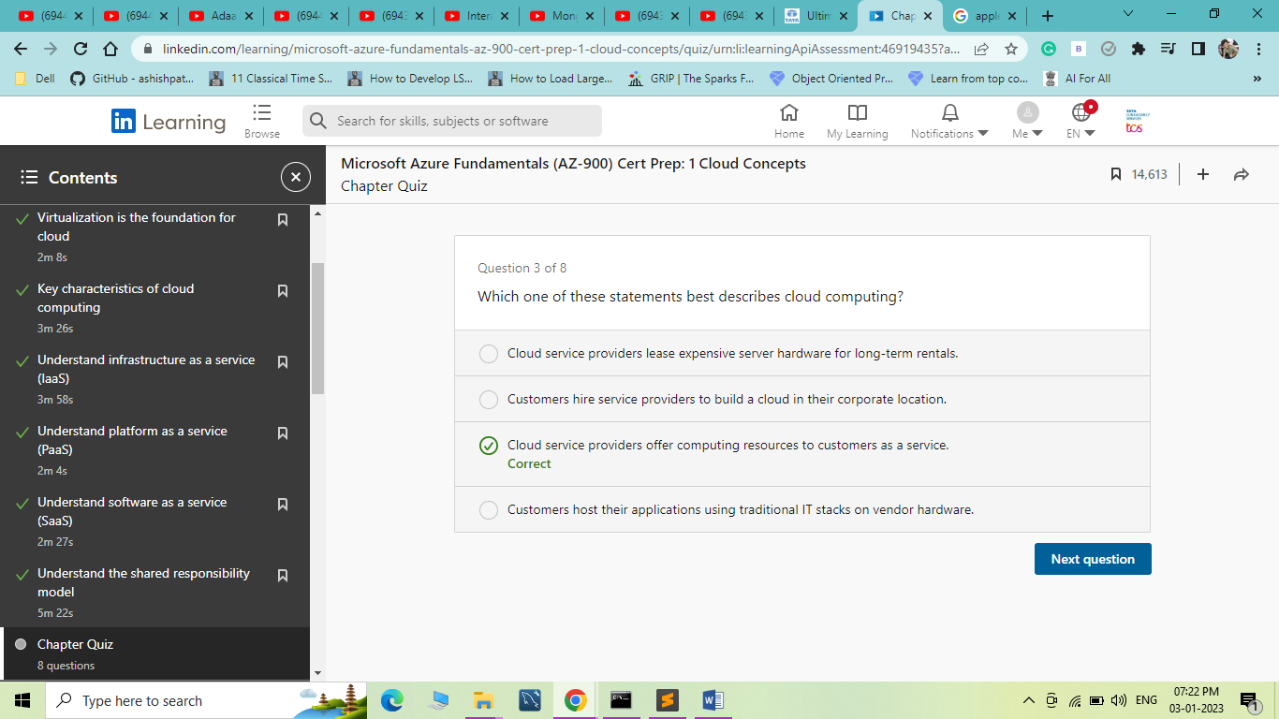

1. Understand Types of Cloud Computing

Understand public cloud

[Instructor] Welcome to the chapter, understand types of cloud computing. Here I'll explain what is a public cloud, a private cloud, a hybrid cloud, and a sovereign cloud along with the differences between them. In the last chapter you learned that a cloud provisions computing resources for a customer. A public cloud is one where it offers its services to not just one but many customer organizations, often over the public internet because it's easily accessible. The services in the cloud are open for anyone to pay for and consume with little or no restriction on who can choose to do so. Hence the term public cloud. The organizations that consume these services are called tenants because they're essentially renting out computing resources from the cloud service provider. The cloud runs instances of all services it has in its portfolio, including services from infrastructure-as-a-service, platform-as-a-service and software-as-a-service models. The tenants can pick and choose what services they want to consume and in what size. Every organization has different needs because their application requirements can widely vary. A public cloud has the power and capability to cater to organizations of all types, let it be startups or small businesses to medium or large enterprises. It's also very economical because public cloud providers run on a low cost but high volume sales strategy. The process of offering shared computing resources to multiple tenants is called multi-tenancy and therefore the public cloud is multi-tenant. I can imagine what you're probably thinking. This is a fair concern for everyone new to the public cloud, the sharing of resources. I know we teach kids that sharing is caring, but when it comes to IT, it's really not. This is where I want to remind you of the role of virtualization. You indeed share physical resources, but your virtualized resources are all dedicated to you and isolated from all other tenants. Your virtual resources and data are never shared with anyone else but you, not even the cloud service provider can read your data. At the ground level, virtualization provides secure isolation between tenant resources. On top of that, there are hundreds of other security controls designed to ensure the security of your data. It's a colossal undertaking, trying to hack into a public cloud. Public cloud providers are experts, not amateurs. They know what they're doing, but again this is subjected to the shared responsibility model. You should take your precautions and they'll take theirs. That's how it works. All the typical key characteristics we discussed in the last chapter apply to a public cloud, resource pooling, elasticity, pay per use and automation. Microsoft Azure is a public cloud.

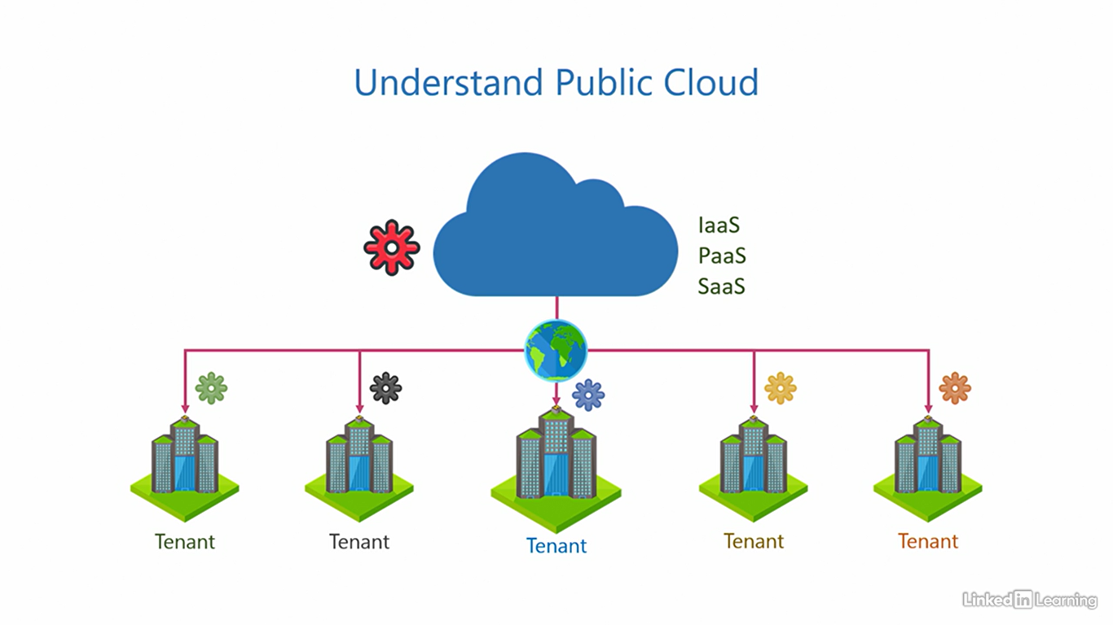

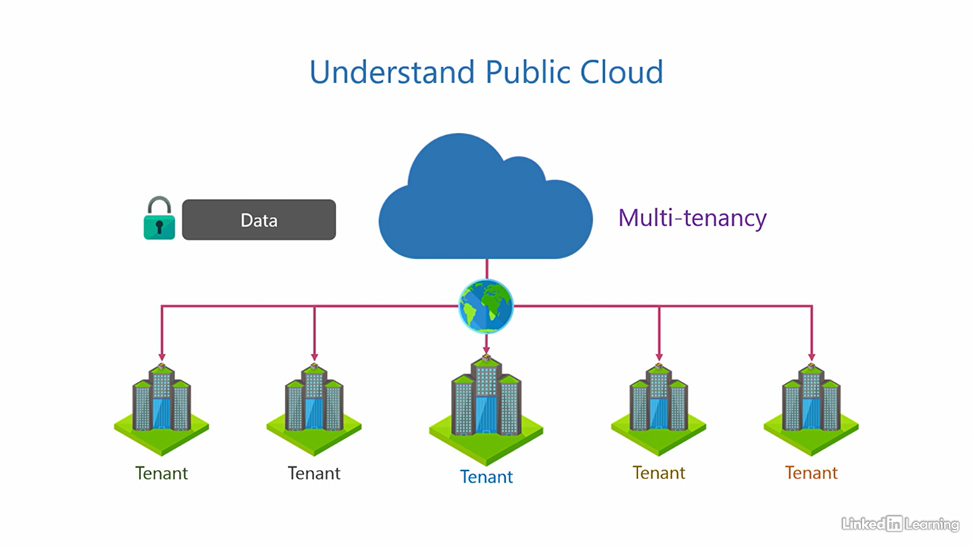

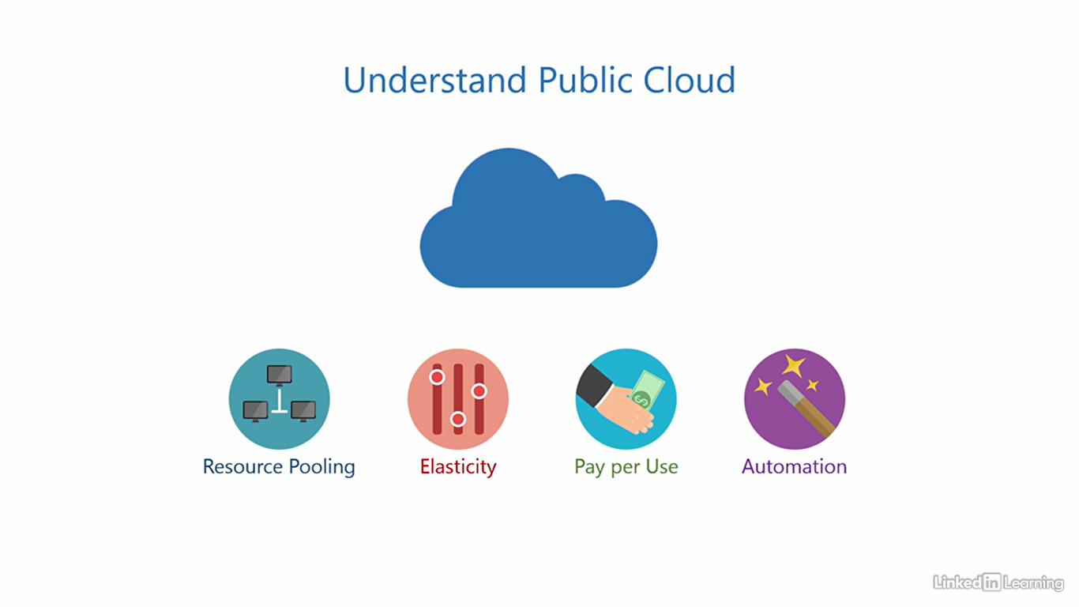

Understand private cloud

[Instructor] A public cloud, that we saw in the last video is great. It has a wide range of services, it's cheap, and available to everyone. But there can be certain situations where you may be restricted from using a public cloud. First is company policy. A company may decide, after due diligence, that the public cloud is not fit for them for various reasons. It's possible that the cloud may not be fully compliant with the requirement the company has, or does not have a service the company needs, or maybe their nearest data center could be in a foreign country the company is not comfortable with. It could also be due to national and regional laws that they're not allowed to use the public cloud. It could be a whole variety of factors. Another reason could be data security. I'm not saying the public cloud is unsafe, but not everyone is entirely comfortable with it just yet. It's also possible that your organization is working on projects where data is extremely sensitive and you want to be in full control. A lot of companies have strict rules governing where the data is stored and how it's transferred. These are the two biggest deterrents to the adoption of the cloud in the industry. So what's the solution here? What organizations can do in such situations, is build a private cloud in their own corporate location, and configure whatever services they need in this private cloud. They can also choose what service models are needed out of infrastructure as a service, platform as a service, and software as a service. Because a private cloud is dedicated to a single organization, and there are no other tenants, it is said to have single-tenancy, and therefore, a private cloud is single tenant. This ensures that organizations can comply with whatever company policy or data security requirements they have. The shared responsibility model does not apply here, because the only party here is the customer organization. They are responsible for the whole environment. I would not blame you if you're a little confused right now. A cloud is supposed to make your job easier, but what's the point if the customer has to set up the entire thing and be responsible for it. It may seem that the very purpose of the cloud is defeated here. And that's a valid question. Here's the thing, the cloud's only purpose is not to handle the part of the IT stack that you want to delegate to it, it's more than that. A cloud is about efficiency, streamlining processes, striving for operational excellence, and implementing best practices. Although a private cloud may not be easy and cheap as a public cloud, it'll sure be a lot more optimized over a traditional on premises IT stack. And how are these optimizations achieved? Back to the basics, through adherence to company policies, data security requirements, resource pooling, and automation. The other two characteristics change in a private cloud as compared to a public cloud. One, there's limited elasticity. I mean, a private cloud is elastic but not to the extent of a public cloud, because no organization can really match the capacity of resources available in the public cloud. The second is cost. A private cloud is not cheap. It's usually more expensive to set up than a traditional on premises IT stack. And there's no pay per use, pay per use instead becomes measure per use. You can use metrics in a private cloud to get insights into how resources are being used internally across departments. It's mostly medium or large enterprises that opt for a private cloud, not startups, or small businesses, because the technical complexity, cost, and effort involved here are significant. If an organization wants a private cloud but does not have the expertise to build it in-house, there are vendors out there who can set it up for them and then hand it over. **Microsoft's private cloud solution is called Azure Stack**, it's not covered in the scope of AZ900.

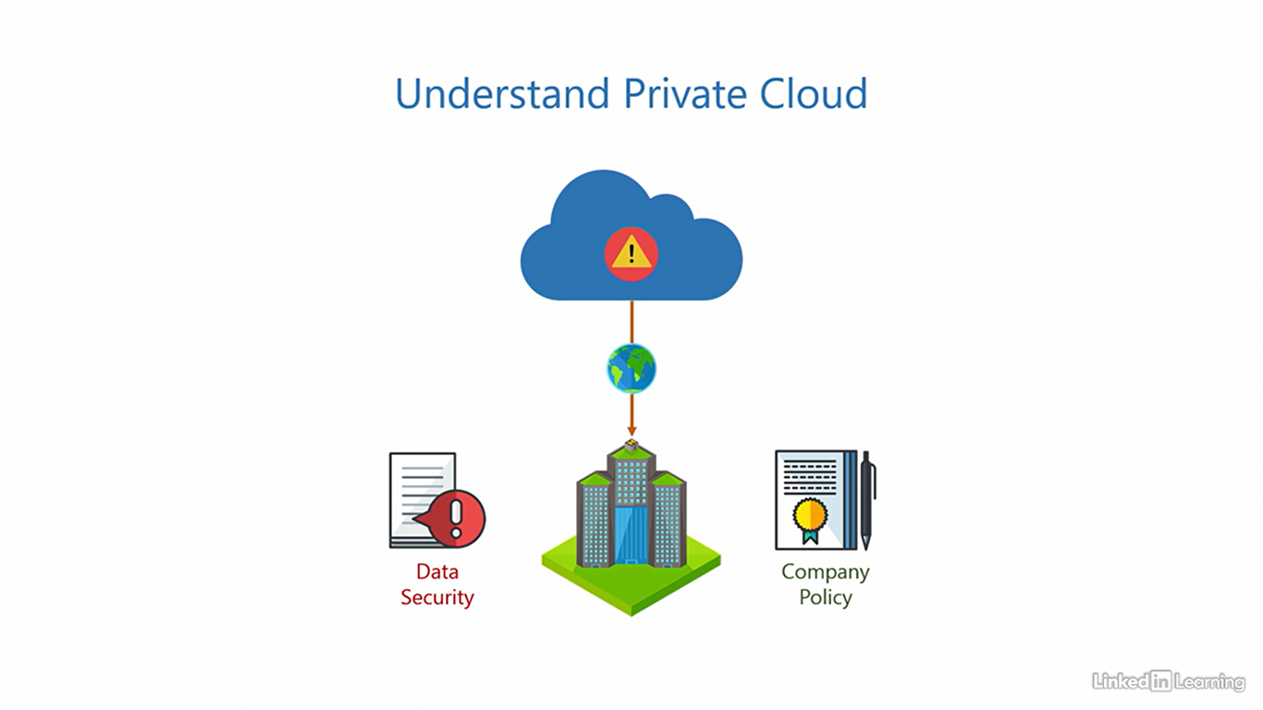

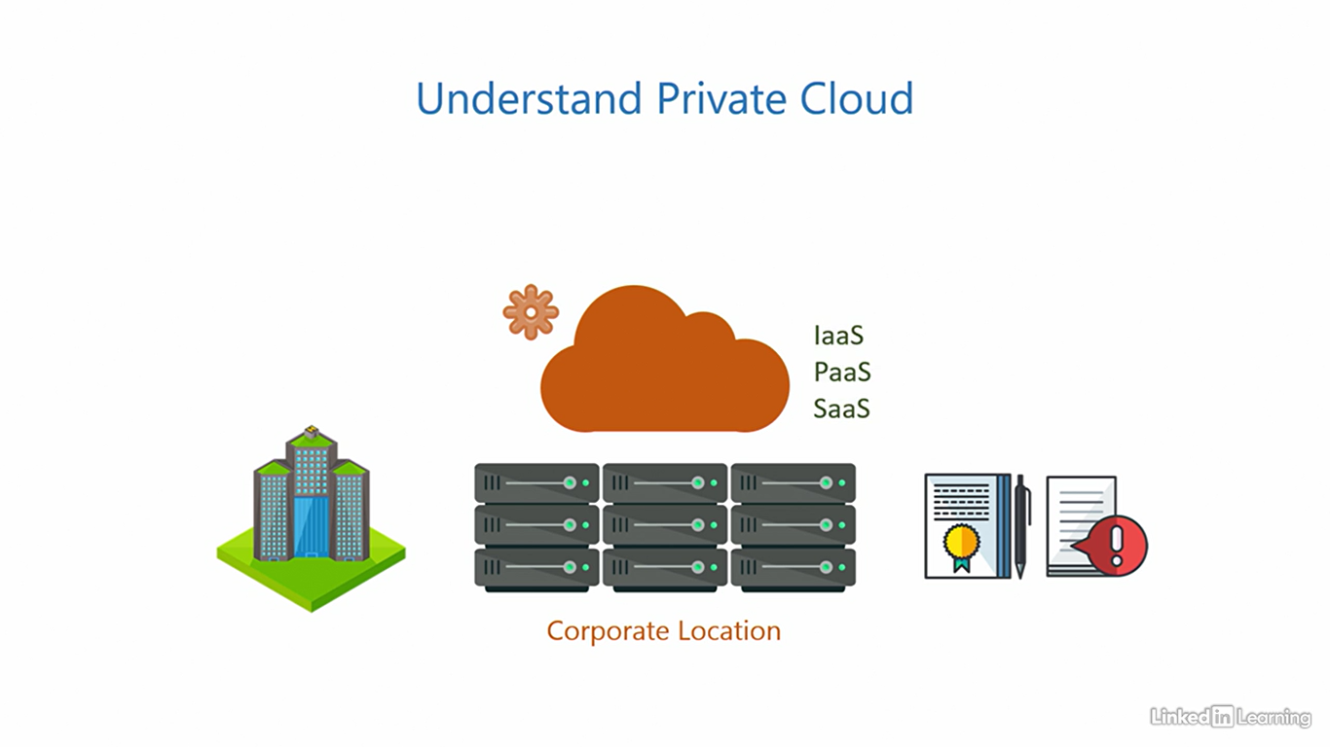

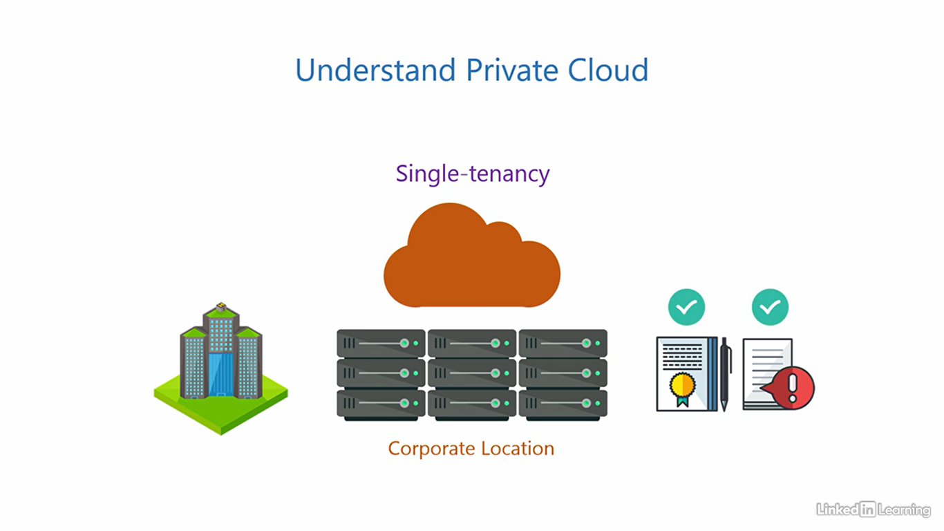

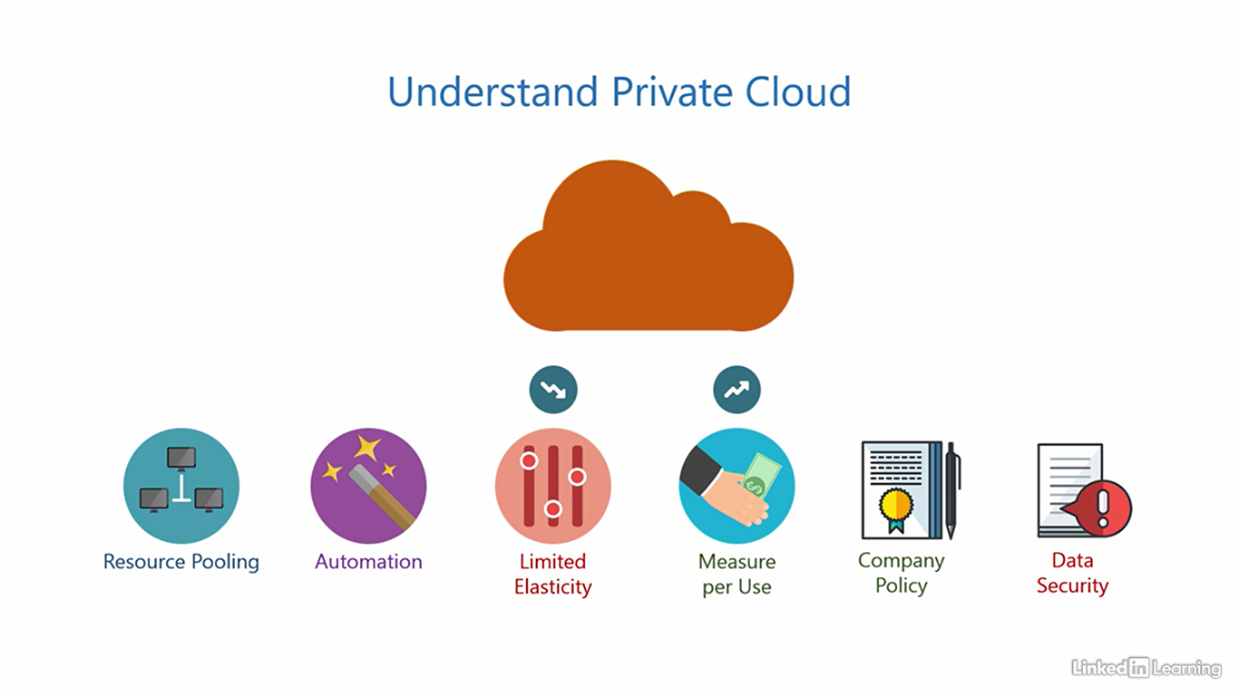

Understand hybrid cloud

[Instructor] You've seen two types of clouds so far. There's a third type of cloud that combines the best of both worlds. And that is a hybrid cloud. Organizations can use a combination of both public and private clouds to distribute workloads across them, often connected through the public internet. The services distributed can be of any type, infrastructure as a service, platform as a service, and software as a service. It is possible for a startup or a small business to run purely off of a public cloud because it's simple and economical. But when it comes to medium or large enterprises, it's rare for them to purely run on just public or private cloud because of their complex needs. It's more common for them to use both in conjunction to realize business goals. Conservative organizations could be more focused on private than public. And modern, ready to embrace the cloud type of organizations can be more public heavy. The exact proportion will depend on how comfortable an organization is with the public cloud. Whatever the proportion may be, it is definite that this unlocks a whole new level of flexibility. The private cloud allows organizations to satisfy company policies and data security for projects that requires stringent control. And other projects within the organization that are not so stringent can leverage the public cloud. That adds up the key characteristics of the public cloud to the equation. So in addition, you also get resource-pulling, elasticity, paper use, and automation. A hybrid cloud also enables a very interesting implementation. Organizations can use their private cloud as a primary environment, and the public cloud as secondary. Let me explain. Let's assume users are requesting resources from the organization. As long as the private cloud has the capacity to support those requests, it serves them and churns out resources. But once the demand for resources in the private cloud comes close to maximum capacity, a cloud burst occurs. All subsequent requests from users are seamlessly redirected to the public cloud for fulfillment. This burst is transparent to end users. They don't have to do anything extra to make this happen. In fact, there's a good chance they won't even realize a burst has occurred. Once resources in the private cloud free up, it can resume serving new requests. The existing resources in the public cloud continue to run there until the users release them. So in essence, in this implementation, the public cloud acts as an extension of your private cloud. Once the private cloud can no longer handle the workload, new requests coming in burst into the public cloud, keeping the business up and running without hiccups. These are the things that will make you fall in love With cloud computing. You can build a hybrid cloud using the public cloud Azure, and the private cloud on Azure stack.

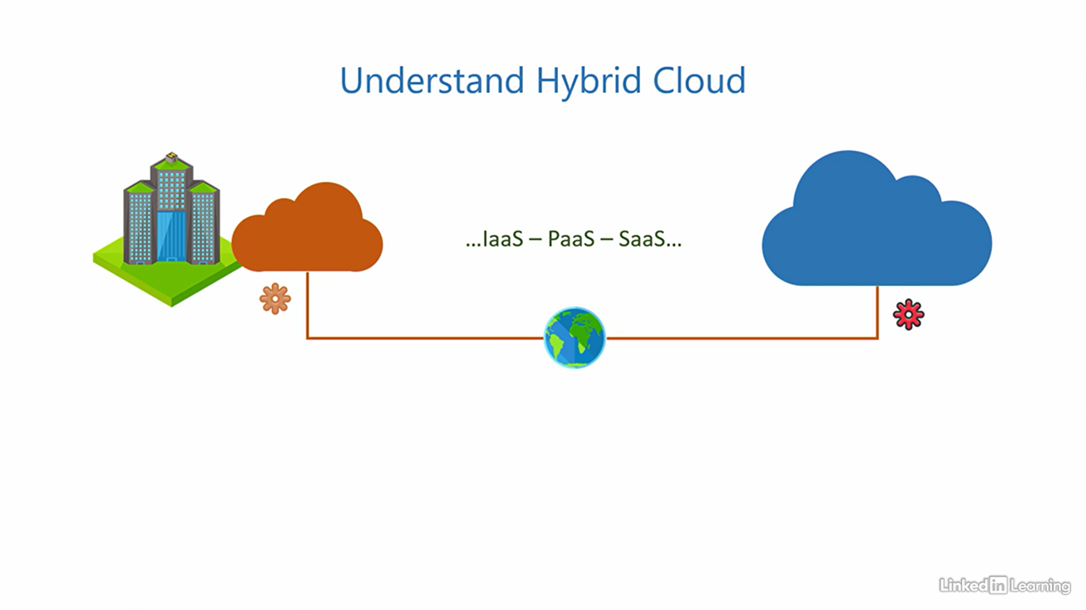

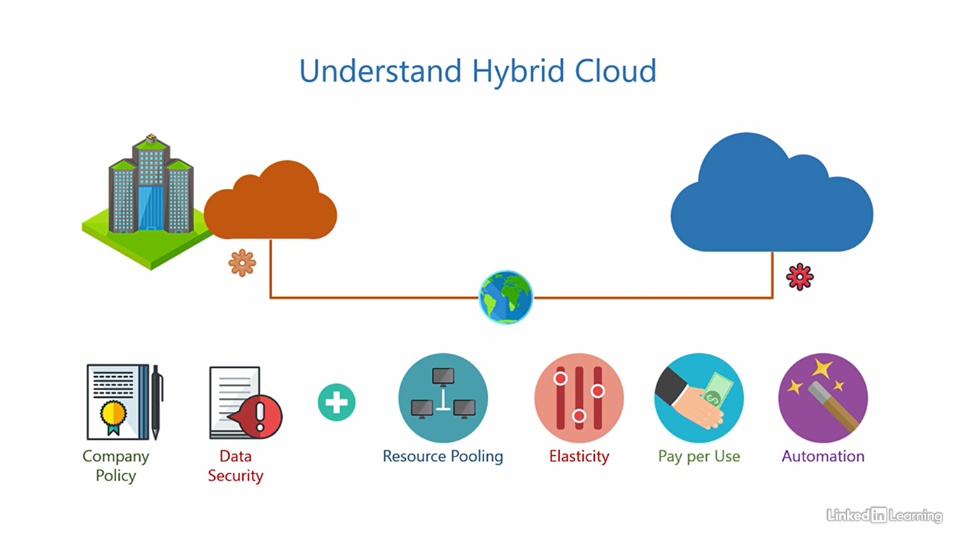

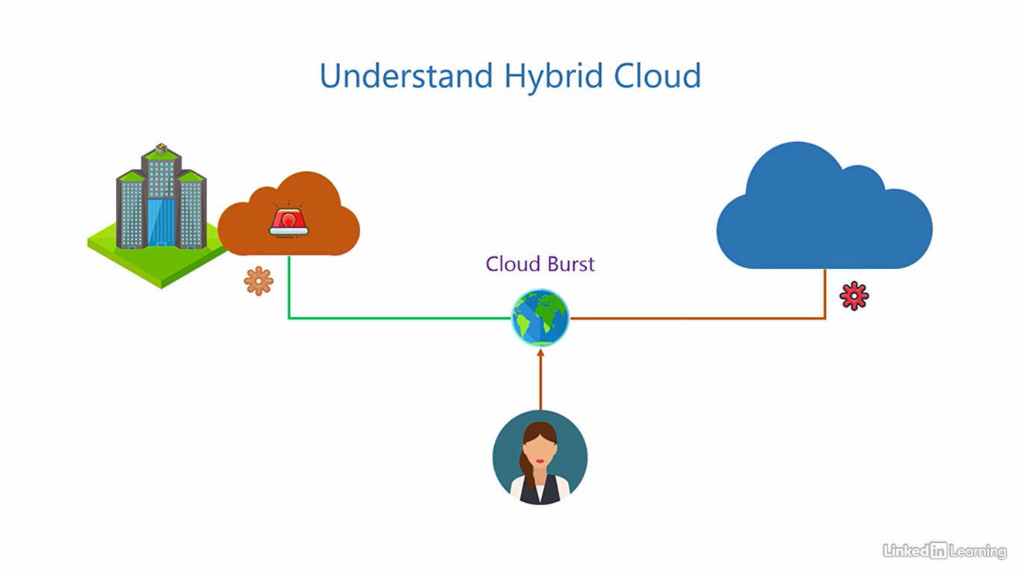

Understand sovereign clouds

[Instructor] There's a fourth special type of cloud called a sovereign cloud. This is reserved for use by national governments to process and store sensitive information pertaining to their country. This includes, but is not limited to, government agencies, armed forces, law enforcement, or any other government organization that processes any information of national interest that needs protection. In an international political conflict, the government is always a primary target of adversaries. Bad foreign actors will either try to steal confidential information, disable functioning of the government, disrupt services, or cause chaos among the citizens. Any of these events can lead to panic, crash the stock market, and cause huge financial losses to a country. The stakes are really, really high, and that's why we have sovereign clouds. These are like isolated, private clouds, but the scale at which they operate, or the capacity they have, compares to that of a public cloud. The government and the cloud service provider outline the terms of such an arrangement. Things like location of the data centers, will it be accessible over the internet or a dedicated network, expected usage, pricing, and any national regulations the cloud needs to comply with. It's all negotiated between the government and the cloud service provider. There are three sovereign clouds active right now. First is Azure US Government Cloud. Microsoft operates this cloud in the US for the US Government as the name suggests. The name has Azure in it, but it is completely isolated from the Azure public cloud. Apart from complying with the data processing and storing regulations, this cloud also requires all personnel involved in the process of running it to be US citizens, and they're only hired after a thorough background check. Only government organizations in the US are allowed to use the Azure US Government Cloud. Second is Azure China. Microsoft has deployed this cloud in China, and the Chinese company, Vianet 21, operates it. Azure China is open to the Chinese Government, as well as organizations that have a business presence in China. Organizations that do not have a presence in the country, are not allowed to use it. Third is Azure Australia Regions. Here, the Australian Government has reserved two regions in Azure for their dedicated use. So two regions are for the government only, and the other regions are open to public. It's all operated by Microsoft. There was a fourth sovereign cloud called Azure Germany, but it is now deprecated in favor of the Azure public cloud in Germany. So yes, sovereign clouds are not something we can get access to unless you are a government employee authorized to do so. But it's good to know what a wide spectrum of demands cloud computing solutions can stand up to.

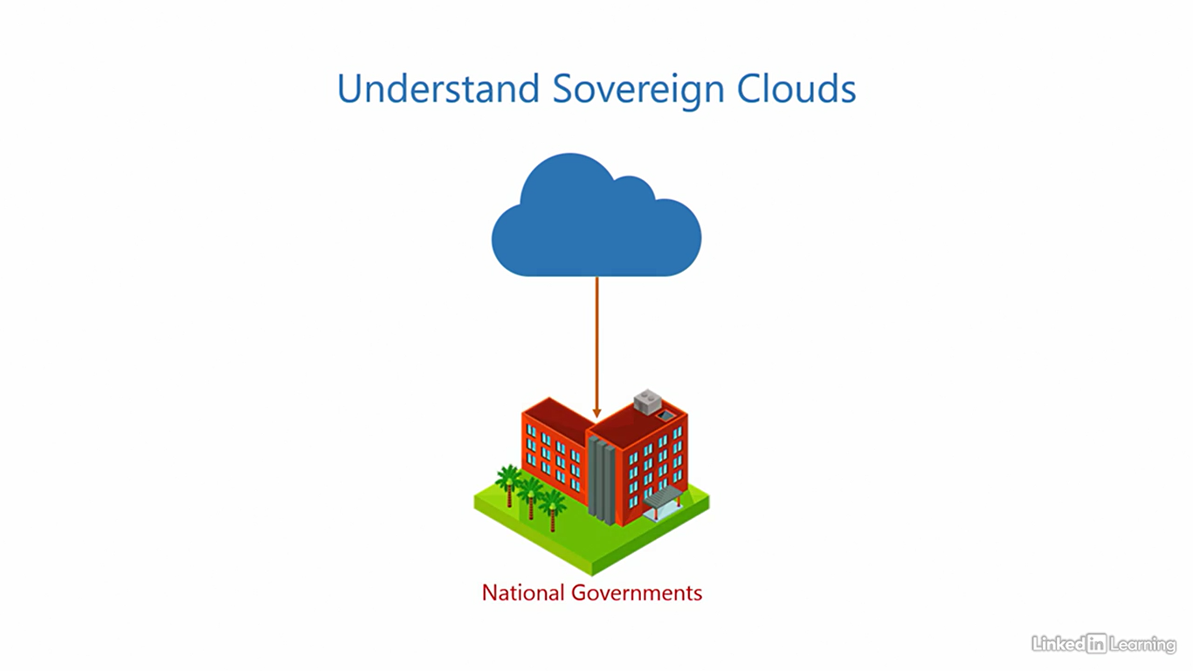

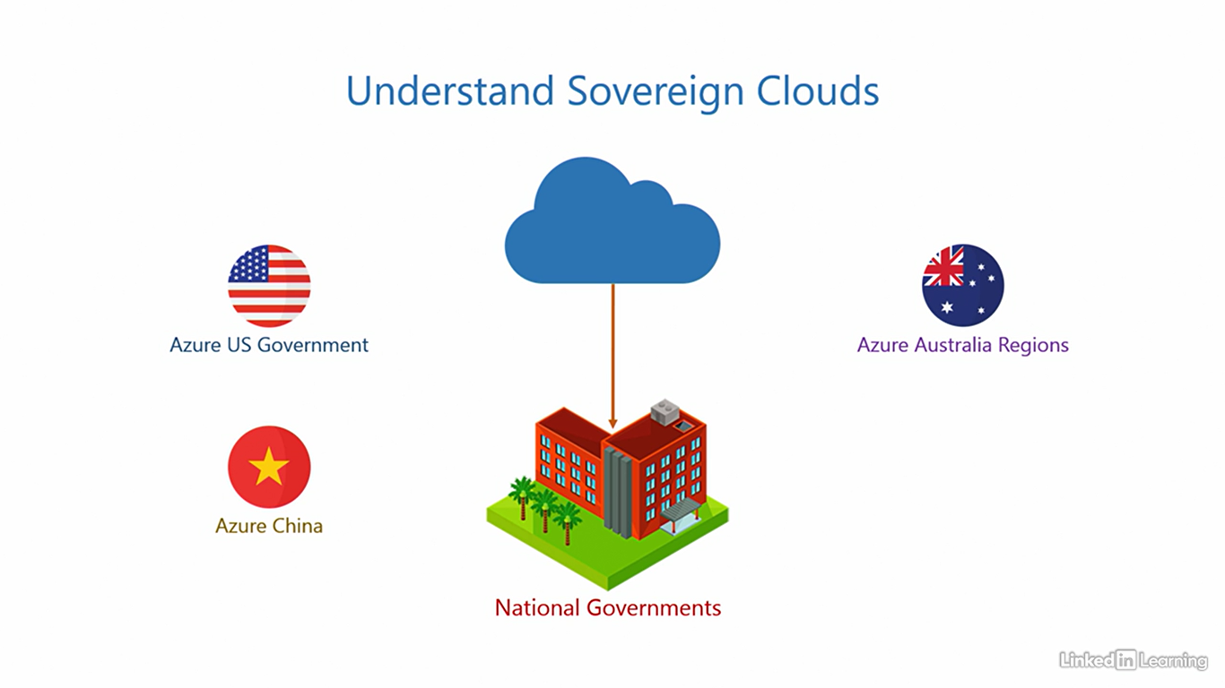

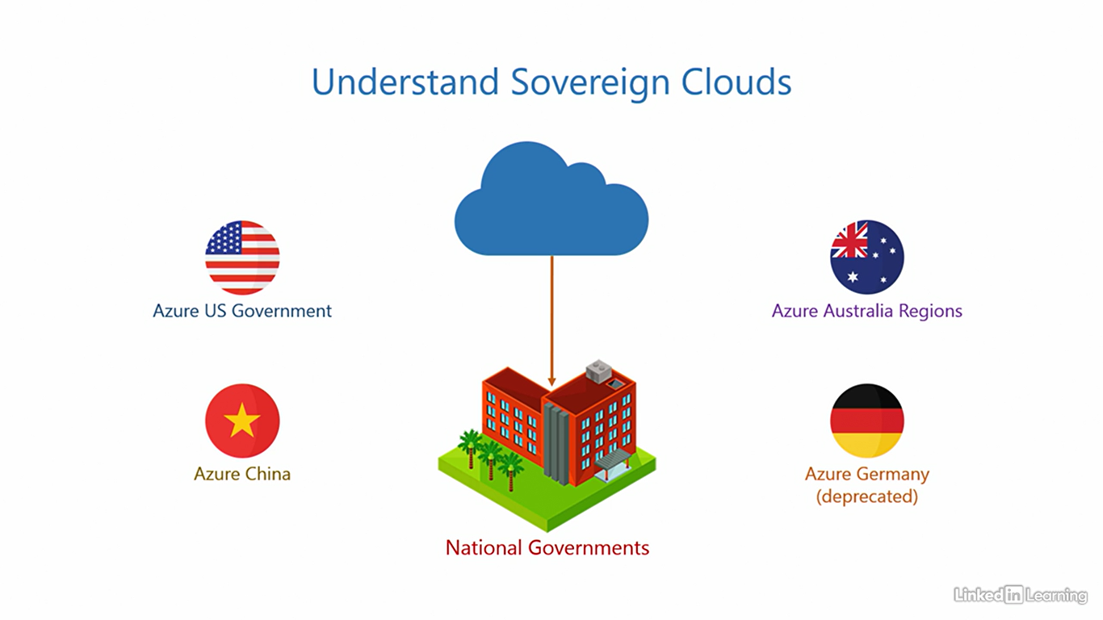

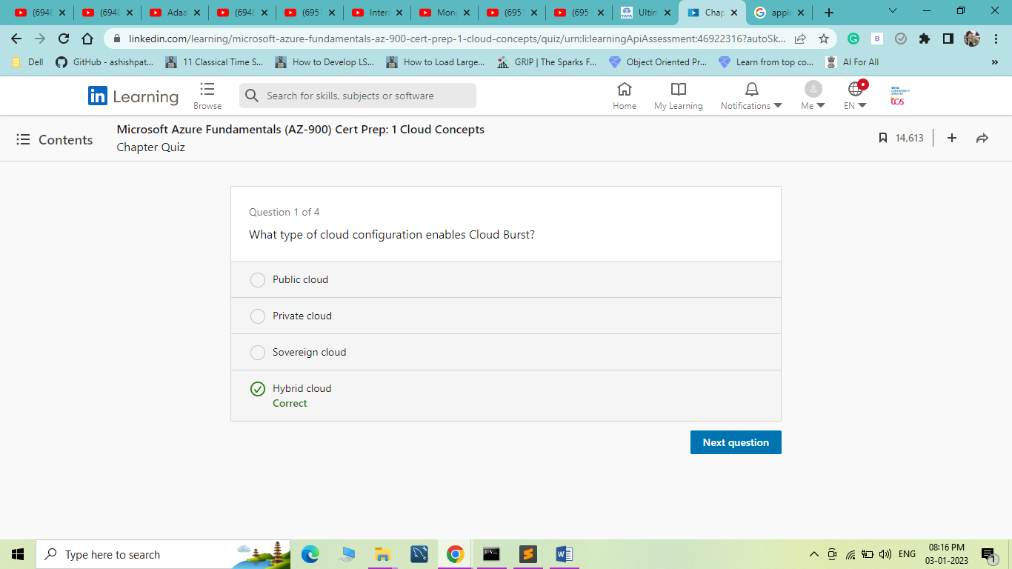

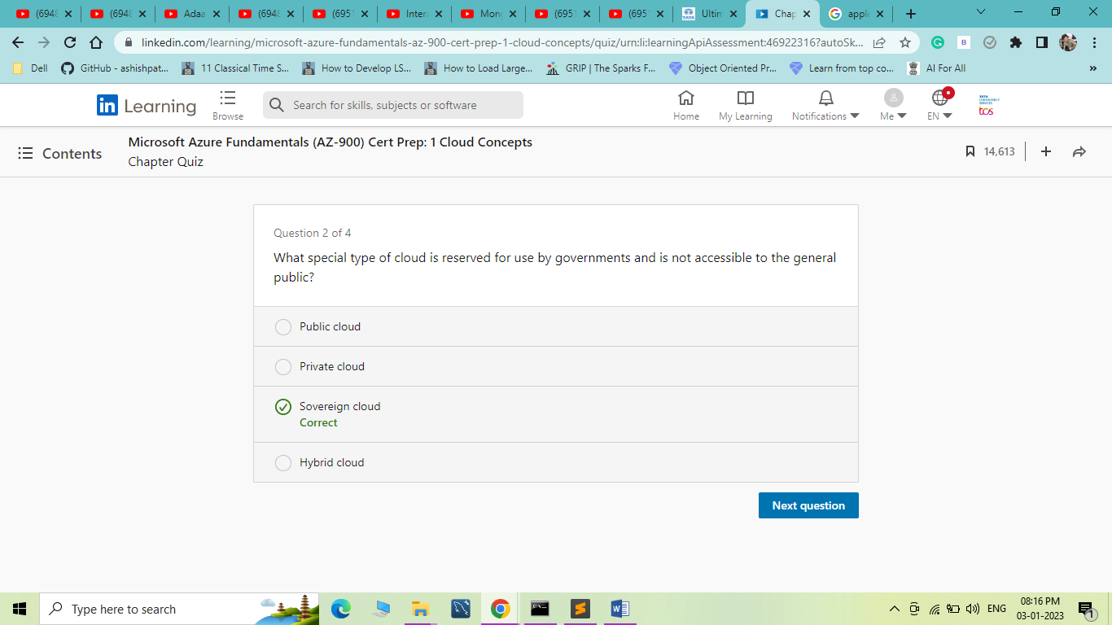

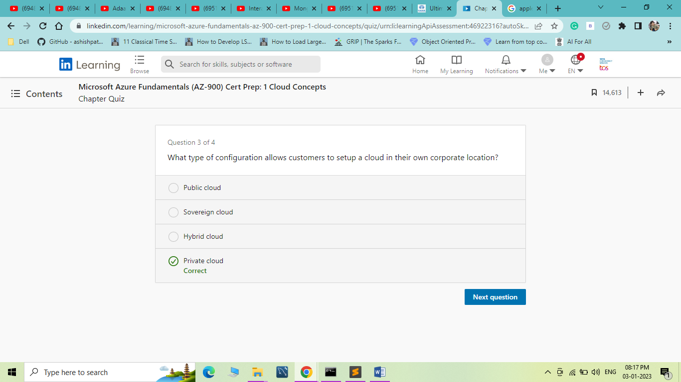

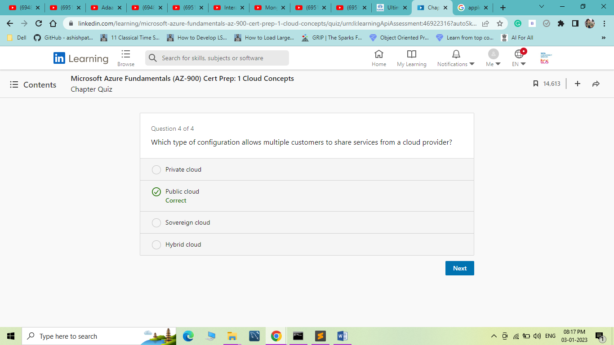

1. Understand the Benefits of Cloud Computing

Understand elasticity

[Instructor] Welcome to the chapter, "Understand the Benefits of Cloud Computing." Here, I'll explain the core benefits of the cloud, like elasticity, scalability, high availability, and fall tolerance. We'll also discuss what we expect from a cloud in terms of security, manageability, and governance. I briefly mentioned the term elasticity in previous videos. Let me put that into context and give you a comprehensive understanding of what it means. Here's our IT stack. To explain elasticity, I'll deconstruct it and only keep the parts of the stack that are relevant. You already know the physical components are called the infrastructure. So for simplicity, I'll represent these three as infrastructure. We'll get rid of things we don't need right now and keep the one we need, the application. So in the simplest of words, we can say, an application needs an underlying infrastructure to run. The infrastructure consists of pools of processor, memory, and storage. When a user provisions this application, a virtualized set of resources is assigned to the application for it to function. If the load on the application increases, it may request more resources from the infrastructure pool to keep up with the demand. The infrastructure pool should be able to do this, that is, provide extra resources when needed. This allows the application to run without disruption despite the excess load. It's like stretching a rubber band to expand it. After some time, if the load on the application decreases and it no longer needs those extra resources, it should be released back into the infrastructure pool, just like a rubber band goes back into its original shape after you let it go. When the application is deprovisioned, the infrastructure pool should reclaim all resources. If the infrastructure pool is able to do these things, that is, assigned resources to an application, provide extra resources when an application requests it, and reclaim it when the application does not need it anymore. If the infrastructure can do this, it is set to be elastic. A cloud should always have an elastic infrastructure. And, therefore, elasticity is a core benefit of the cloud. The cloud service provider is responsible for ensuring elasticity in all three service models, infrastructure as a service, platform as a service, and software as a service. Remember, elasticity is an attribute of the infrastructure. Microsoft Azure also provides elasticity for applications running on it.

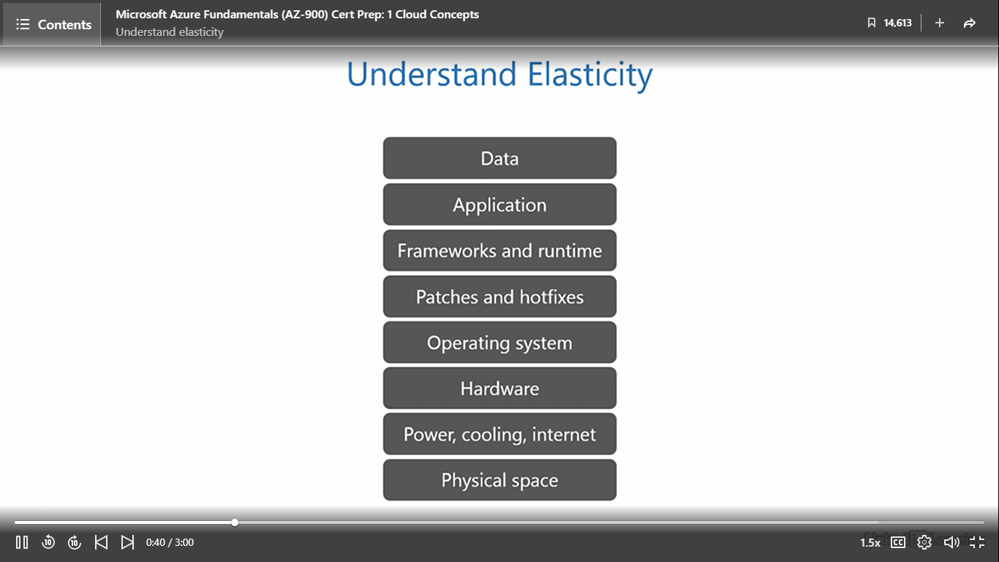

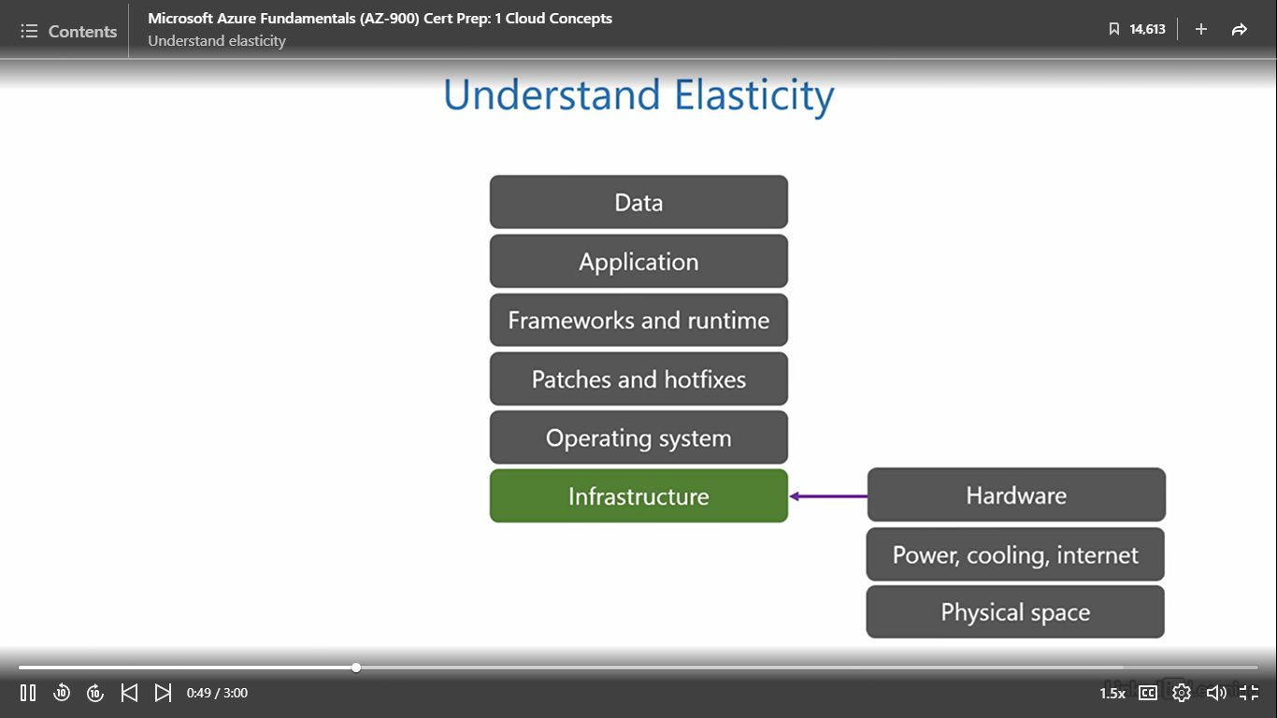

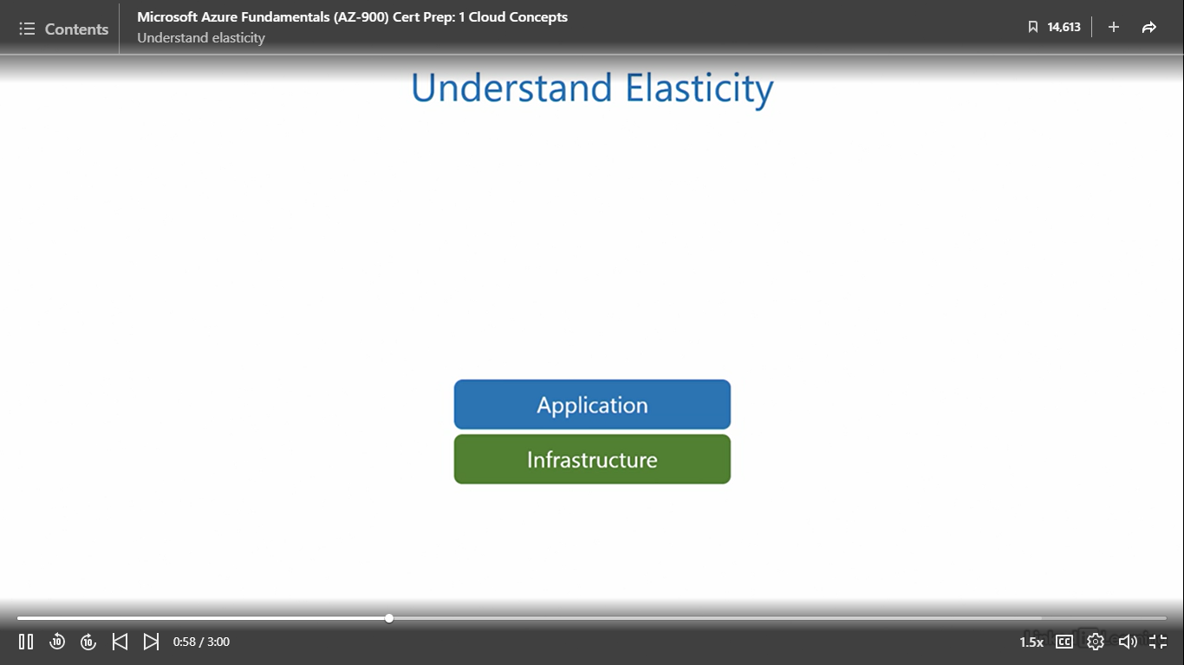

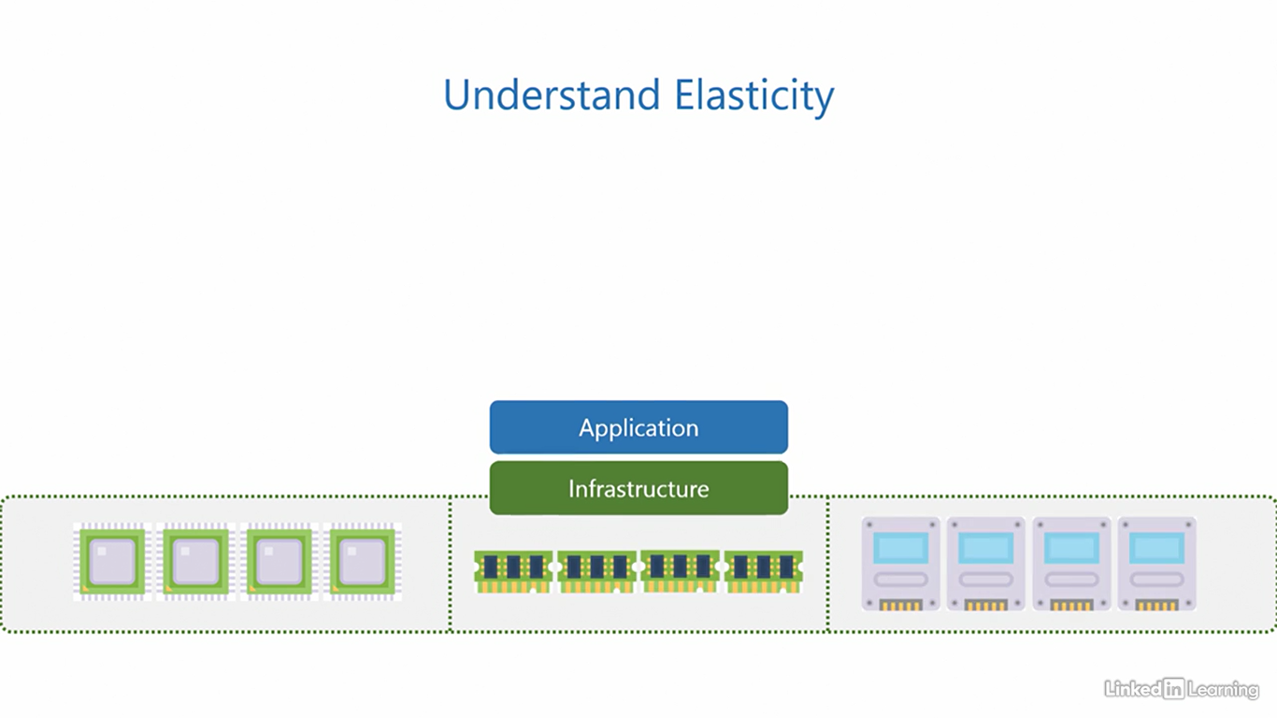 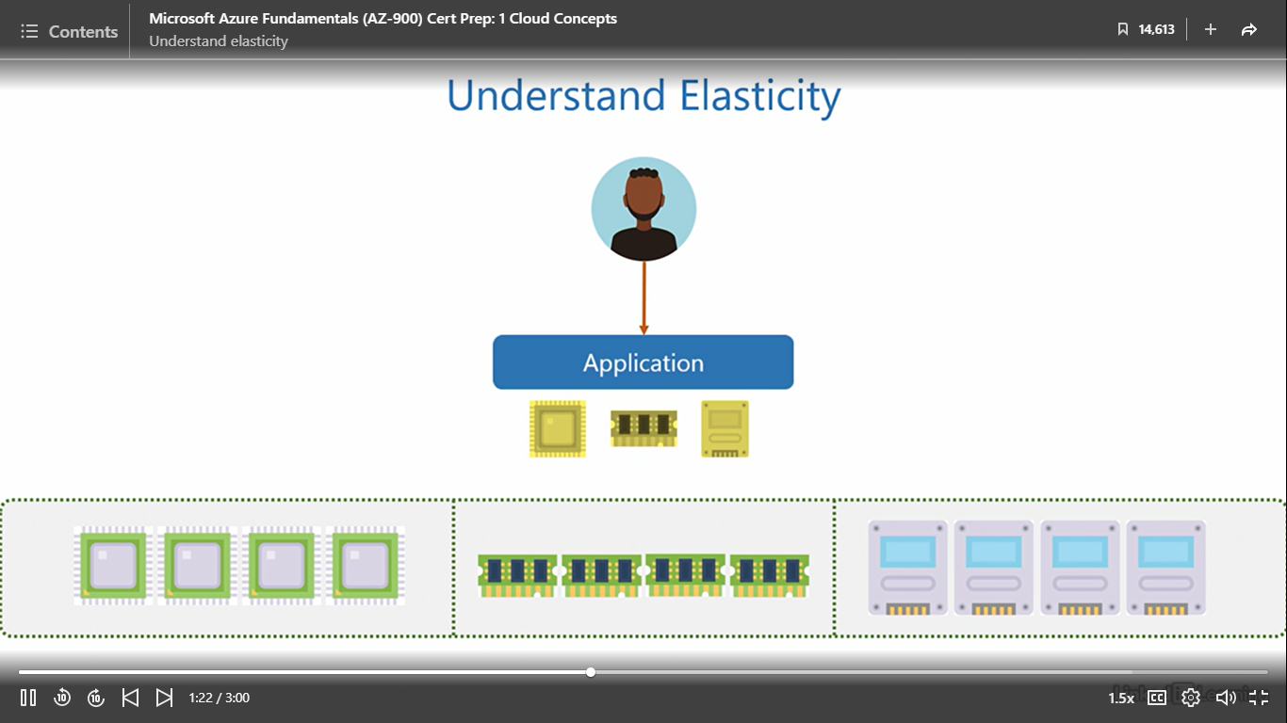

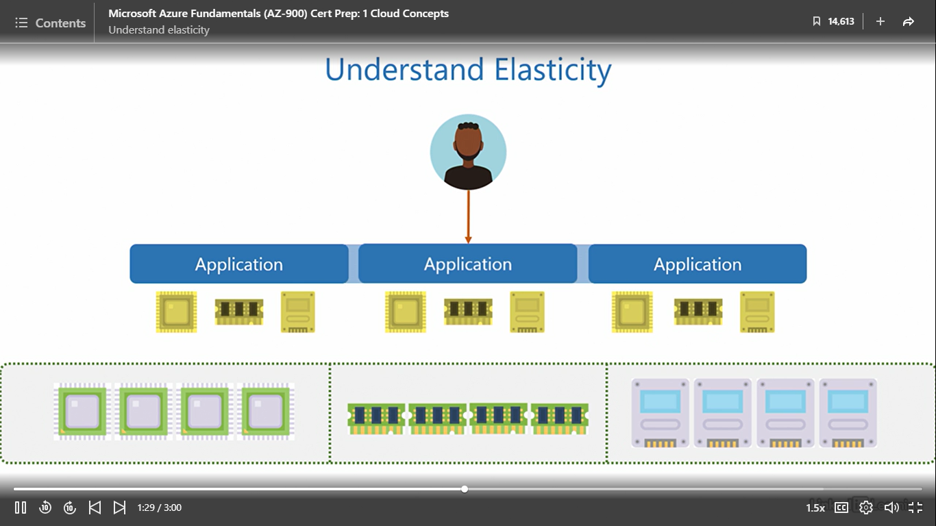

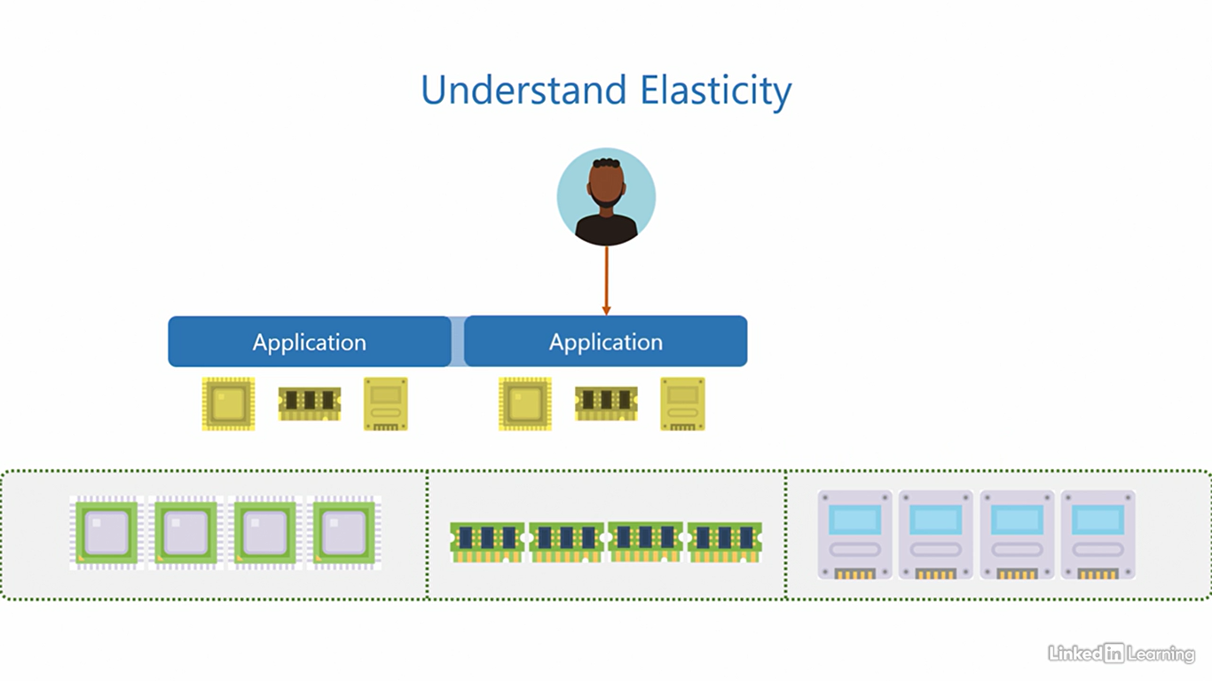

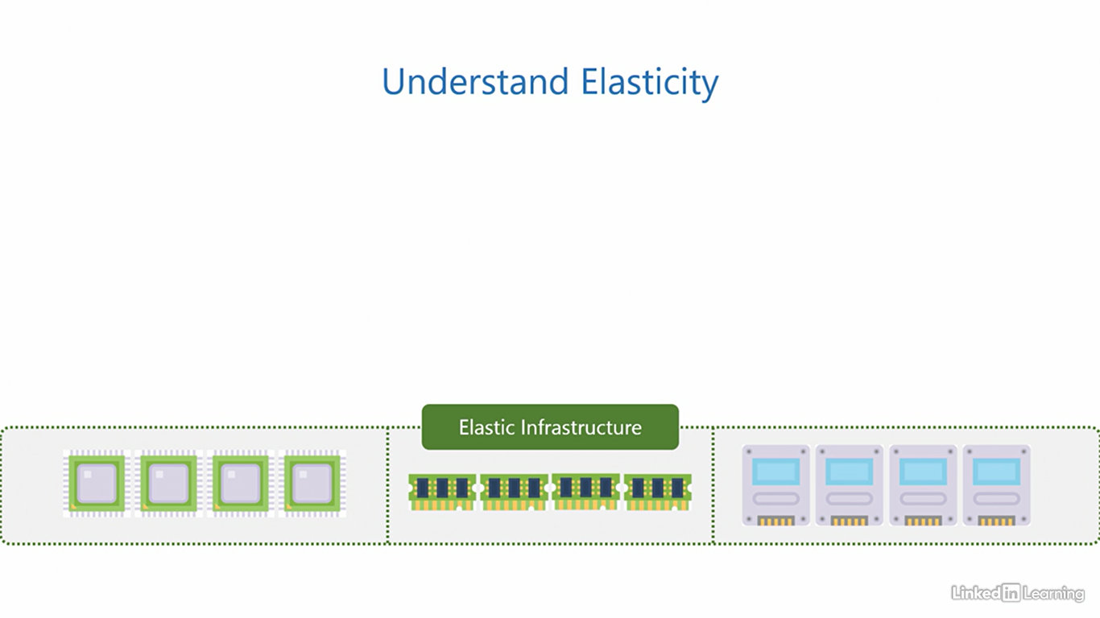

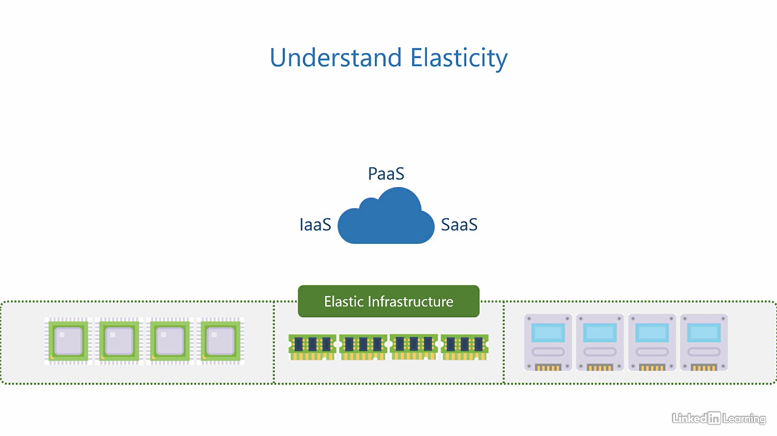

Understand scalability

[Instructor] To understand scalability, let's assume we have an application running on an elastic infrastructure. You already know how an elastic infrastructure responds to an increase in load. Now, let's shift our focus to see how an application behaves during the same circumstances. When a user provisions an application, the elastic infrastructure assigns sufficient resources for it to run. If the load on the application increases, it can react in one of two ways. Let's see what happens in the first case. To keep up with the increase in load, the application can increase the size of its instance and demand a bigger set of resources from the elastic infrastructure, kind of like making itself more powerful to sustain the excess demand. This allows users to continue using the application without disruption despite the excess load. When an application does this, that is, increase the instance size with the help of bigger resources, it is said to scale up. Once the load on the application drops, it should decrease the instance size and adjust the request for resources to match the new load. When an application does this, that is, decrease the instance size and consume a smaller set of resources, it is said to scale down. Here, since the application scales up and down, we collectively call this vertical scaling, going up and down vertically, hence, vertical scaling. This was the first case. Now let's see what happens in the second case. Here, to keep up with the increase in load, the application increases the number of its instances. Each instance is of similar size and consumes a similar amount of resources, kind of like cloning itself to sustain the excess demand. When an application does this, it is said to scale out. Once the load on the application drops, it turns off the extra instances and returns to its original form. When an application does this, it is said to scale in. Since the application scales in and out, we call this horizontal scaling, moving in and out horizontally, hence, horizontal scaling. If an application is able to either scale vertically or horizontally to adjust with an increase or decrease in demand, it is said to be a scalable application. An application can only be scalable if it is supported by an elastic infrastructure. We already know the cloud is elastic, so that means the cloud enables scalability for applications. The customer is responsible for implementing scalability in applications for IaaS and PaaS. But for SaaS, the cloud service provider takes care of the application scalability. Remember, scalability is an attribute of the application. Azure also enables scalability for applications running on it.

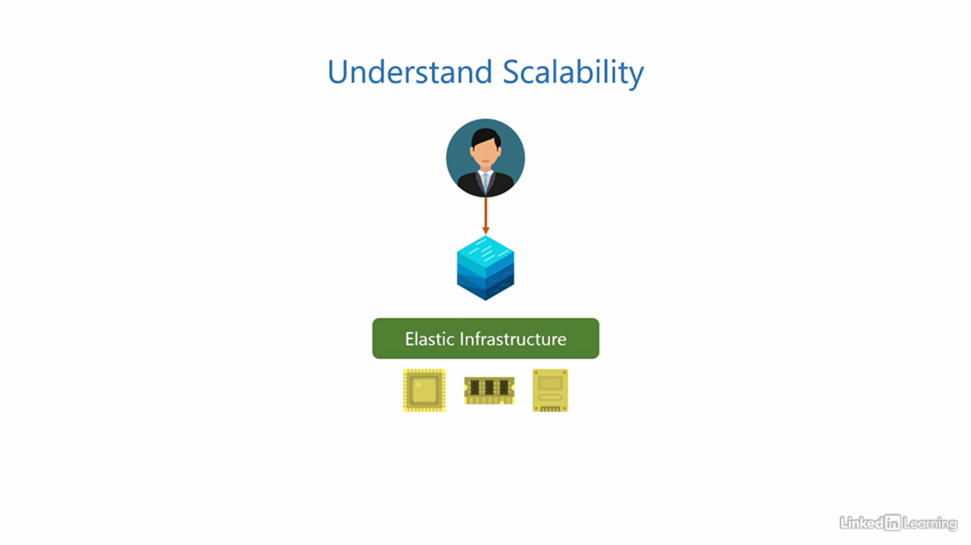

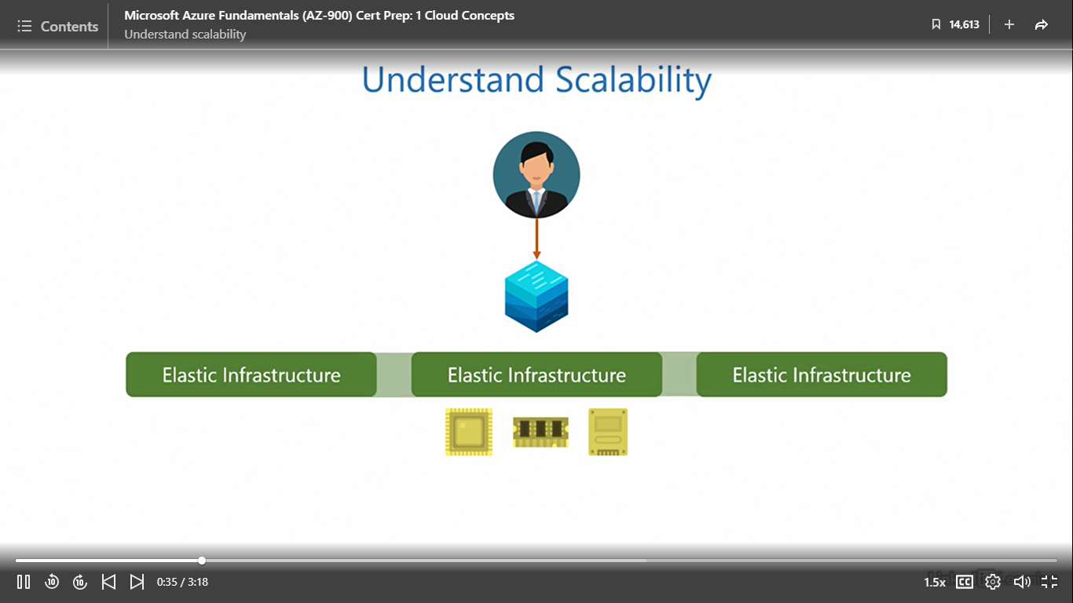

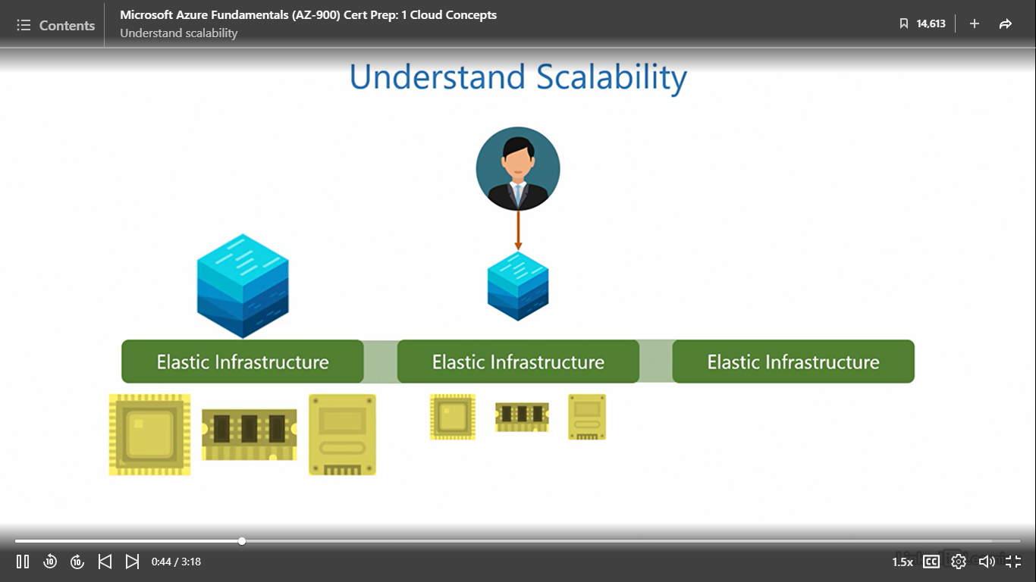

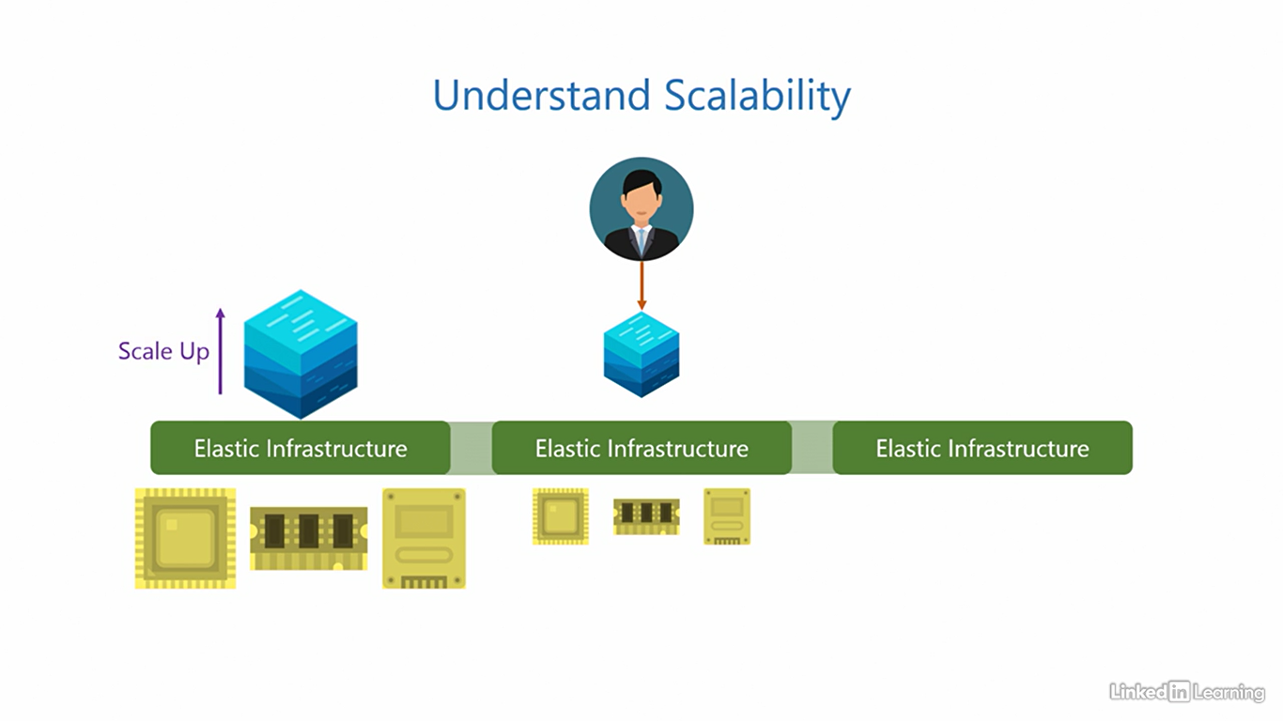

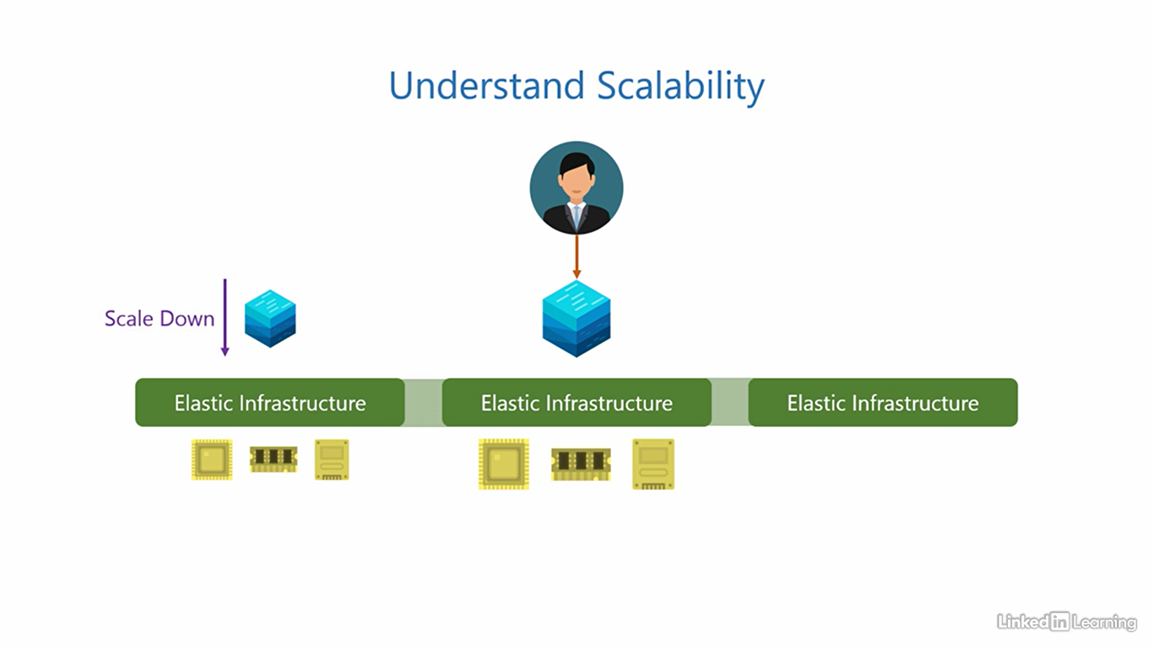

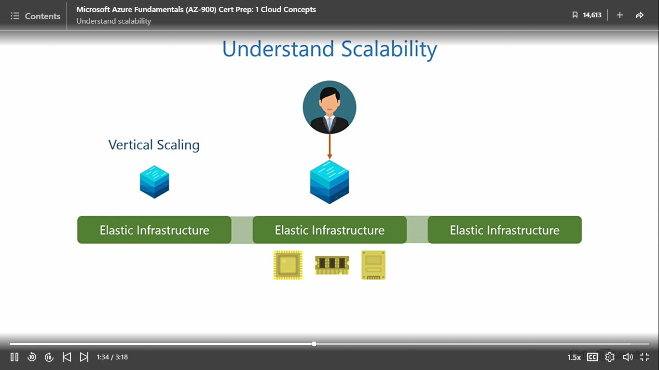

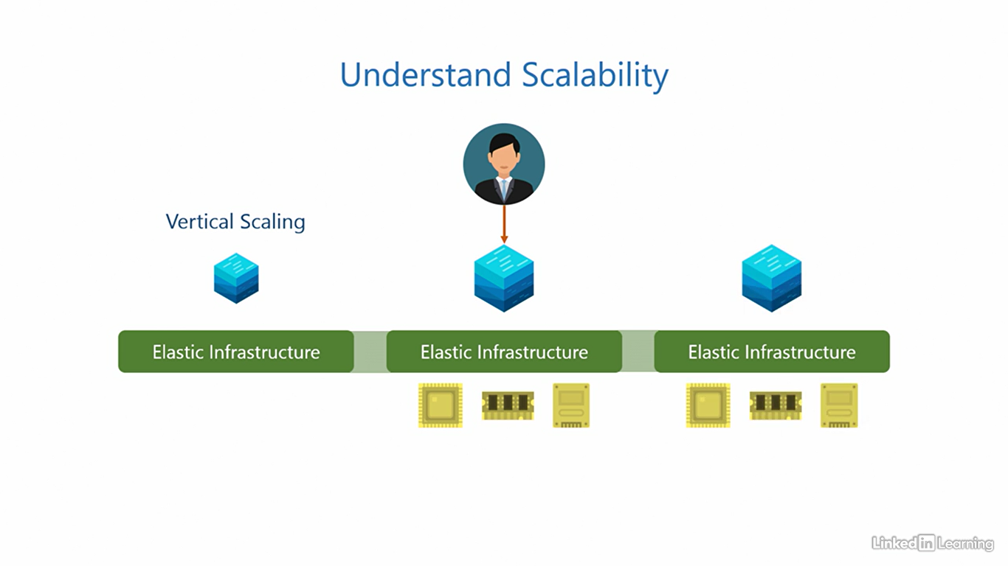

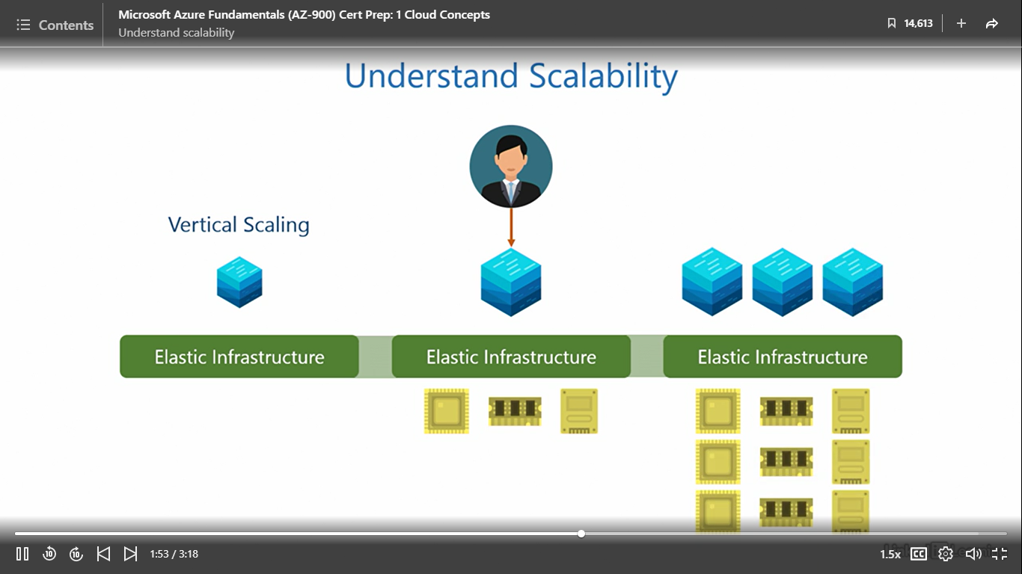

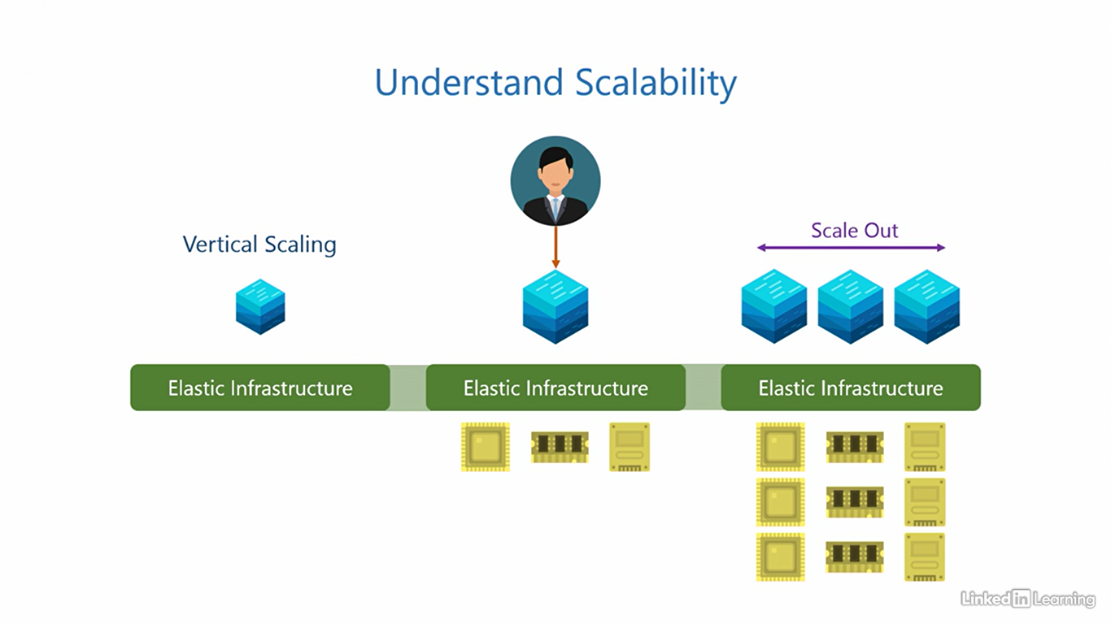

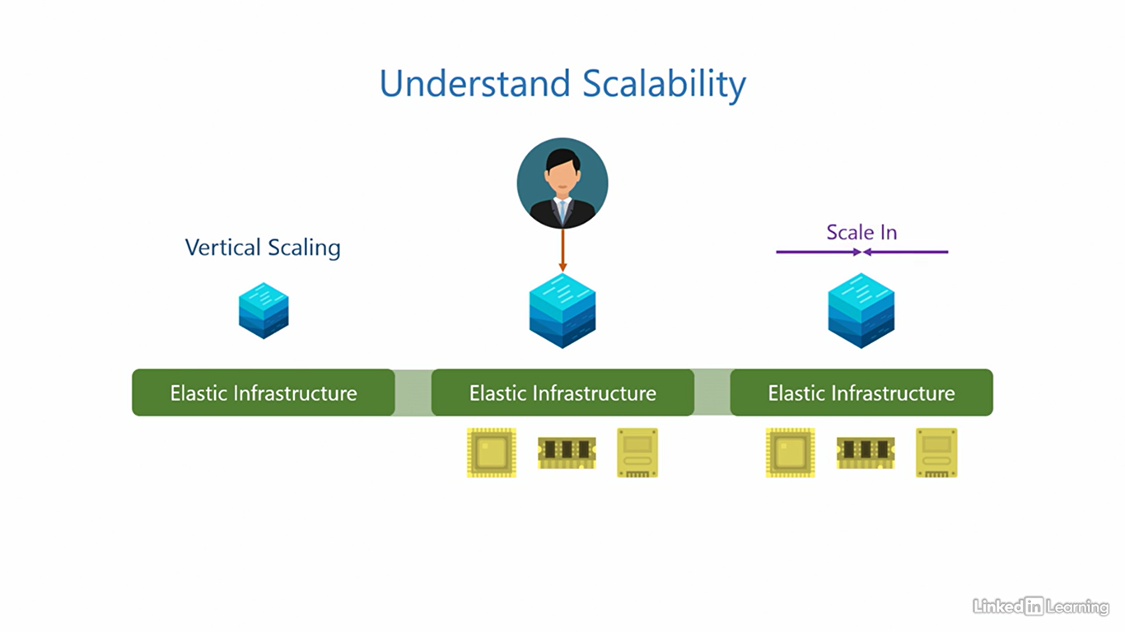

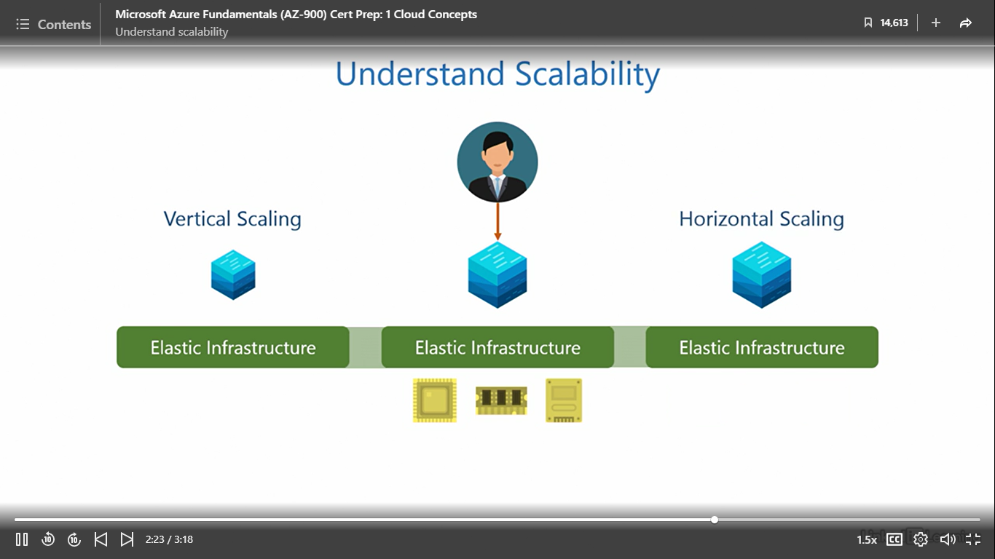

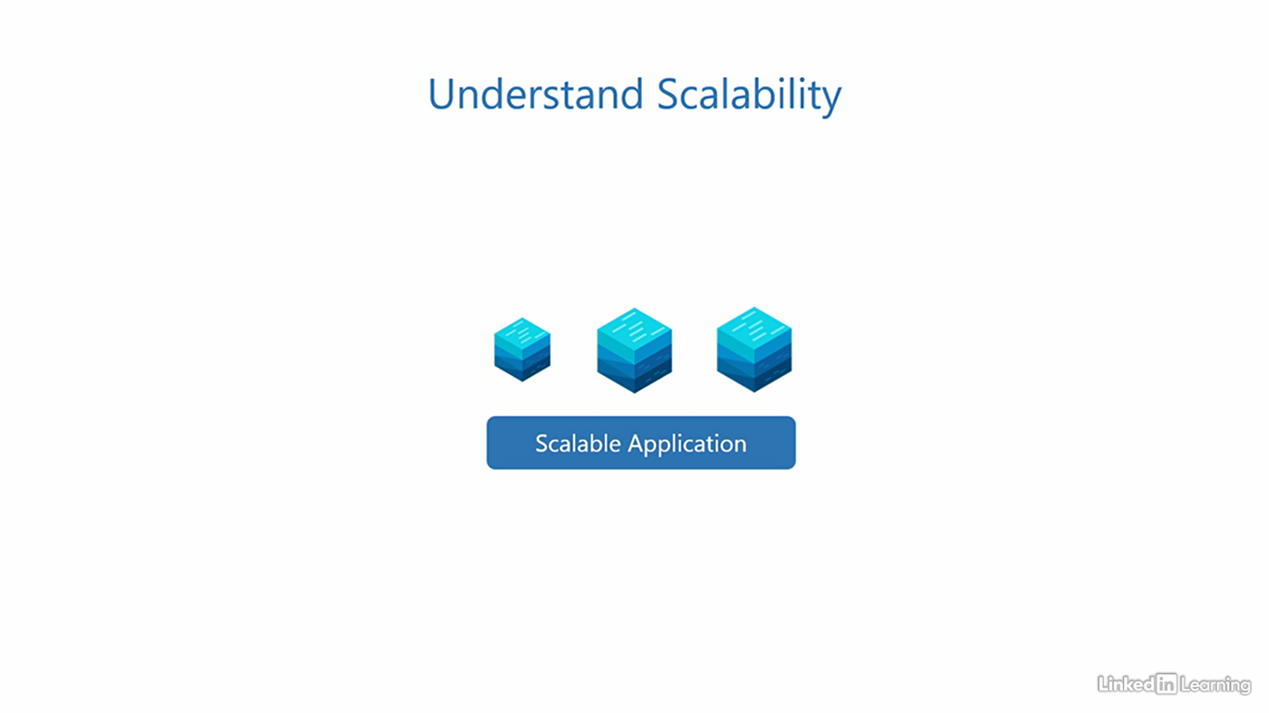

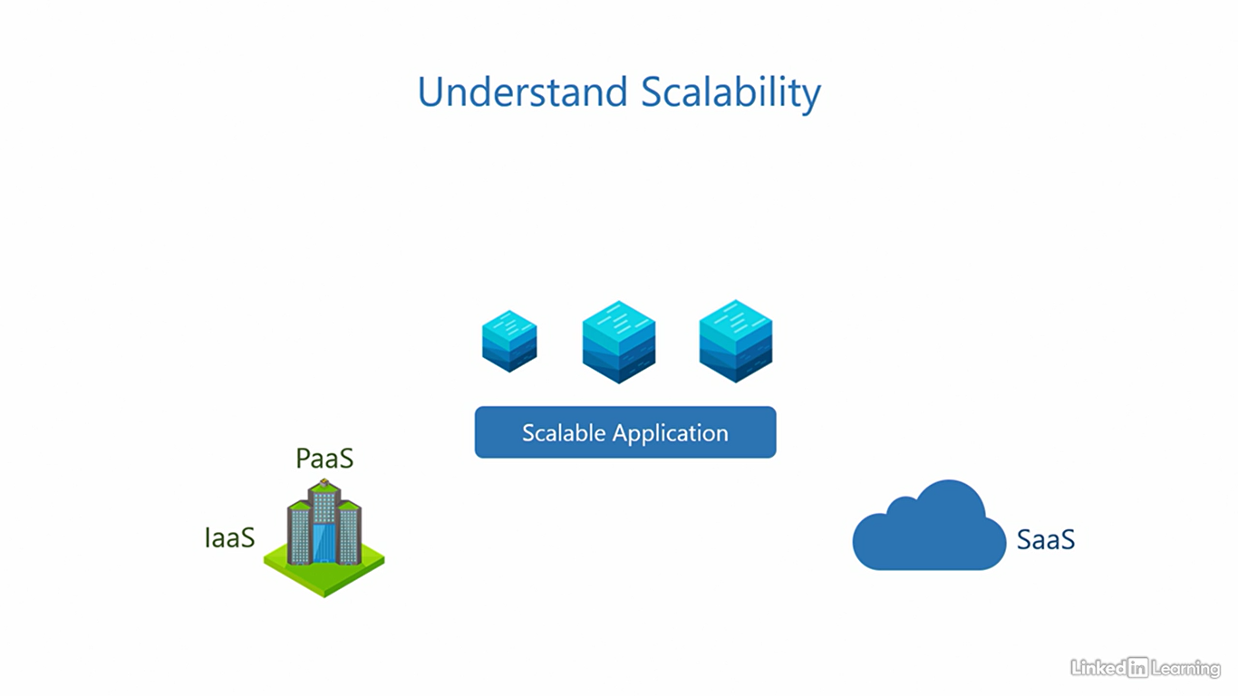

Understand high availability

[Instructor] Both elasticity and scalability ensure business continuity when user demand for an application fluctuates. So an irregular jump in user requests will not overwhelm the application and bring it down, it'll keep running. But what happens when there is a disturbance in the components an application runs on? Let me elaborate. When a user provisions an application it runs with the help of underlying components in the IT stack, a service disruption can occur when any part of the underlying stack needs maintenance, like replacement or upgradation because servers may need to be turned off or restarted in such situations. The users can experience a significant downtime of the application during this time. The purpose of high-availability is to minimize application downtime and maximize uptime, keep the application available for as long as possible, hence the term, high-availability. To achieve that, we configure a planned failover of the application to another node before performing maintenance on the servers. It's called a planned failover because we can prepare for it in advance before doing the replacement or upgradation on the servers. The application can be in a running state and accessible to users during the failover. The user may never even know the application was migrated from one node to another, it's quite seamless. Once the maintenance is done we can configure the application to failback to its original node, again, without any interruption to the users. So there is almost zero downtime in planned failovers, thus ensuring the application is highly available. There's another type of service disruption that we cannot plan for and those are failures of any component in the underlying stack. Failures are sudden and can happen without notice, whatever the failure is or its cause, the application can become inaccessible during this time. To achieve high-availability, its best not to wait until the failure is resolved. Instead, the first thing we do is immediately configure an unplanned failover of the application onto another node and then redirect users to this new instance of the application, it's called an unplanned failover because we can never predict a failure. There's a good chance users will know that somethings amiss for a little time. Once the failure has been rectified, we configure the application to failback to its original node. The downtime here is greater than zero but because we did not wait for the failure to be rectified and immediately spun up an instance of the application on another node, the application can still be highly available with minimal downtime. The uptime for services is defined in a document called the Service Level Agreement and measured in percentage. For example, if a service claims to have a 99.999% uptime in its SLA, we call it five nines because there are five nines, 99.999 and if the uptime is five nines, the downtime is 0.001%. That roughly translates to five and a half minutes of downtime per year. For context, a year has more than half a million minutes, 525,600 minutes to be precise. This means the service may go down for a combined five and a half minutes over a period of one year, applications that use multiple services have a composite SLA, it's calculated keeping into account the SLAs of each service it uses. The customer has to calculate this in IaaS and PaaS because they control the application architecture and the services it uses. But in SaaS, the Cloud Service Provider will define it for you. Remember, high-availability is measured over a period of time. Azure also offers services that are highly available.

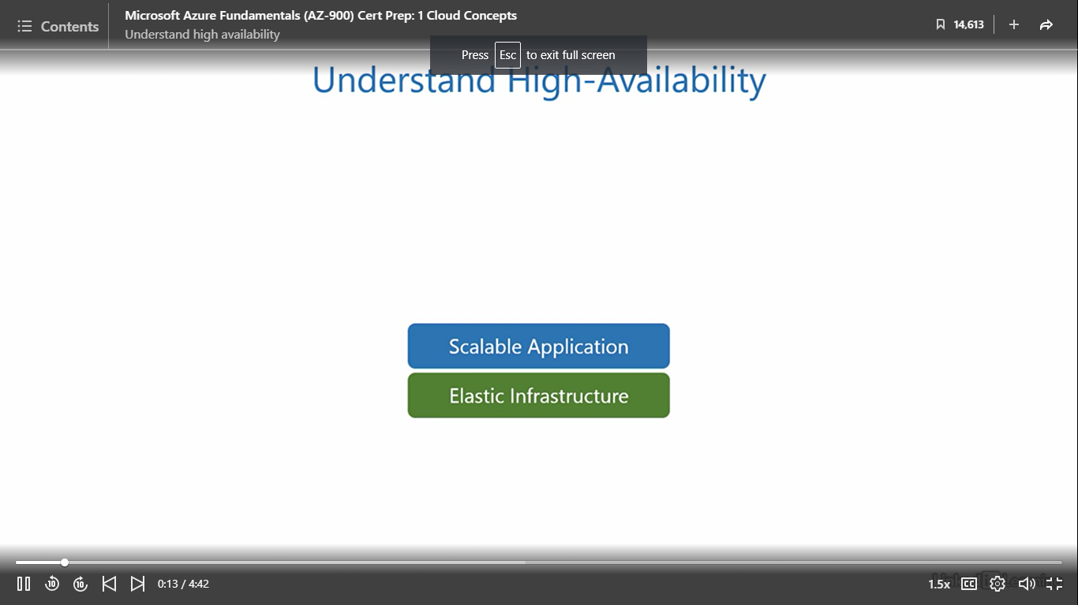

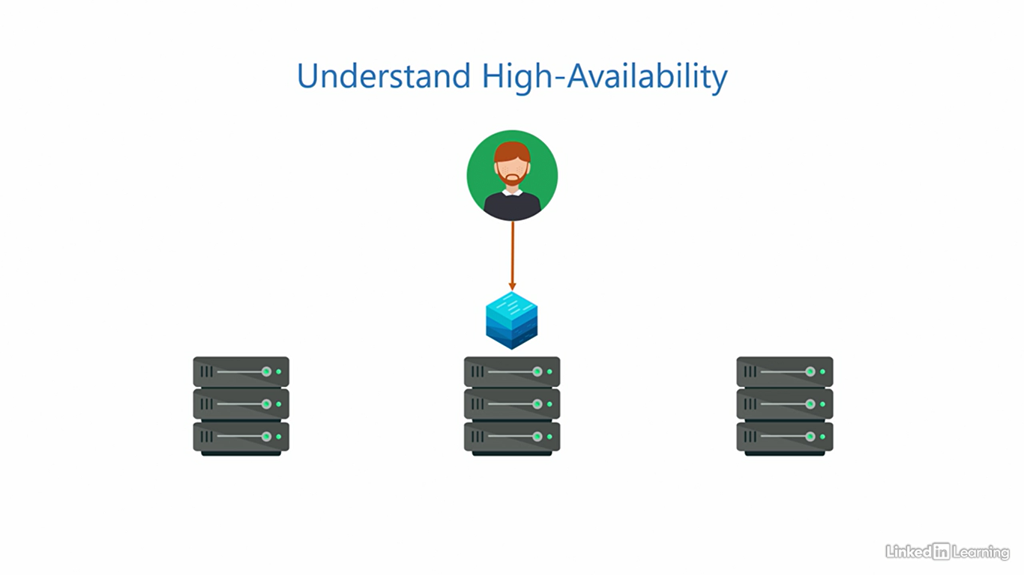

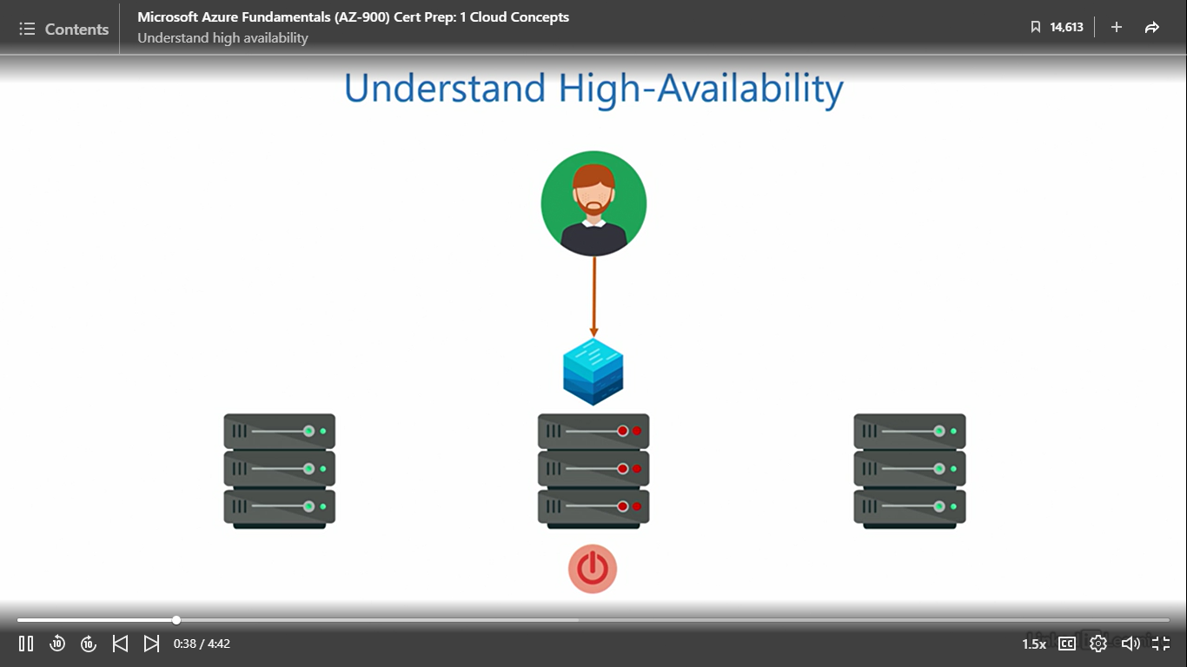

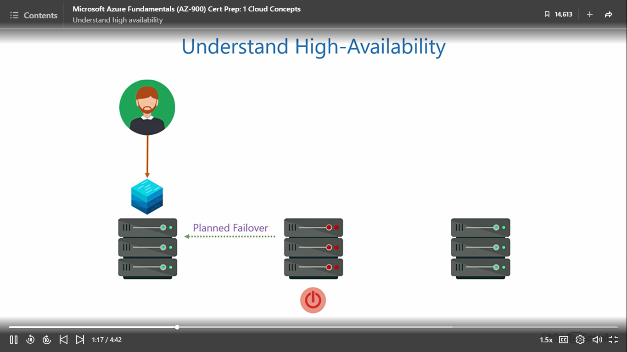

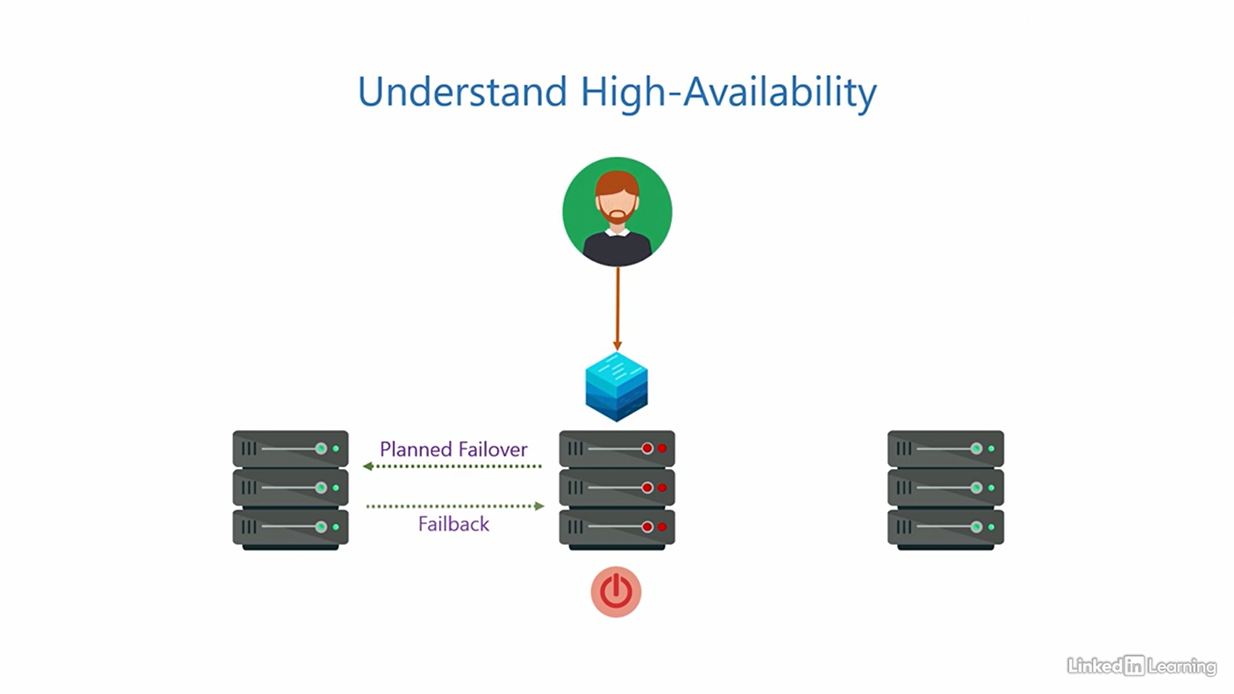

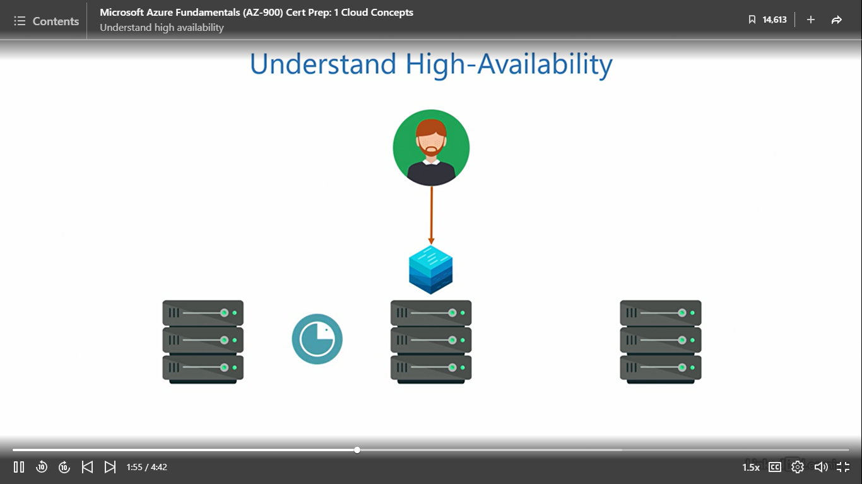

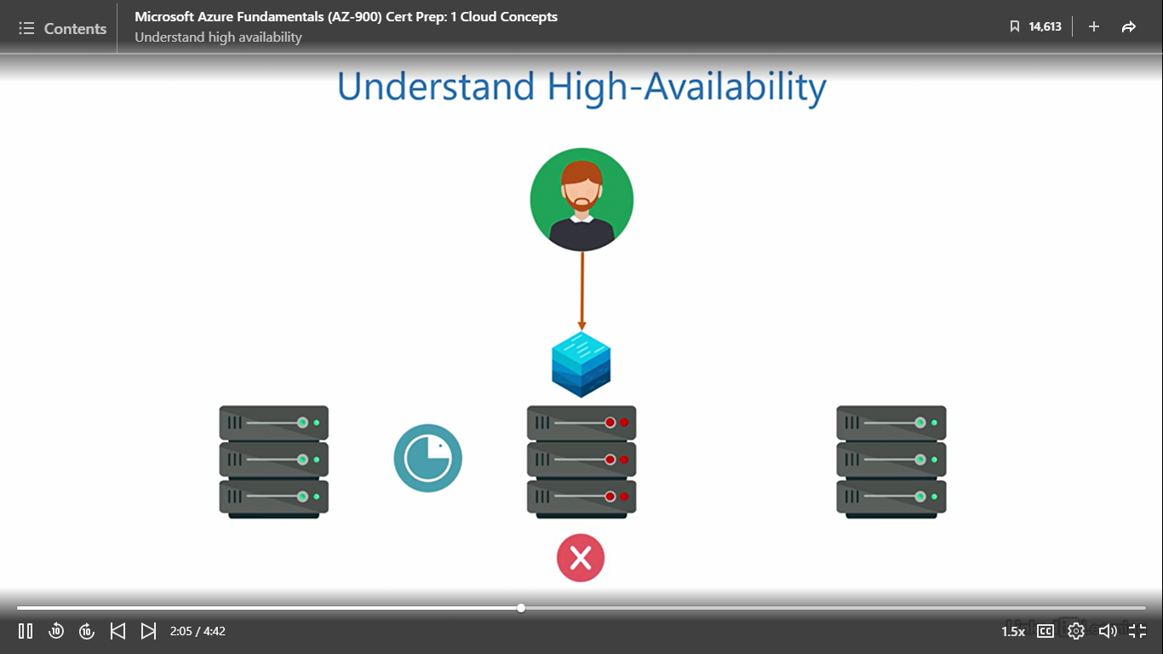

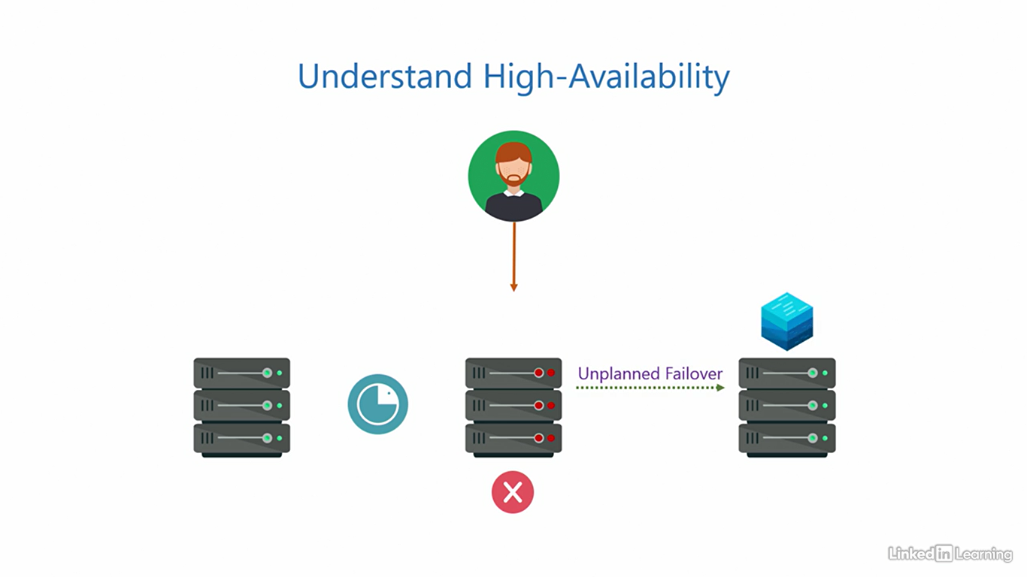

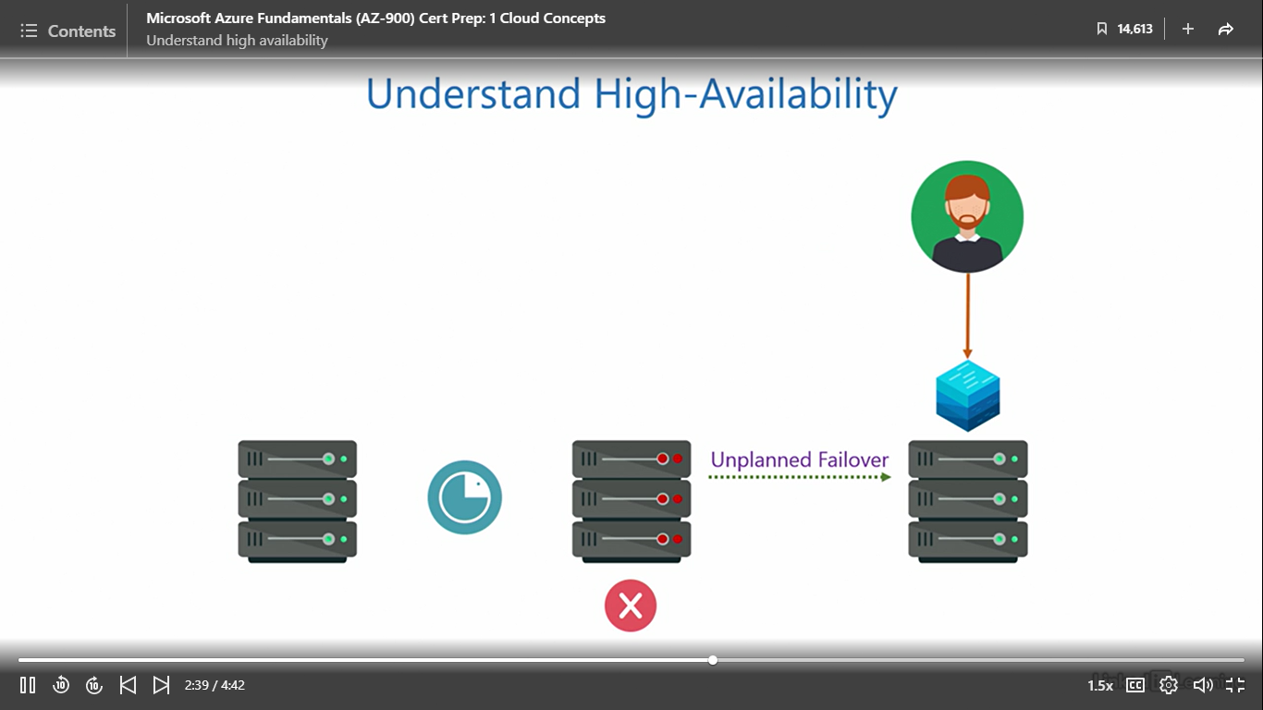

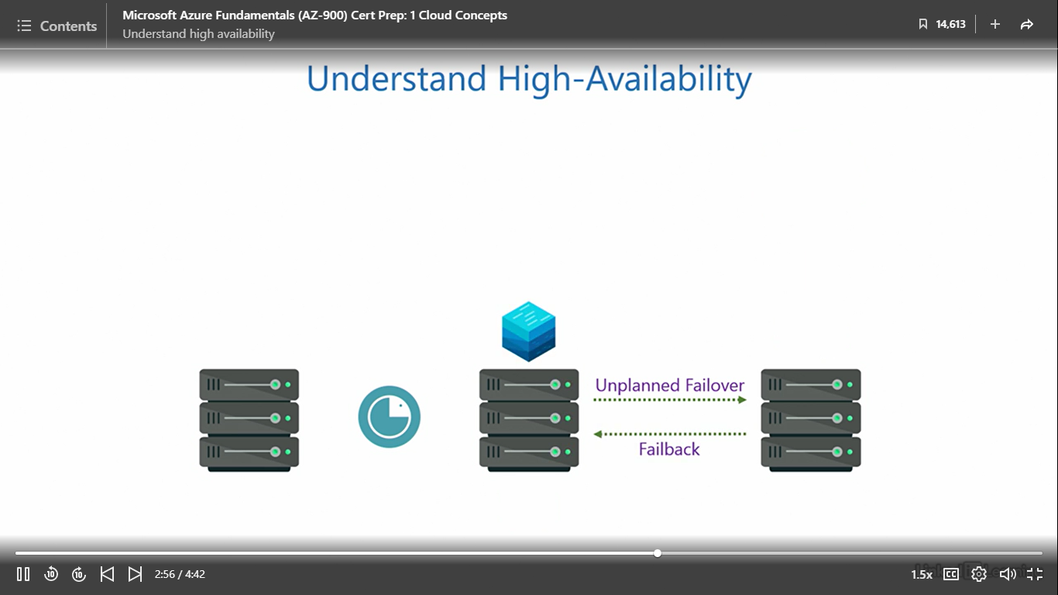

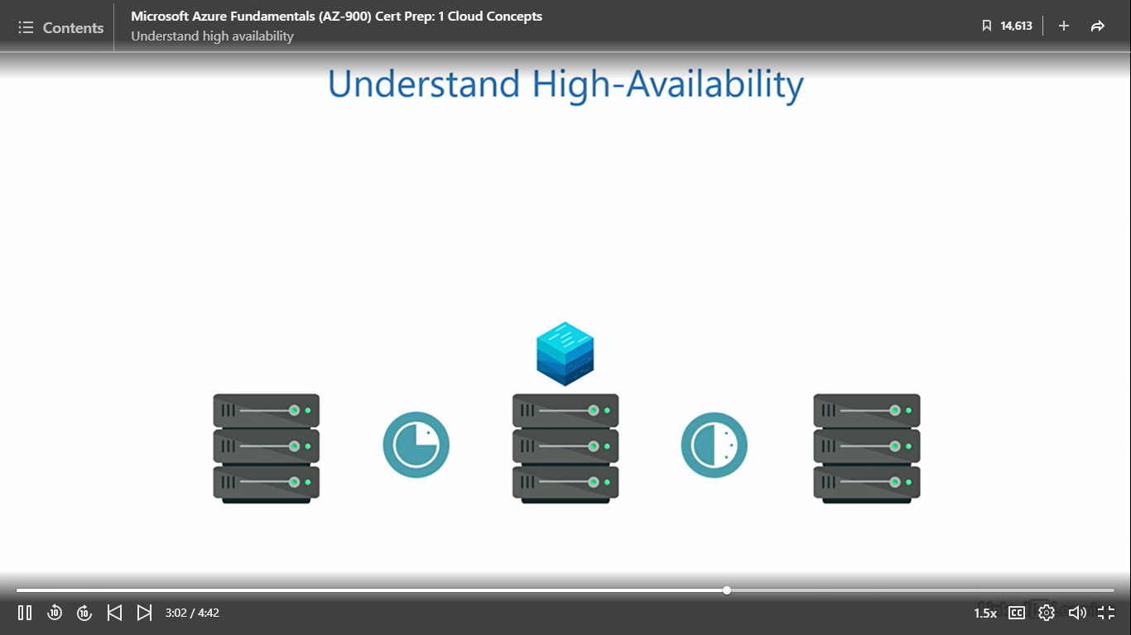

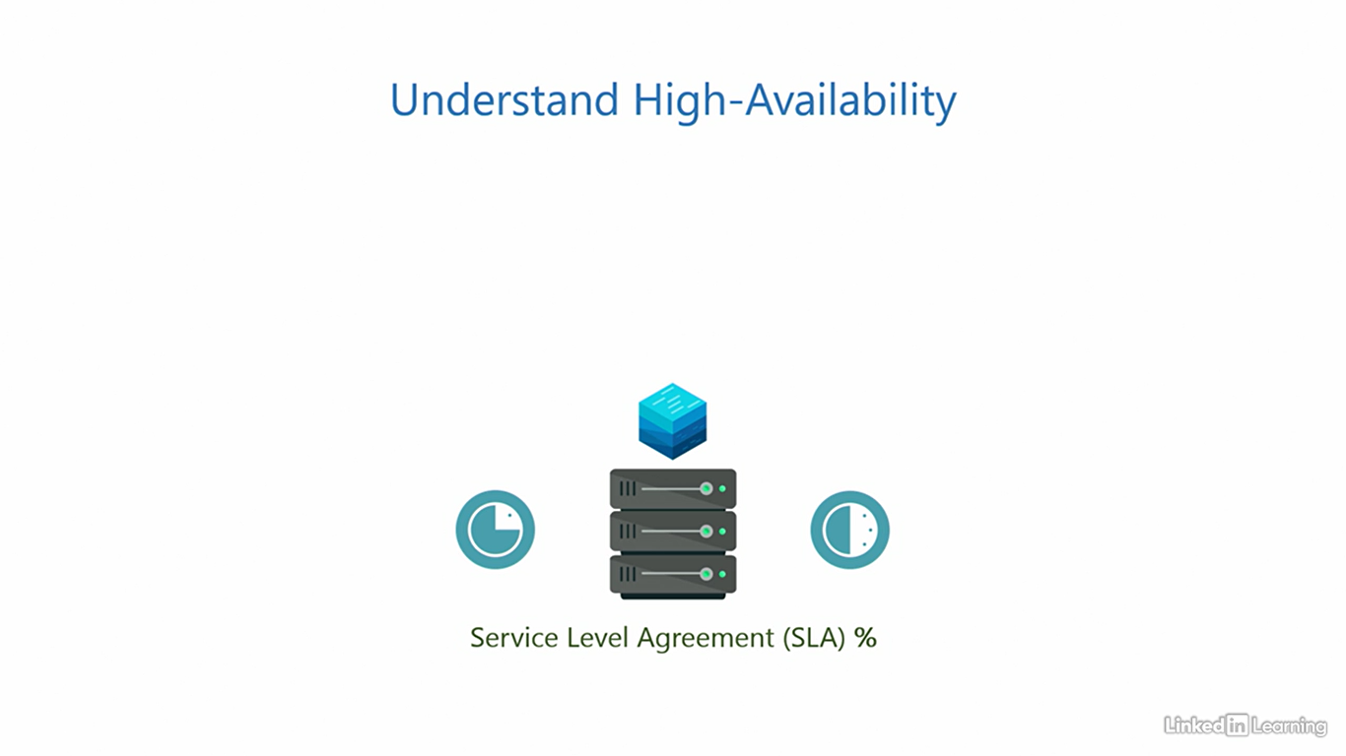

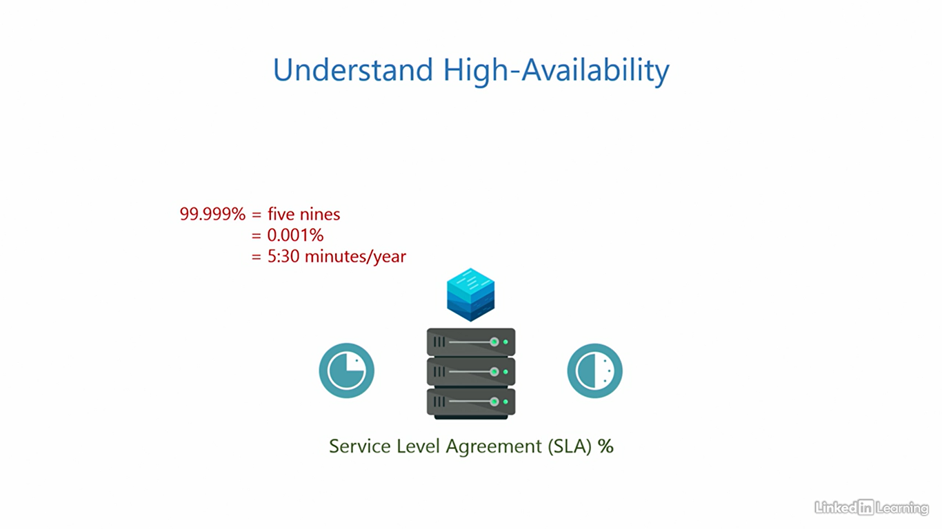

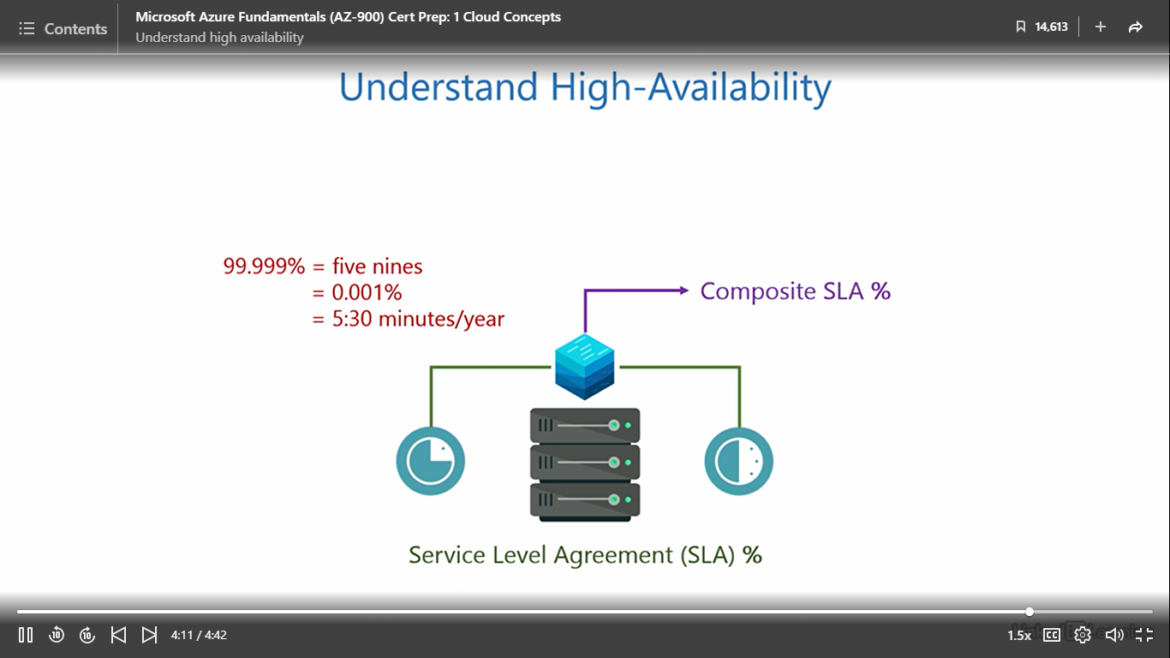

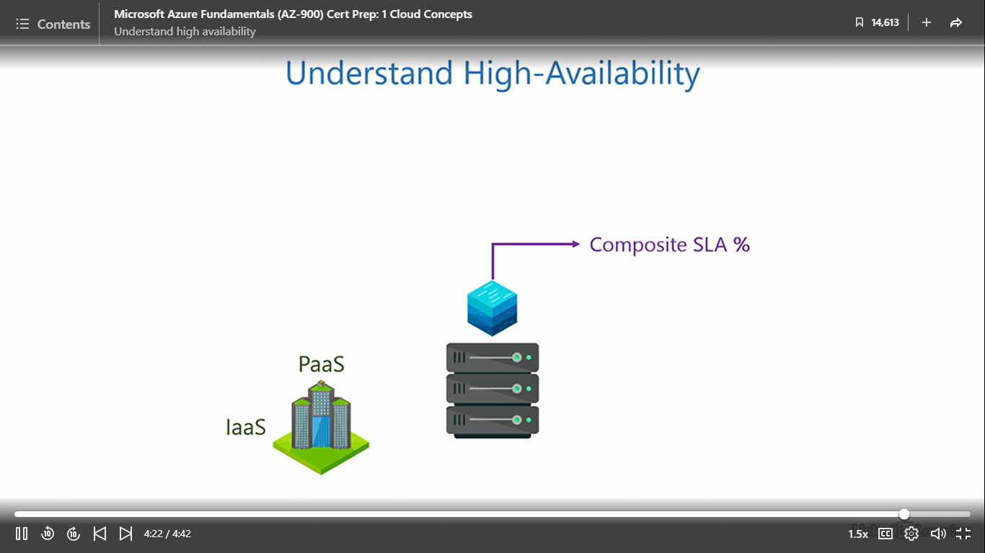

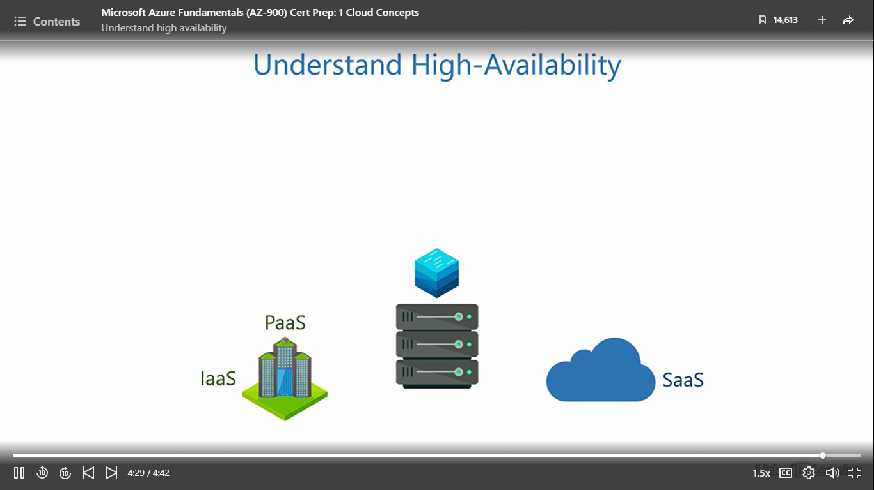

Understand fault tolerance

[Instructor] Here's a variety stack. Fault tolerance is typically an attribute of the operating system. We know when a user provisions an application it runs on a set of computing resources. At any given moment, the system may experience an unexpected event called a fault. This could be due to an exception, error, interrupt, or any other fault in the software or hardware components like the processor, memory, and disc. If you are wondering how a fault is different from a failure, a fault is instantaneous and temporary, but a failure is usually a longer lasting event and needs greater effort to resolve. A car going over a speed bump is like a fault, but an empty fuel tank is like a failure. Anyway, whatever the reason for the fault may be, it has the potential to impact the running of the application, even if it is for a short interval, and that's not good. That's where fault tolerance comes into the picture. A system is said to be fault tolerant if it can preserve the system state when the fault occurs and continue to process the information it was processing without breaking the flow at that given instant. A system that can sustain this successfully is said to have fault tolerance, or else it does not. This feature is usually built into the operating system, and thus is not something we need to manage. The cloud service provider takes care of it in all service models. Azure also has fault tolerance built into its core.

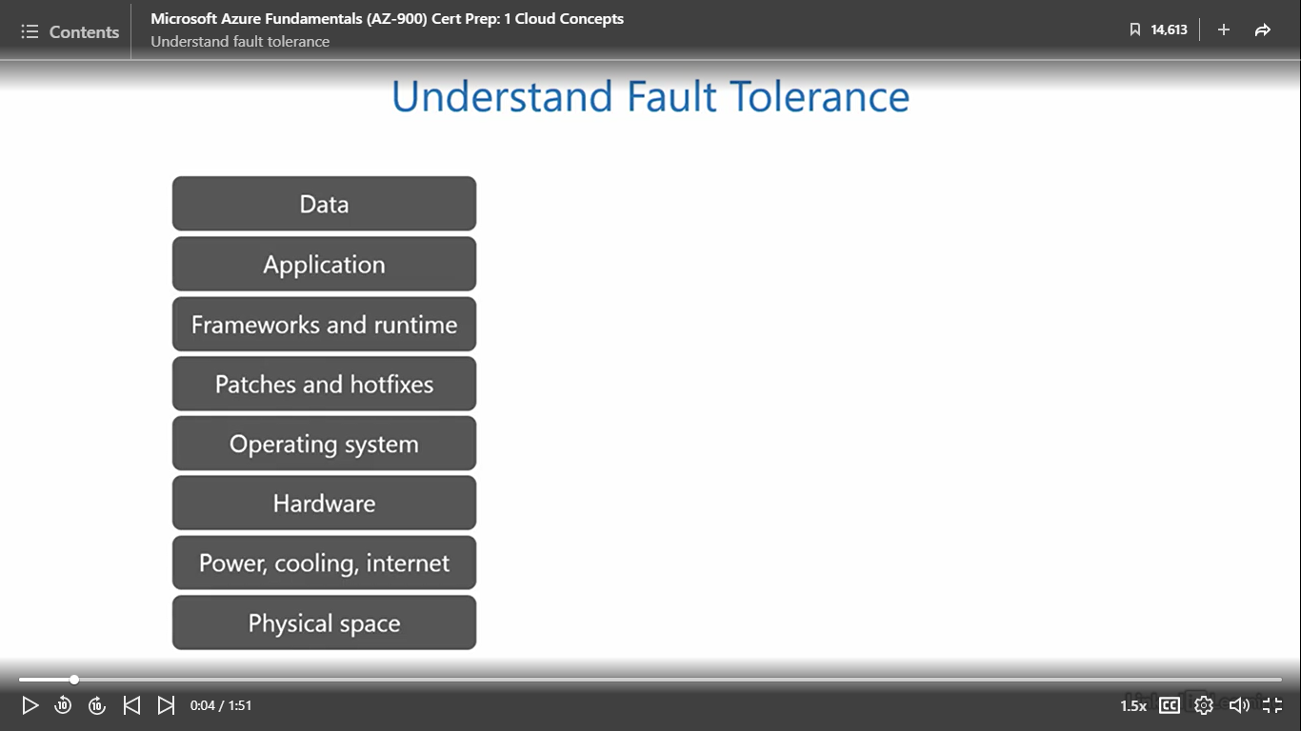

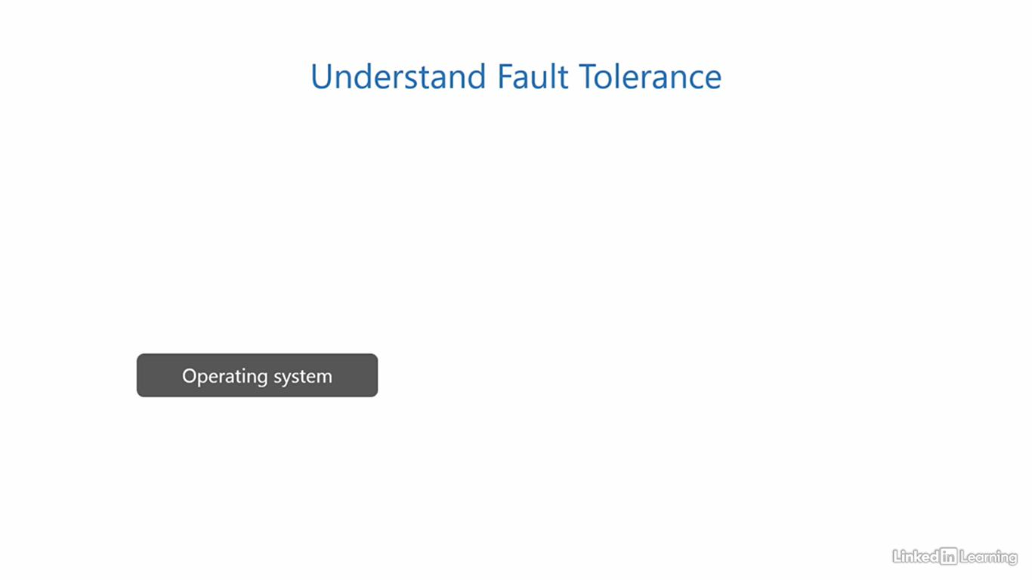

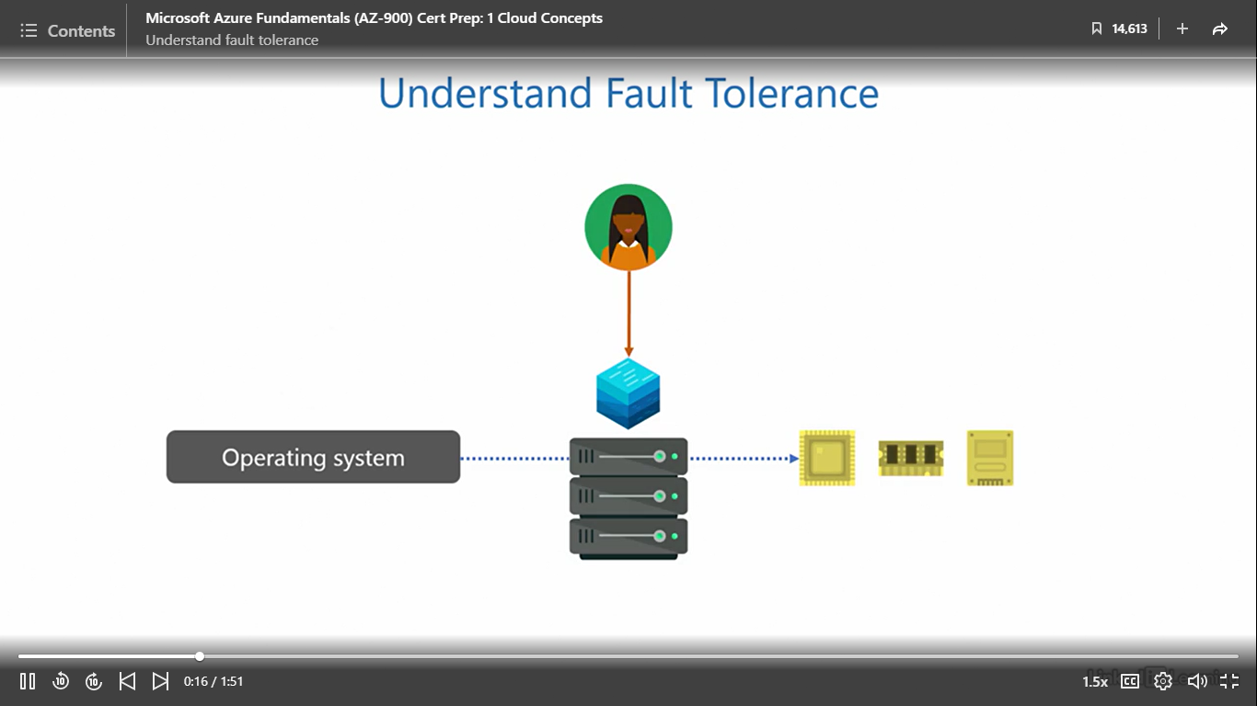 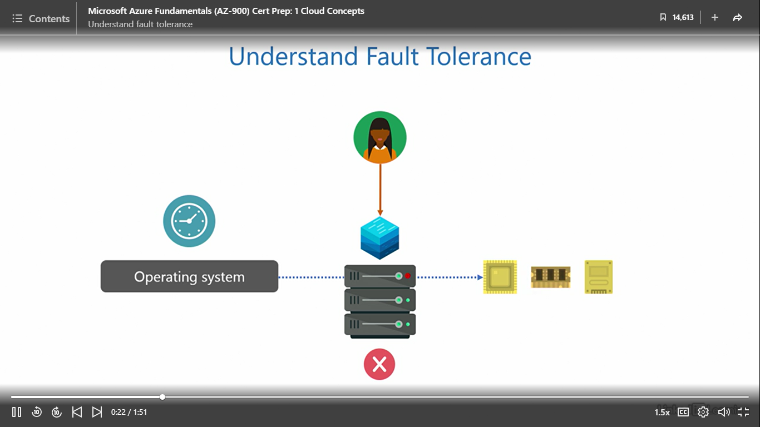

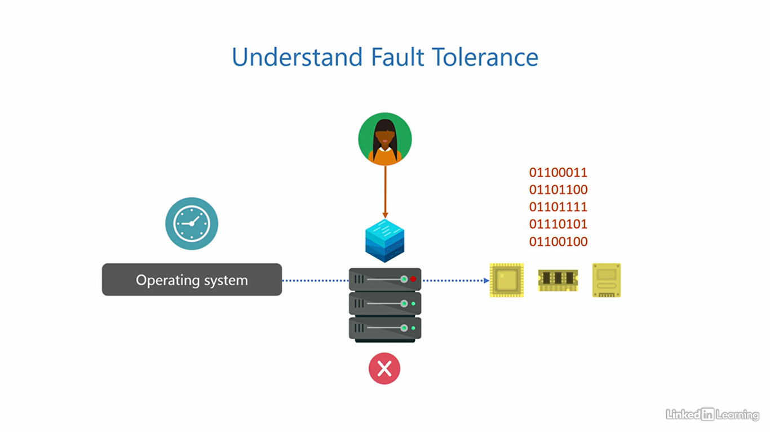

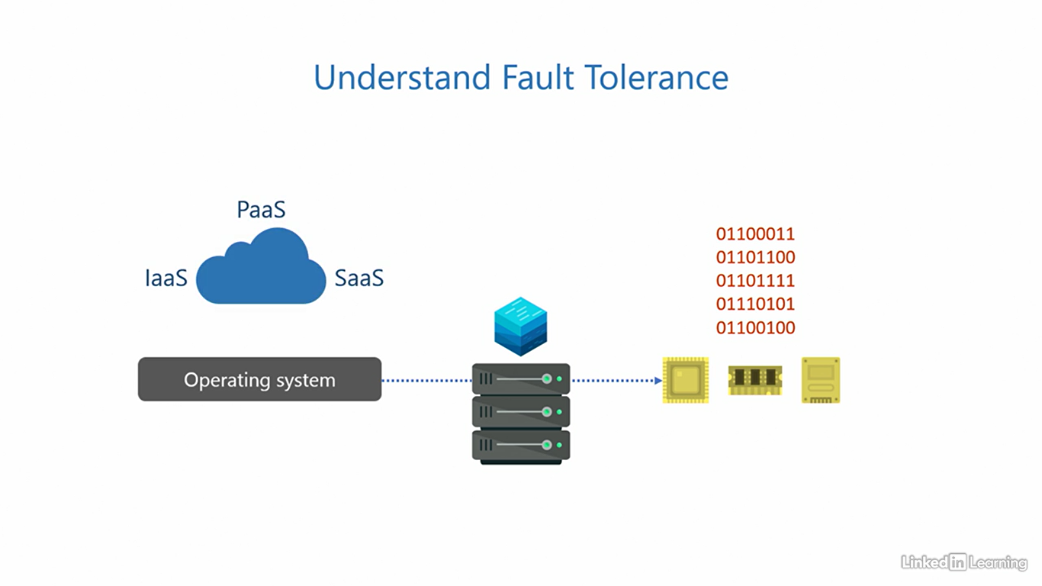

Disaster recovery

[Instructor] The benefits you learned so far are designed to protect customers from smaller impacts, like an overload of requests from users, failures, and faults. But we also need to ensure data is safe from larger impacts, even if the probability of such occurrences is low. A disaster is a large-scale catastrophic event that has the potential to take down an entire region, including one or more data centers. Earthquakes, flooding, hurricanes, forest fires, wars, or any other unforeseen event. From an IT perspective, preserving the integrity of data in such situations is a high priority. Typically, data is stored on servers in the on-premises environment. To avoid losing the data, we take backups. Depending on how critical the data is, the backup schedule can be hourly, daily, weekly, or monthly. If anything goes wrong on the main servers, we can restore data from the last backup. Here's the caveat. Local backups cannot protect data from disasters. That's because both the servers and backups are on the same site, on premises. A disaster will wipe out both. That's why we need disaster recovery. In this strategy, we store backups of the data off site in a physically distant location that's planned in a way that a disaster does not affect them both together. We call this an off-site backup. While this is possible, it can be really expensive to build and maintain an entire site purely for backup. Most small/medium businesses don't quite have such deep pockets to afford it. Here's where things become interesting. You can make the cloud your off-site backup destination at a mere fraction of the cost. The cloud can be the secondary site to your primary site on premises. This means even if your entire primary site goes down, your data is completely safe in the cloud. In fact, cloud service providers use the same disaster recovery strategy to protect your data. Anything you store in the cloud is, in real time, replicated to a secondary site within the cloud service provider's network. So hypothetically, even if the cloud service provider loses an entire site, they can quickly and seamlessly redirect customers to the secondary site. The worst case could be minimal downtime of the application without data loss. And in the best case, you wouldn't even realize anything went wrong.

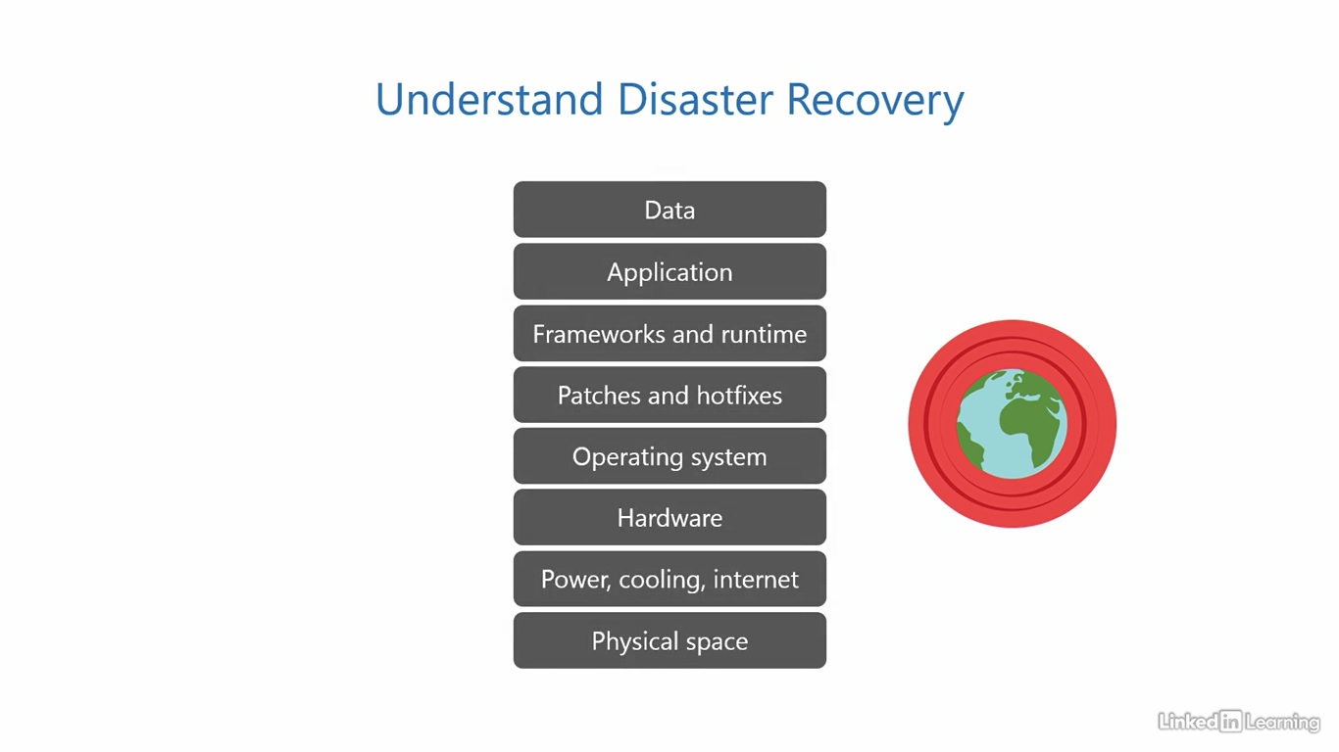

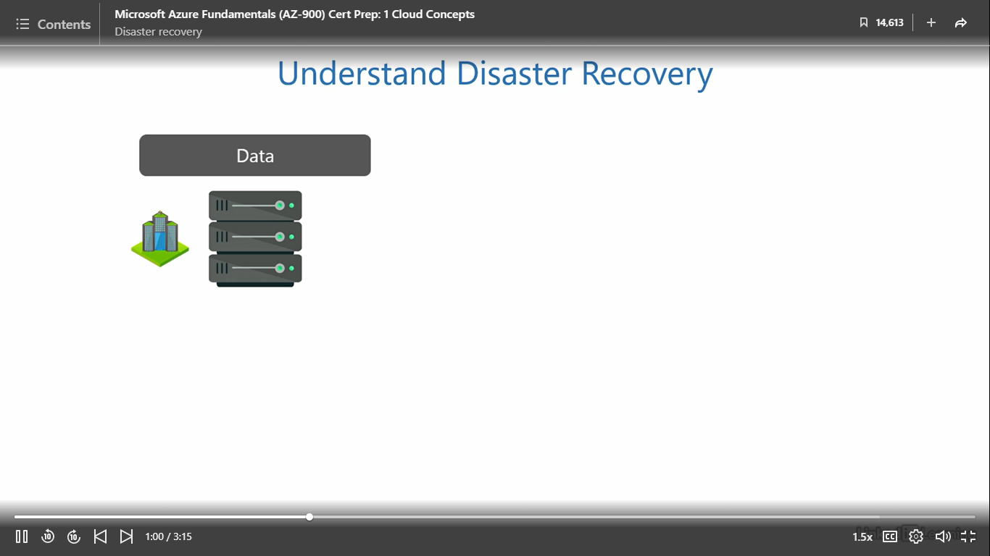

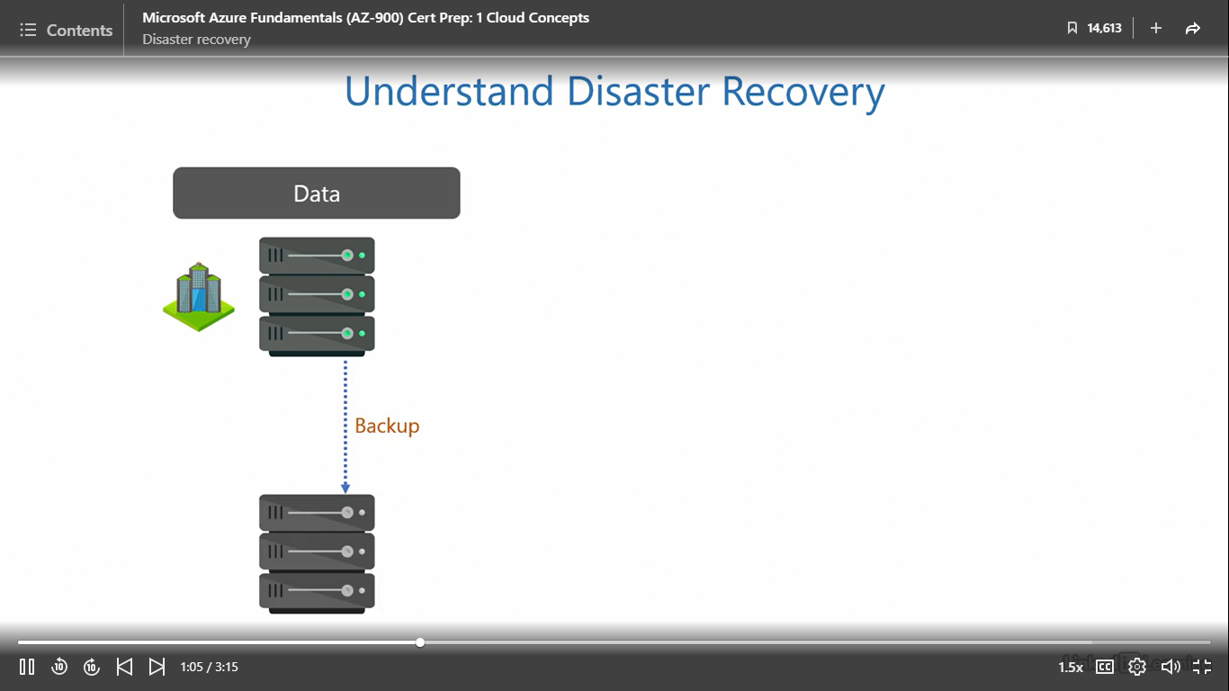

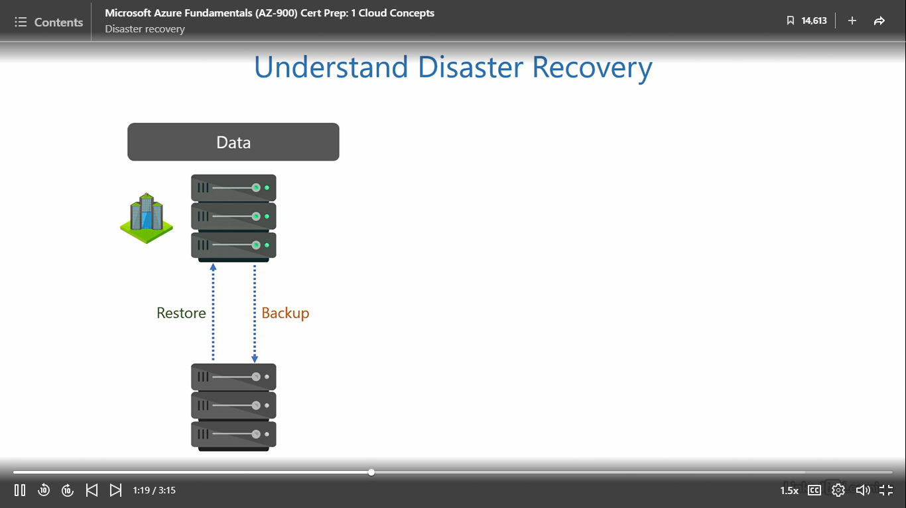

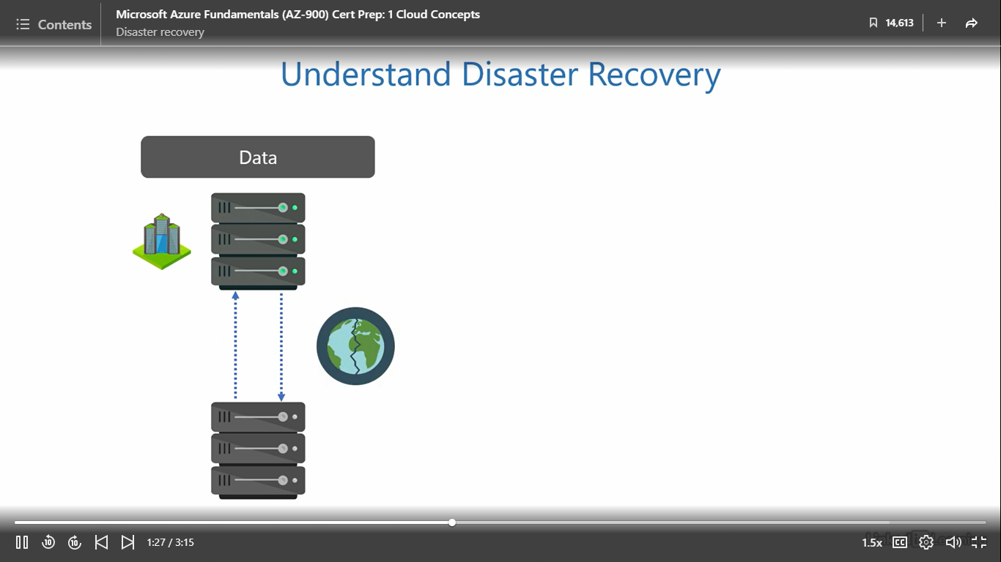

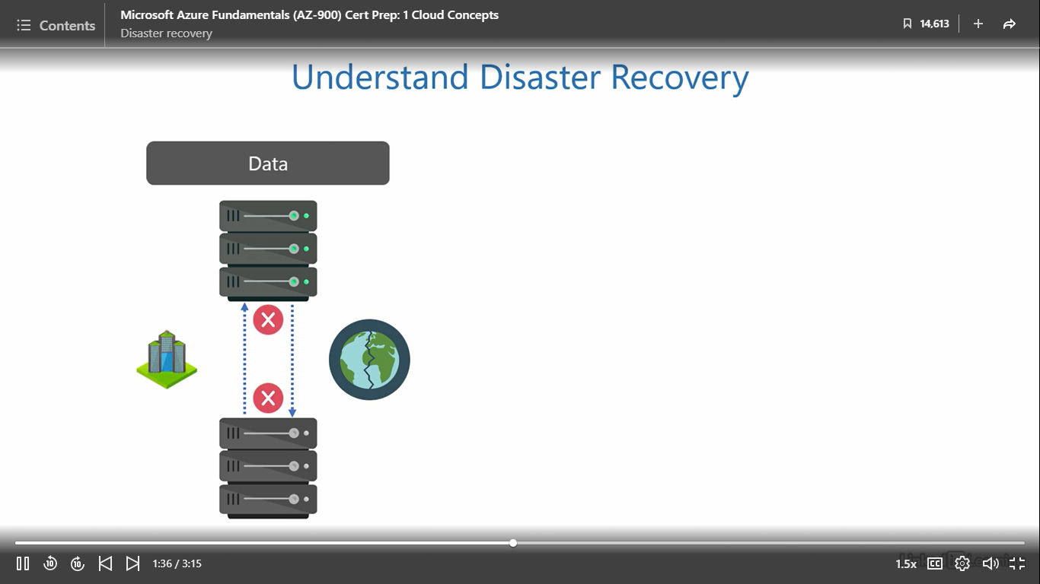

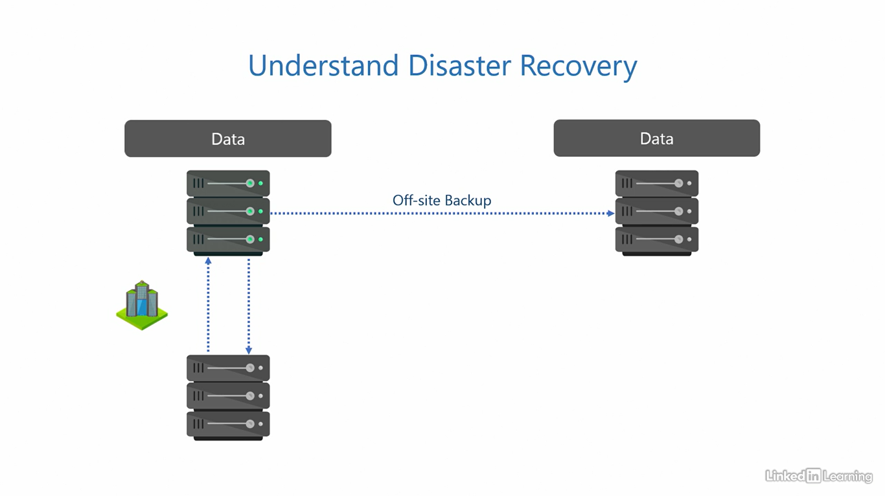

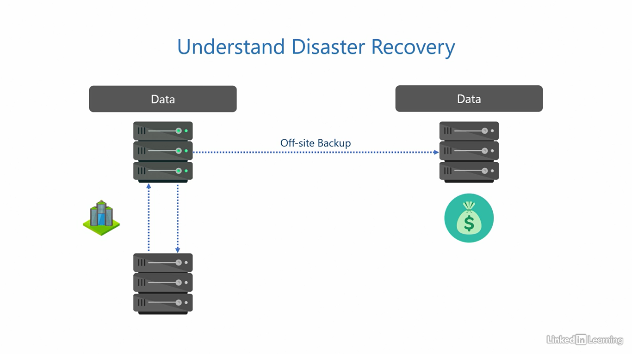

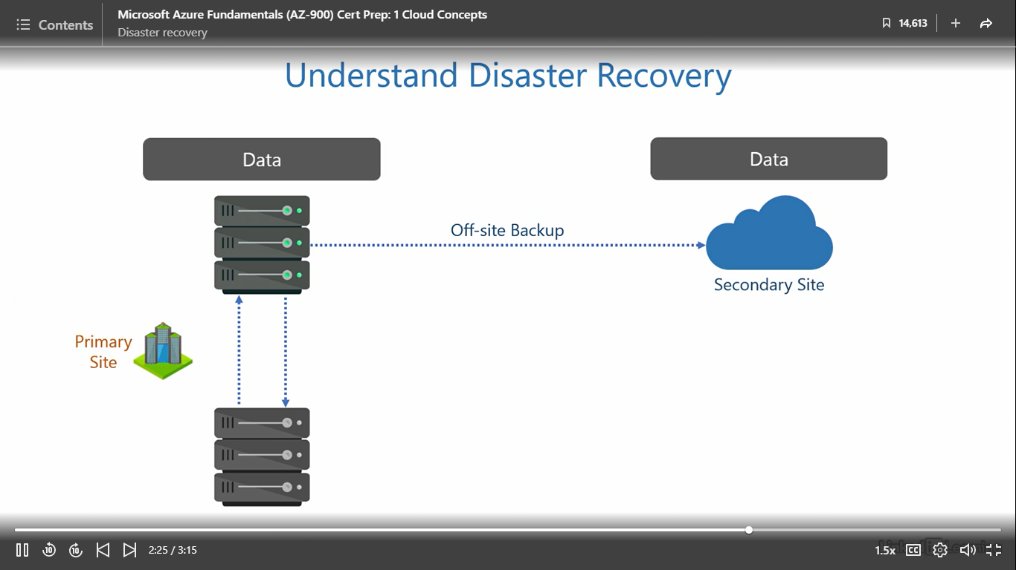

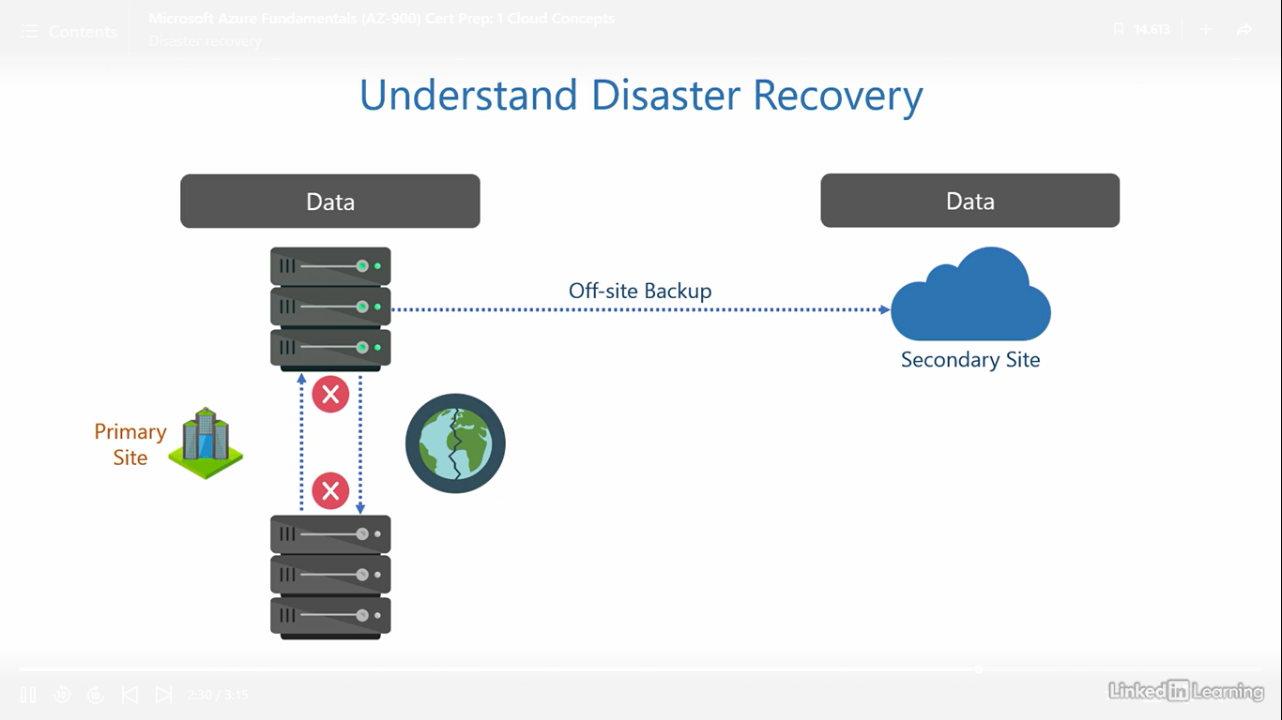

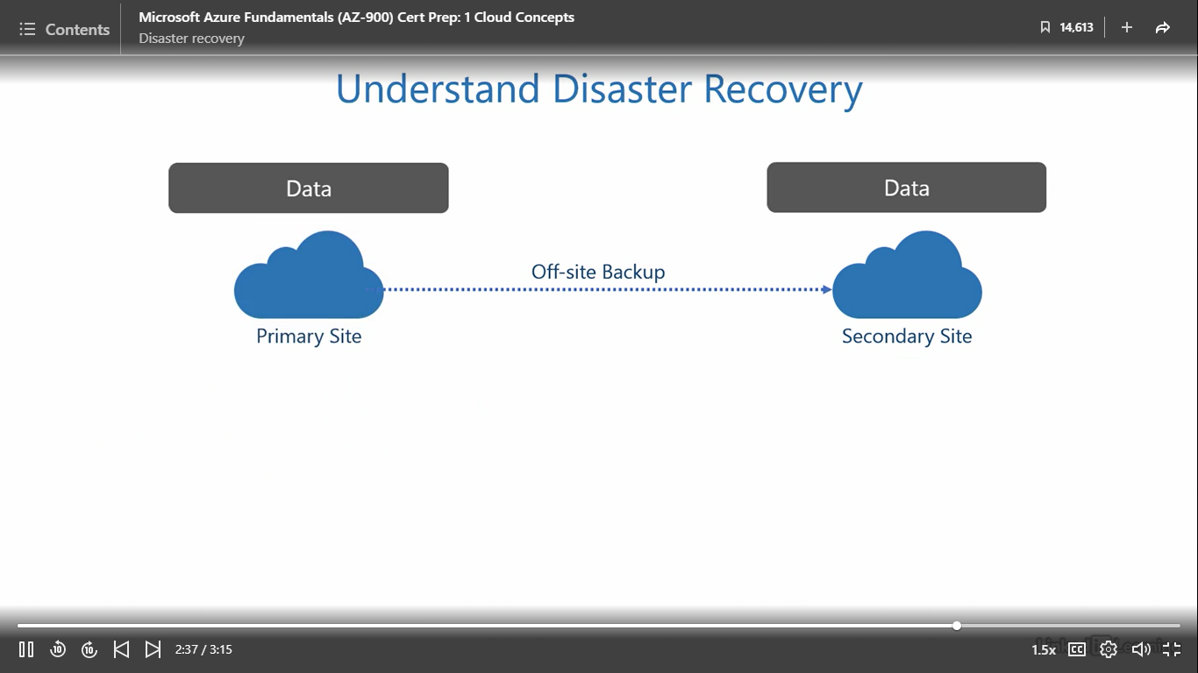

Understand security in the cloud

[Instructor] We know how important data is for an organization. It can contain trade secrets, design of a proprietary product, business strategy, personal and financial details of users, or any other information that is crucial for the organization to succeed. Any part of this in the wrong hands can severely damage the organization's revenues and reputation. And that's why a cloud should be security centric. It takes years for organizations to earn the trust of their users and build a reputation, but just one night is enough to lose it all. We need to be constantly on the lookout for bad actors, every minute of every day. But the bad guys only need one chance to destroy everything. That's why security is a complex subject. In addition to being security centric, let's see what other security controls we expect in the cloud at the bare minimum. The data should be protected with industry standard encryption when it's at addressed and in transit. Doing this prevents bad actors from getting access to readable data when it's stored in the cloud or being moved from one point to another. Administrators should also have tools for identity and access management at their disposal. This helps protect user accounts, passwords, groups, and devices from bad actors. Leaked passwords and stolen devices are the most common weak links in any organization. Then, there should be multi-layered approach to security for end-to-end protection. Because security is not just about protecting one or two parts, it's about protecting the whole string of components. Ideally, there should be multiple barriers to entry, one at each stage, just like when you peel an onion, there is one layer after another, after another, and so on. Legitimate users should get through easily, but bad actors must be stopped from unauthorized access. I also believe in proactive prevention over passive cure. It's better to proactively monitor, detect, and mitigate threats before they can do any damage. Trying to fix a security breach after it happens is not very helpful because of the impact it has on an organization's reputation. We all know a loss of reputation is the hardest to recover from. Next, there should be a unified pane that gives deeper insights into the overall security posture of the organization. Because tracking numerous security alerts across multiple metrics, services, and tools can be chaotic. There's a possibility an administrator may miss a warning because of the sheer number of tools involved. Having one single management interface with consolidated reporting of all security events can be very useful. And finally, there should be logs for auditing and tracking. Keeping a record of who did what is necessary for accountability. Any activity attempted or performed by internal employees and external actors should be recorded and retained. Because when people know any mischief they make with bad intent can be traced back to them, they usually refrain from doing it. These mechanisms keep everybody honest.

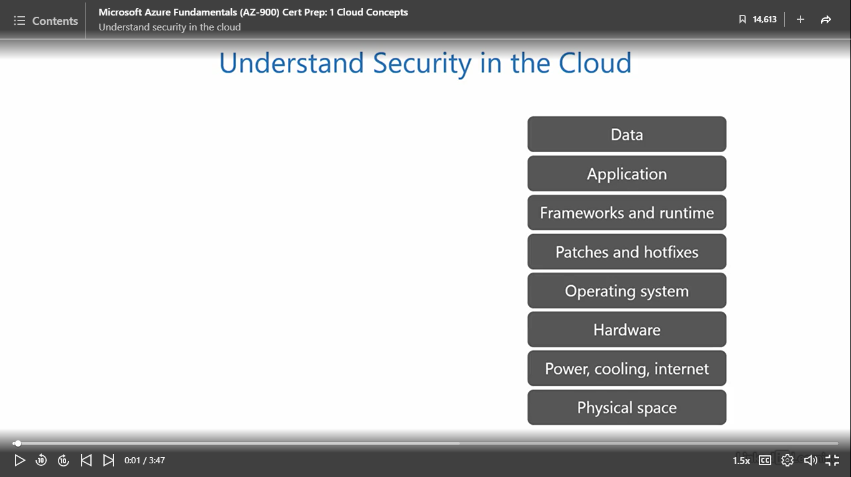

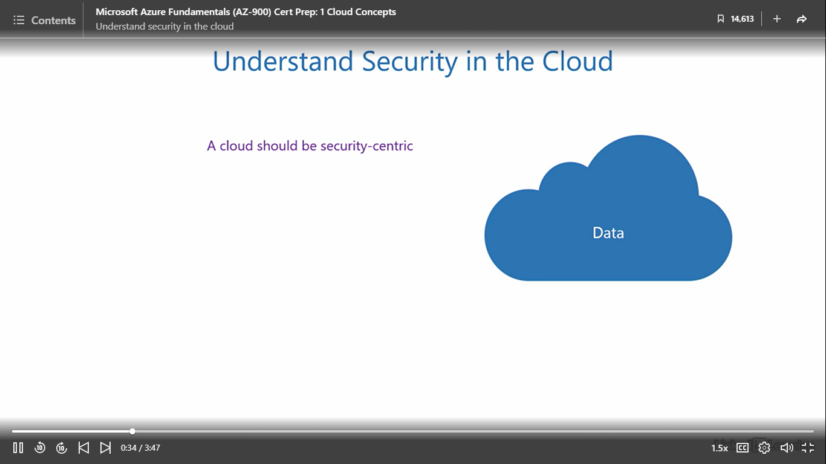

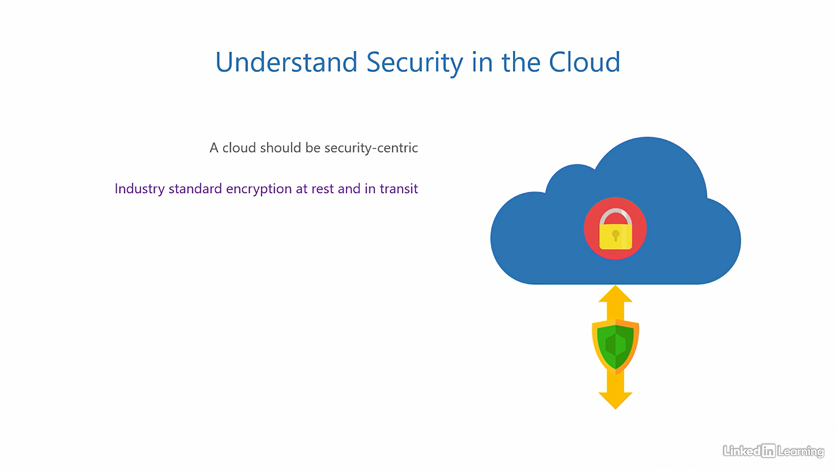

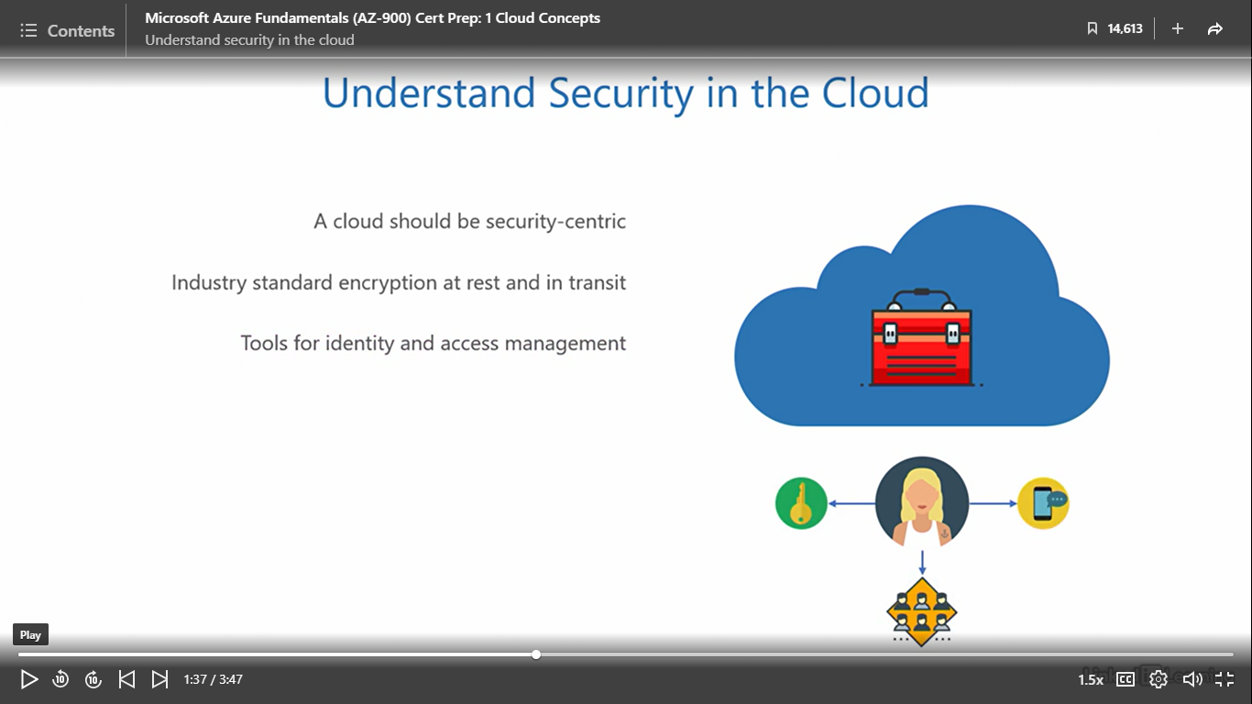

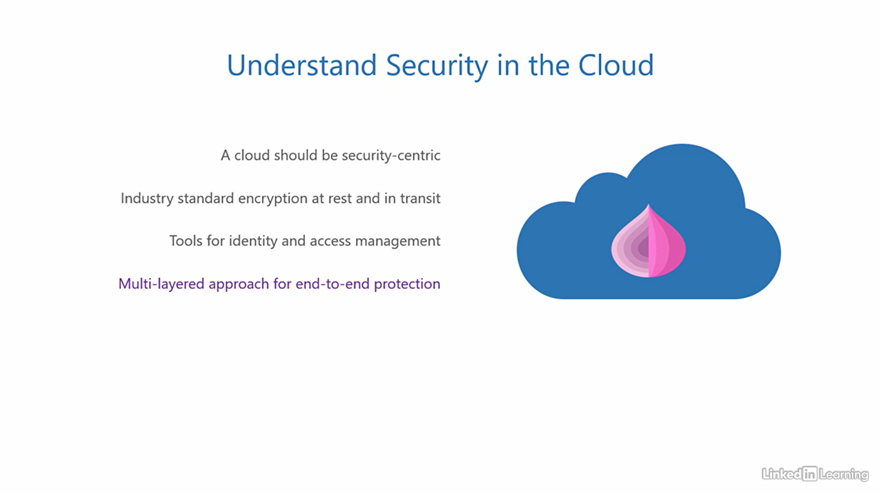

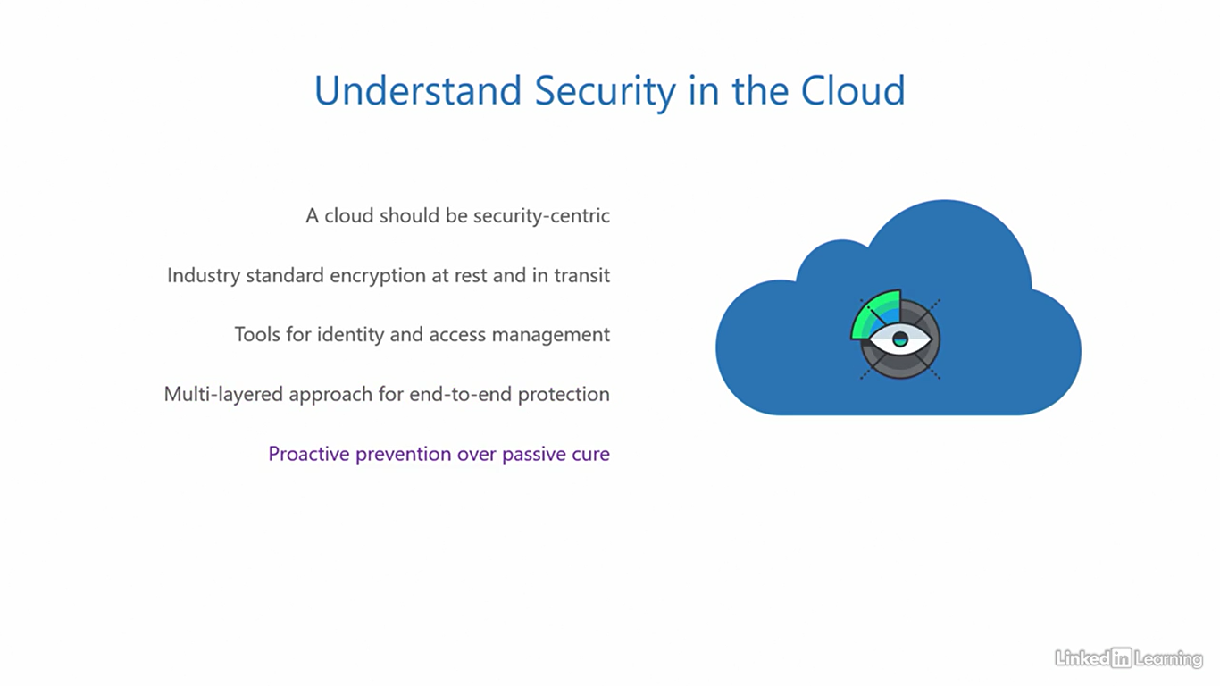

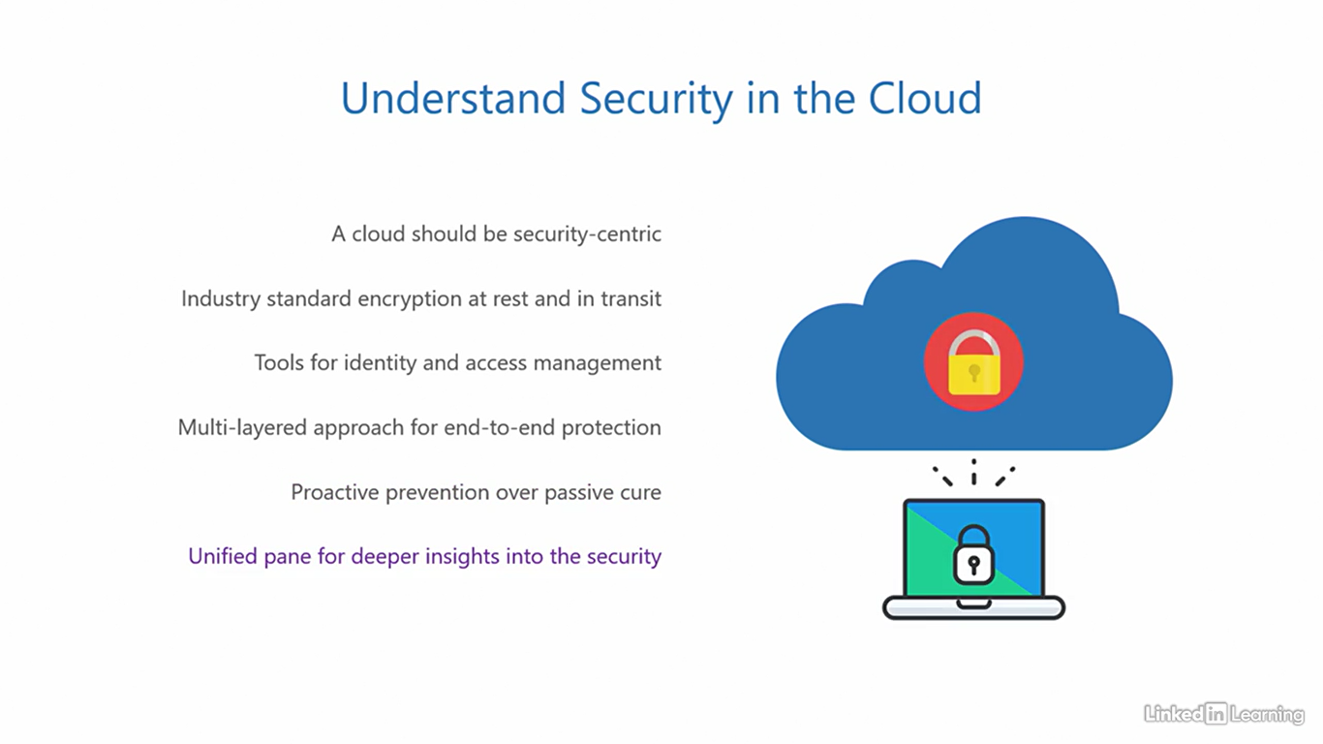

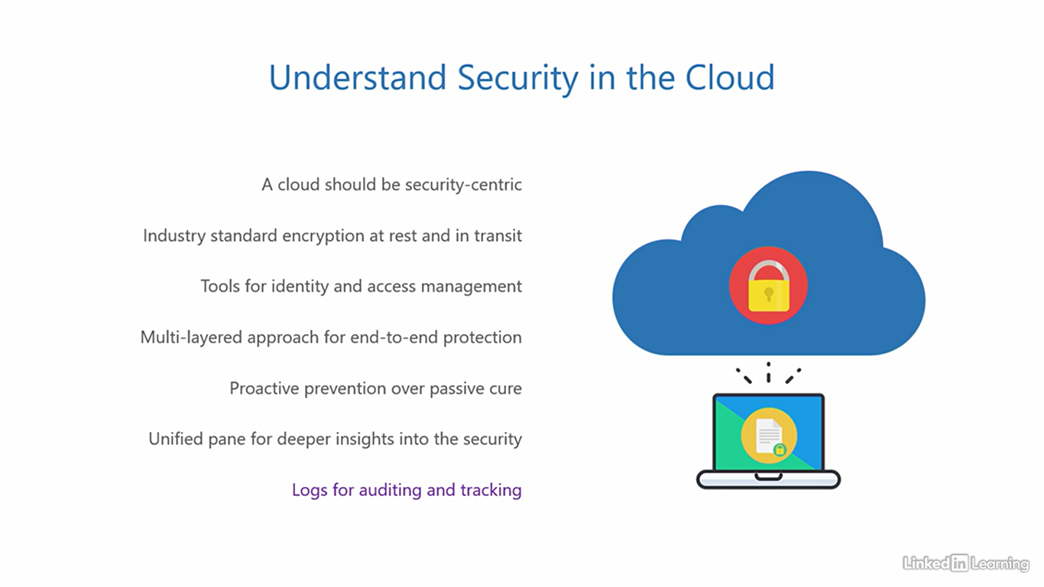

Understand management and governance

[Instructor] In the last video, you saw what we expect a cloud to be capable of from a security point of view. Here, I'll outline the expectations from a management and governance standpoint. First of all, when it comes to management, we appreciate comfort. A cloud should be intuitive to manage. It shouldn't be like walking through a maze or solving a jigsaw puzzle. The interface should be clean, understandable, and easy to navigate. Then, the cloud should support applications that leverage common industry standards and offer adherence to regulatory compliance requirements. Industry standards give developers the freedom to choose any popular language and platform to build their applications. And regulatory compliance ensures the application runs within the confines of company policies and regulations. Next, the cloud should offer a myriad of services, tools, and utilities to configure and deploy. An organization should never be limited by the range of services in the cloud. The cloud should be able to provide any and all resources to an organization for turning their idea into a real functional application. A cloud that restricts you is no good. Then, the cloud should also allow you to monitor the health of its services and the application, provide performance reports at regular intervals, trigger alerts when the application performance falls below a fixed threshold, and recommend best practices to optimize and fine-tune the resources in the cloud. Next, the cloud should be transparent about its pricing. It should help estimate costs an organization will pay for services and applications. There should be no hidden costs added with the intention of unethical profits. In case the organization struggles with a problem that they cannot figure out, the cloud should be able to extend support for both business and technical queries. This can be done through a fleet of trained customer support engineers who are experts in the cloud. And finally, it's beneficial if the cloud can integrate with existing solutions and third-party products that an organization already uses and is familiar with. This helps an organization to smoothly transition to the cloud without having to build and pay for new solutions. Smaller effort and lower costs lead to better outcomes for cloud adoption. As we progress through the learning path, you'll discover where Microsoft Azure stands with respect to security, management, and governance criteria we just discussed.

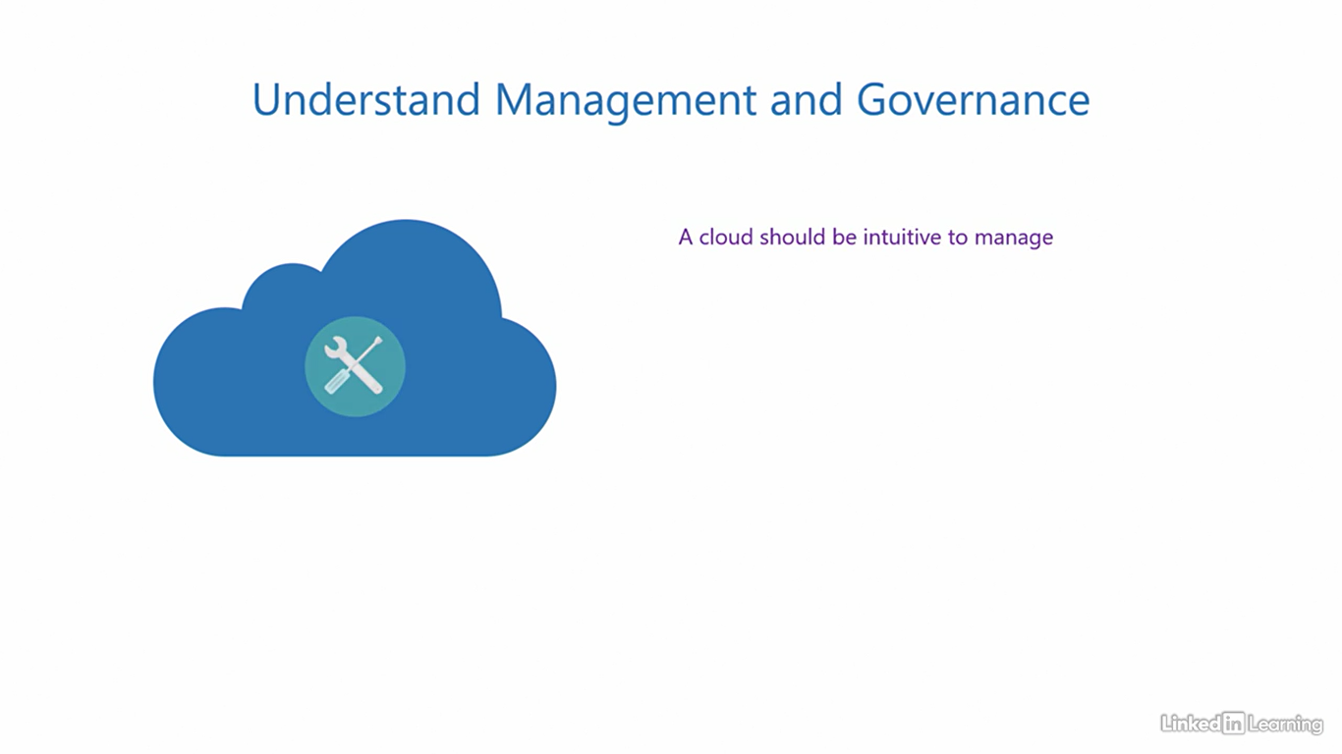

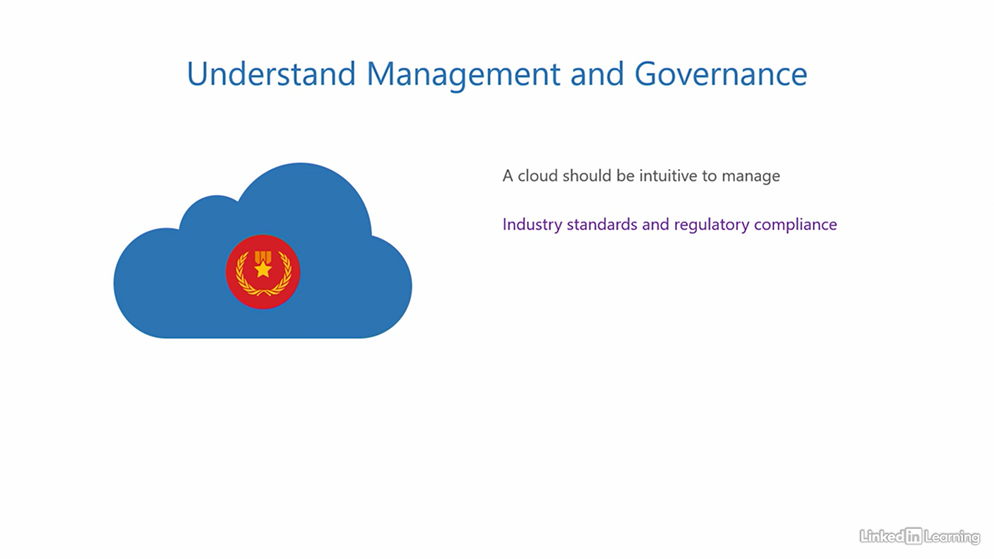

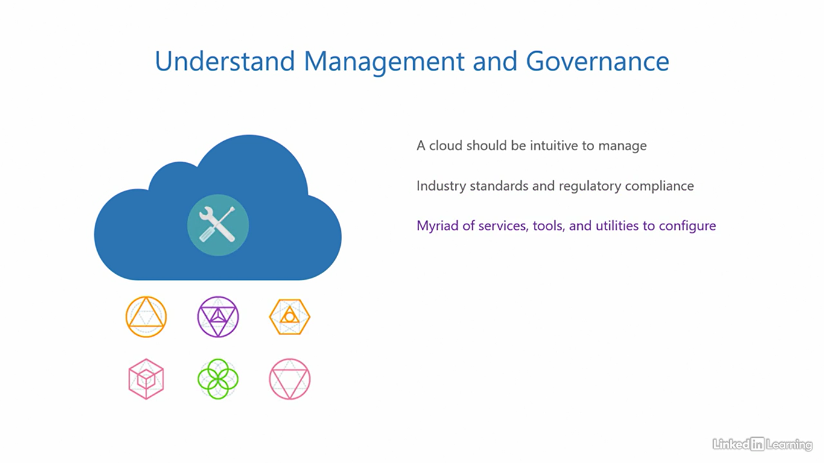

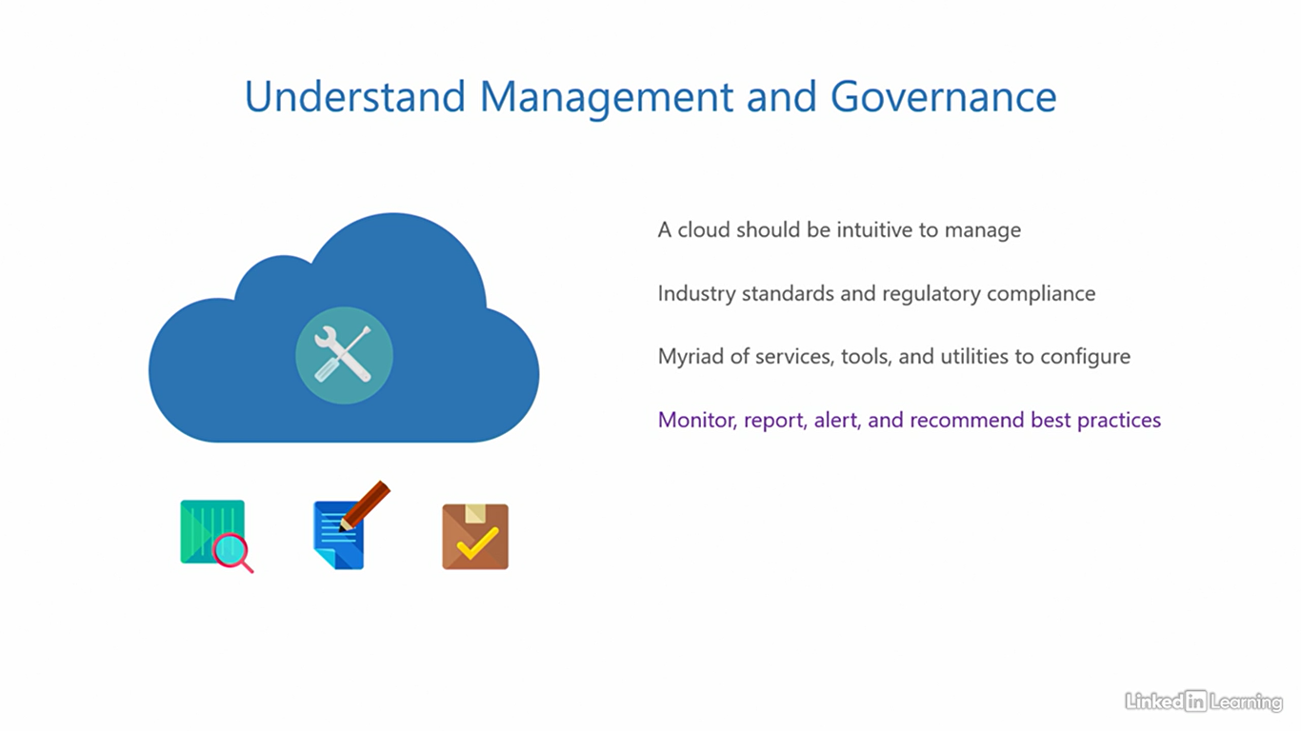

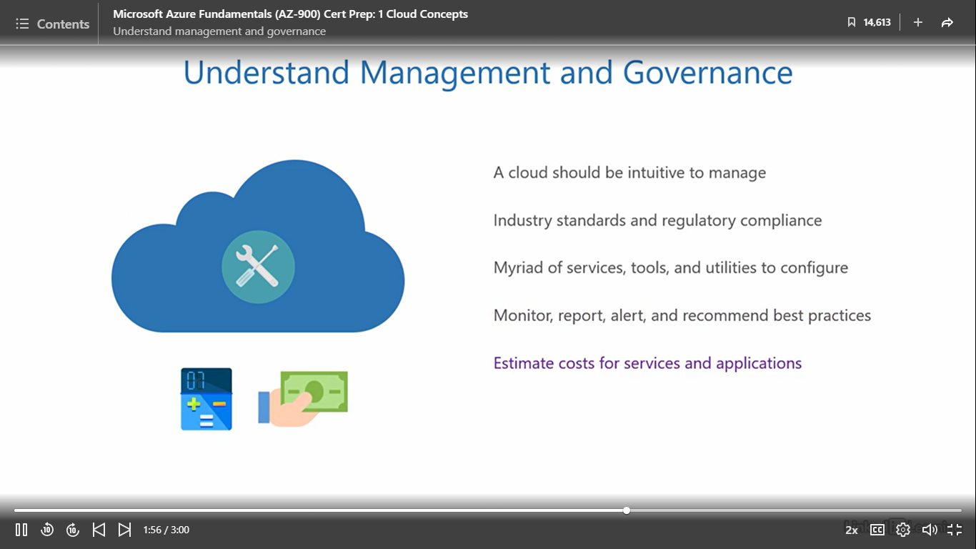

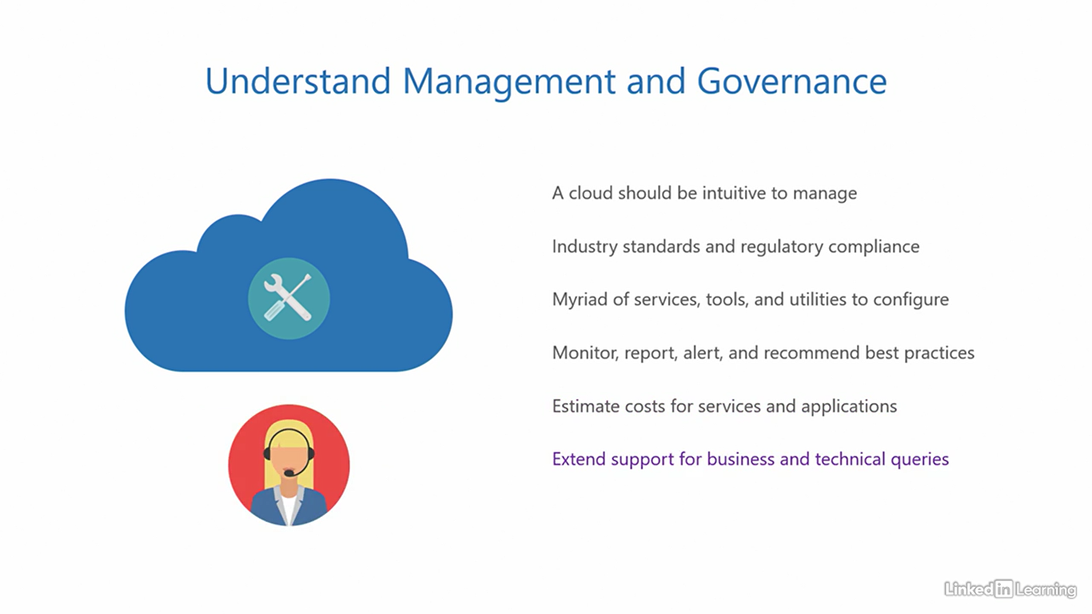

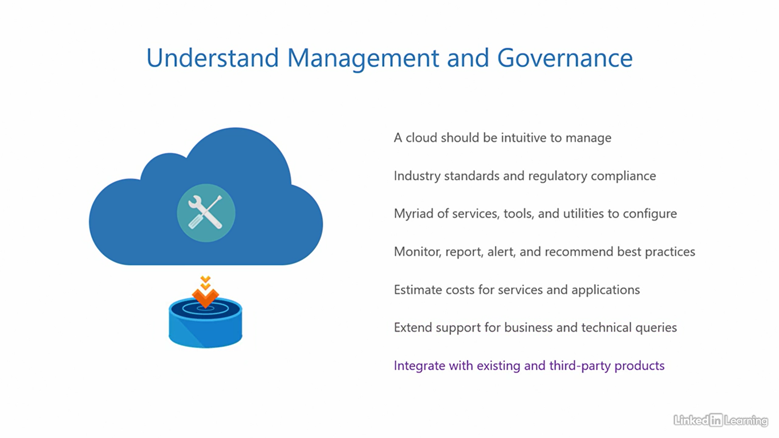

Course summary

[Instructor] Welcome to the last chapter of this course, the conclusion. Here, we'll wrap up the course by reviewing the important bits that are essential for the AZ-900 exam. So let's go back into a quick flashback. In this course, we covered the first section of the AZ-900 exam, describe cloud concepts. In the first chapter, I mentioned how every IT enabled organization has an application that is critical for its business. This application needs to be up and accessible for users around the world around the clock. For that, you need to traditionally build an IT stack and constantly maintain it. To make things easier, you can use cloud computing where a cloud service provider offers parts of the IT stack as a service to customer organizations. Then we learned about the three cloud service models; when an organization consumes virtual hardware resources and its underlying components from the cloud service provider, it's called infrastructure as a service. When it consumes the application dependencies and the underlying components, it's called platform as a service, and when it directly consumes the application ready made from the cloud service provider, it's called software as a service. After that, I showed you the shared responsibility model that outlines how the responsibility of parts of the IT stack is distributed between the customer and the cloud service provider, depending on the cloud service type. And lastly, I emphasized that the data is always under the control of the customer. I also illustrated the four key characteristics of the cloud; resource pooling, elasticity, pay per use, and automation. In the second chapter, I explained the types of cloud computing, a public cloud, which is open for anyone to access, then a private cloud that organizations can deploy for dedicated use to comply with company policy and data security. The third one was a combination of these two, a hybrid cloud. You also learned about a fourth special type of cloud called a sovereign cloud that is reserved for national governments and not open for general public use. In the third chapter, you learned about the benefits of cloud computing. We saw how an infrastructure pool provides and adjusts resources for an application based on demand enabling elasticity, and therefore the infrastructure becomes an elastic infrastructure. Next, you saw if an application can scale vertically or horizontally based on user demand, it enables scalability and therefore, the application becomes a scalable application. Then we saw how maintenance and failures can be handled without disrupting the application and keeping the downtime minimum through high availability. And finally, we saw how instantaneous faults in a system can be handled by the operating system without affecting the application through fault tolerance. And that was an express recap of everything we learned so far in this course.

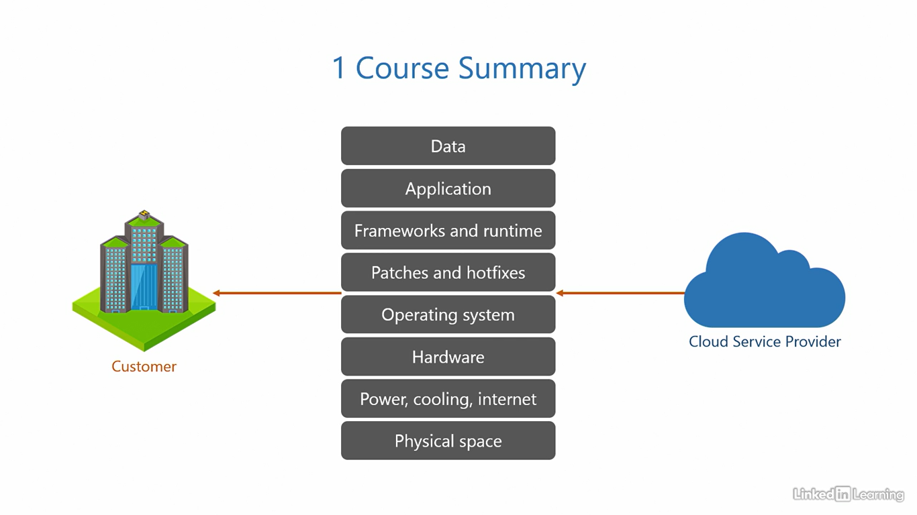

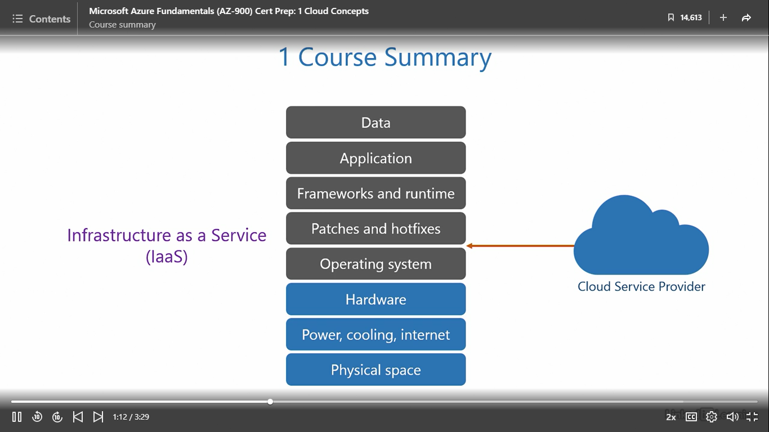

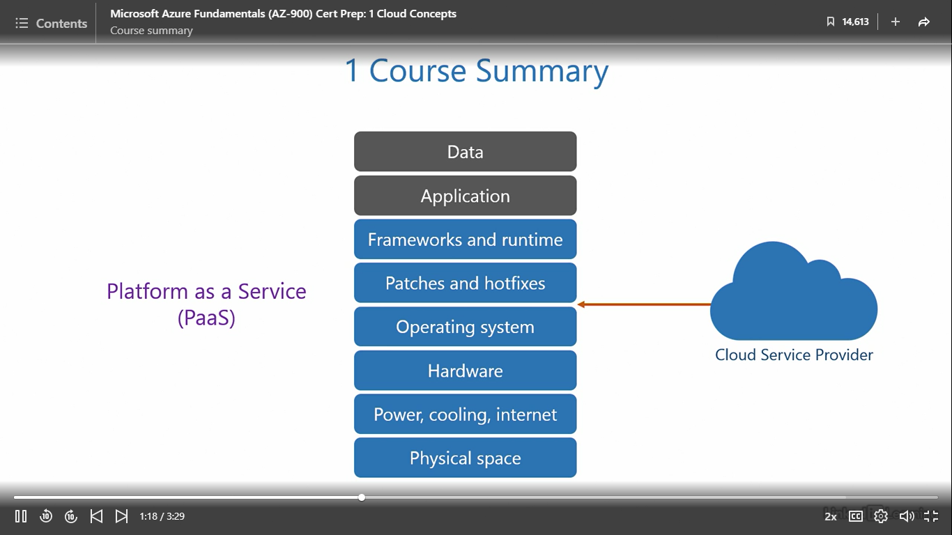

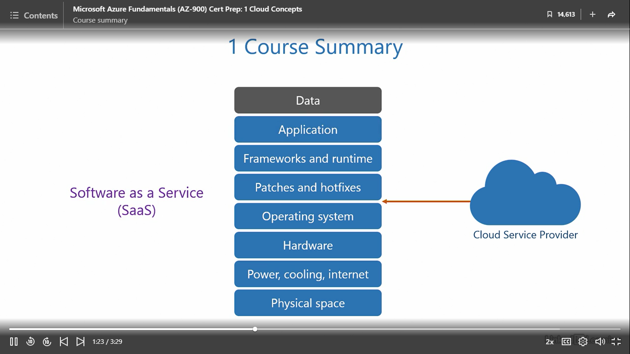

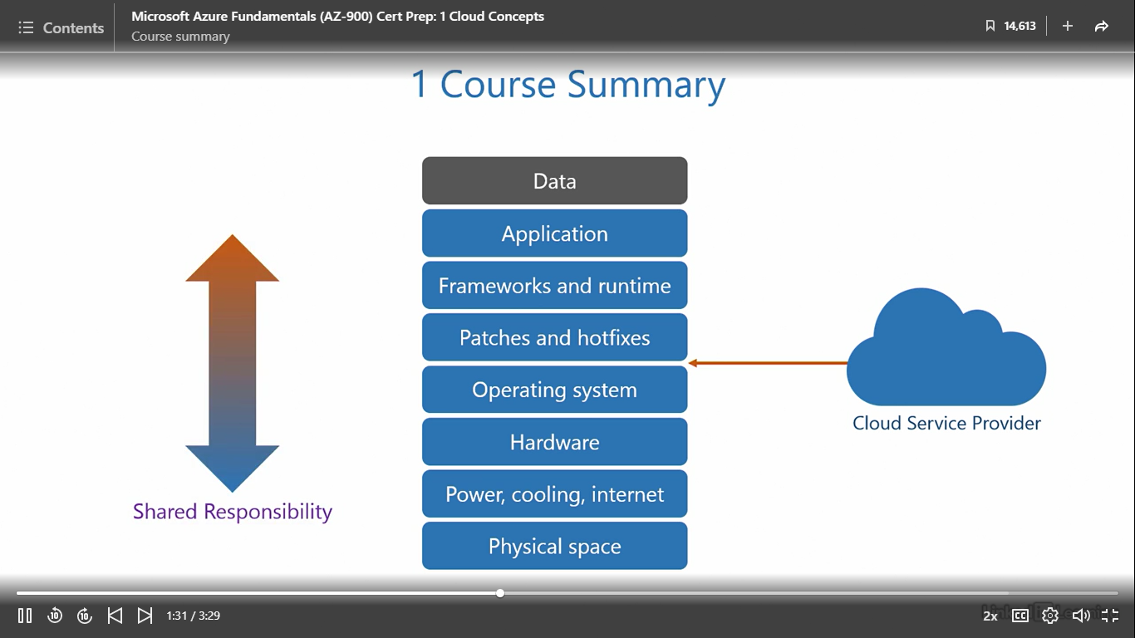

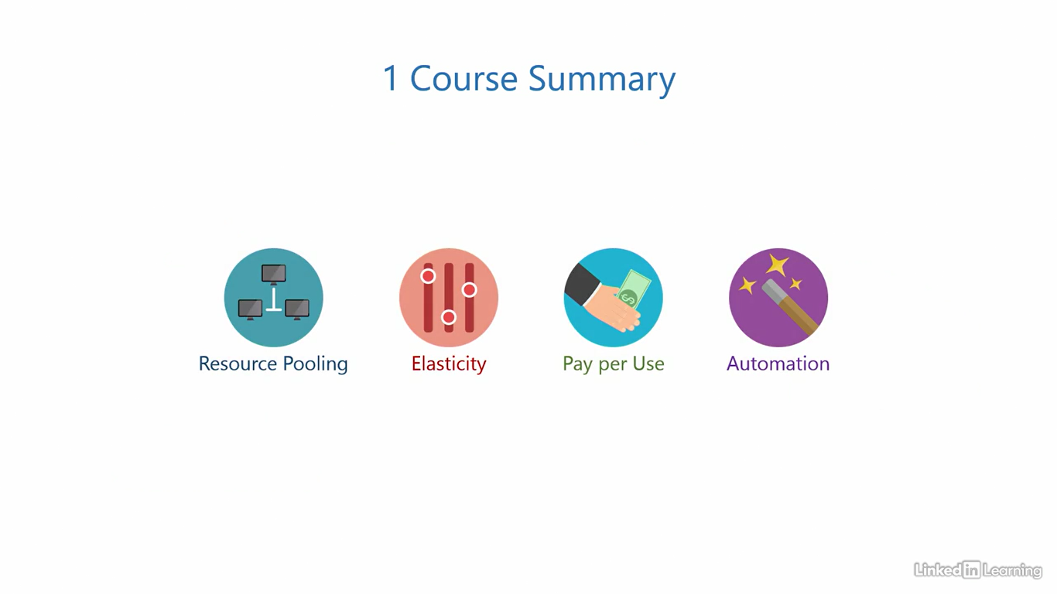

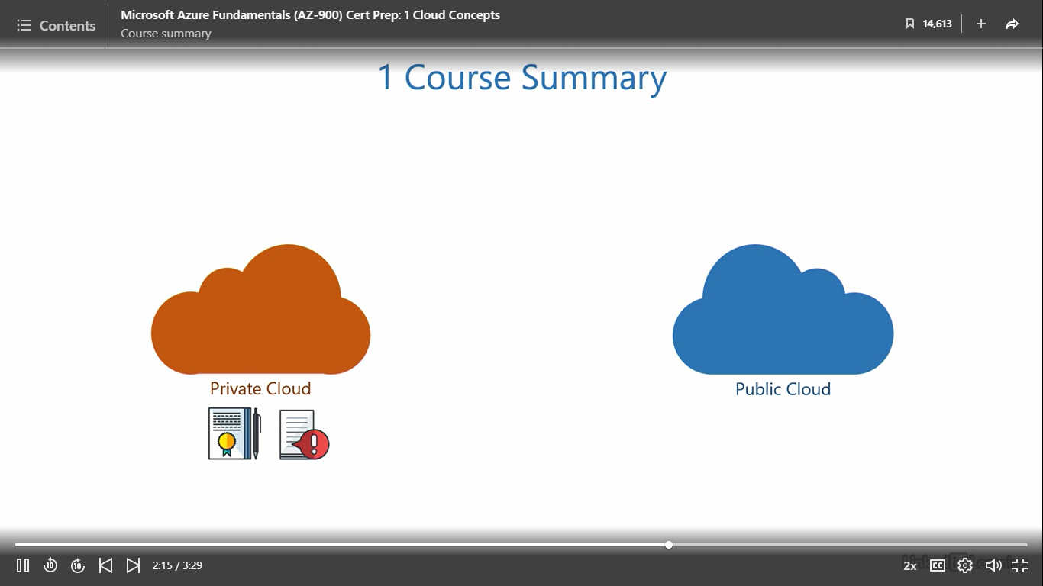

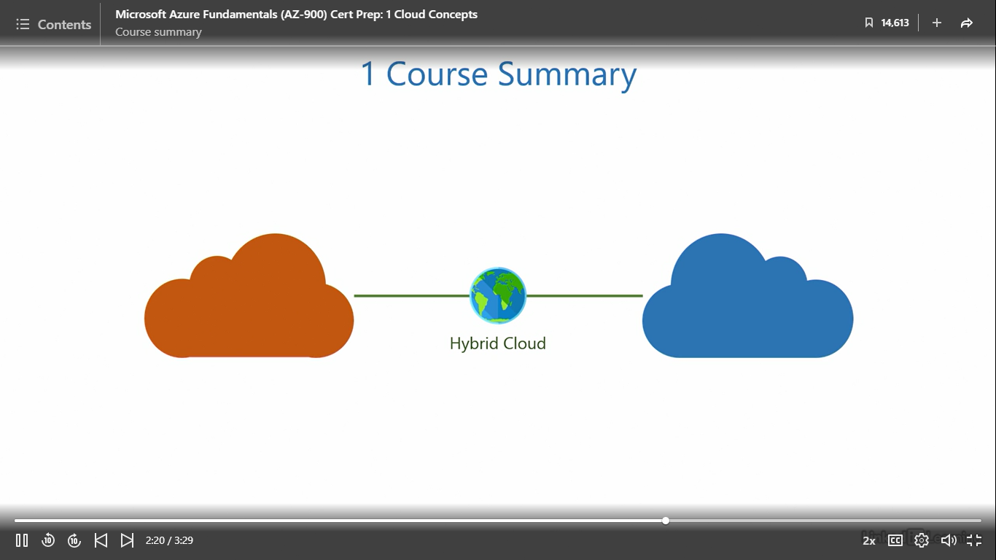

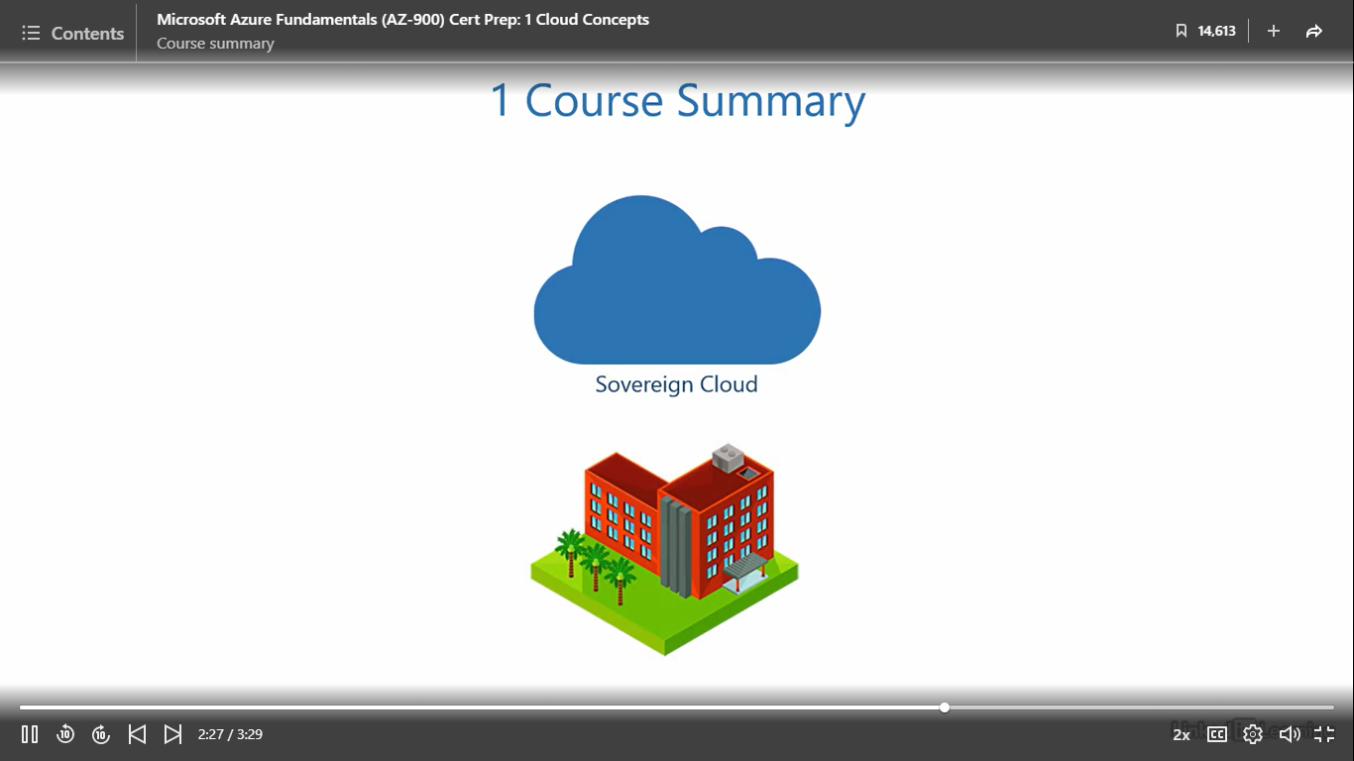

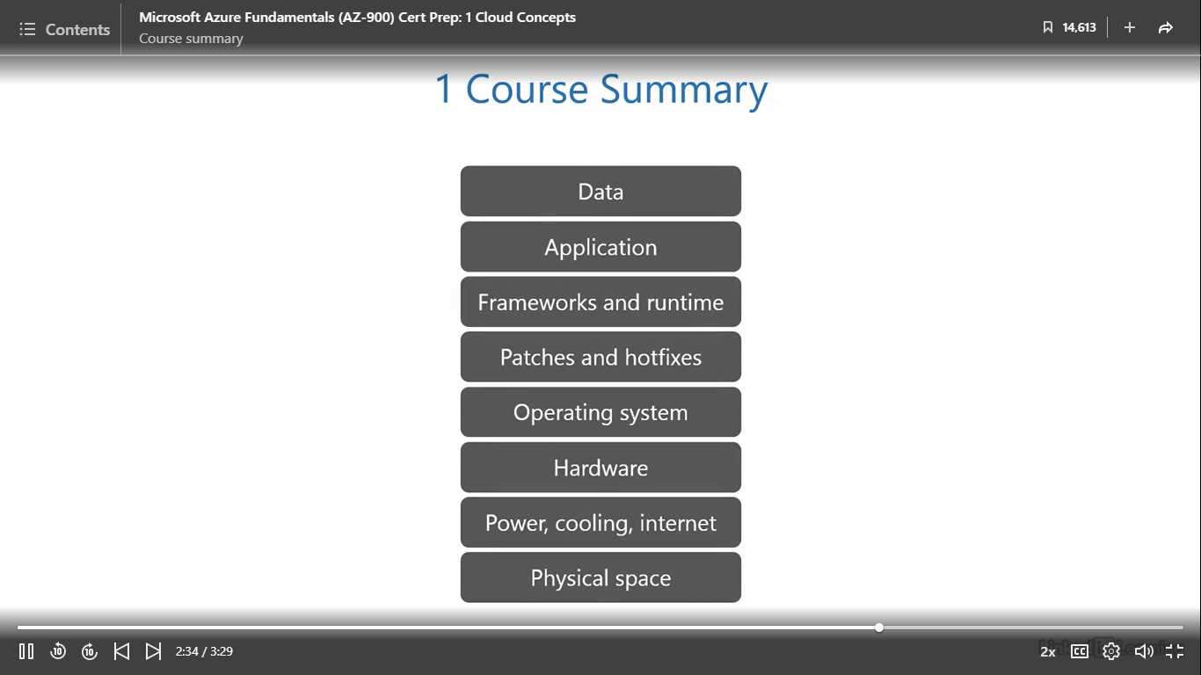

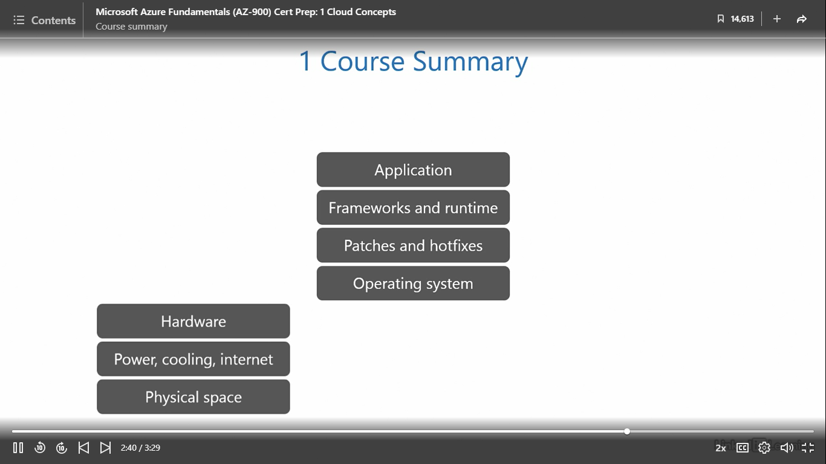

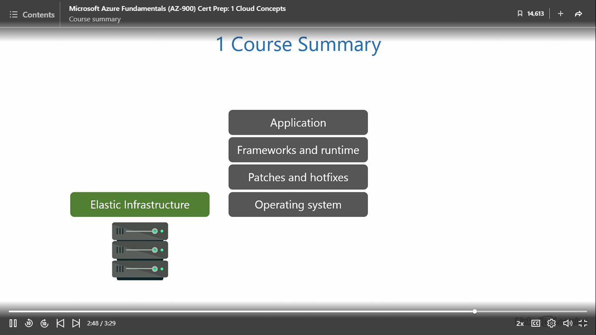

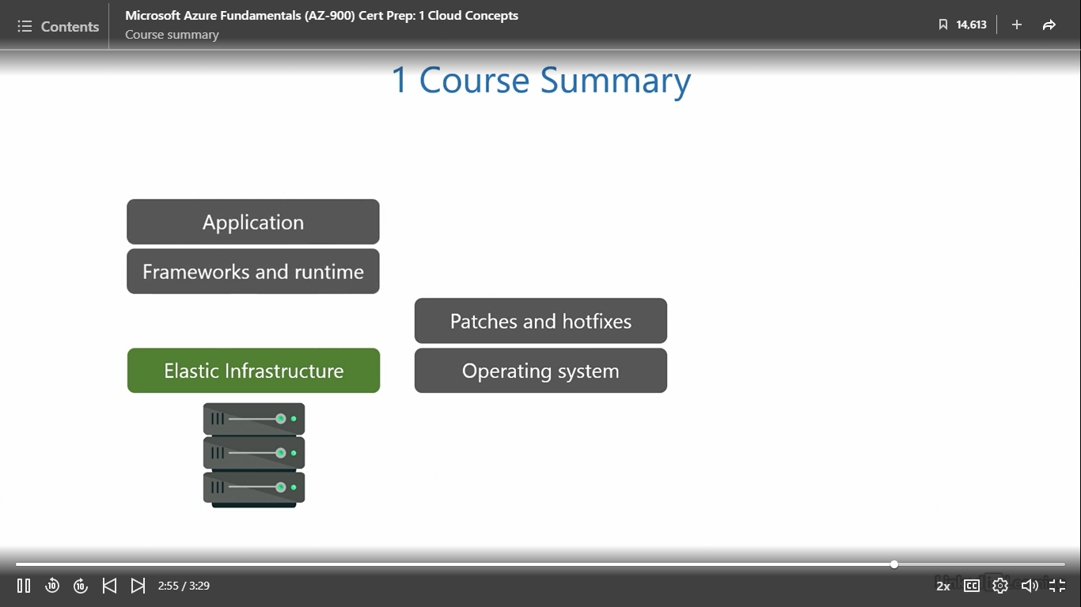

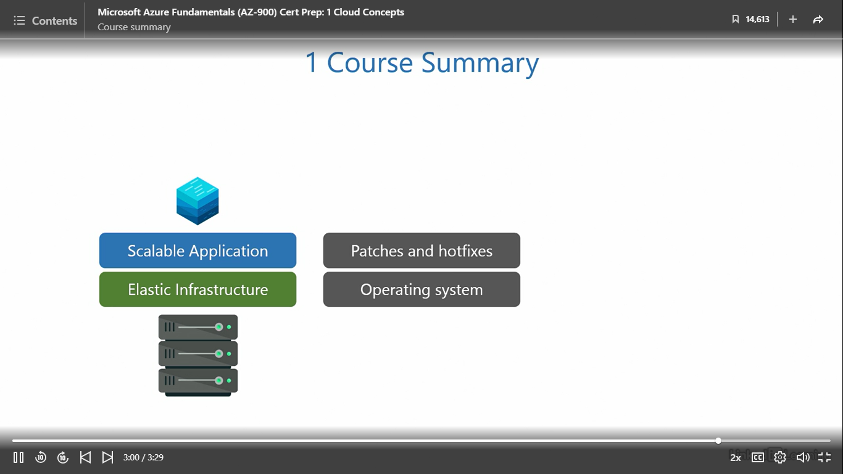

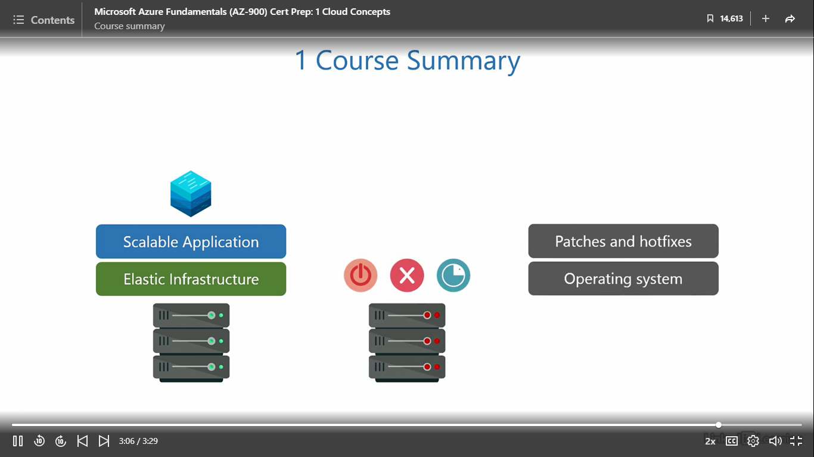

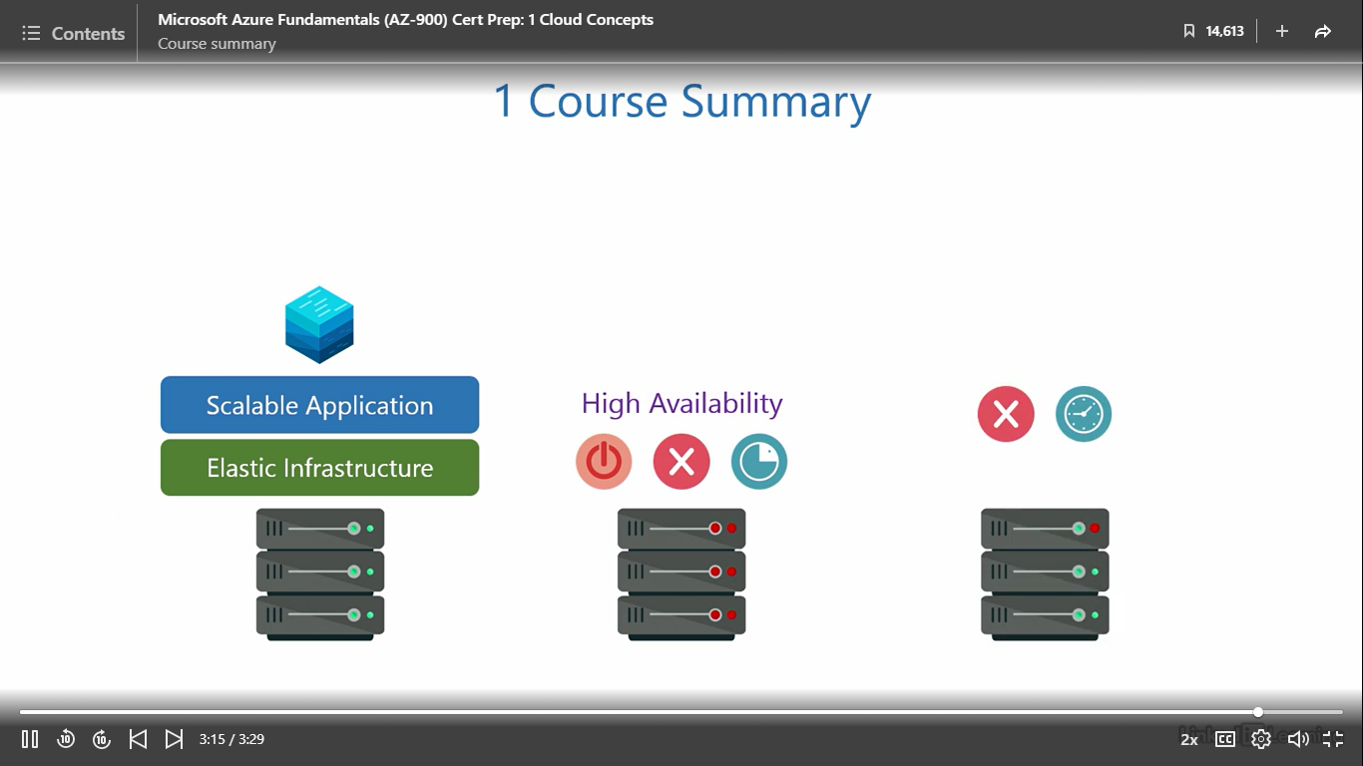

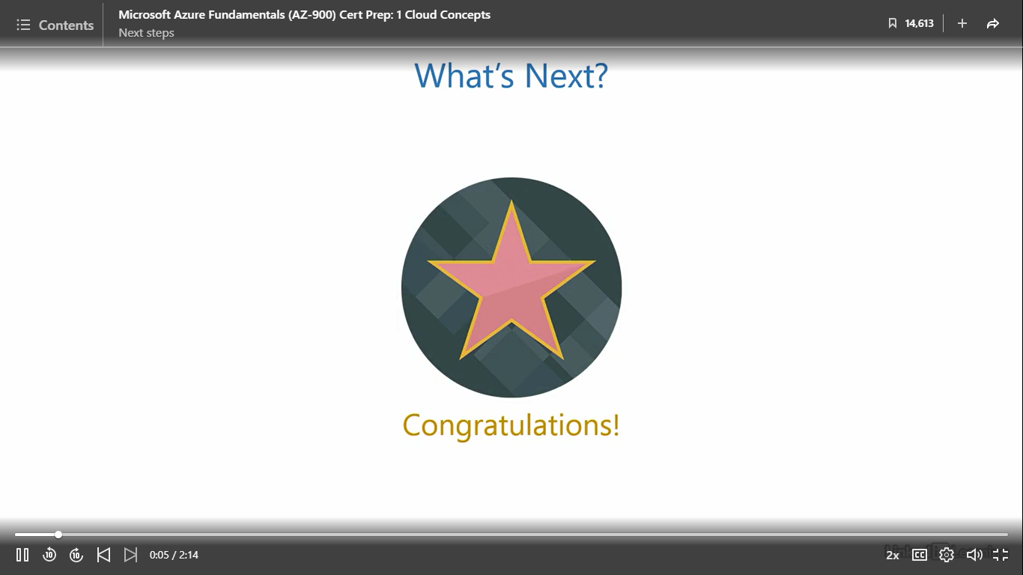

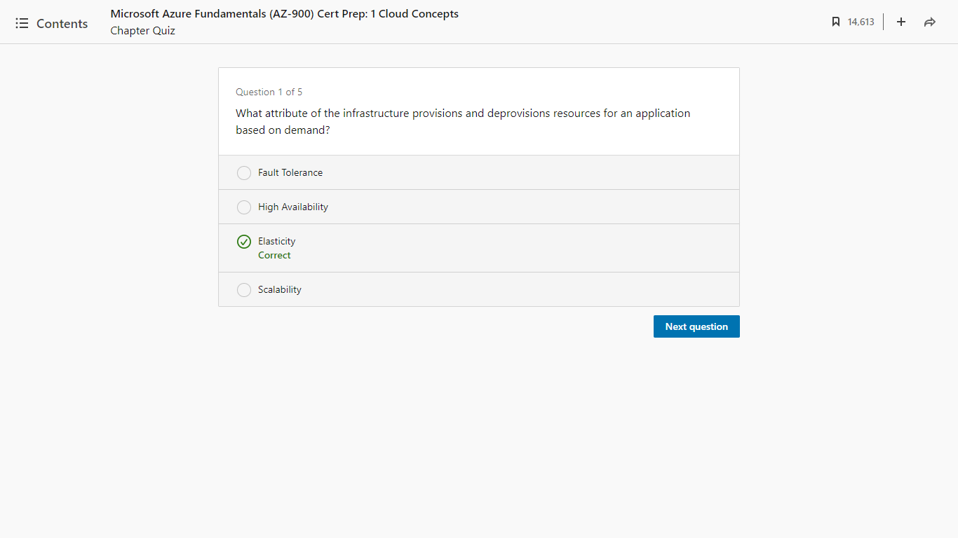

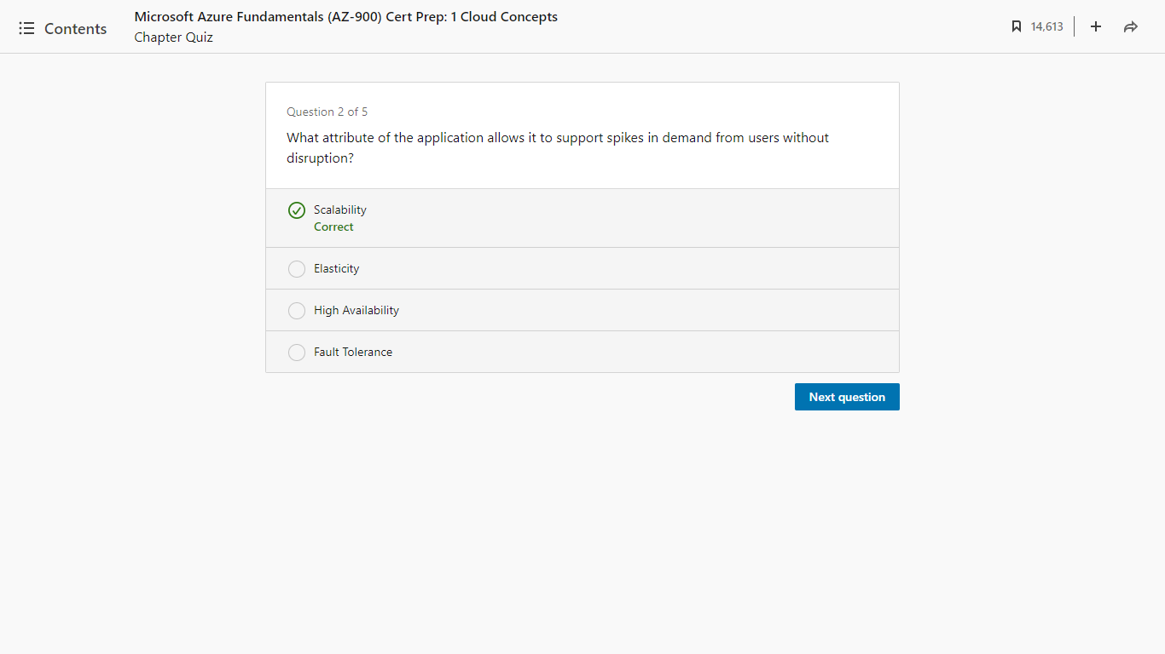

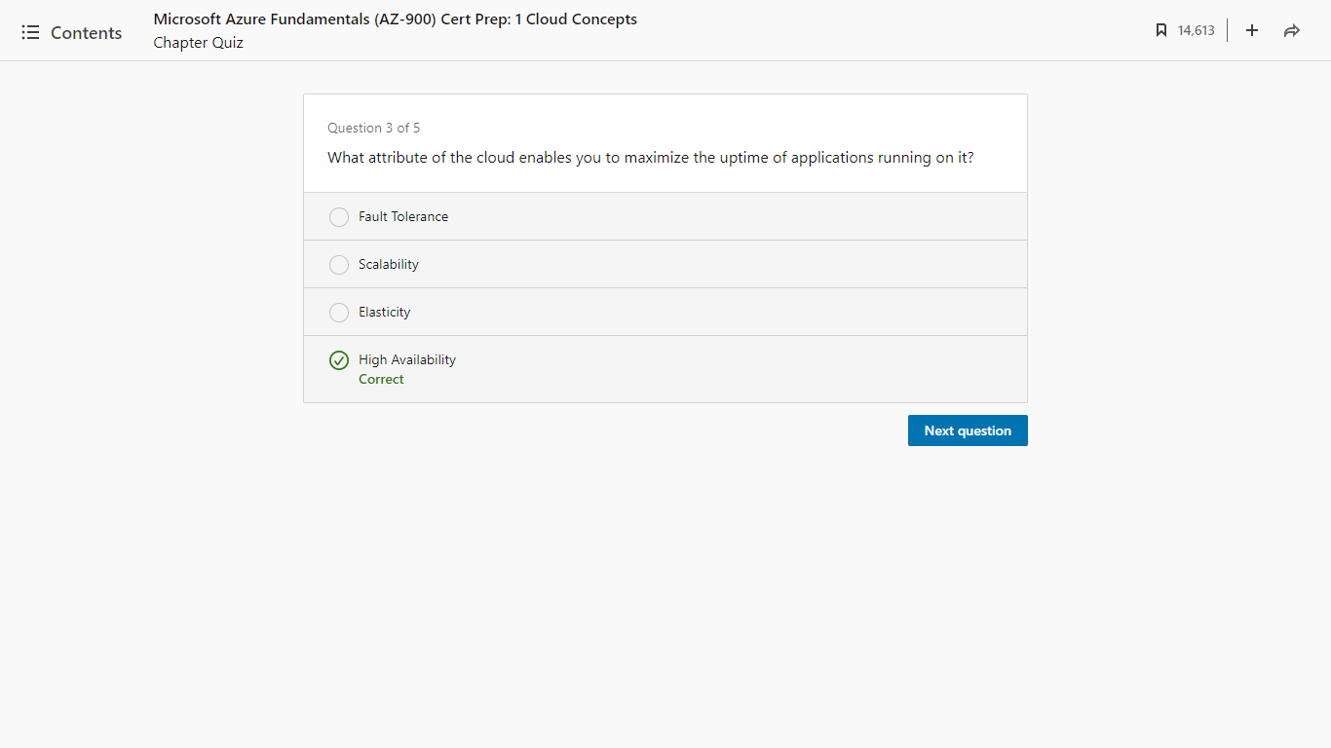

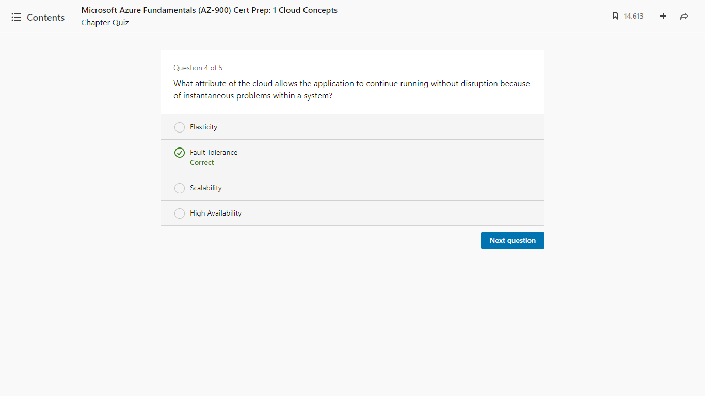

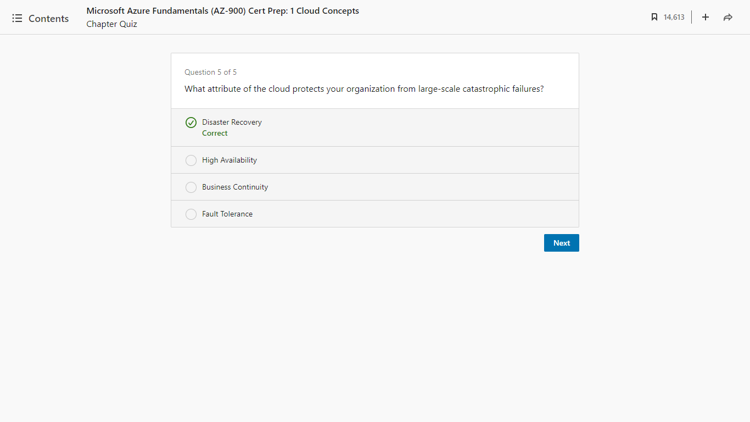

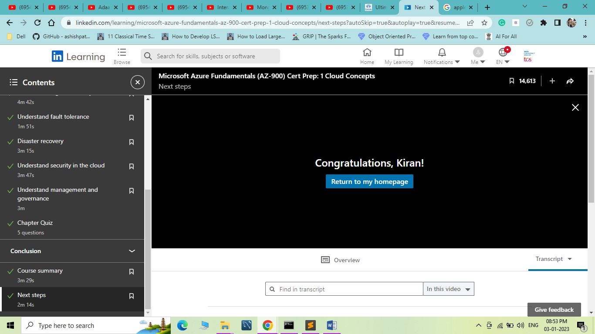

Microsoft Azure Fundamentals (AZ-900) Cert Prep: 2 Azure Architecture and Security

Introduction

Hello Azure

[Instructor] It's quite common for beginners to think of the cloud as just a few connected data centers, but soon, you'll realize it's a lot more than that. Public clouds are ginormous and really sophisticated. It's the culmination of all the knowledge and experience of the smartest IT professionals in the world put together. What you see on your screen is the massive presence of Microsoft Azure, engulfing pretty much the entire planet Earth, ranging from satellites in outer space, to capsule data centers submerged in the oceans. Each data center has custom-built hardware and connects over 150 countries through high performance networks. It also has the best-in-class security and redundancy to ensure your data is always safe, all of that while maintaining a carbon neutral footprint for the environment. The big question is, why should you choose Microsoft Azure and not some other cloud service provider out there? Personally, I've been using Microsoft products all my life. For me, there's a sense of familiarity, comfort, and, most importantly, trust that comes with Microsoft. Azure has all the technology and services you need to materialize your vision. If that thought resonates with you, then you understand why Azure. If you are not convinced yet, stay with me and I'll try my best to change that perspective. Say the magic words, "Hello Azure," to begin.

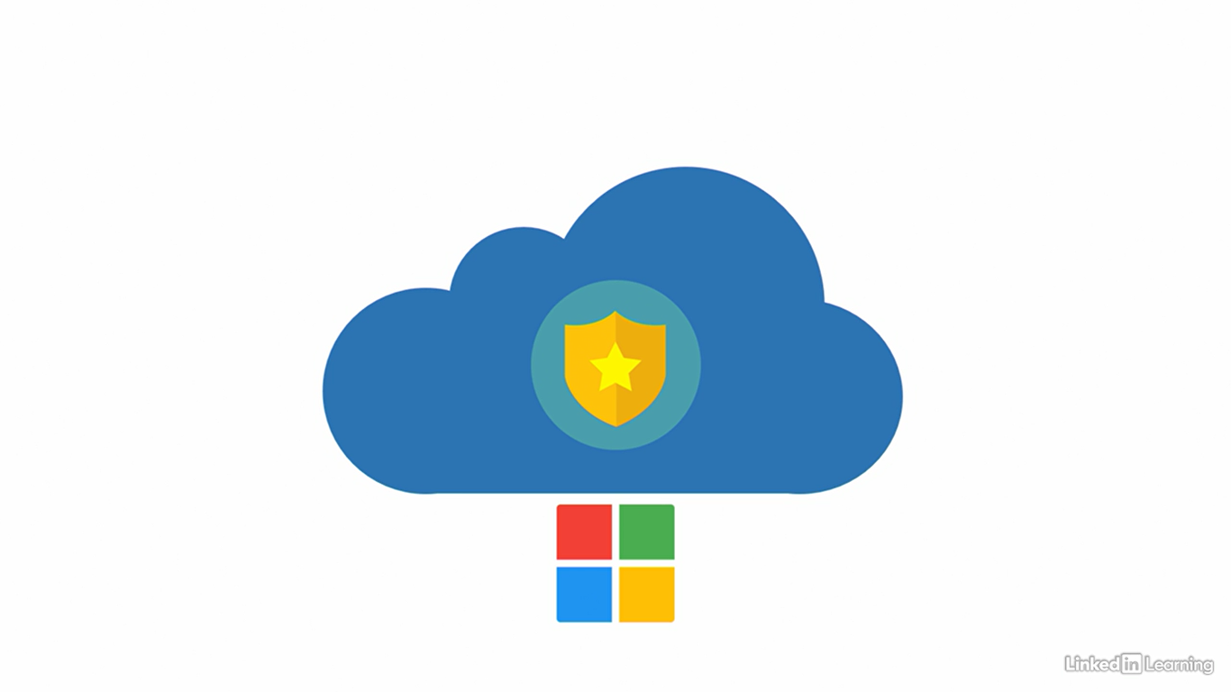

Prerequisites

[Instructor] Here are the prerequisites you need to know. This course is second in the Learning Path for AZ-900 on LinkedIn Learning. I strongly recommend that you watch the previous course before starting this one. That is Microsoft Azure Fundamentals AZ-900 Cloud Concepts. The AZ-900 exam is divided into three sections: describe cloud concepts, describe Azure architecture and services, and describe Azure management and governance. The previous course covered the entire section, describe cloud concepts. You must understand the concepts taught there before you begin this course. If you've already watched that, fantastic. Let's move forward. The target audience for this course is, just like the last course: beginners in IT, helpdesk staff, infrastructure professionals, and software developers. In addition to that, because of the topics we'll cover in this course, I recommend that identity, as well as security professionals, watch this. For required knowledge, as I've mentioned, you need to have watched my Cloud Concepts course. Then, although you don't need to, it'll be extra helpful if you have a basic understanding of Identity and Access and Security. For required resources, you need access to the LinkedIn Learning Path for AZ-900 a Microsoft Learn account, and the Workbook-2 document from the exercise files. Optionally, it'll be a bonus if you have an Azure subscription.

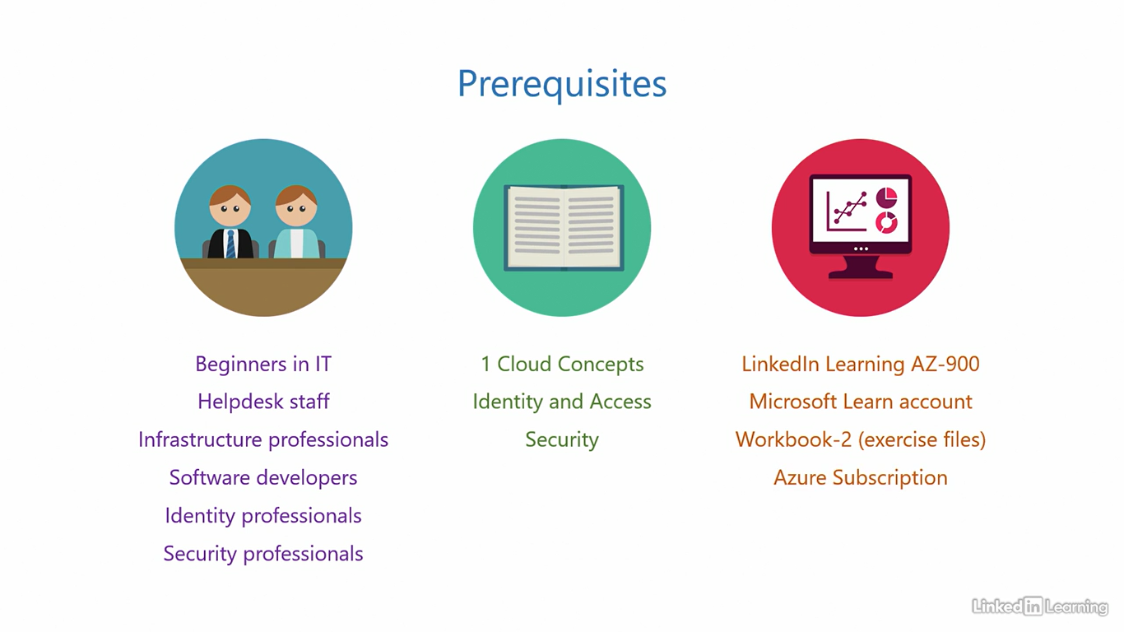

Agenda

[Kunal] Here is the agenda for this course. Our focus in this part will be on the section two of the AZ-900 exam objectives. "Describe Azure Architecture and Services." Now, because this is a core objective with high weightage, we will split this objective over two courses, this one and the next. This course will cover Microsoft Azure Fundamentals, AZ 900, Azure Architecture and Security. Whereas the next will cover Azure Services. So, Architecture and Security here and Azure Services in the next course. This course contains five chapters. The one you're watching right now is the "Introduction." The next will be "Understand Azure Architecture." Here I'll give you an overview of the Azure Global Infrastructure, it's structural components, and the basic administration hierarchy. After that, we'll get to "Understand Azure Active Directory." This is an identity and access management solution for the cloud. Then we'll follow that up with the chapter, "Understand Azure Security." Here, we'll talk about security in the cloud and the tools Azure provides for starters to protect your resources. The final chapter will be the conclusion, where we summarize everything from this course and see what's next. Before we go any further, let me take a moment to introduce myself. I'm Kunal D Mehta, an IT consultant who specializes in Microsoft Cloud and Datacenter technologies. When I'm not doing geeky stuff, I like to swim, scuba dive, travel, or just relax, watch a movie, and eat pizza. I'm absolutely thrilled to be your instructor for this AZ-900 learning path on LinkedIn Learning. For best experience, watch this course on full screen. If you feel I'm speaking too fast or too slow, you can use the controls in the video player to adjust the speed for your comfort. Alright, without any further ado, let's jump right in.

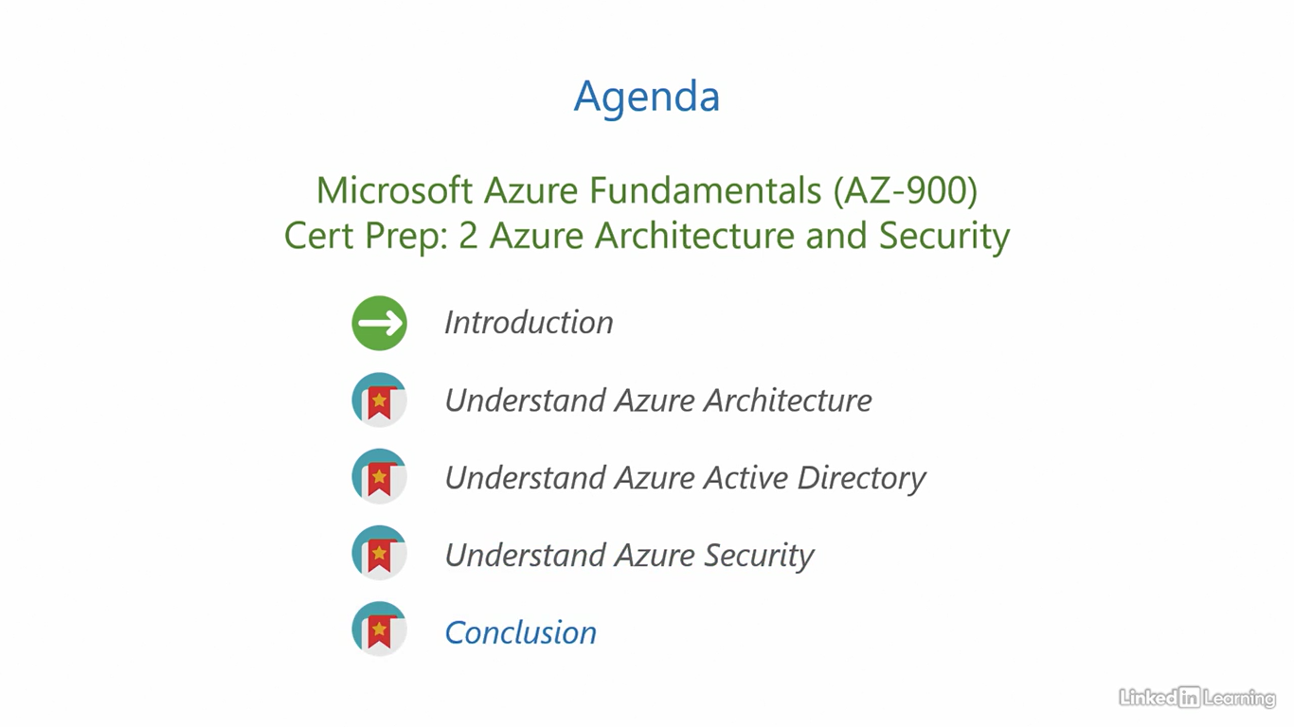

1. Understand Azure Architecture

Azure global infrastructure overview

[Instructor] Welcome to Understand Azure Architecture. In this chapter, we will get an overview of the core architectural components in Azure and their hierarchy. When you see how mature Azure is, it'll help you appreciate and trust the cloud a little more. We will also cover the basic administration hierarchy for Azure. How the services and resources are organized, so that you can plan an optimum strategy for arranging your assets in the cloud. Let me walk you through it. Let's start with Azure Global Infrastructure overview. At the highest level, what we have is an Azure geography. An Azure geography is typically a country like for example United States or India. This is the largest unit in the Azure architectural hierarchy. A country, if I had to loosely define it, has a boundary, its own government, and national laws. Now, why is this important? Most countries have common laws across the land that apply to data, depending on where it's stored and how it's processed. Different rules apply to different types of data. Like financial information or healthcare information, countries require these to be handled in a very specific way. So defining an Azure geography helps meet those shared regulations and compliance requirements from the government or the organizations a country may have. Another important criterion that countries and organizations have is data residency. This means the data should reside within a given geography. When data is stored in another country different rules may apply to it, which may or may not be favorable to those who own the data. So ideally, data should reside within a geography that the customer chooses. Microsoft picks and decides which geography or country to venture into based on customer demand. Countries with greater IT orientation have a bigger Azure presence compared to countries that are less IT oriented. A geography subsequently contains one or more Azure regions. Before we talk about regions, let's jump into the Microsoft website that gives you a realtime view of their global infrastructure map. To open the Azure Global Infrastructure Overview website, you'll have to visit the URL infrastructuremap.microsoft.com using your browser. This is the Azure Global Infrastructure. Each dot on the globe represents an Azure architectural building block. You can see there are hundreds of them of different colors, shapes, and sizes. The glowing lines are dedicated high speed network connections connecting these Azure building blocks across the planet. If you observe carefully, you'll also notice satellites circling around the earth in an orbit. The longer you look at it, the more you'll realize how massive this infrastructure is. But don't be overwhelmed, we'll take one step at a time and learn each building block one after another. To inspect these building blocks, I'll switch to the map mode by clicking on the map button on the left bottom corner of the screen. Here's the map mode. To simplify things, I'll first use the filter on the top left corner to uncheck the components we don't need right now. So I'm going to uncheck Edge Zones, Network PoP, Ground Stations, and Sustainability Projects. Close out of the filter. Much better now. These are the components we need to know at this point. Each white colored diamond that you see on the screen is an Azure geography. Let's see what happens if I click on this white dot on the northwest side of the map. This is the United States geography. You can see the details of how many regions it has, how many are upcoming. And if you scroll down, you can read relevant news articles for this geography. Note how dense the Azure presence is in this geography. That's because of higher customer demand. Let me close out of this geography, zoom out, and show you a simpler geography. Let me click on this white dot in Asia. This is the India geography. You can see the similar details, the number of regions, upcoming regions, and relevant news articles for the geography. The Azure presence here is less compared to the US because the demand here is lower than it is over there. You should now have a better understanding of an Azure geography.

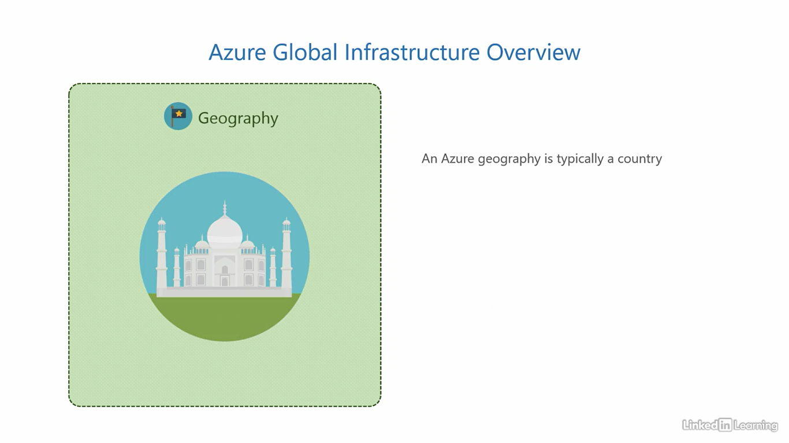

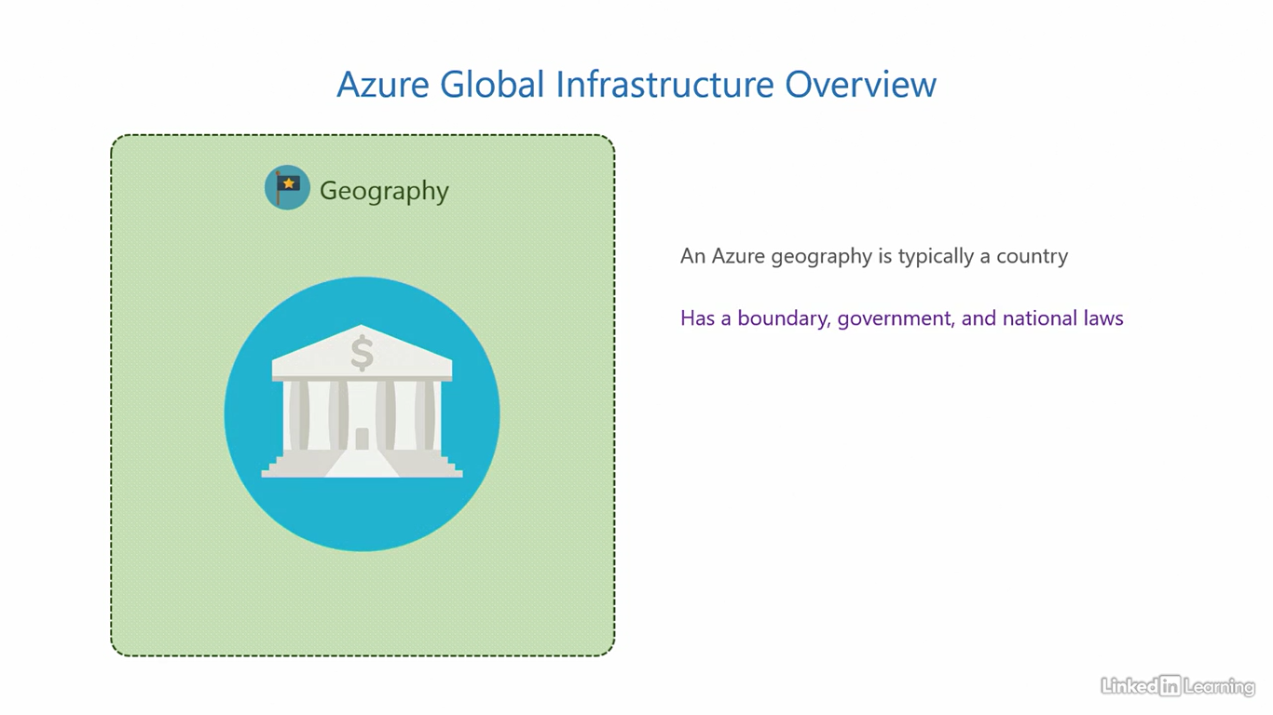

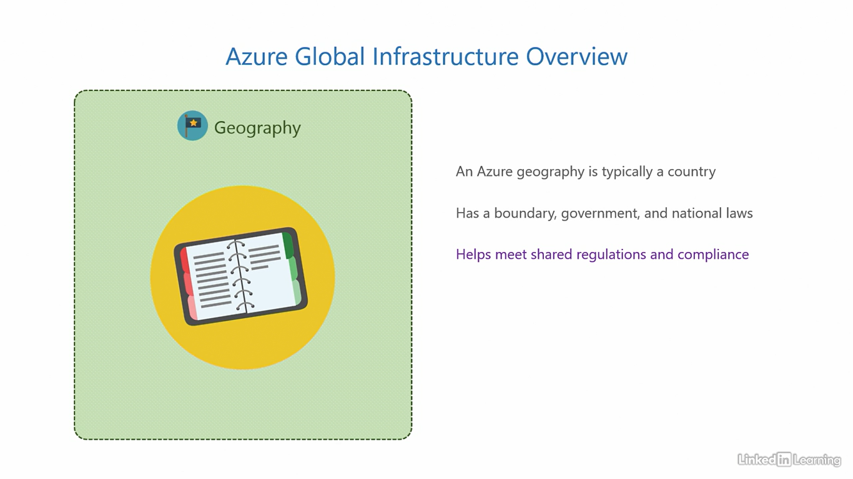

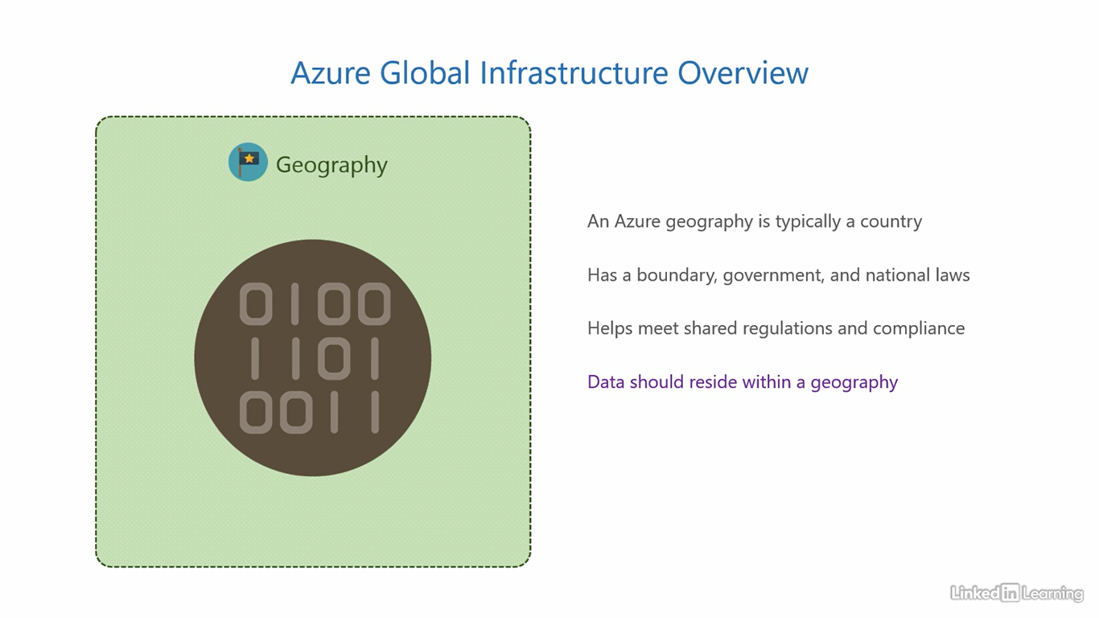

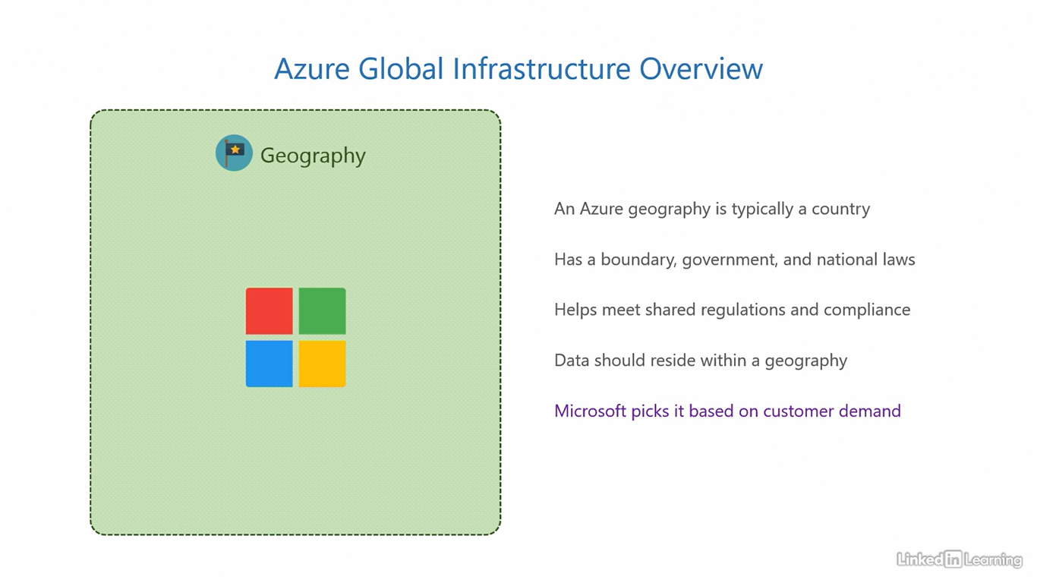

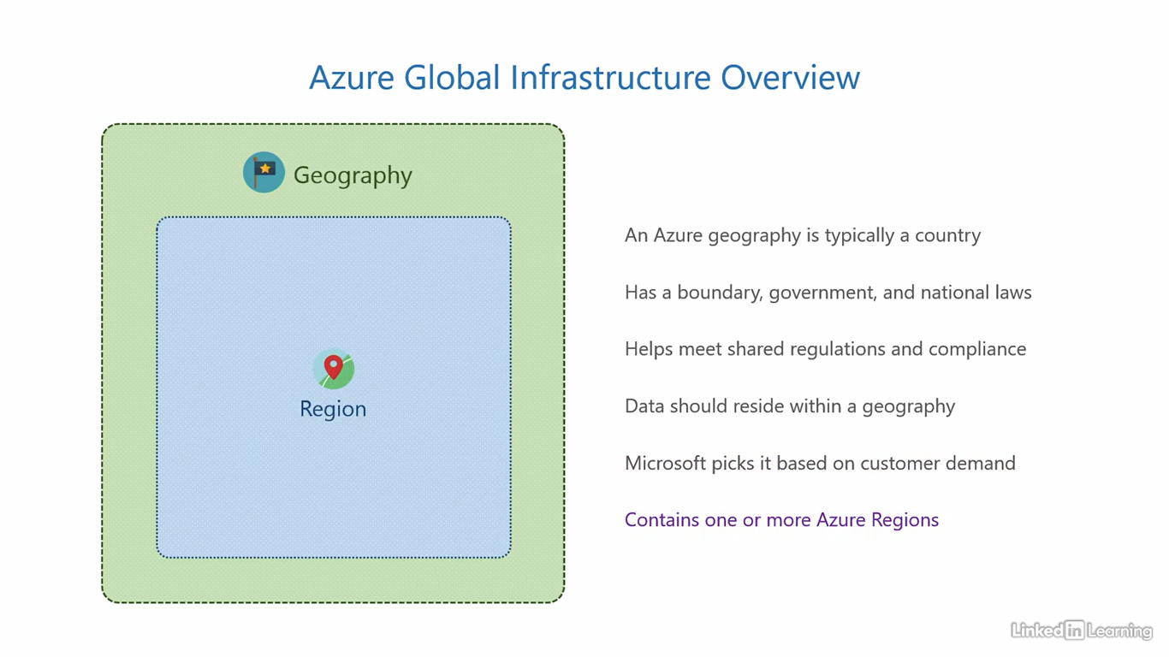

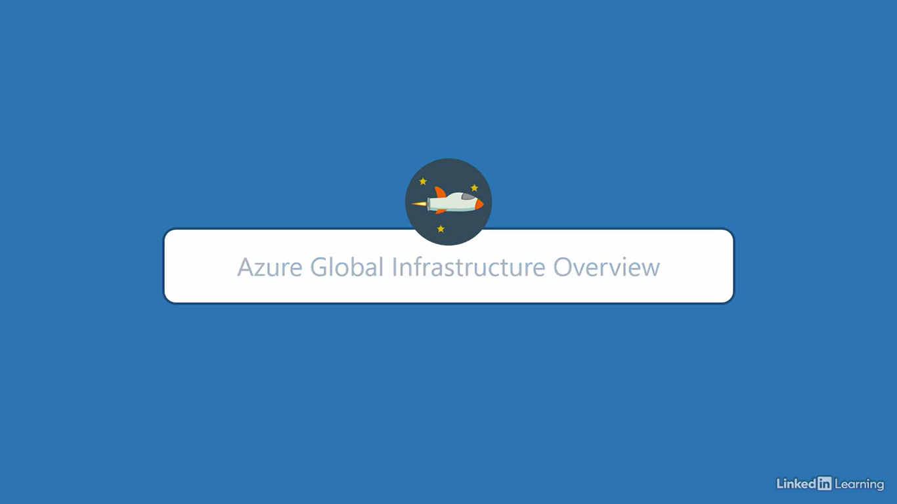

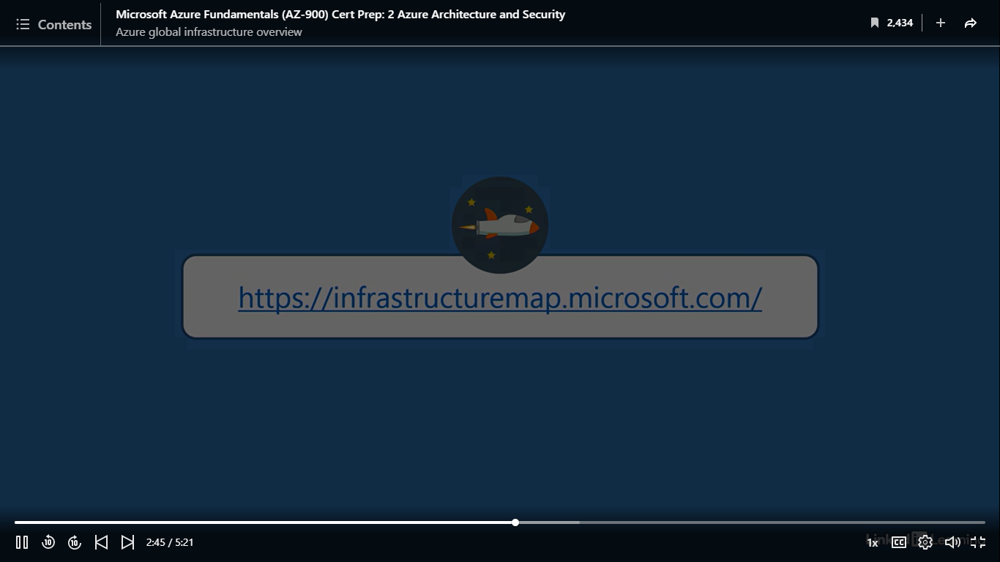

Understand regions

[Instructor] At the next level, after a geography, we have an Azure region. An Azure region is usually a part within the geography. You know how countries are segmented based on their direction? A region is similar. There can be north, south, east, west and central regions for Azure within a single geography. That's because countries vary in size, and just one region cannot always serve the entire country. The actual number of regions depends on the market size, that is, how big the geography is and the demand. Microsoft decides how many and where to place Azure regions in that geography. But there is a call to action for customers here. Customers must choose a region for their services. Every time you deploy a new service in the cloud, Microsoft requires you to specify what region you want to deploy it to. Because today's businesses operate globally, specifying the region parameter will help Microsoft to place your service appropriately. Now the question is, what region should you choose? You should choose a region that is closer to users who consume the service you deploy. So if you're developing an app that delivers cakes to people in Los Angeles, you should pick a region that is on the western side of the US, near California. A region subsequently contains one or more Availability Zones. All regions have Availability Zones, but a region becomes special when it has three or more Availability Zones. Regions are said to be Availability Zone enabled regions when they contain at least three Availability Zones. Take a moment to understand this. So if you hear someone mention an Availability Zone enabled region, it basically means the region has at least three Availability Zones, and if they say a region is not Availability Zone enabled, the number of Availability Zones in that region is less than three. Let's jump back to the infrastructure map and see the regions in real time. Let's go back to the United States geography and click on the blue circle on the eastern side. This is the East US region. That's the name of the region, East US. You'll see the same name in the Azure portal when you're deploying services. You can see the details of the region in the flyout pane. You can see its location is Virginia, it was opened in the year 2014, and its data residency is the US. This means the data in this region will remain in the US. Microsoft will not copy or move it outside the country in any circumstances, but as a customer, if you want to copy or move your data anywhere else, you're free to do so. If I scroll down, I can see the products available in this region, and the compliance offerings. If users consuming your services are on the east side of the US, you should choose one of the regions on the east side, either this one or any other ones on the eastern side. Let's move to the west side. This blue circle is the West US region. Its location is California, opened in 2012, and data residency, United States. Scrolling down will give you the products available in the region, and its compliance offerings, similar to the last region. You can use this region or any closer regions for users on the western side of the country. Let's come out of this geography, zoom out, and then go to the India geography. It says two regions available and one coming soon. Click on this blue circle. This is the Central India region, location, Pune, opened in 2015, data residency, India, and if I scroll down, the products available and compliance offerings. All the information is right here. Let's go a little south, to the South India region. Location, Chennai, year 2015, and data residency, India, plus the products available and compliance offerings. You know the drill. Now let's click on this gray circle here. This is the upcoming South Central India region. At the time of this recording, it hasn't opened yet, but what is special about this region is that it is in the city of Hyderabad. That's where I live, so I'm quite excited about this, having a region right next to me. That concludes the concept of regions. This is very important when it comes to Azure, so make sure you understand this well.

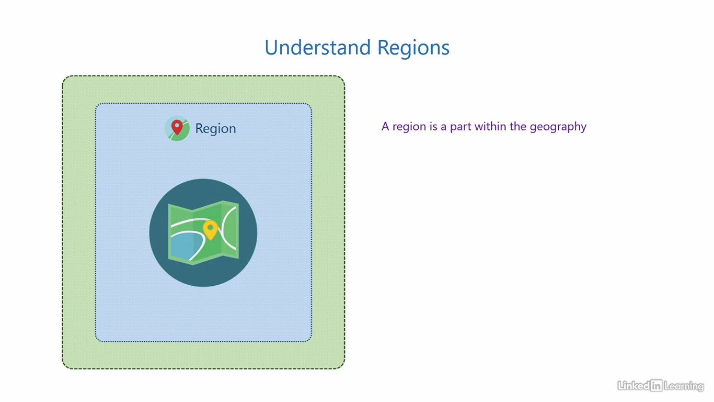

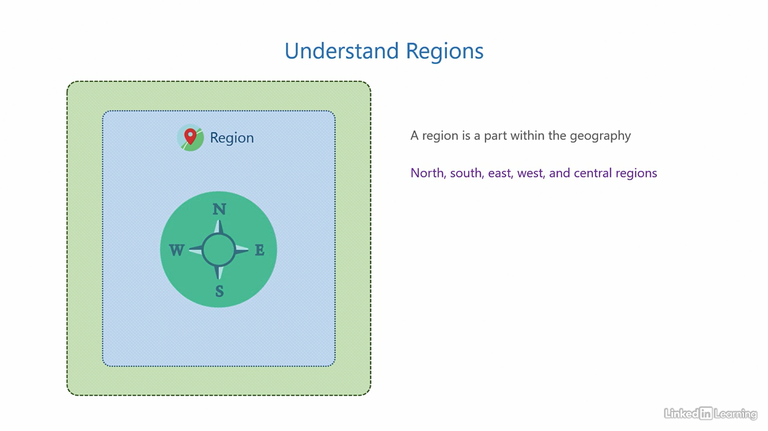

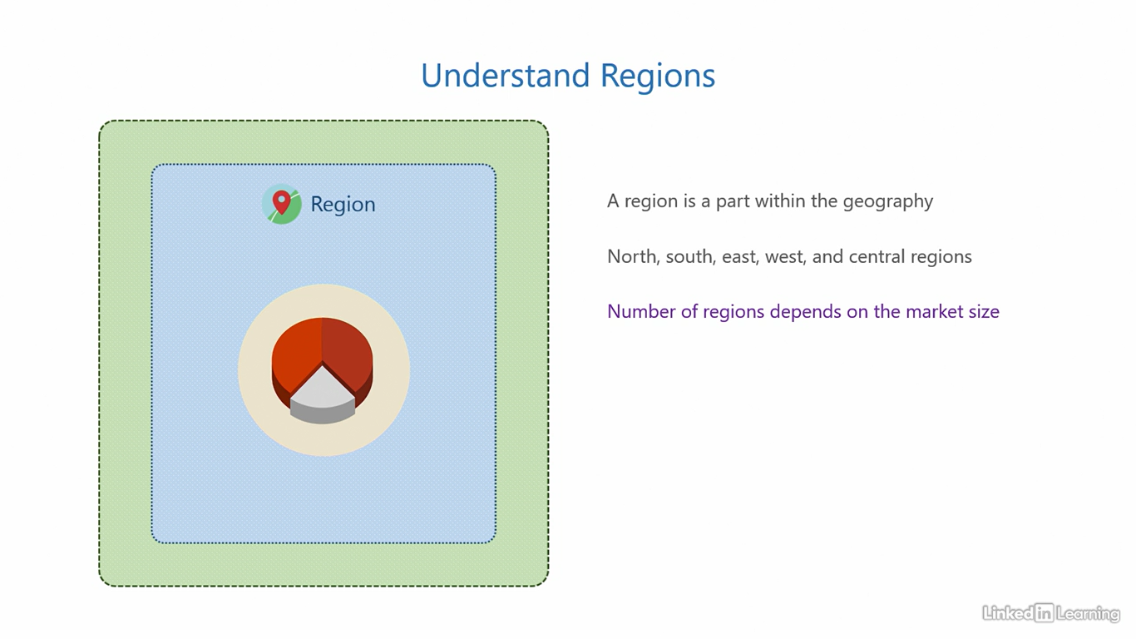

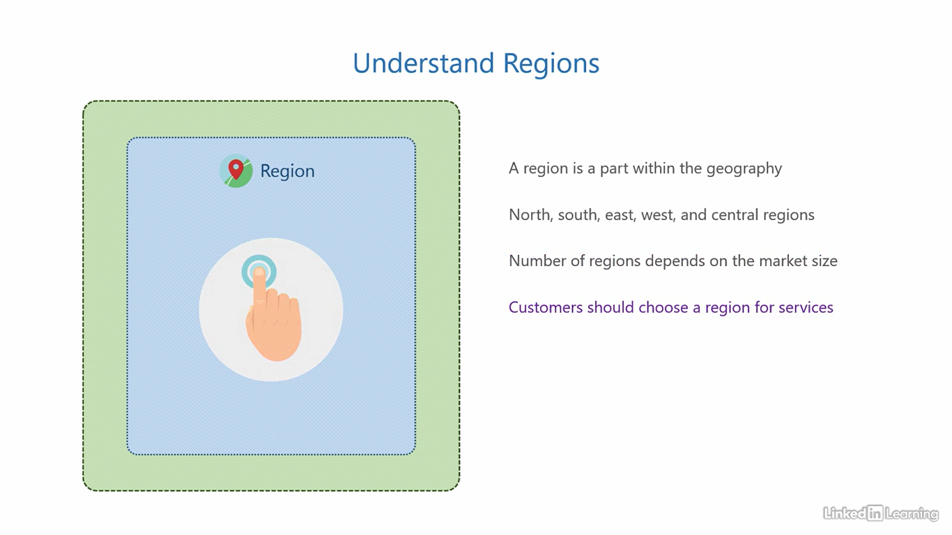

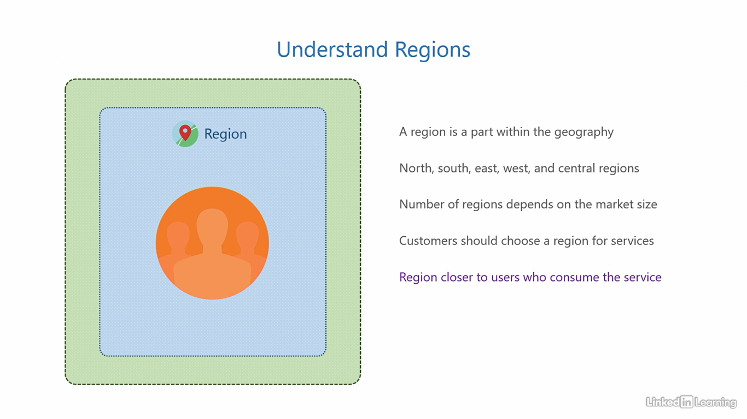

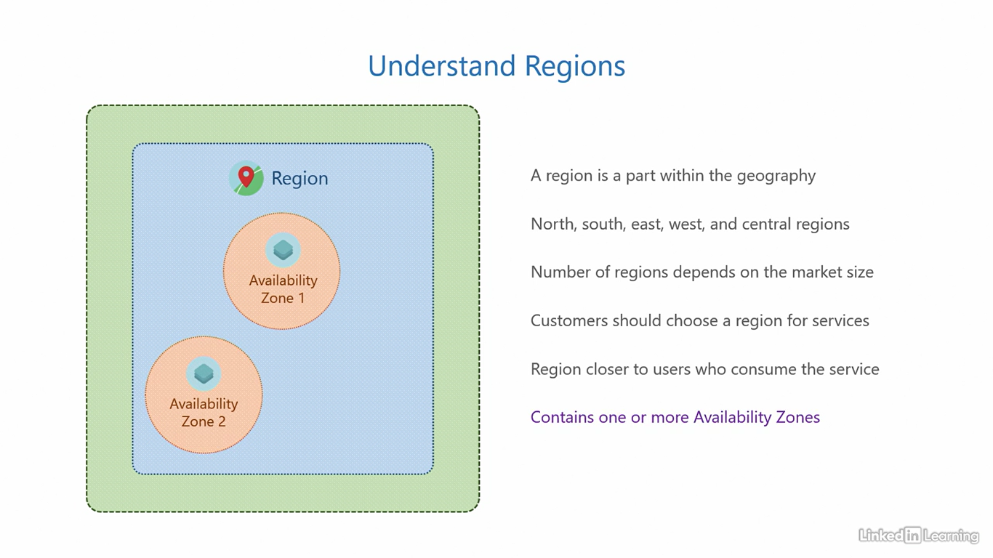

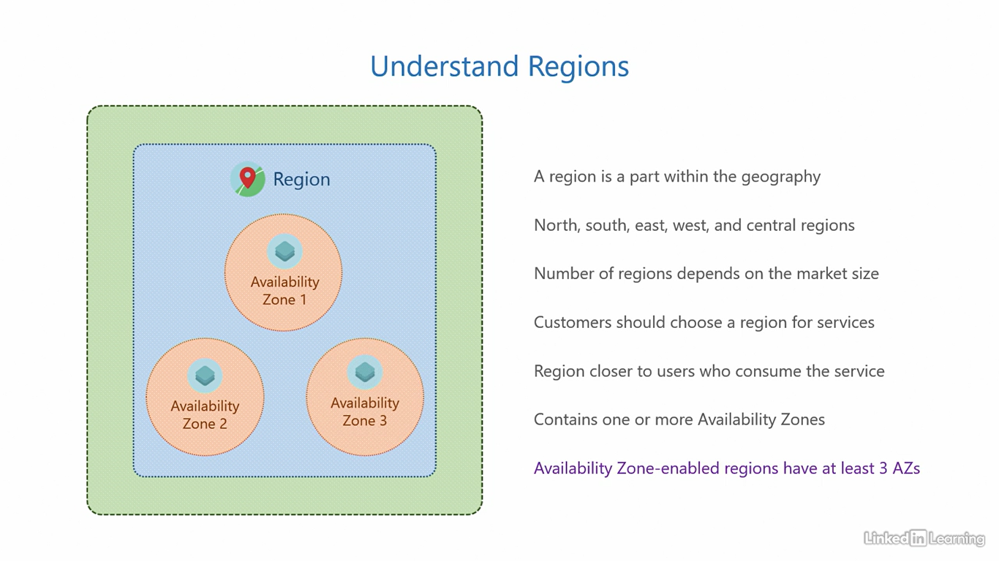

Understand regional pairs

[Instructor] Before we talk about availability zones, you should know about Azure regional pairs. Microsoft ties Azure regions, usually two, into regional pairs. These regions are connected through dedicated low-latency WAN links of less than 20 milliseconds roundtrip. And the physical separation between regions in a regional pair is at least 300 miles or 483 kilometers. Now, you may be wondering, "What's the purpose of regional pairs?" Fair question. The core reason to pair up regions into regional pairs is to facilitate cross-region data replication for high resiliency. It essentially means replicating data from one region to its pair region for redundancy, this enables support for disaster recovery. You already know what a disaster is, a catastrophic failure. So hypothetically speaking, if there's a disaster that destroys an entire region, which is your primary, a secondary region can take over and provide business continuity without data loss. That also explains why we need a low-latency network and a physical separation between the regions. A low-latency network helps with faster replication and consistent copies of the data across regions. And the physical separation lowers the possibility of both regions being affected by the same disaster. Not just that, even when Microsoft performs planned maintenance and upgrades, they only do it for one region at a time. Only when one region is complete, they move on to the next in pair. It's very strategic. Then, the pairing of regions may be unidirectional or bidirectional. This could be done when one region is smaller than its pair region. It's not possible for a smaller region to accommodate replicated data from the larger region. So, in such cases, Microsoft may configure a unidirectional pairing where data is replicated from the smaller region to the larger, but not vice versa. Azure mainly uses bidirectional pairing, but there are rare cases where there is a unidirectional pairing. Let's jump into the infrastructure map and see what regions constitute two regional pairs. You understand the concept of regions by now, let's see what regional pairing looks like. To do that, we'll go back to the US geography and click on the East US region. If you look under the Disaster Recovery section, you'll see a link for Region Pairing, this one over here. Clicking on that should bring you to this webpage, scroll down and search for the Regional Pairing table. There it is. If you see next to North America, you'll see East US is paired with West US. The East US and the West US are a bidirectional regional pair. Let's switch back to the map and visualize this information. This is the West US region, and this is the West US and East US regional pair. I'm going to close out of the US geography, zoom out, and go to the India geography. This is the same South India region we saw in the last video. To find the regional pair for this region, we'll go back to the table. Here, next to India, you'll see Central India is paired with South India. That looks good, but right below that, you'll see West India is also paired to South India. That's because the first is a bidirectional pair, whereas the second is a unidirectional pair. If you scroll below on the page, it'll mention that. Switching back to the map and visualizing this information, this is the South India and Central India regional pair. If you are interested, go through the pairing table and it'll give you a good idea of all the combinations of regional pairs.

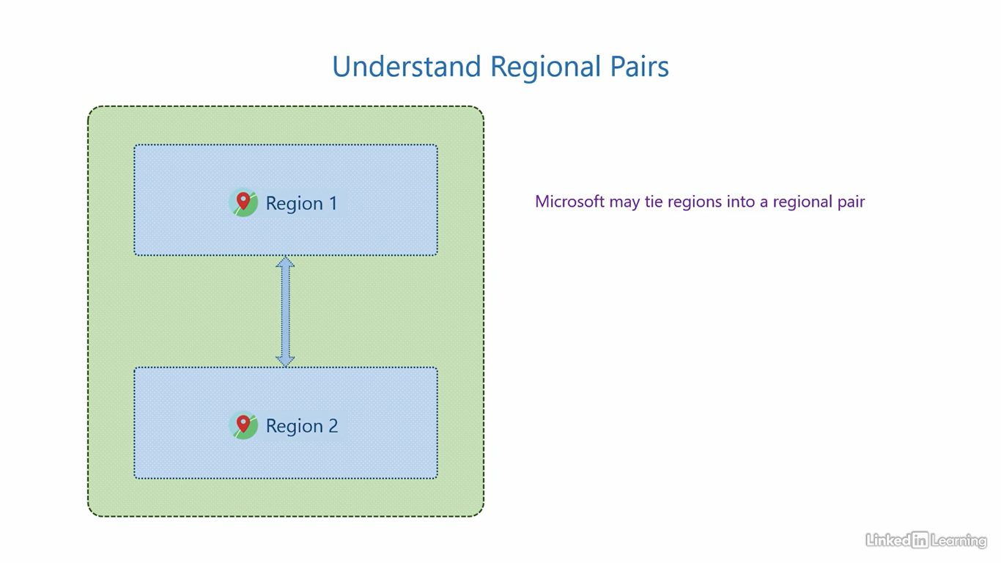

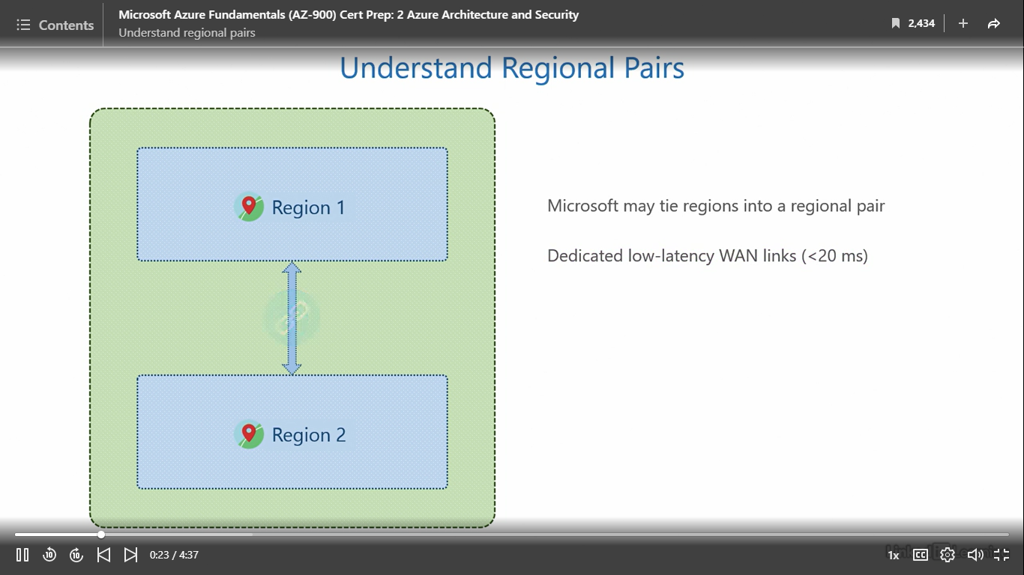

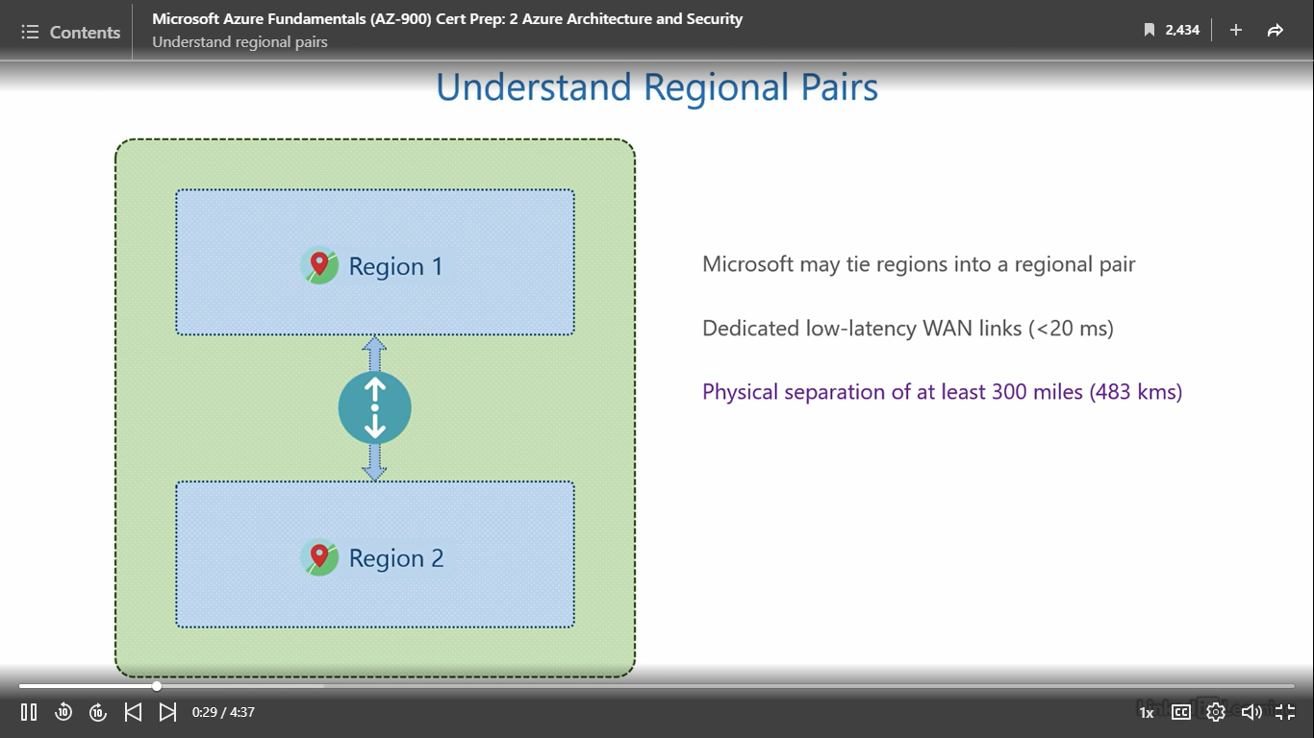

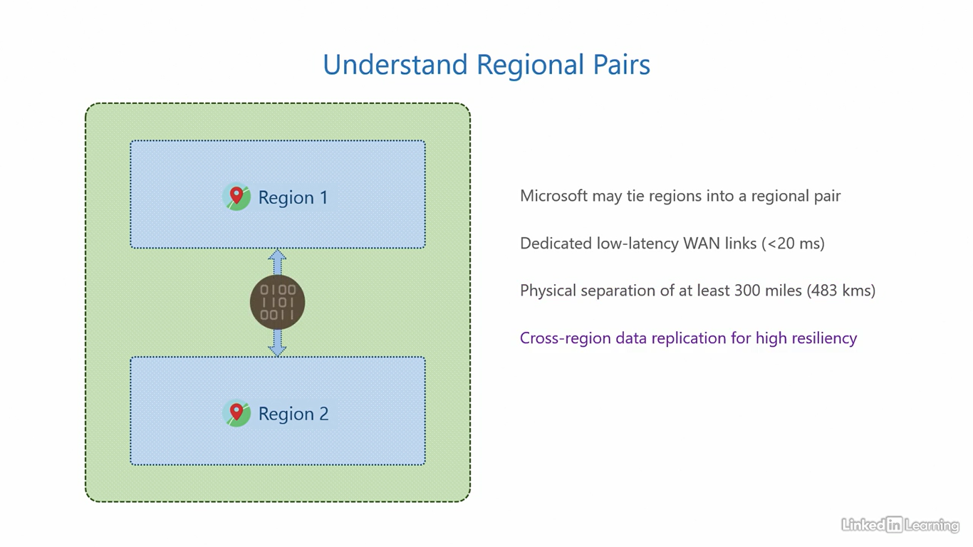

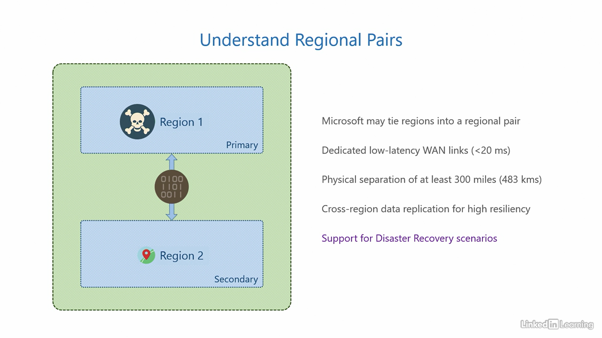

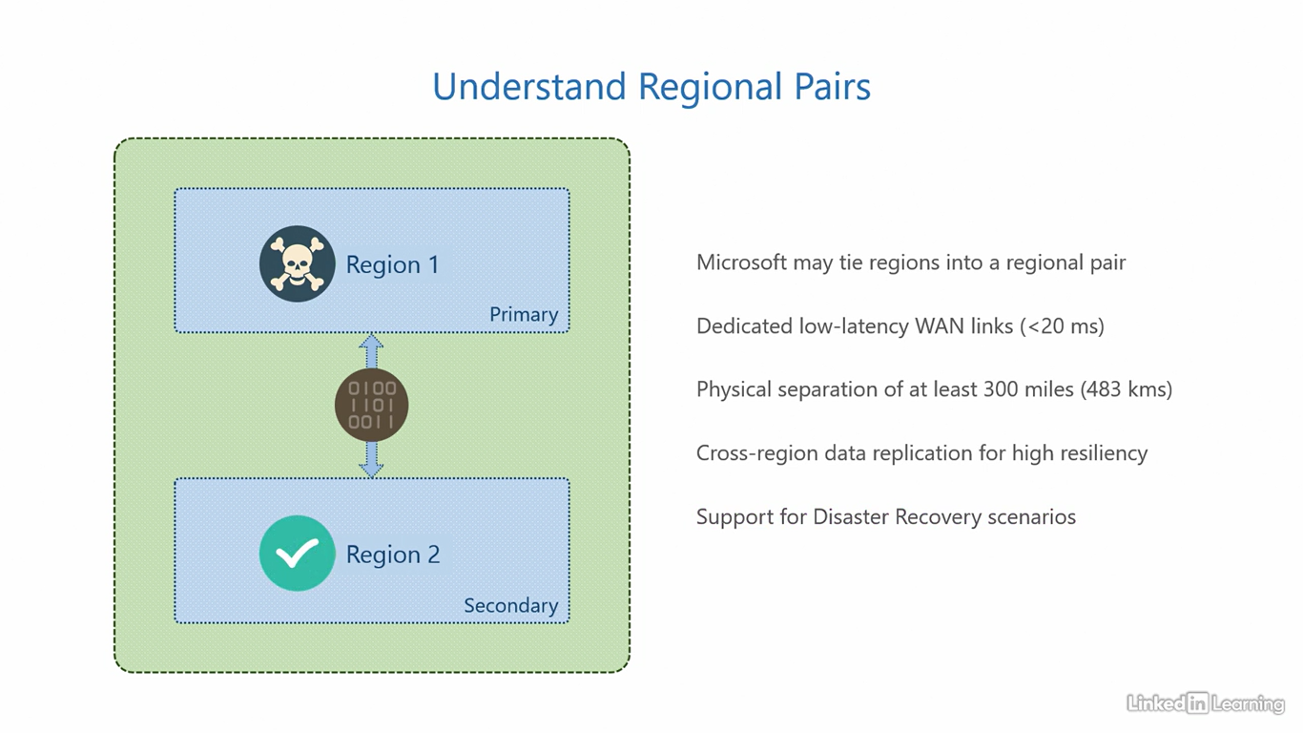

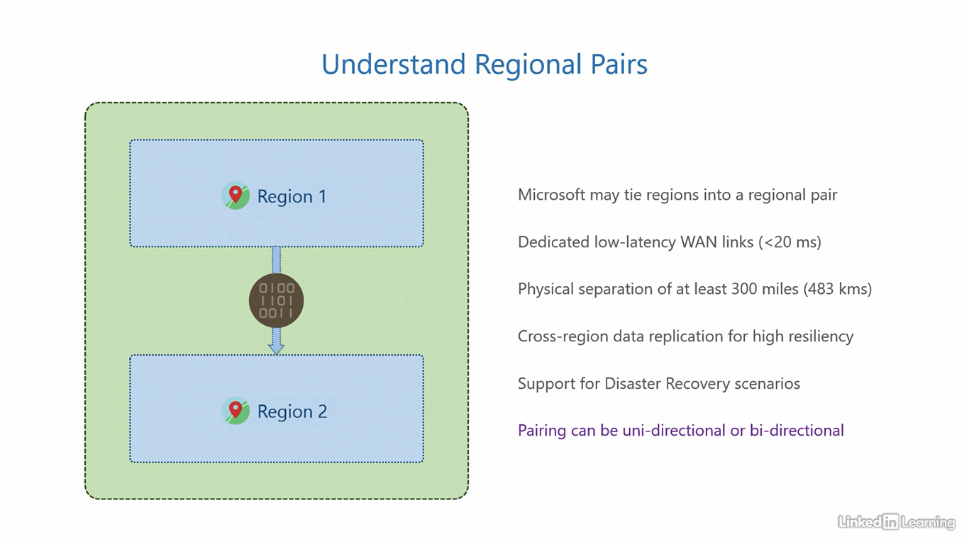

Understand availability zones

[Instructor] Let's talk about availability zones. Availability zones are areas within a region. A quick refresher, geographies contain regions, and regions contain availability zones. These availability zones are connected through dedicated high-performance networks, with a round trip latency of less than two milliseconds. And the physical separation between them is around 75 miles or 120 kilometers. This is another point where customers have a call to action. Customers have the option of choosing either zonal or zone redundant replication of data. You're probably thinking, what that means? Zonal replication is when data is replicated within a single availability zone. So zone local is zonal. In this type of replication, the data is confined to one availability zone. There is redundancy, but only within that specified AZ. In zone redundant replication, the data is replicated across availability zones. Customers can choose zonal replication for low priority services, and zone redundant replication for higher priority services. Because of the stronger data resiliency it offers. The logic behind the high speed networking and the physical separation is the same. Providing support for high availability against local failures, including natural calamities like earthquakes, flooding, fire, or anything that can potentially destroy an area or a zone. So through replication, if one availability zone goes down you still have the other ones that can protect your data. An availability zone subsequently contains one or more data centers. Let's go back to the infrastructure map, and see what we can find about availability zones. The role of availability zones is to provide redundancy in a region. If the number of availability zones is less than three, you can only choose zonal replication. That is replication of data within a single zone. If the number of availability zones is three or greater, then you can choose zone redundant replication of data, that is, replication of data across zones. Let's see if we can find the exact number of availability zones in a region and use that information to determine, what type of replication we can choose in various regions. To do that, we'll go to the US geography and then to the East US region. You can see here it says, this region is available with three zones, three availability zones. This means you can configure, zone redundant replication of data in this region. Next, let's go to the East US 2 region. It's the same here with three availability zones. That means you get zone redundant replication. Let's close out of this geography. Zoom out. And head to the India geography. Click on the Central India region. It is the same here as well, with three availability zones. So we get zone redundant replication. Now let's see what happens in the South India region. Under availability zones here, it does not mention three zones. It says the nearest region with three zones is the central India region. This essentially means there are fewer than three availability zones in this region. Central has three, but this has less than three. Microsoft does not publish a precise number. So in this region, you'll only be able to configure, zonal replication of data, not zone redundant. From the perspective of application design, and data redundancy, it is important to know if a region is availability zone enabled or not.

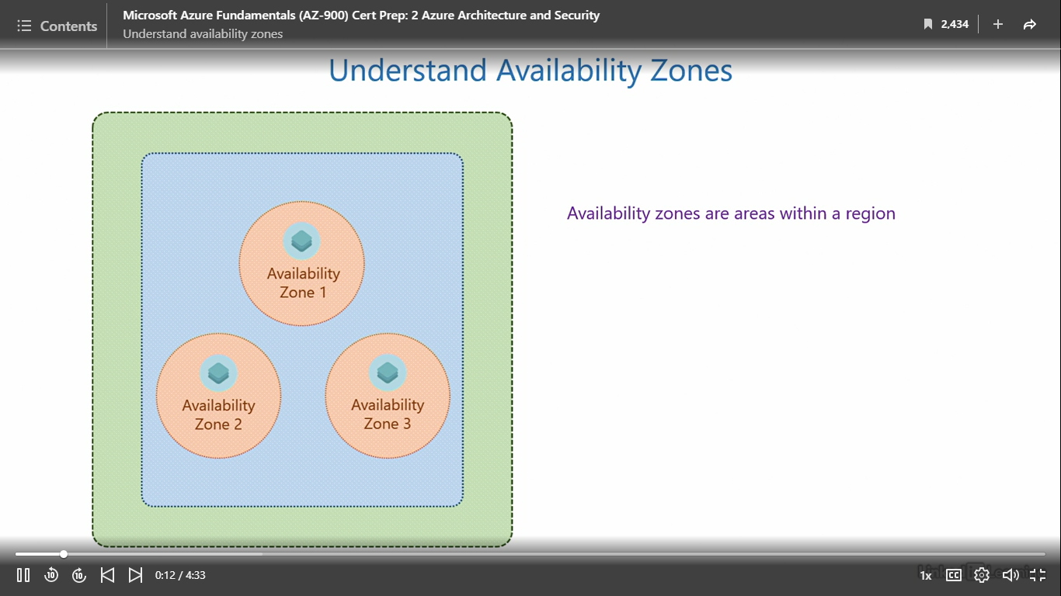

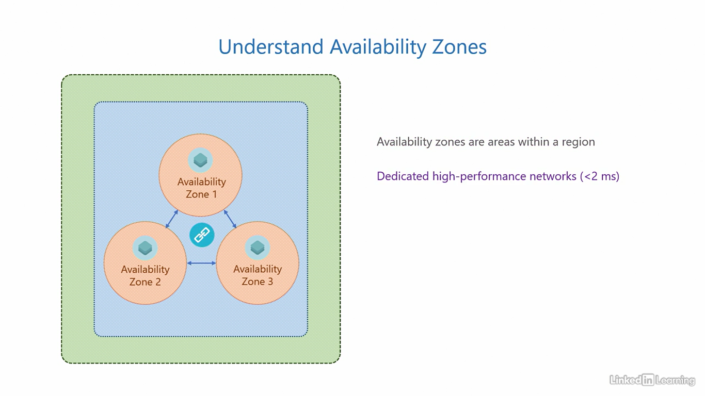

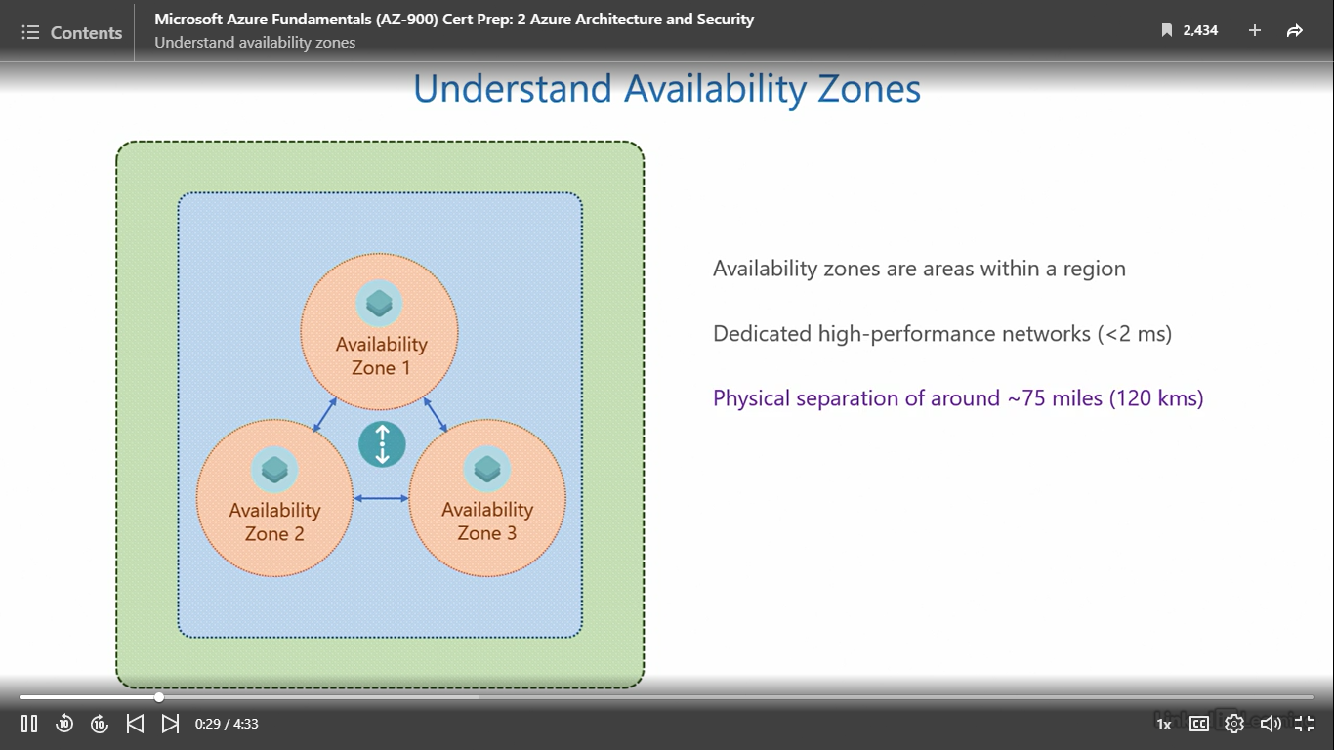

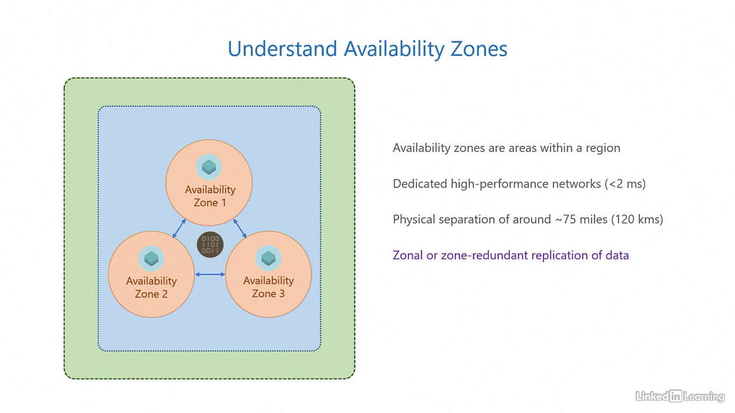

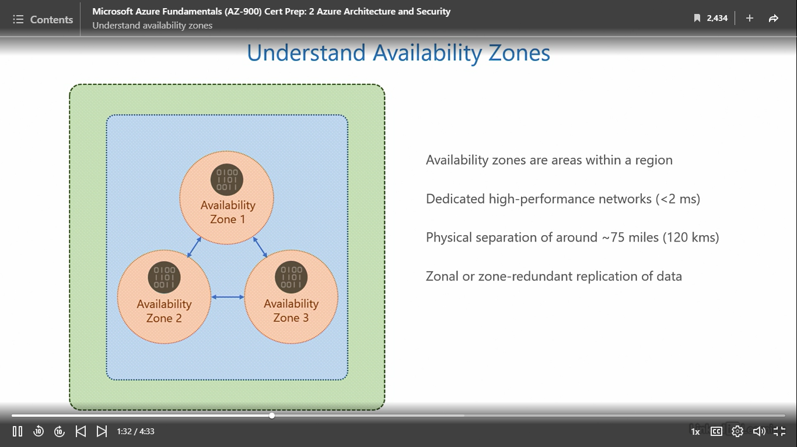

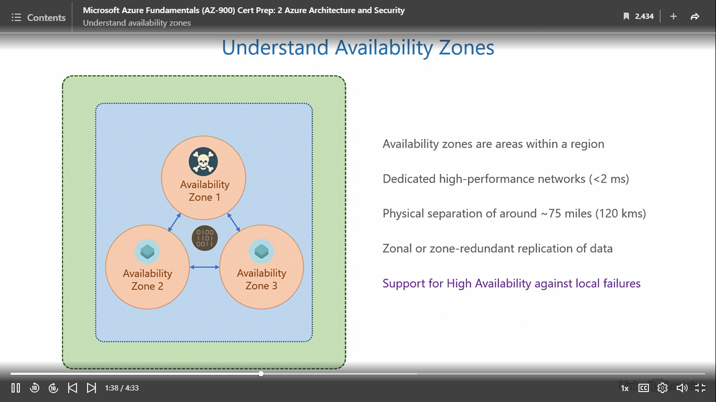

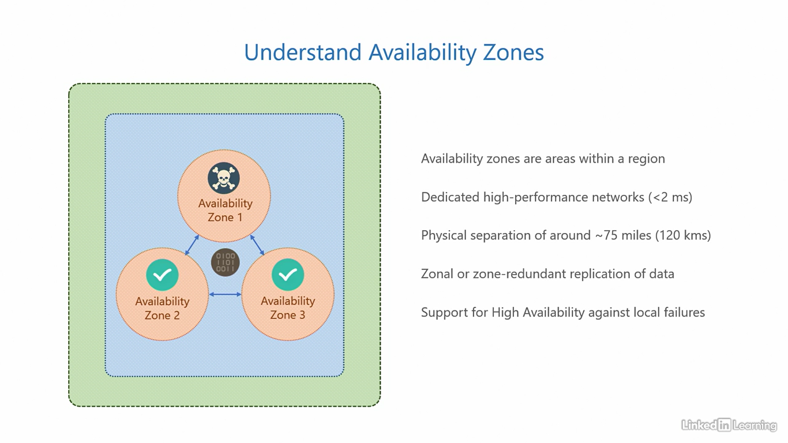

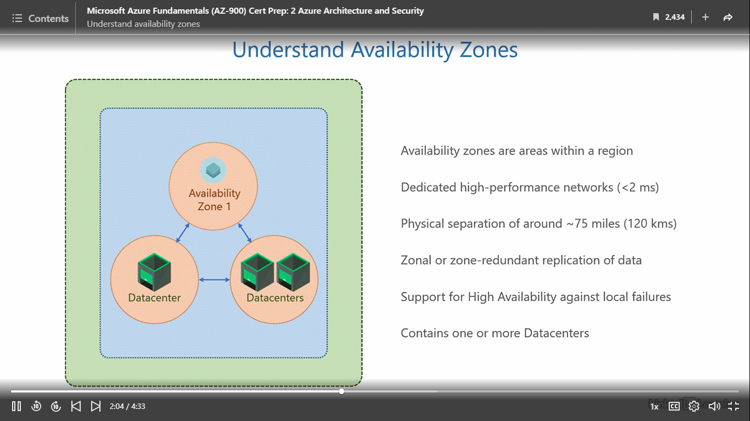

Understand data centers

[Instructor] Datacenters are the last link in the chain of components in an Azure architecture. An Azure datacenter is a physical building in an availability zone. This is where the servers that run and process your services, applications, and data are stored. Microsoft picks the location for its datacenters after a thorough scrutiny of the land. They assess the location for risk of all possible natural calamities and then zero in on a location. This means they don't just depend on procedures to deal with disasters, they try to avoid them altogether in the first place. In addition to the servers, datacenters also house tons of enterprise storage, networking, and firewall equipment. Here's an interesting fact. Any piece of data you store in the cloud, Microsoft locally stores a total of three copies for it. You only pay for one copy, and Microsoft keeps two backups of it so that you never lose your data. When customers specifically request extra redundancy in addition to these three local copies, more copies of the data can be created across availability zones. So at any given time, there can be anywhere from three to six or seven copies of your data. That's a phenomenal amount of redundancy. The enterprise storage and networking infrastructure are designed from the ground up to handle such demanding redundancy and throughput. This computing infrastructure is supported by redundant power, cooling, and internet connections. They all must be redundant because a failure in any one of them can bring down the whole datacenter and there are physical security controls loaded throughout the datacenter: thick concrete walls, cameras, biometrics, key cards, security personnel, and all of that. I've heard that even the approach road to the datacenter isn't straight. It's zigzag with sharp turns so that no one can plow a speeding vehicle right into the datacenter. We could do a whole course on datacenter design, but for now, this is what we need to know. Finally, despite all the advanced technology, Microsoft strives to keep their power usage effectiveness and water usage effectiveness numbers as close to one as possible. The higher the number, the less efficient and less environment-friendly the datacenter is. One is ideal. Azure datacenters are currently at 1.12, and Microsoft is working on lowering that number even further. This is important for sustainability, making sure we don't do more harm to the planet than we do good for businesses. Let's see if we can find any information on datacenters in the infrastructure map. Let us first go to the US geography and then into the East US region. Scroll down and search if there's any information on datacenters. It looks like there is no information here. I'll close out of this, zoom out, and then head to the India geography. Here, let's click on the Central India region and scroll down. It appears that there is absolutely no information on datacenters here, either. This is not an accident. Microsoft did not forget to add that information. It is by design. For security, Microsoft does not publish any information on its Azure datacenters. And if you think about it, it kind of makes sense. You don't want people randomly showing up at Azure datacenters, let it be people with bad intentions or just geeks like me who would go there to take a thumbs-up selfie with the datacenter in the background. Withholding this information also reinforces the vision of the cloud. The whole intent of cloud is to enable customers to focus on their business, not the underlying layers. The datacenter is a lower layer, which is not something customers should have to think about. It's irrelevant for them. Customers should only be clear on their plan for the region and replication in availability zones. I would highly encourage you to explore this infrastructure map as much as you can in your free time. It'll be immensely helpful in strengthening your foundational knowledge.

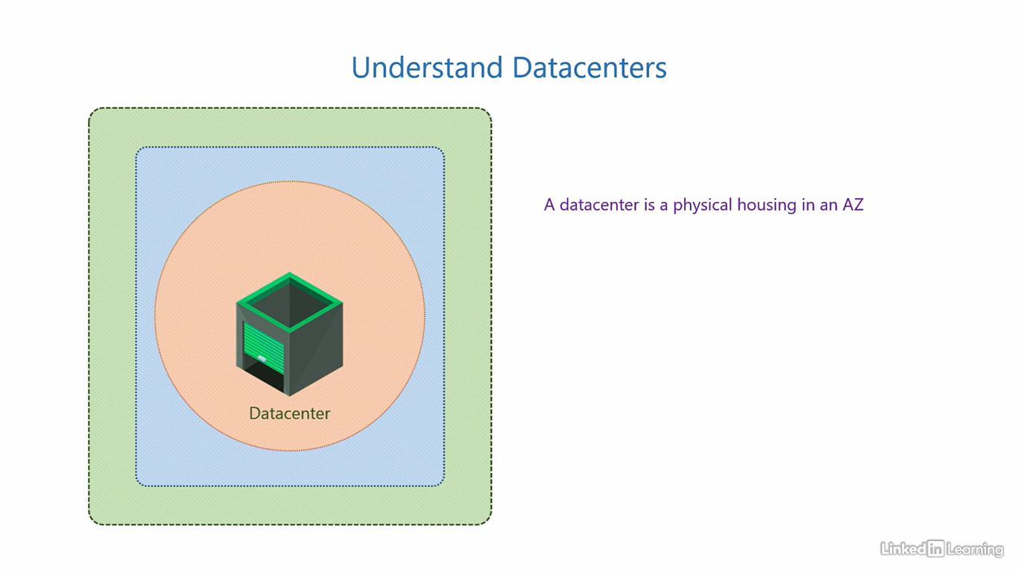

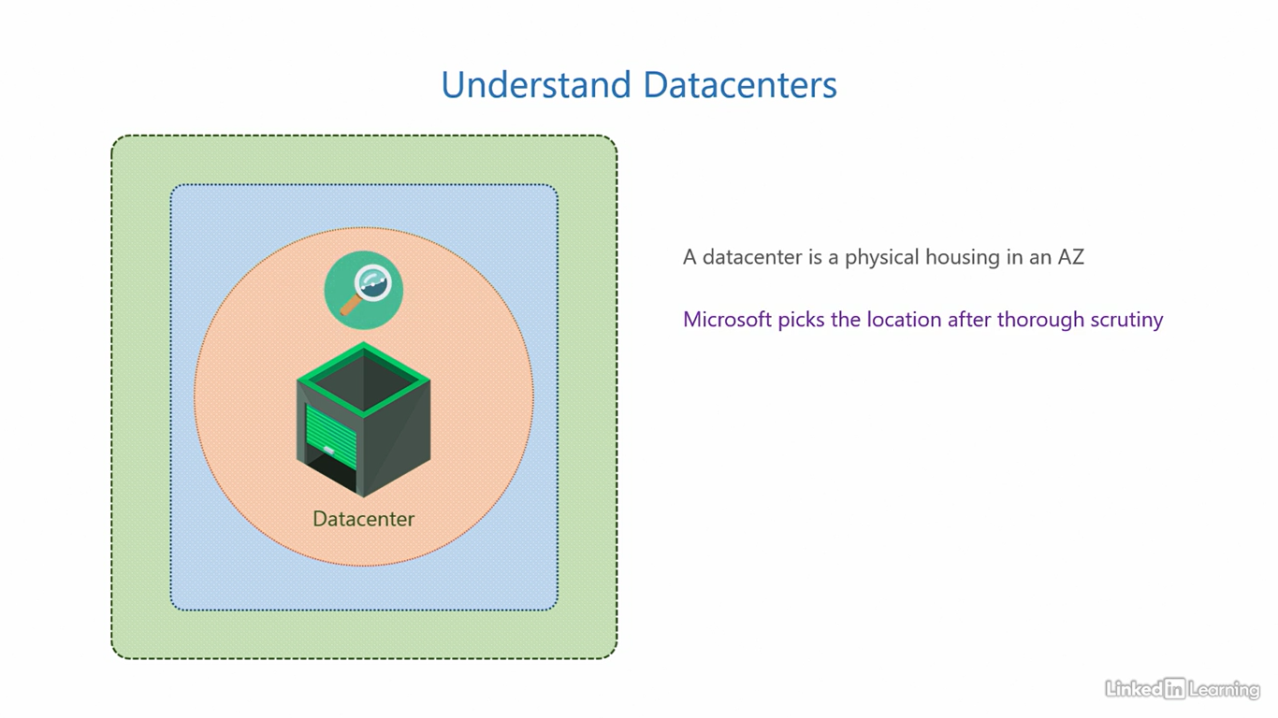

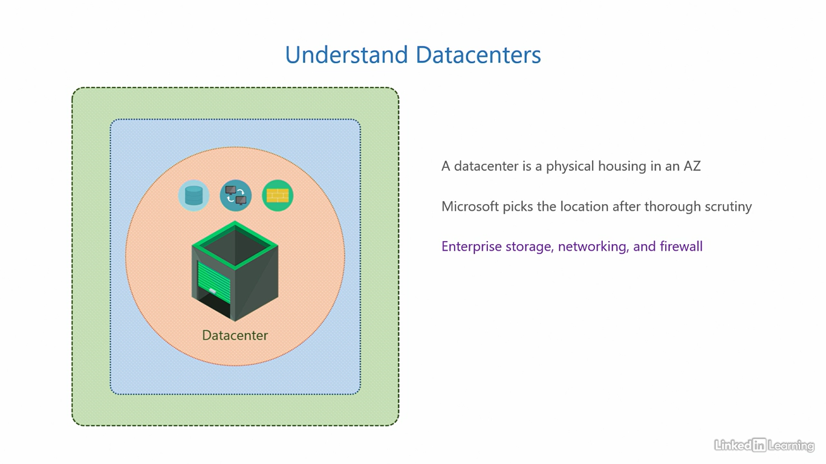

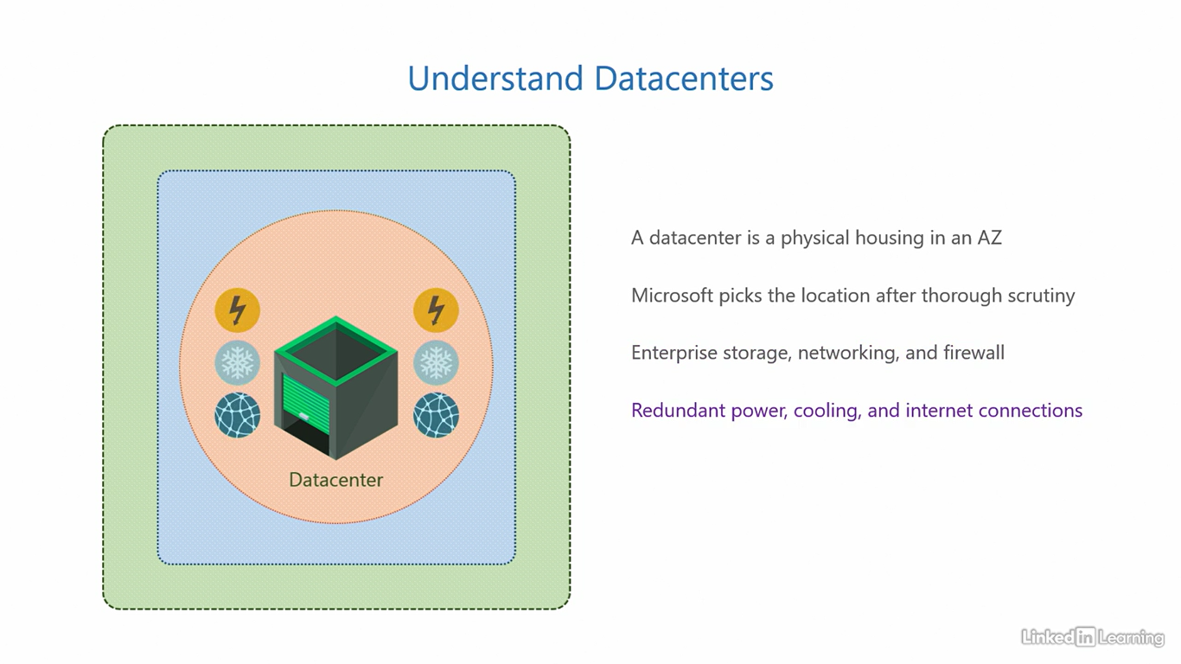

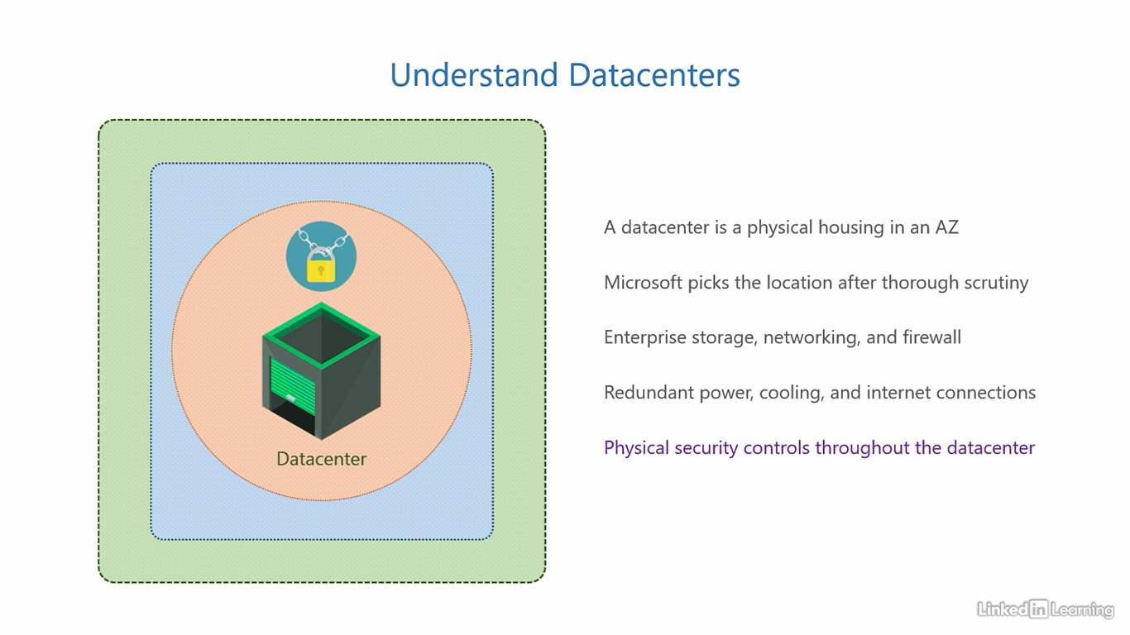

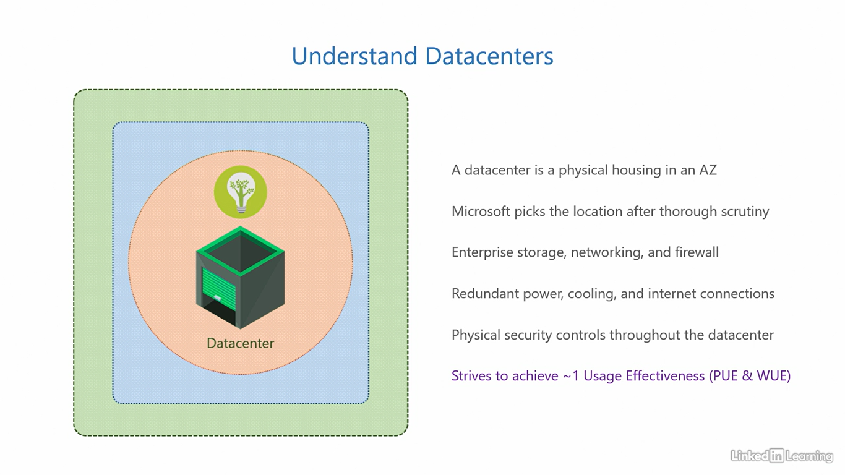

Exam trick #1

[Instructor] That concludes the discussion of Azure's core architectural components and its hierarchy. First, we have a geography, a geography contains regional pairs. Then, regional pairs are composed of regions, regions contain availability zones, and lastly, availability zones contain datacenters. Only two of these require a call to action for customers. Customers need to specify what region they want to deploy their service in and specify if they want zonal or zone-redundant replication. Then, a region is set to be AZ enabled if there are at least three availability zones in that region. I do understand it can be a bit difficult for beginners to correctly remember the order of these components, so I have a trick that will make it very easy for you, it's silly, but it works. Let's take the first letters of all the components in order, G, RP, R, AZ, and D, and convert that to a sentence. Garbage repurposing reaps amazing dollars. I know, it's silly, but it works, and it's a fun way to remember the Azure architecture. If that's not enough, feel free to imagine me holding a garbage bag in one hand and a bundle of dollars in the other. That's garbage repurposing reaps amazing dollars.

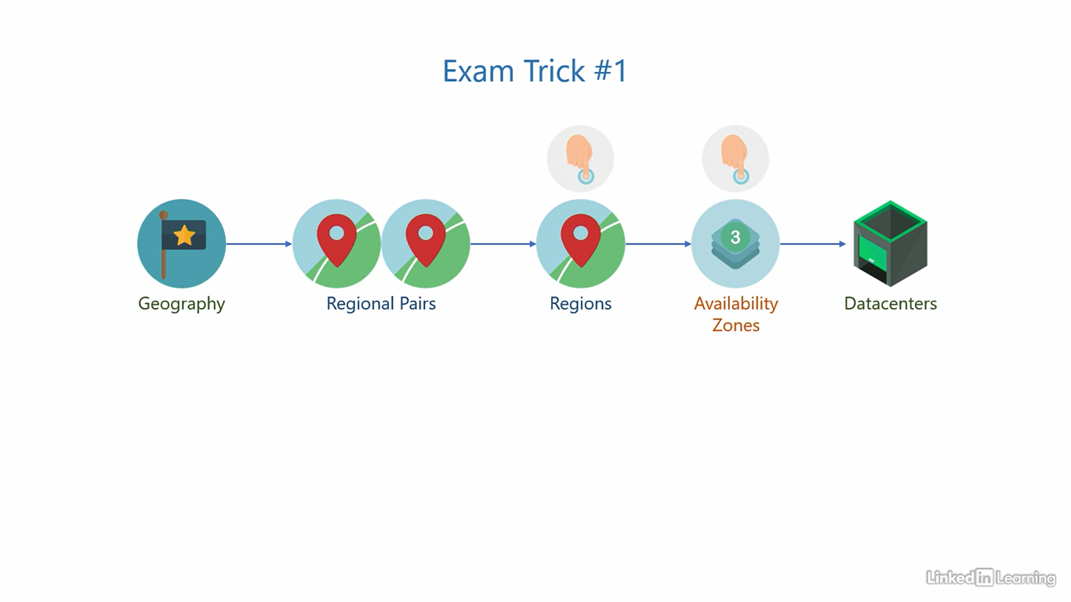

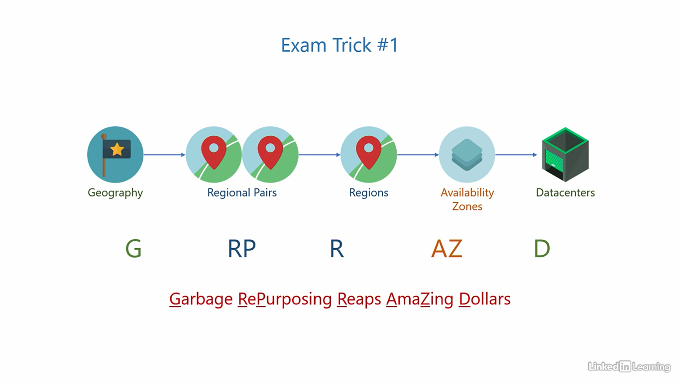

Understand subscriptions

[Kunal] We covered the Azure architecture up to this point. Now, we'll move on to the basic administration hierarchy in Azure, and that journey starts with subscriptions. **A subscription is a unit of consolidated billing.** In general, when you use a service in the cloud, you have to pay for it. A subscription is where the charges for all those services are put together in a single bill and sent to you through email. Imagine a shopping cart in the supermarket. You go around the aisles, put all the items you need in the shopping cart, and at the end, go to the billing counter to pay for whatever is in your cart. A subscription is pretty much the same. It's like the shopping cart, but for the cloud. You deploy whatever services you need to a subscription and then pay for it in a single bill every month. The typical billing cycle is monthly. This is the starting point for all customers who want to take their first step in adopting Azure for their environments. Remember, it all starts with a subscription. You will need an email account and a payment method in order to sign up. A credit card works the best in my experience. Organizations can use one or more subscriptions depending on their need. For most small to medium businesses, one subscription is sufficient, but some organizations may need more than one. As you know, a subscription is a unit of consolidated billing. So when organizations want to segregate billing by departments, offices, or types of workloads, having more subscriptions can be useful. For example, you can have the technical and non-technical teams on separate subscriptions, or the US and India offices on separate subscriptions, or the development and production environments on separate subscriptions. There's no right and wrong answer here. Whatever best suits your need. But typically, larger organizations do this. When you sign up for a subscription, Azure also provisions it's associated assets behind the scenes. A subscription isn't a completely standalone entity. It has dependencies on other resources, and they are provisioned before your subscription is ready to use. We'll get to what those dependencies are shortly. The good news is you can sign up for a free trial that comes with a 200 US dollars credit and a validity of 12 months. This makes it easier for new learners to explore and play around the services without having to worry about the cost. After the trial ends, you can easily convert it to a paid subscription. Let's jump into a demo and see how we sign up for a new subscription. To sign up for an Azure subscription, you will have to go to the URL signup.azure.com. This link should bring you to a page that looks like this. I have already created a Microsoft account that we need to sign up for Azure. Any email ending with @outlook.com, hotmail.com, or live.com is a Microsoft account. You can get any one of those email addresses for free. I will use the email address az900kdm, KDM stands for Kunal D Mehta, @outlook.com to sign up for Azure. I'll enter this email address and click on the Next button. Enter the password for my email account and then click on Sign in. Do I want to stay signed in? Let's say Yes. Once you do that, you should see this page or a similar page. Microsoft keeps tweaking the design every now and then. Fill in this form with your profile details to create an Azure account. Select the country where your company is based. Then, enter your name, middle name, email address, phone number, organization name, and business address. After you fill all of that, you will have to agree to the Microsoft agreement at the bottom of the page and click on the Next button. That will bring you to a page like this. Here, you'll have to verify your identity by adding a payment method. In my experience, credit cards work the best. Enter the cardholder's name, card number, expiry, CVV, and billing address. Finally, click on the Sign up button at the bottom of the screen. If the payment method was successfully set up and everything goes smoothly, you should land on this page, the Quickstart Center in Azure. If you look at the top right corner of the screen, you'll see you are signed in to Azure with the email address you used to sign up for Azure. This page is a confirmation that the signup was successful.

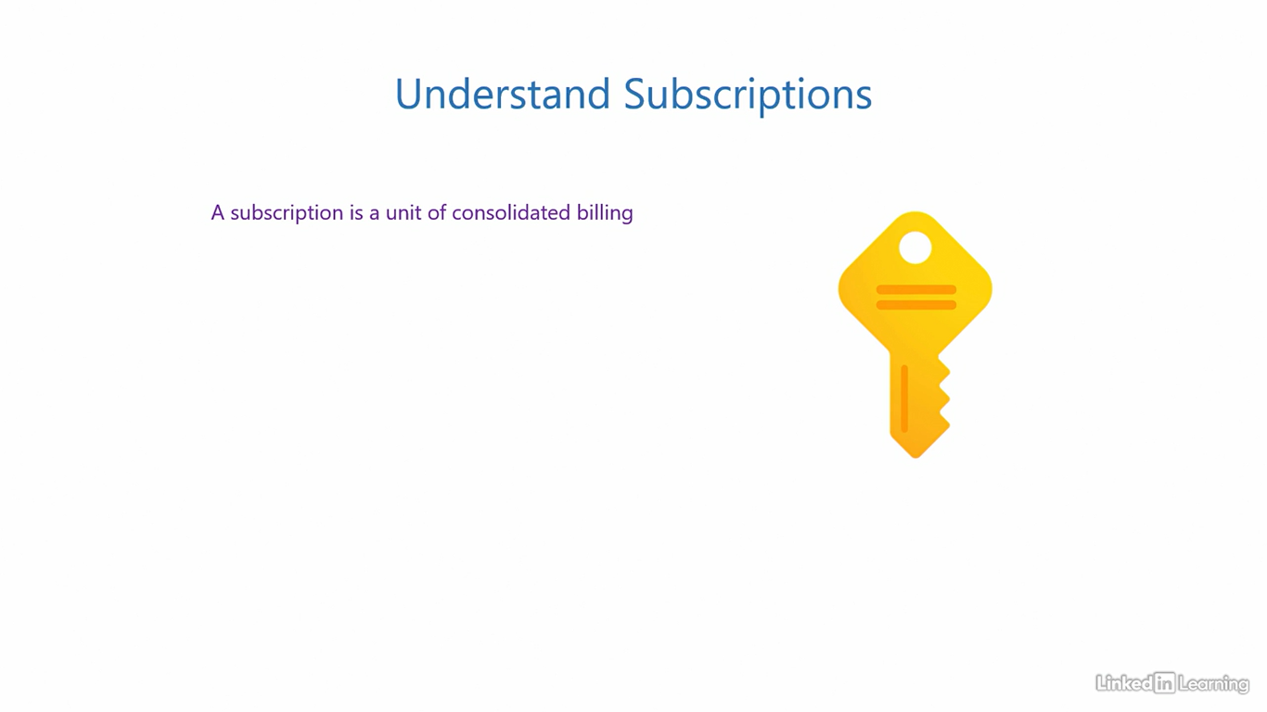

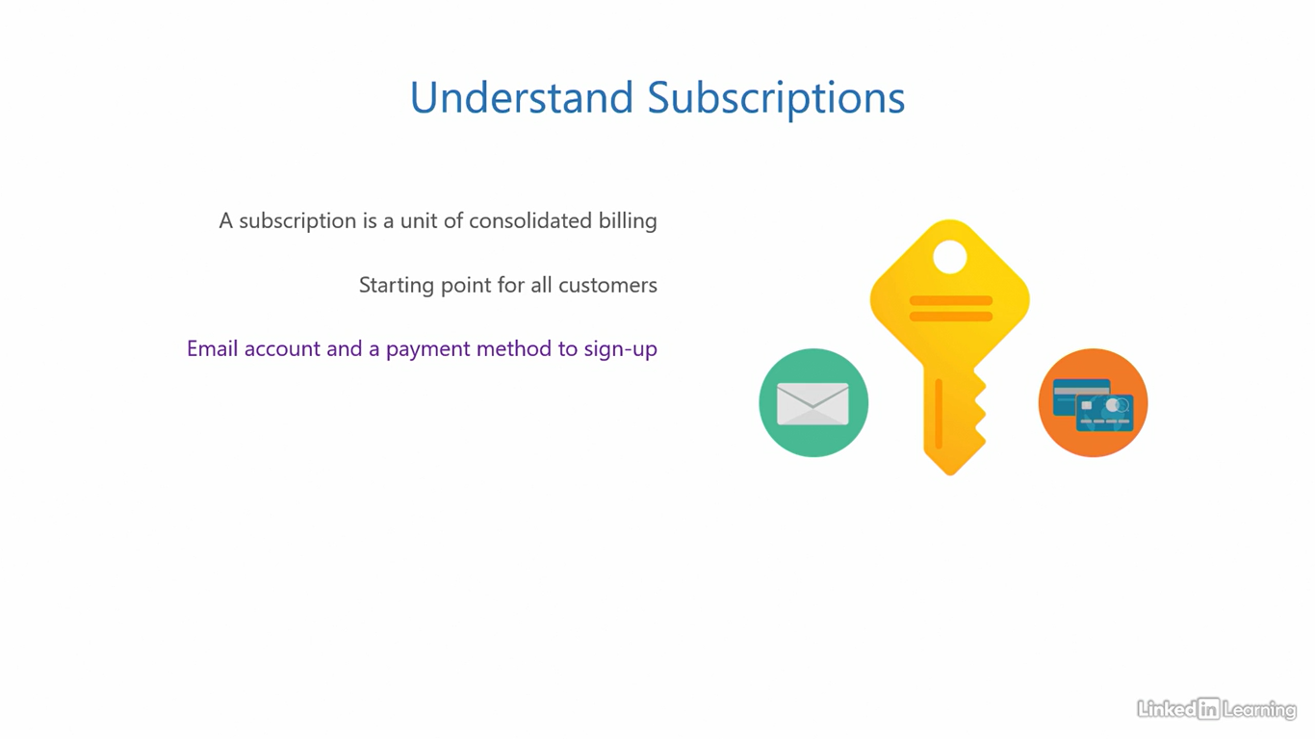

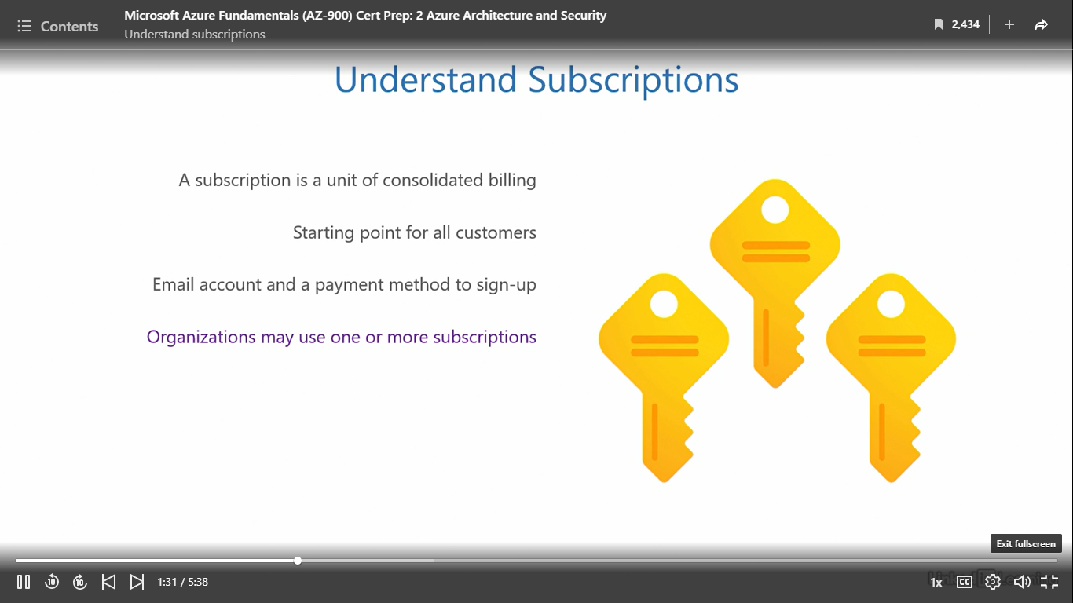

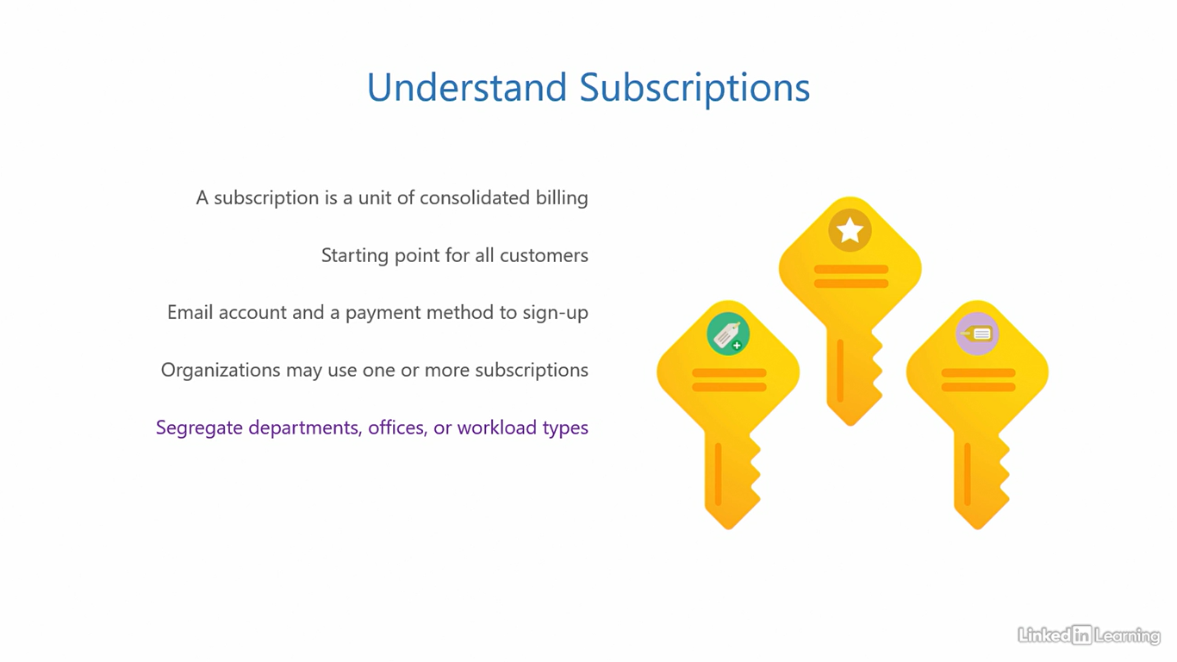

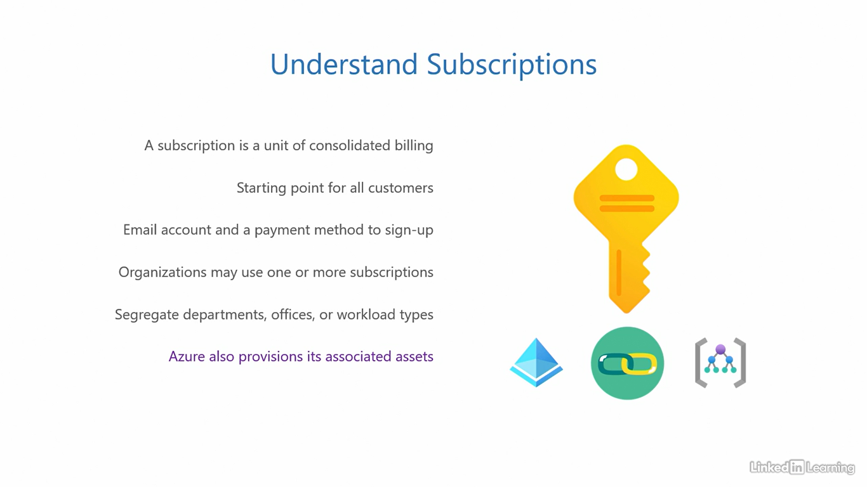

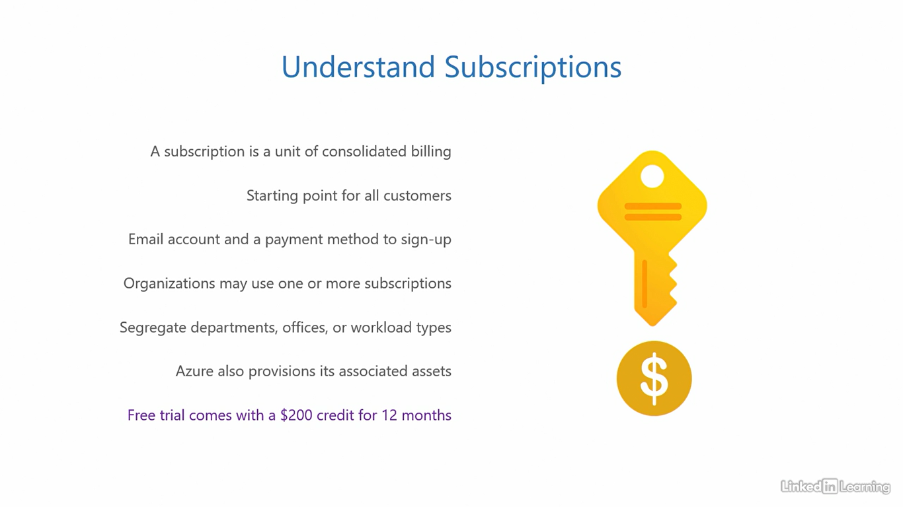

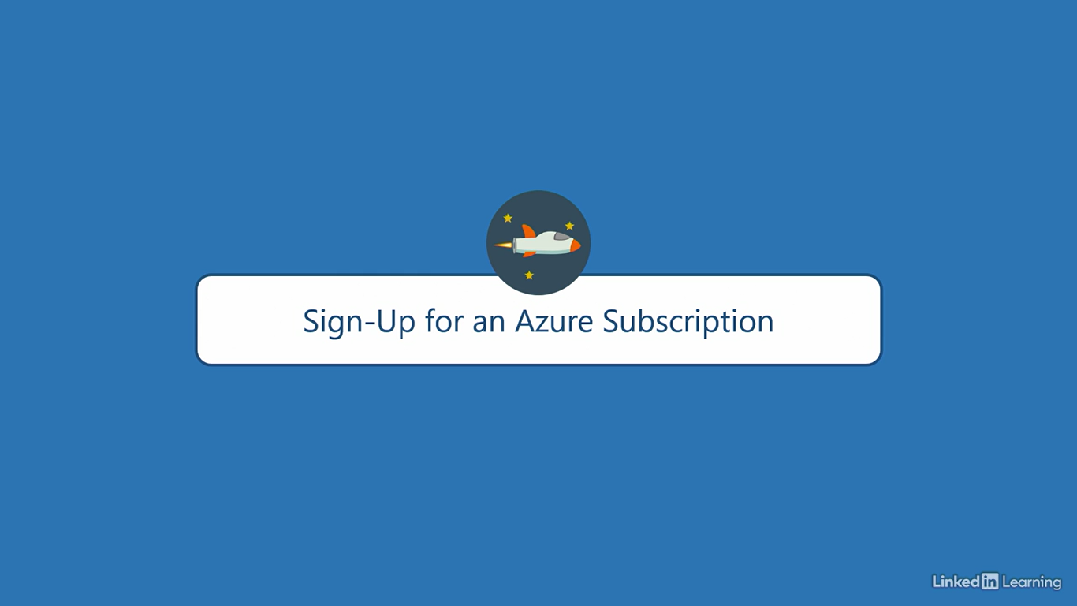

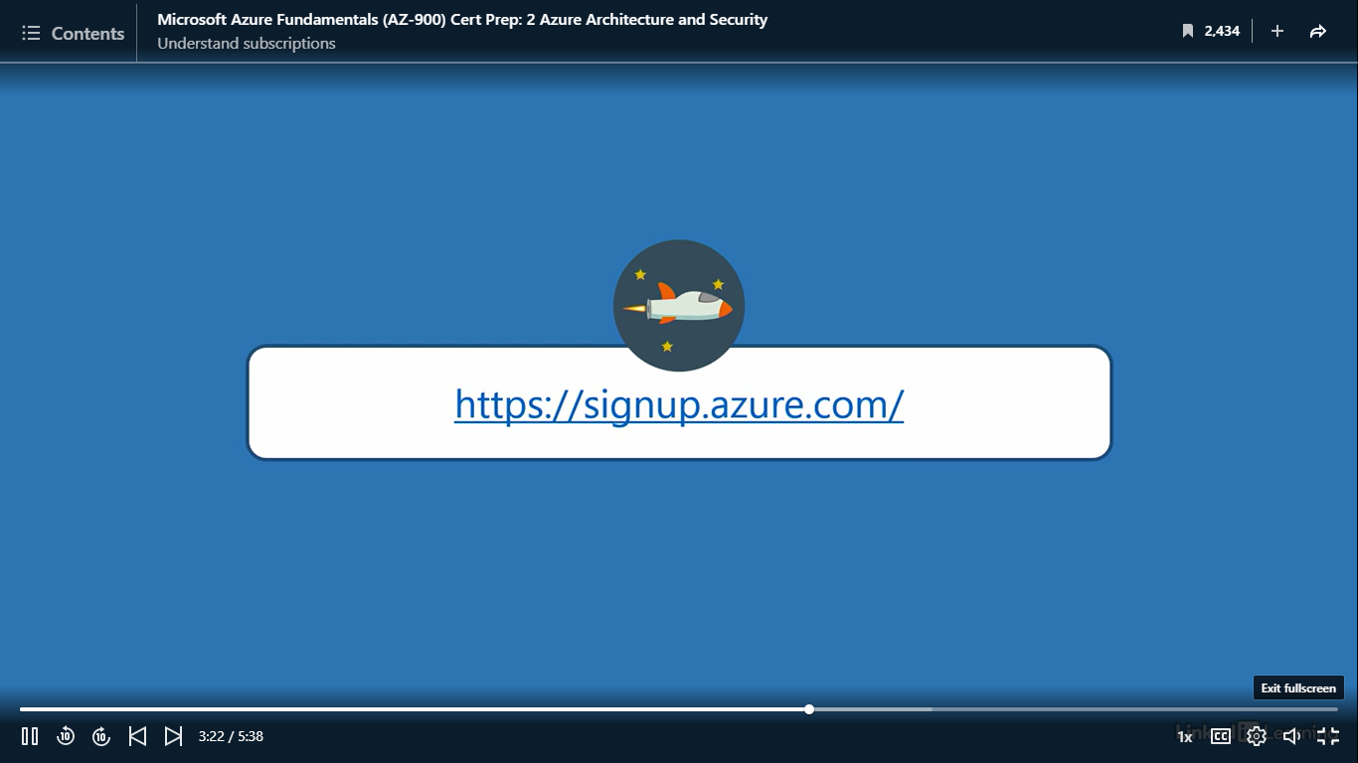

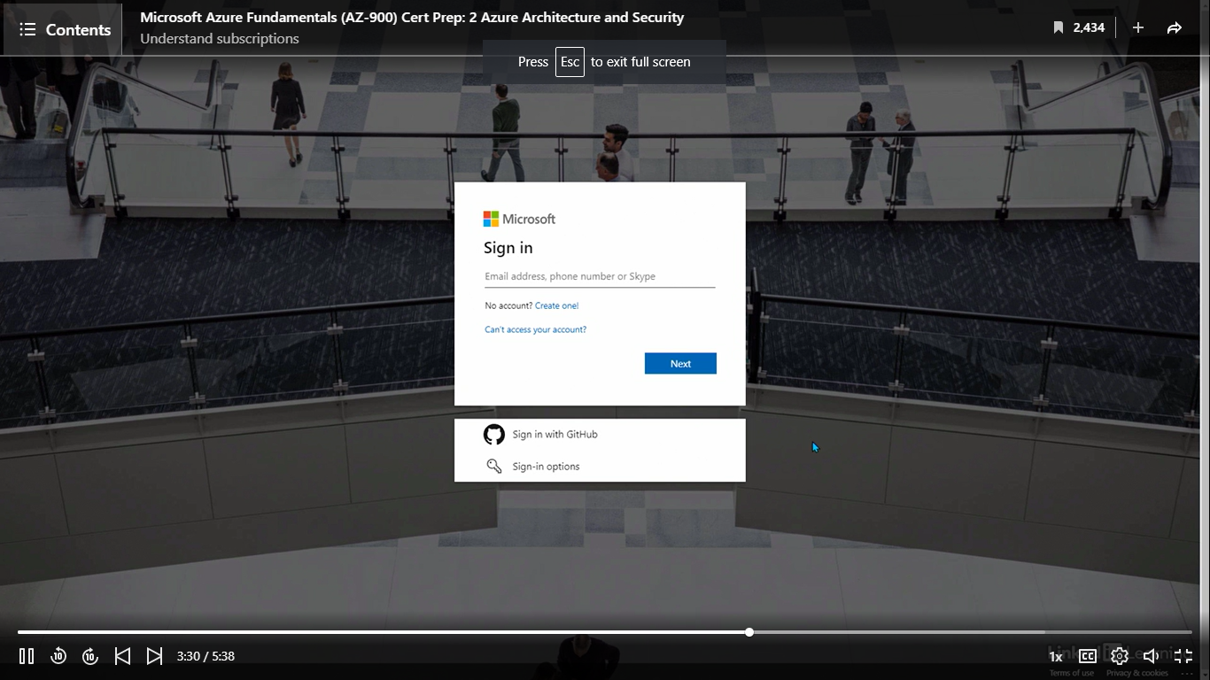

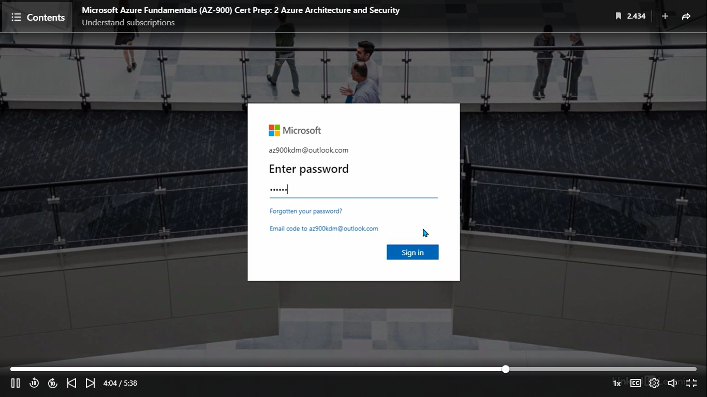

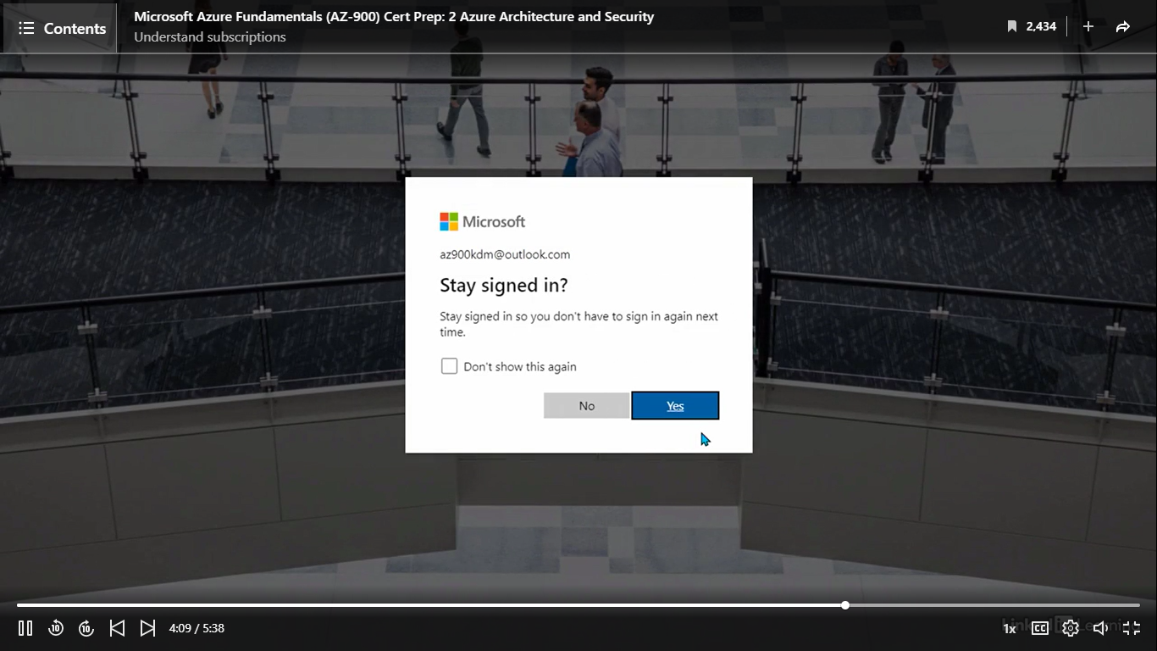

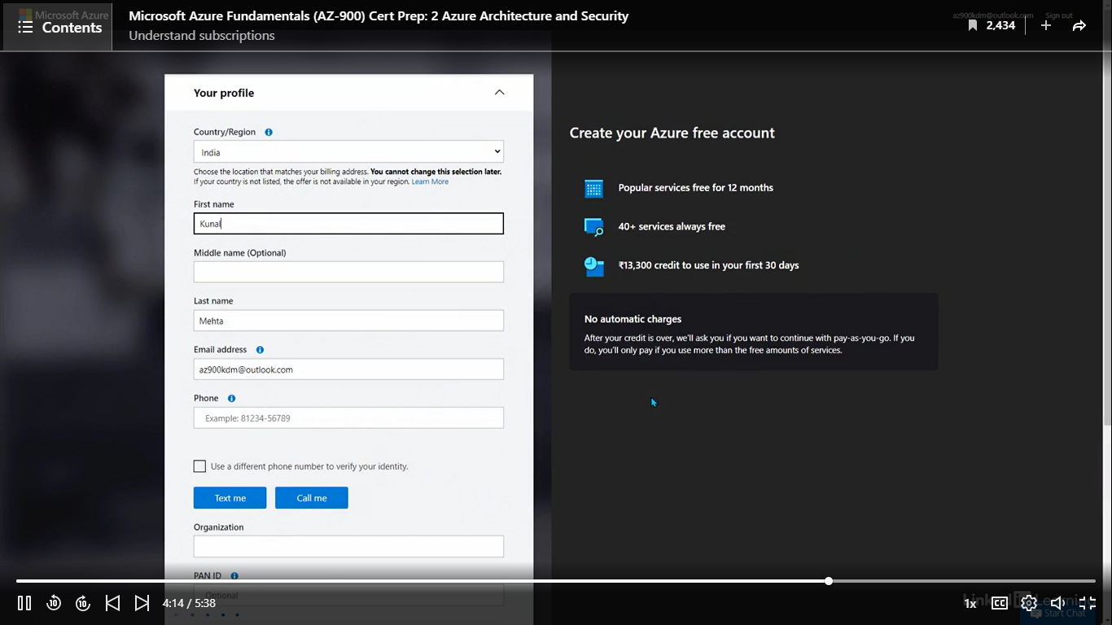

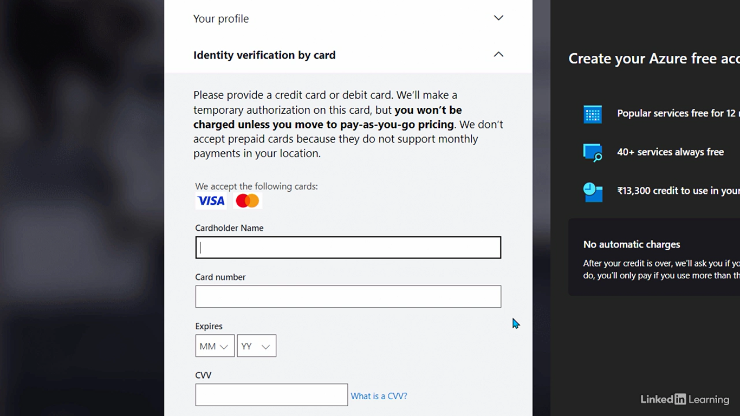

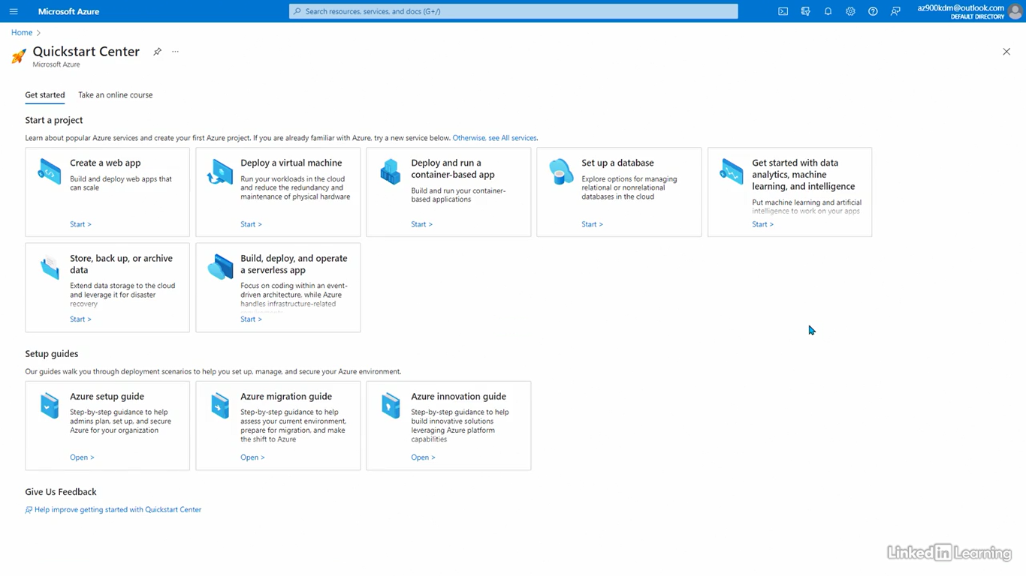

Understand management groups

[Instructor] Next in hierarchy is a management group. A management group manages a subscription. It is one of the associated assets that is created when you sign up for a new subscription. All subscriptions have to be under a management group, because if you remember, a subscription isn't a standalone entity. Back to the shopping cart example. You need a person to push the cart forward. It won't just roll itself, so if the shopping cart is like a subscription, the person pushing it is like the management group. Every cart needs a person and every subscription needs a management group. A group called the Tenant Root Group is provisioned when you sign up for Azure the very first time. When you are creating a new subscription, Azure first creates the root management group which is the Tenant Root Group and then assigns the subscription under it. This group serves as the root for all entities you create from this point forward. Management groups are used to control access, policies, and compliance for subscriptions. When you apply these settings at the management group level, it applies to all services, applications and resources that are under it. This is the topmost level of control. You can either create new subscriptions directly under the root or under new management groups. A new subscription directly under the root would look like this, or the other option would look like this. A new management group under the root and then a new subscription under it. Child management groups like the one you see here inherit settings from their parent management group. Settings trickle down in the tree of management groups. If business needs change, subscriptions can be moved across management groups. You can move this subscription from under the root to the child management group or the opposite. Not just that, child management groups can also be moved or deleted if that is what is needed. You can move one child management group under another child management group along with its subscriptions. There's only one rule. You cannot move or delete the Tenant Root Group. Everything else is mostly possible. If you're feeling a bit overwhelmed with the information, don't worry. With experience, these things will slowly become natural to you and you'll automatically know by instincts when to choose which option. It all depends on the circumstances and the requirements. Let's jump into a demo and see if there's a Tenant Root Group in our subscription. The quick start page that you saw in the last demo only comes after you sign up for Azure. All further configuration in Azure is done using the Azure Portal. You can open this by visiting the URL portal.azure.com. Once you successfully sign in using your credentials, you'll land on this homepage. In the interest of full disclosure, I want to mention there are two configuration changes I've made off the screen before this demo. One, I've applied the dark mode theme to the Azure Portal and two, I've changed a small setting to unhide the root management group, which is hidden by default. I have added a document with the exact steps for both changes in the exercise files, just so you don't feel like you're missing anything. You can go through them after you complete the course. To view the Tenant Root Group, I'll click on the management group's icon over here. If this icon is not present in your Azure Portal, you can always use the search bar on top of the screen and type management groups in it. Clicking the icon brings us to this overview page for management groups. This is the Tenant Root Group, the group that is created when you sign up for your Azure subscription. And right below it, this is the subscription itself. The name of my subscription is Pay-As-You-Go. This is a default name. If you sign up for a free trial, you may see the name free trial written here. Either way, it doesn't matter because you can always change the name of the subscription to something that's more meaningful to you. If I click on this ellipses next to the Tenant Root Group, you can see the operations I can perform on it. Note how the move and delete options are disabled because you cannot move or delete the root group. If it was any other management group, these options will be enabled. Apart from that, you can either create a child management group or a subscription directly under this root management group. If I click on the ellipses next to Pay-As-You-Go, I have the option to move this subscription under another management group if one was available. Alternatively, I can also use the buttons on top of the page to create new management groups or add new subscriptions.

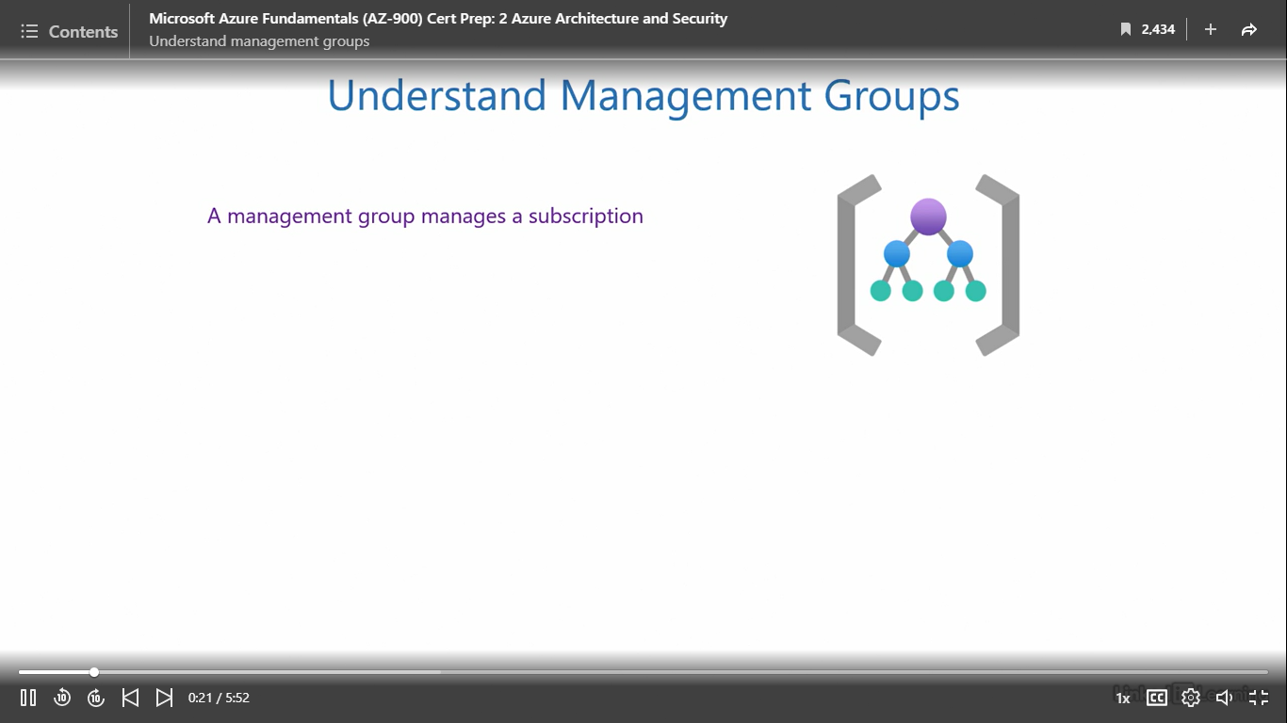

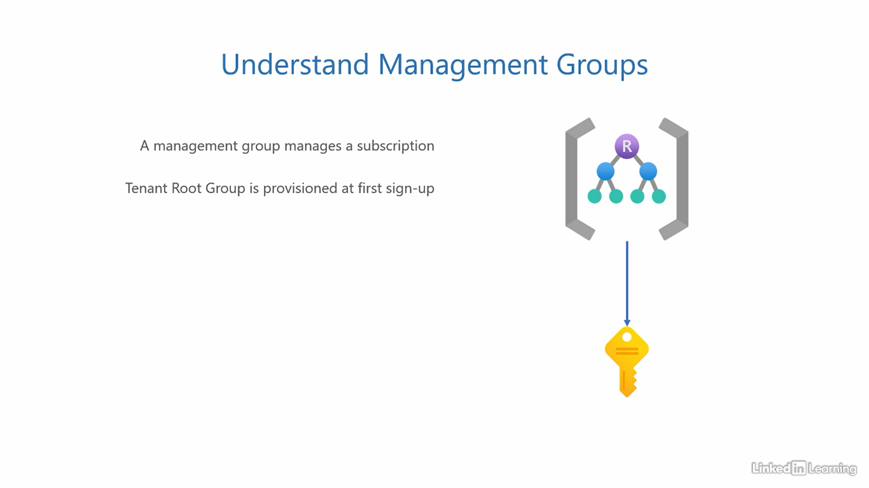

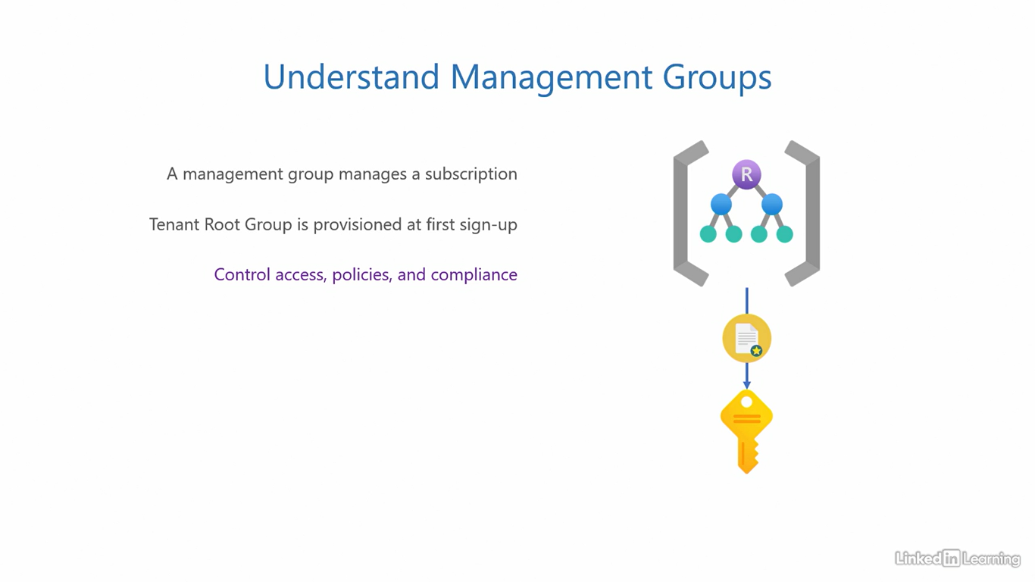

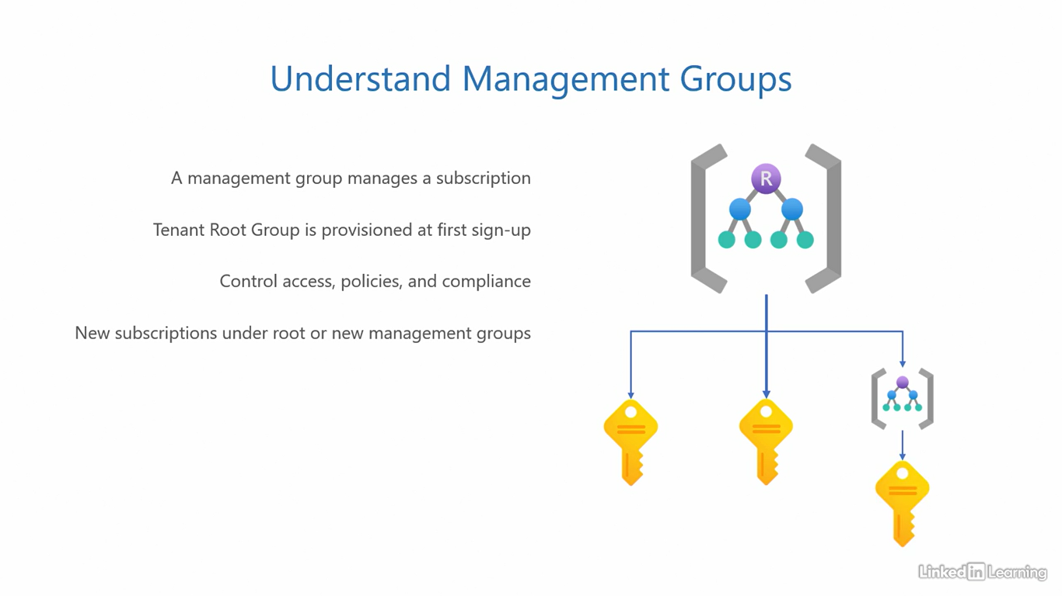

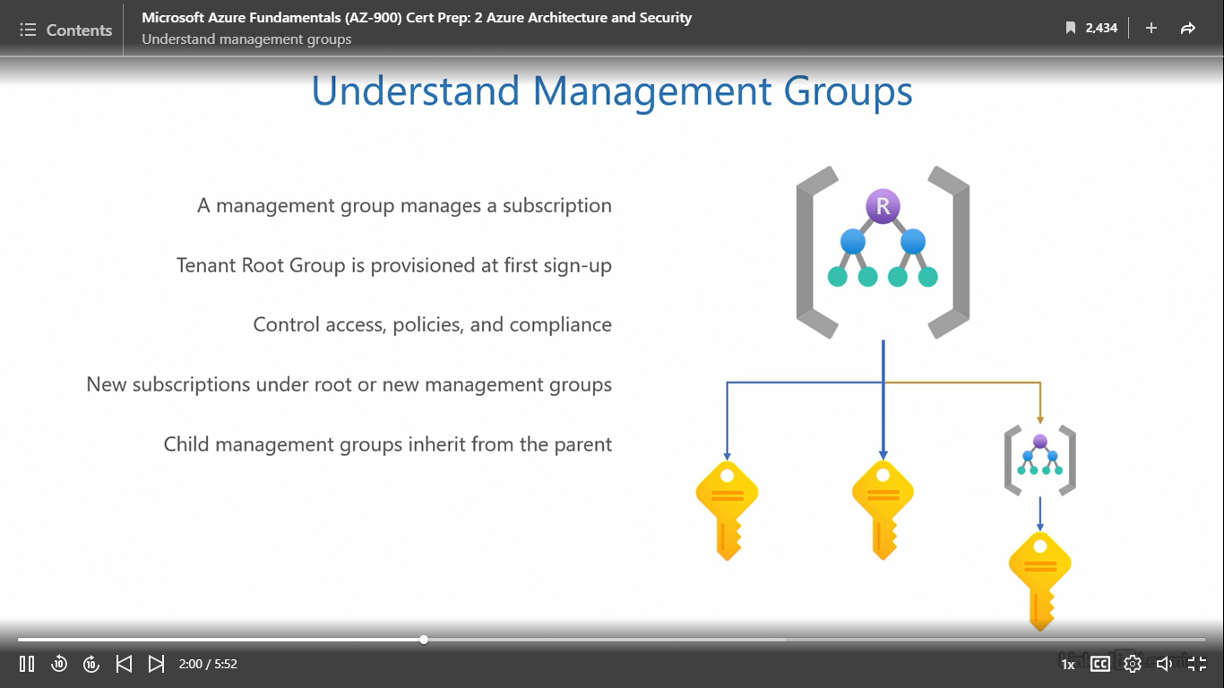

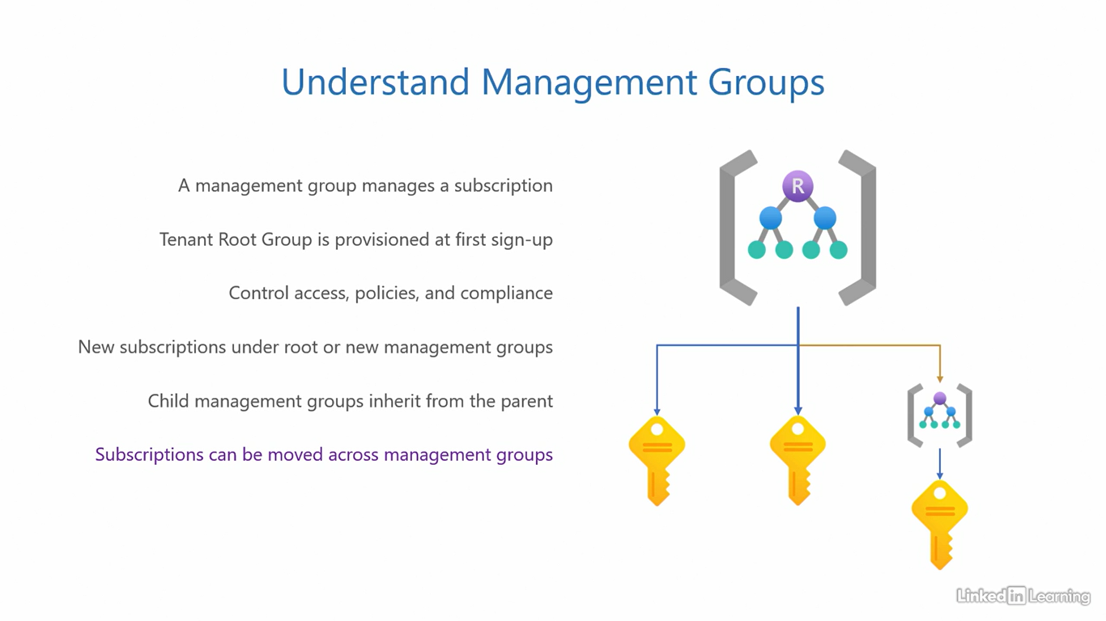

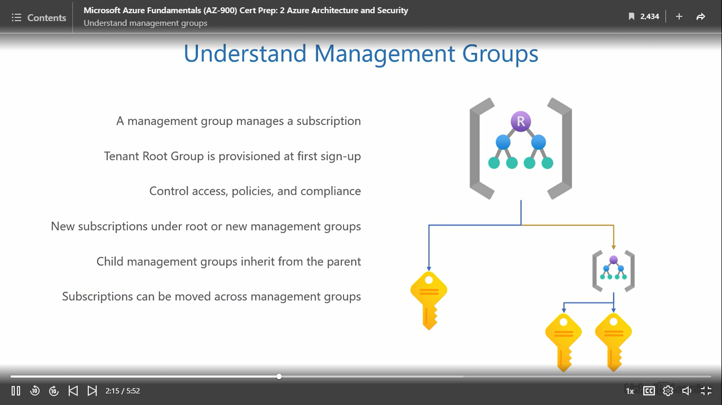

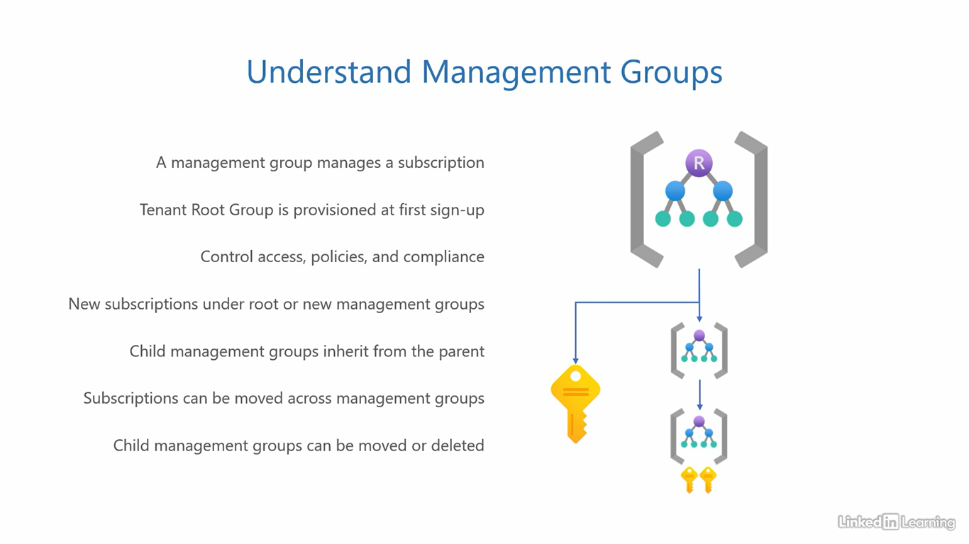

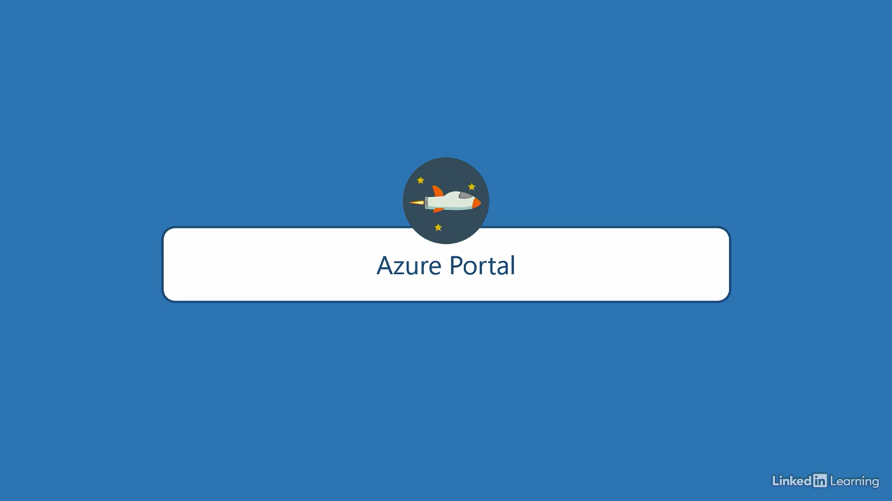

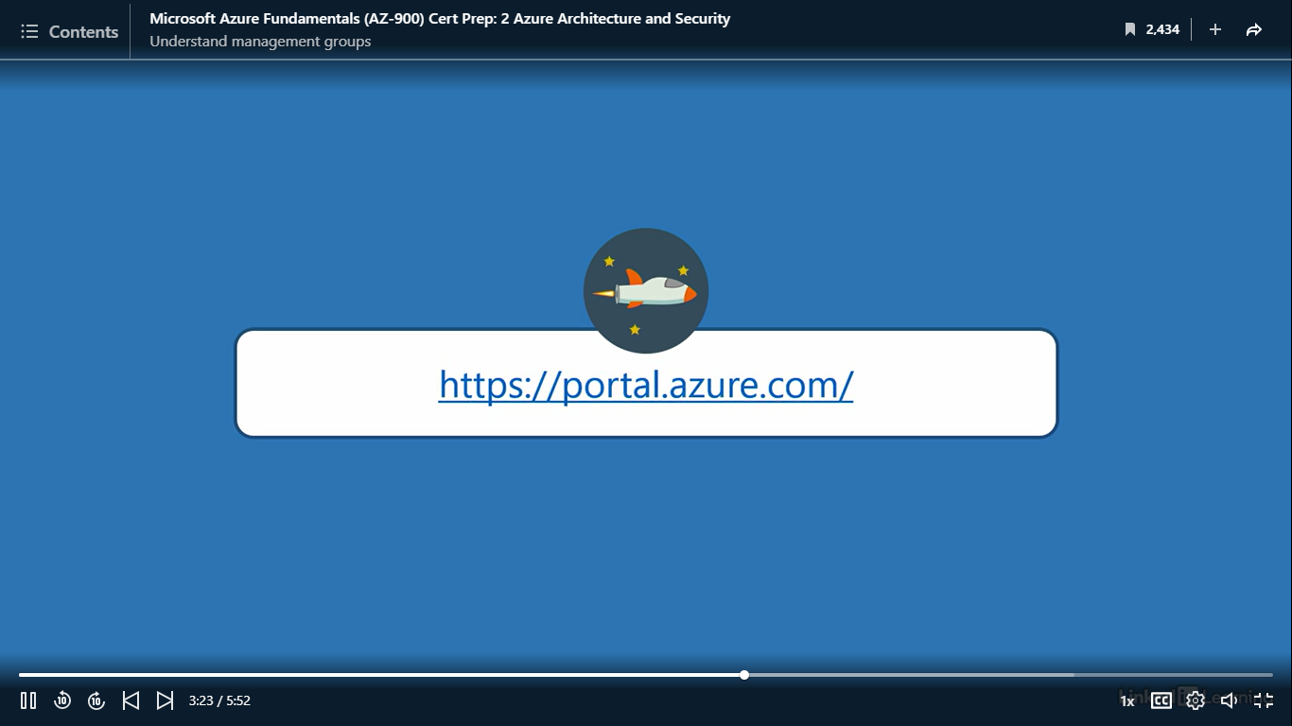

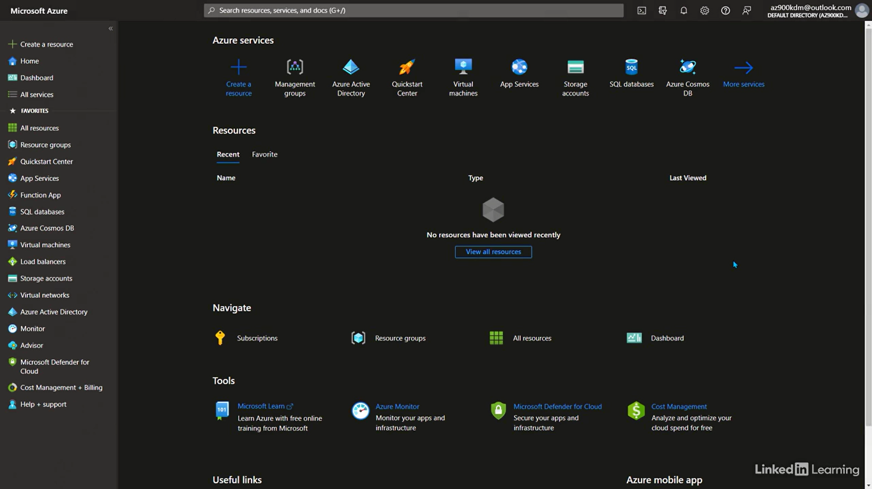

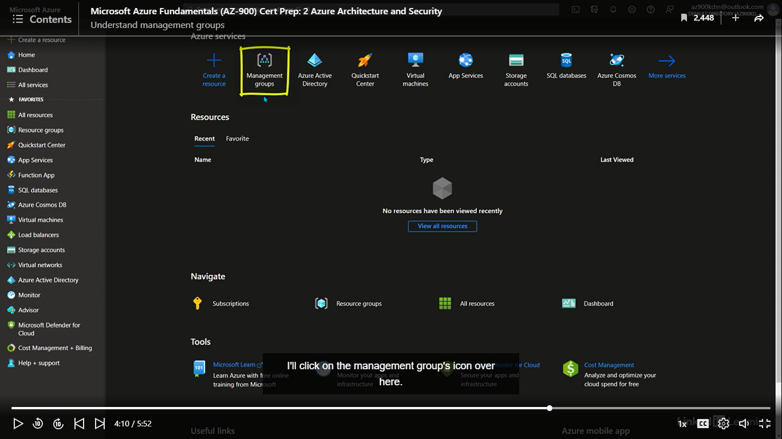

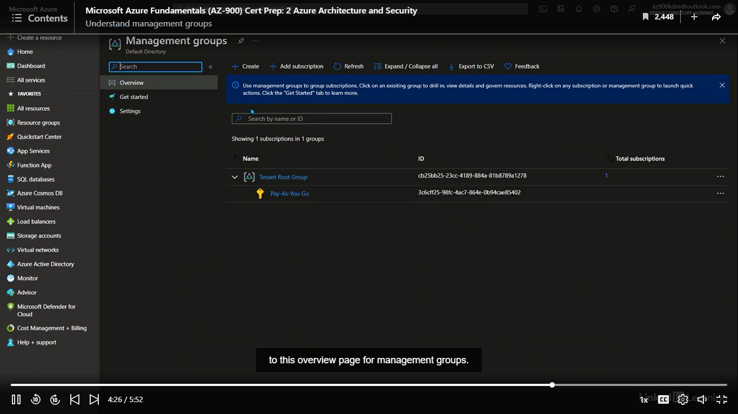

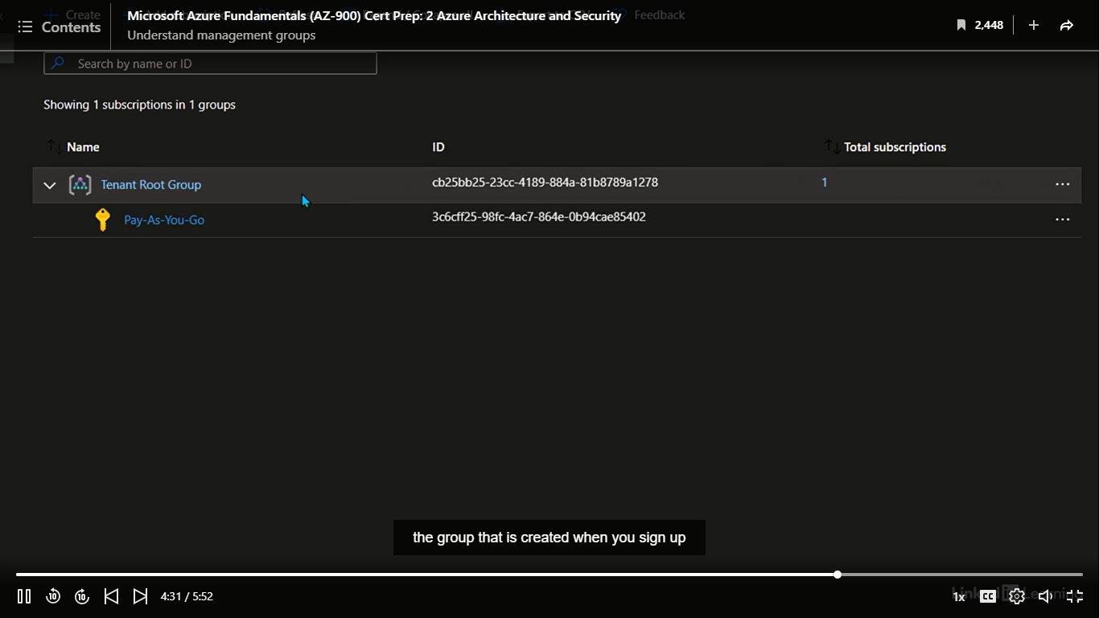

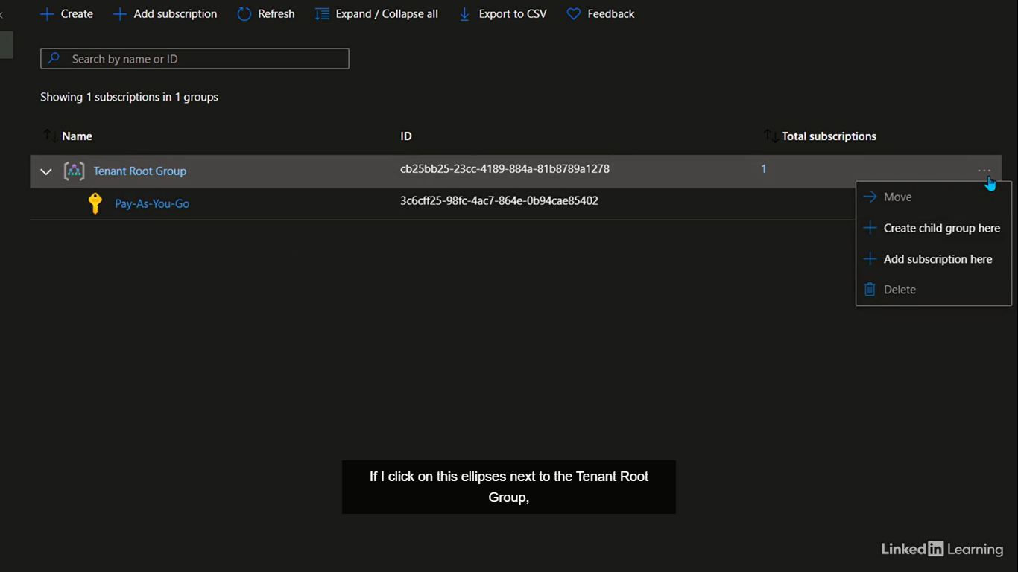

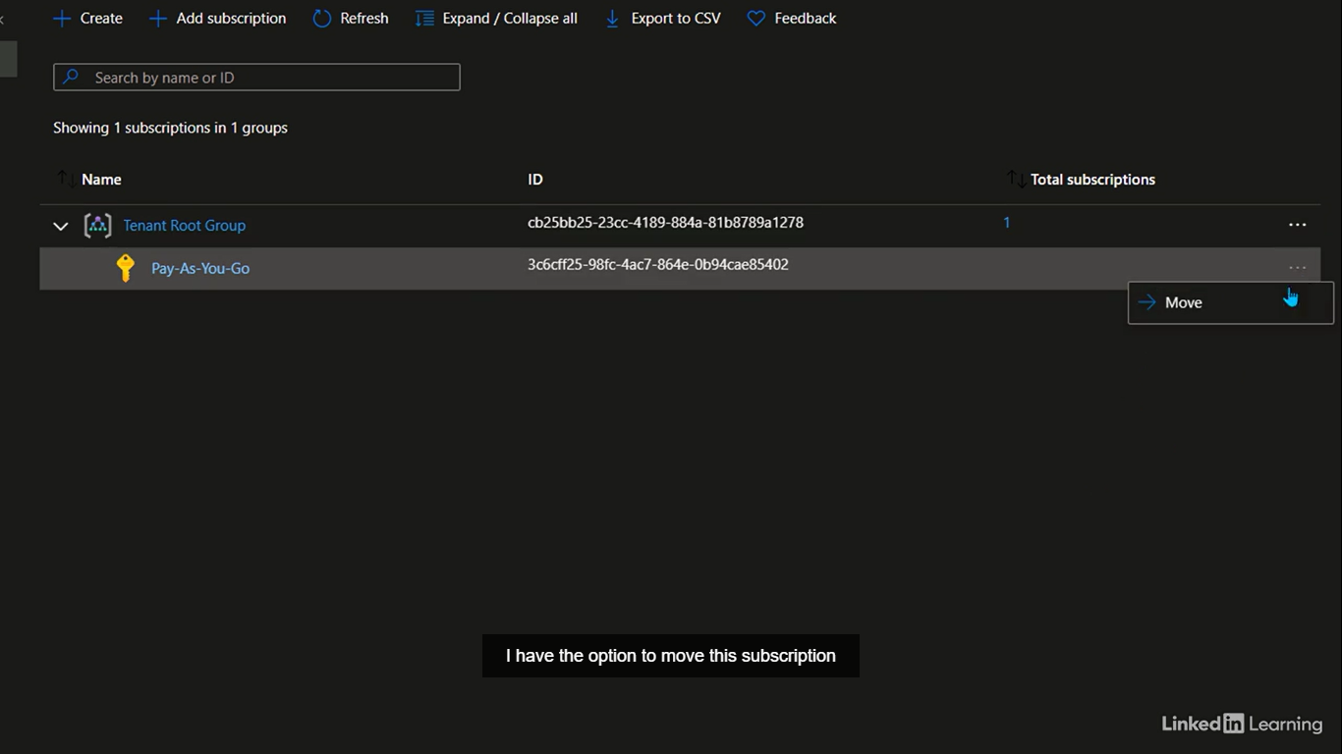

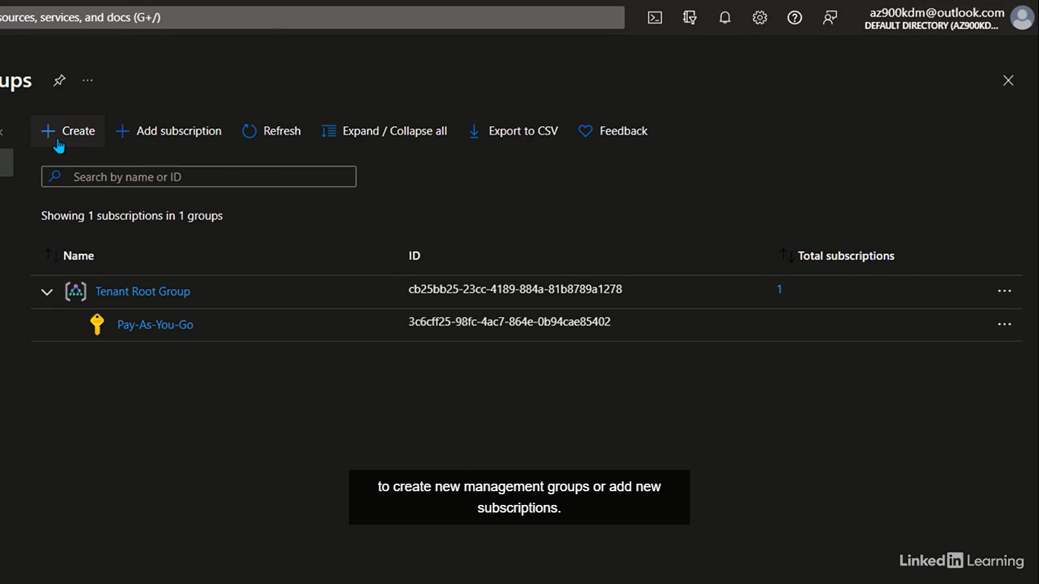

Understand resource groups

[Instructor] A resource group is a set of resources within a subscription. Management groups hold subscriptions and subscriptions hold resource groups. We use resource groups to collate resources pertaining to an application or a solution, because enterprise applications that run on the cloud are complex and leverage multiple services and resources. Managing this mixture of items can become chaotic really fast. That's why we use resource groups to classify and organize related or relevant resources together. Back to the shopping cart example. After you bring home the items you shop for, you group similar products together. You take fresh fruits and vegetables out to wash, put chips and nachos in the junk food drawer, and frozen items in the freezer. It's easier to categorize and manage them as a group because of their similar compositions. Resource groups serve the same purpose in the cloud. You classify and organize resources to manage shared permissions, policies and lifecycle. Services and resources that support a single application often have similar settings. So instead of applying permissions and policies for each individual resource, you group them together in a resource group and manage them collectively. To create a new resource group, you need three things. A name for the resource group, the subscription that it needs to be put under, and a region. Only the metadata for the resource group is stored in the region you specify. Information like group name, unique identifier, and settings that you apply to it. Only these things are stored in the region but the resources it holds can be in other regions. It's not necessary that the resources be in the same region as their resource group. You could have a resource group in region A it's member resource in Region B, and another member resource in Region C. This is possible. The only rule here is you cannot nest resource groups. You cannot have one resource group, be a member of another resource group. Everything else is mostly possible. Let's jump into a demo and see how resource groups work. I'm back in the Azure portal and in this demo we will try to create a new resource group. To do that, I'll click on this icon here that says Resource groups. If you don't see this icon, remember you can search for resource groups, in the search bar on top of the screen. Clicking on this icon brings me to the resource groups page. To create a new resource group, I can either use this create button on top or use this button in the center that says create resource group. This button will only appear, if you do not have any existing resource groups. We don't have anyone yet because this is a brand new subscription. I'll click on this button and that'll bring me to the create a resource group page, looks quite simple. If I had multiple subscriptions, I could select under which subscription, I want to create this resource group, using this dropdown menu. We only have one subscription right now, the pay as you go, so I leave that as it is. Give the group a name. Let's say az900-rg1, rg1 stands for resource group one. Simple and easy to remember. And at last, the region for this resource group. I'll click on the dropdown button and select the Central India region. That's because it's close to me and also at the center of my geography. Click on the review button at the bottom. Azure then runs a small validation test to see if the information entered on the previous page is valid. If everything looks okay, you'll see a validation passed message on the top. I'll review the information one last time to make sure everything looks correct. If you have made any errors or mistakes, now is the time to correct them. This looks good to me, so I'll click on the create button at the bottom. This should take a couple of seconds and soon you will have the resource group, az900-rg1, ready to use. As a confirmation, you will see a success message in the notifications on top right corner. And the resource group you just created on this page, right here.

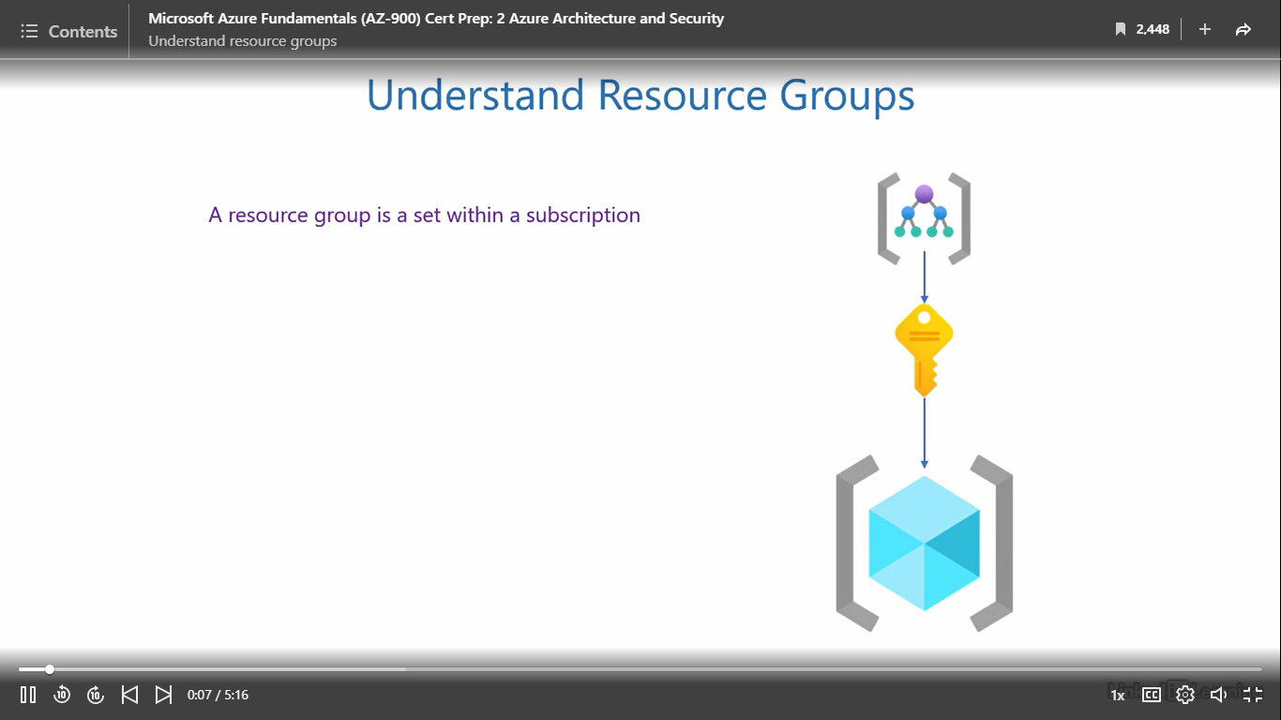

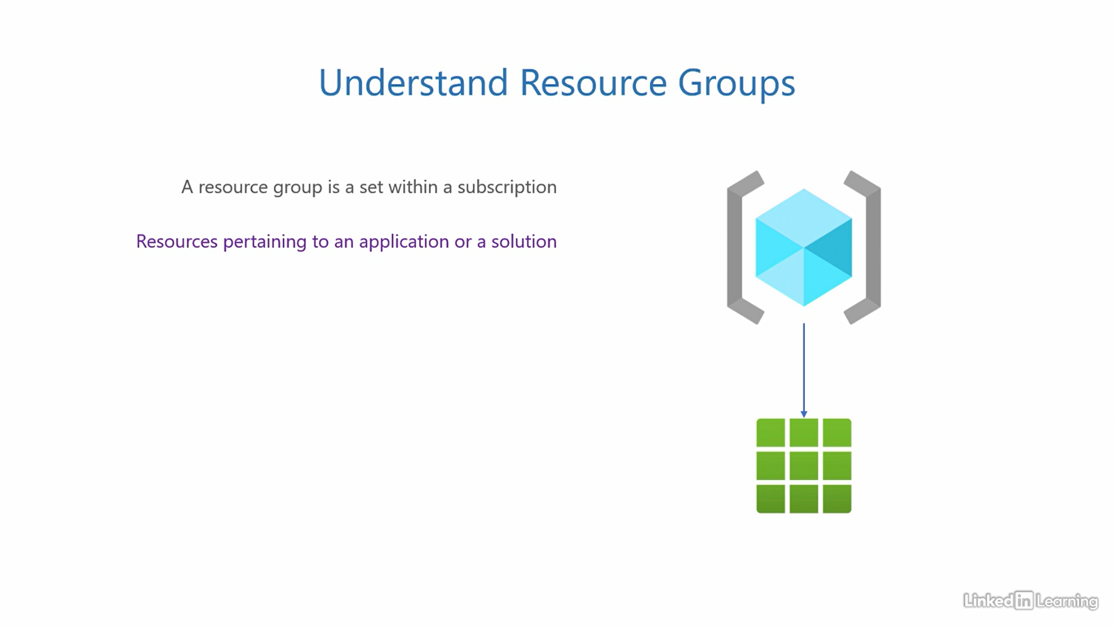

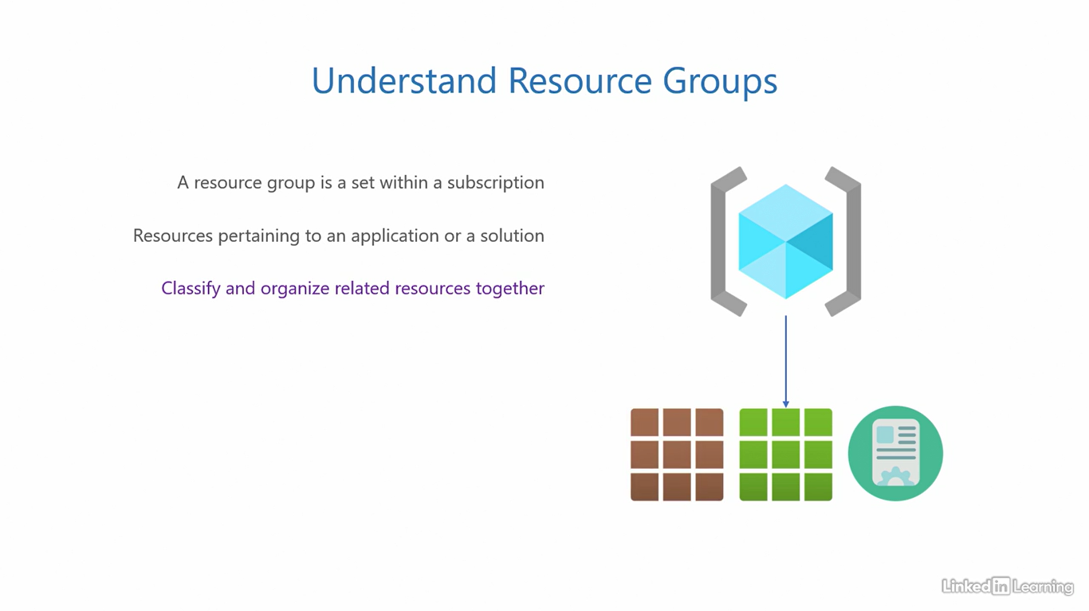

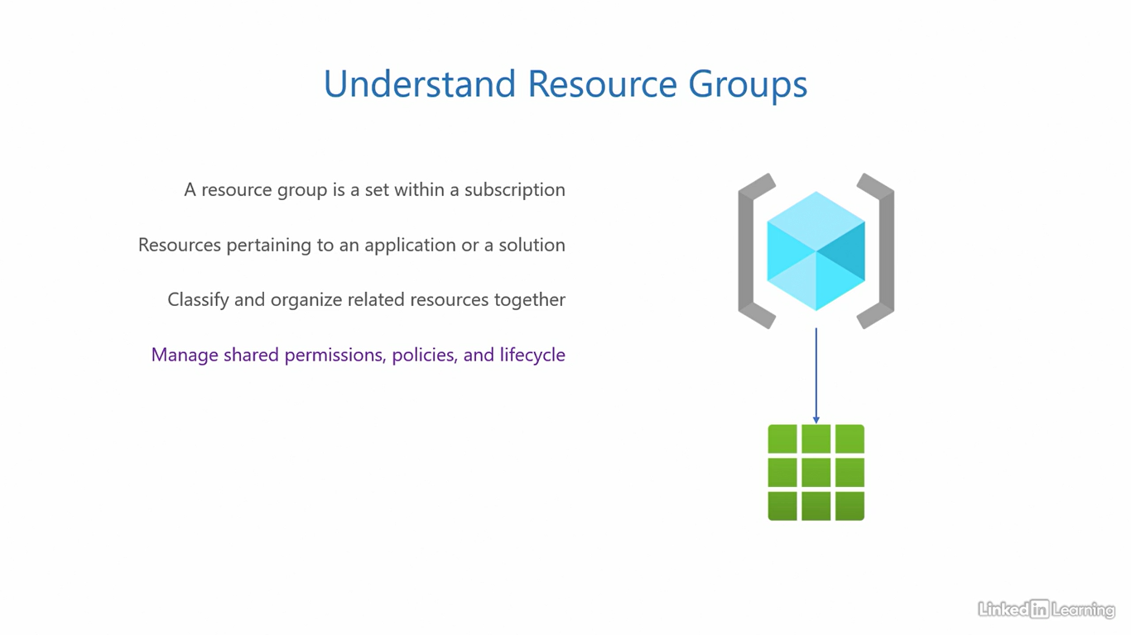

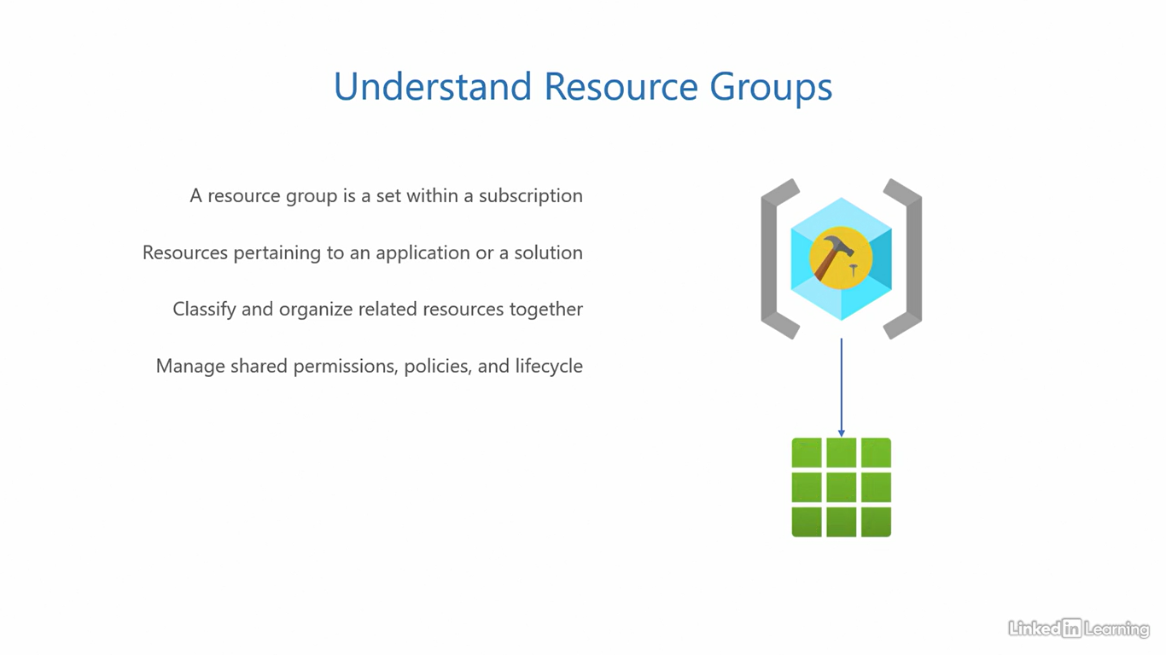

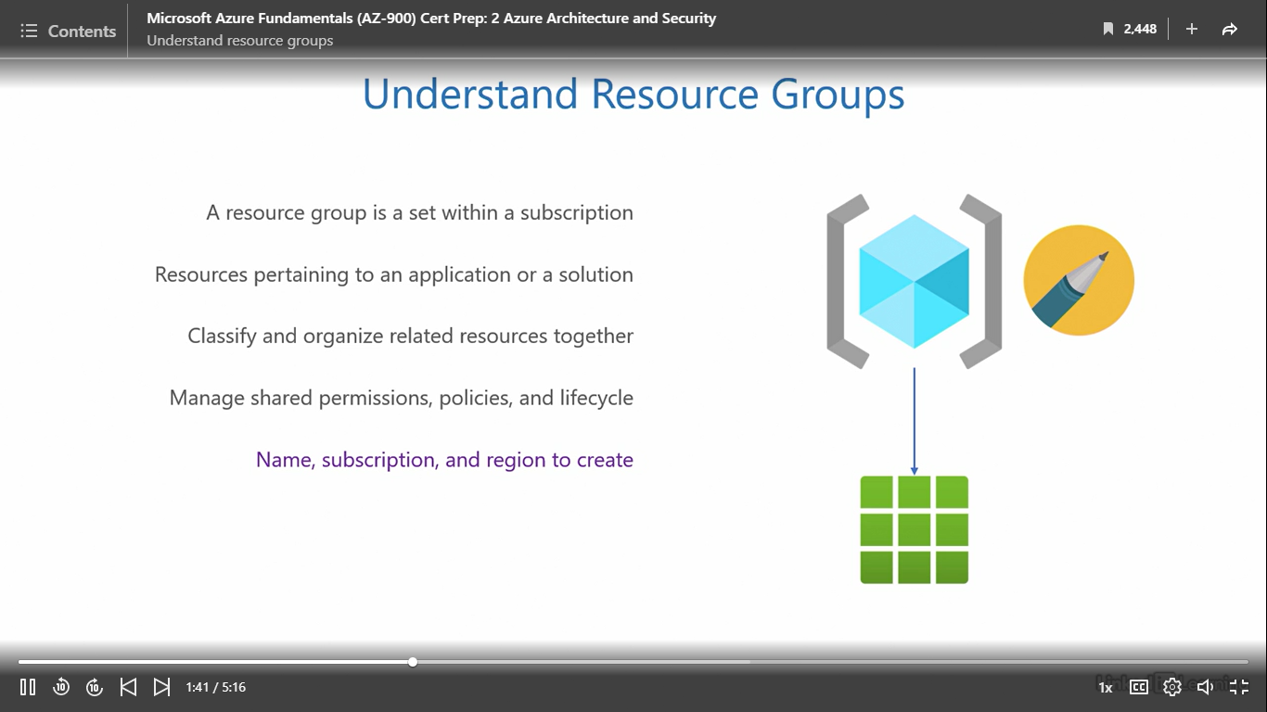

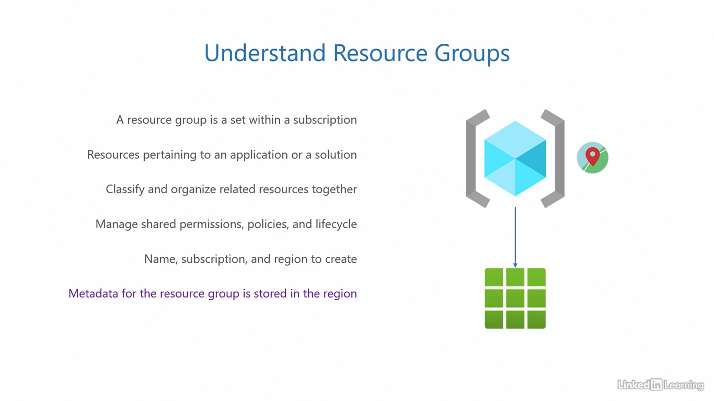

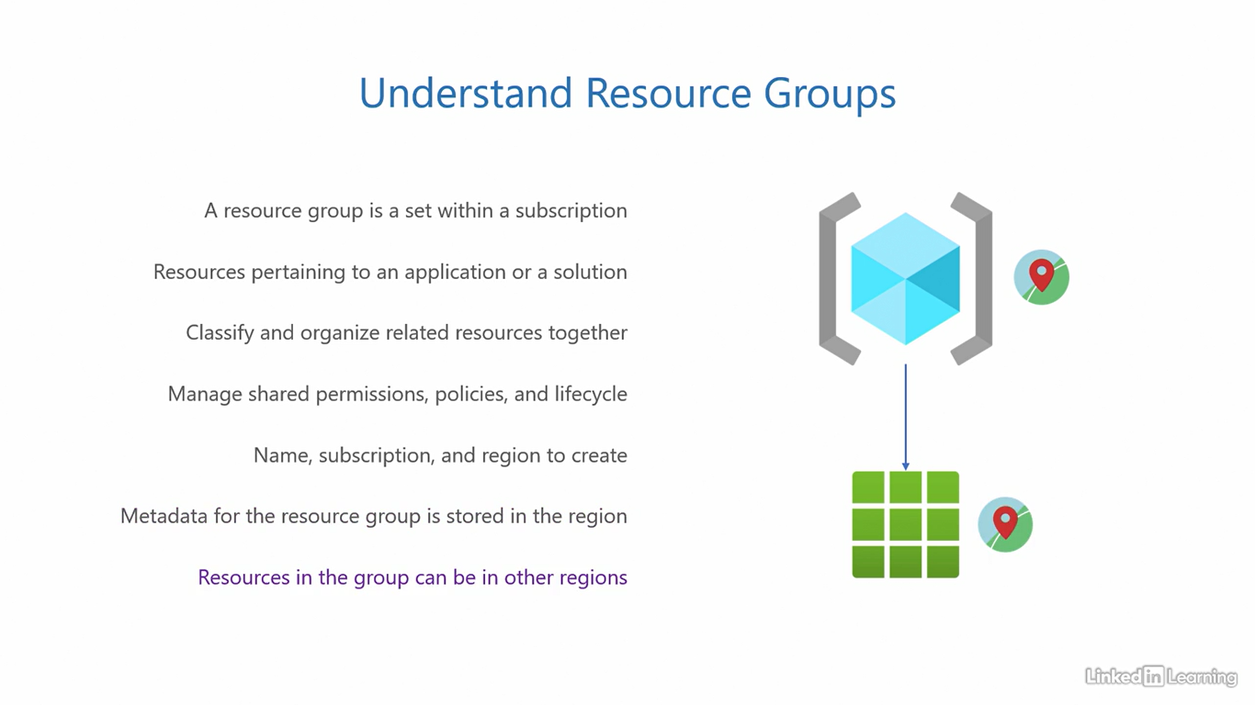

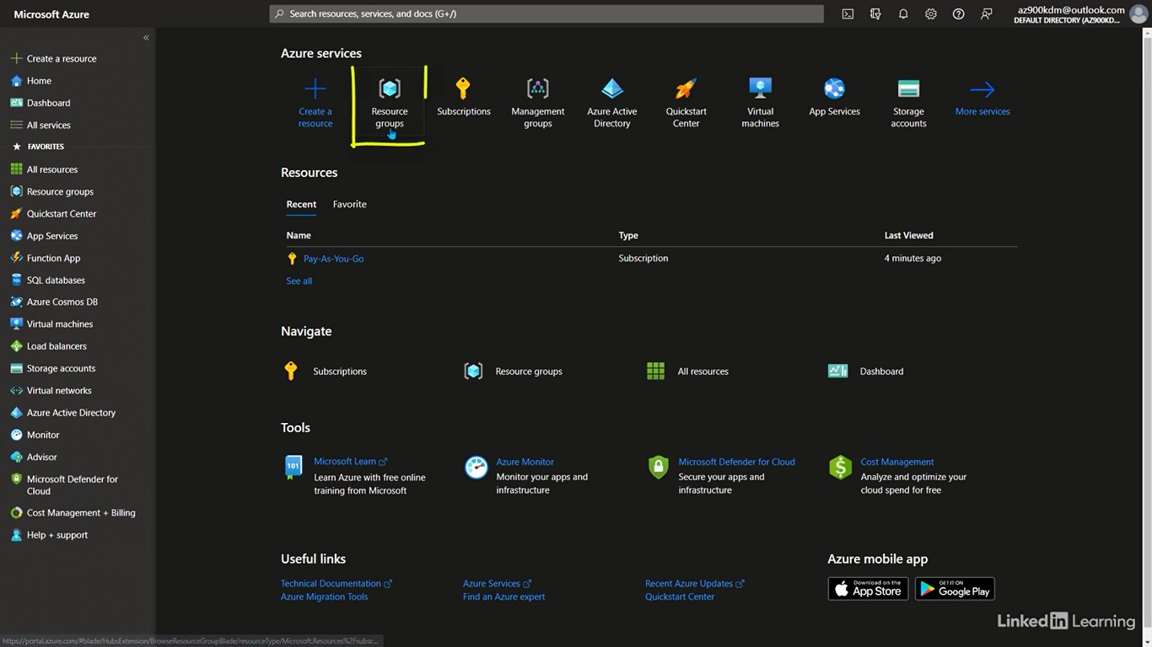

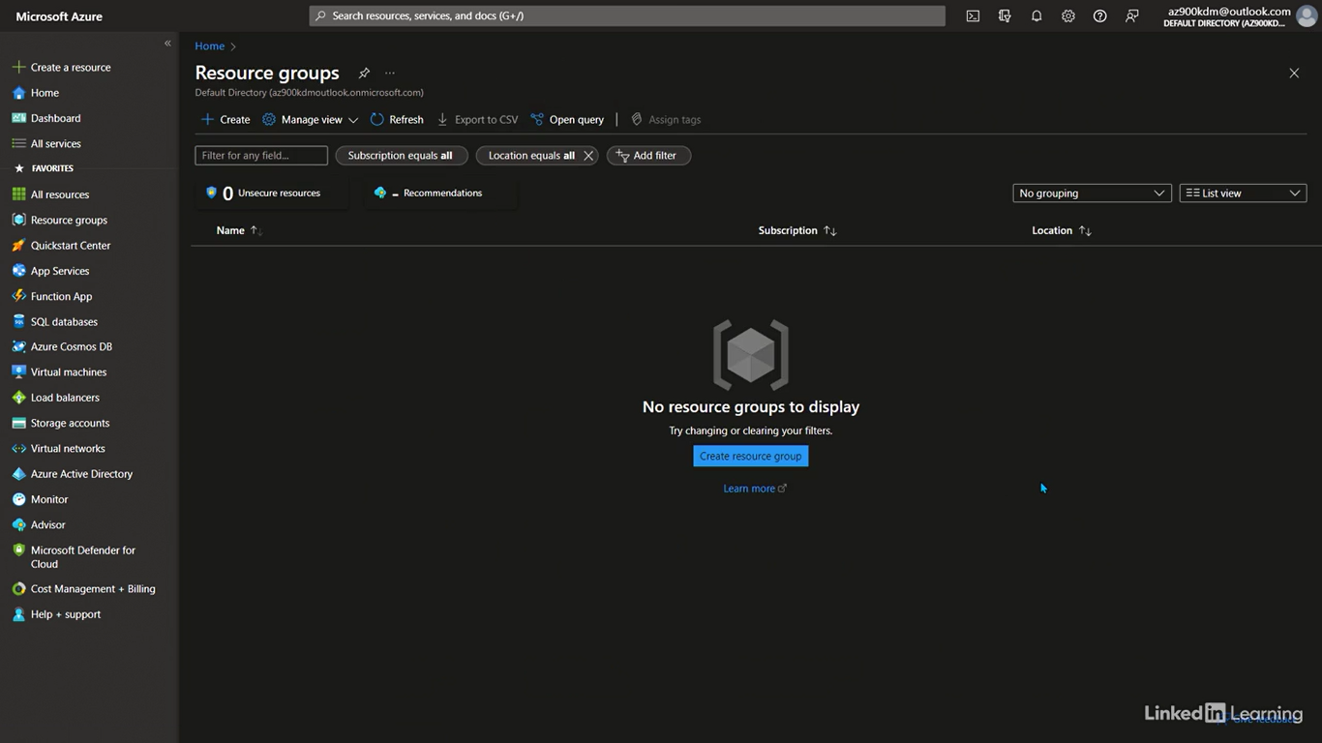

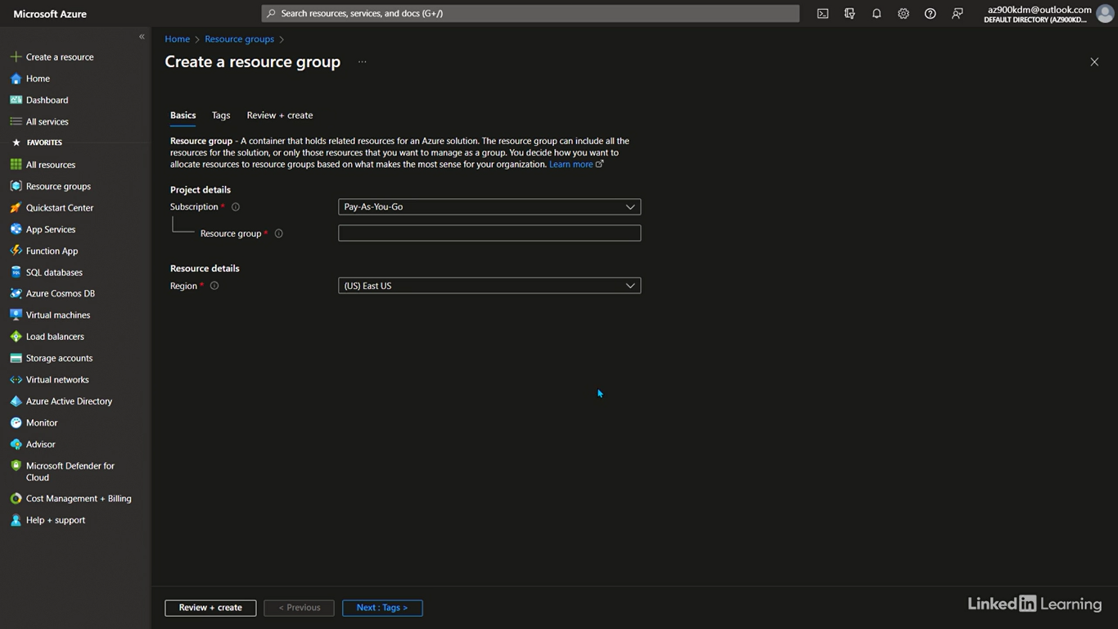

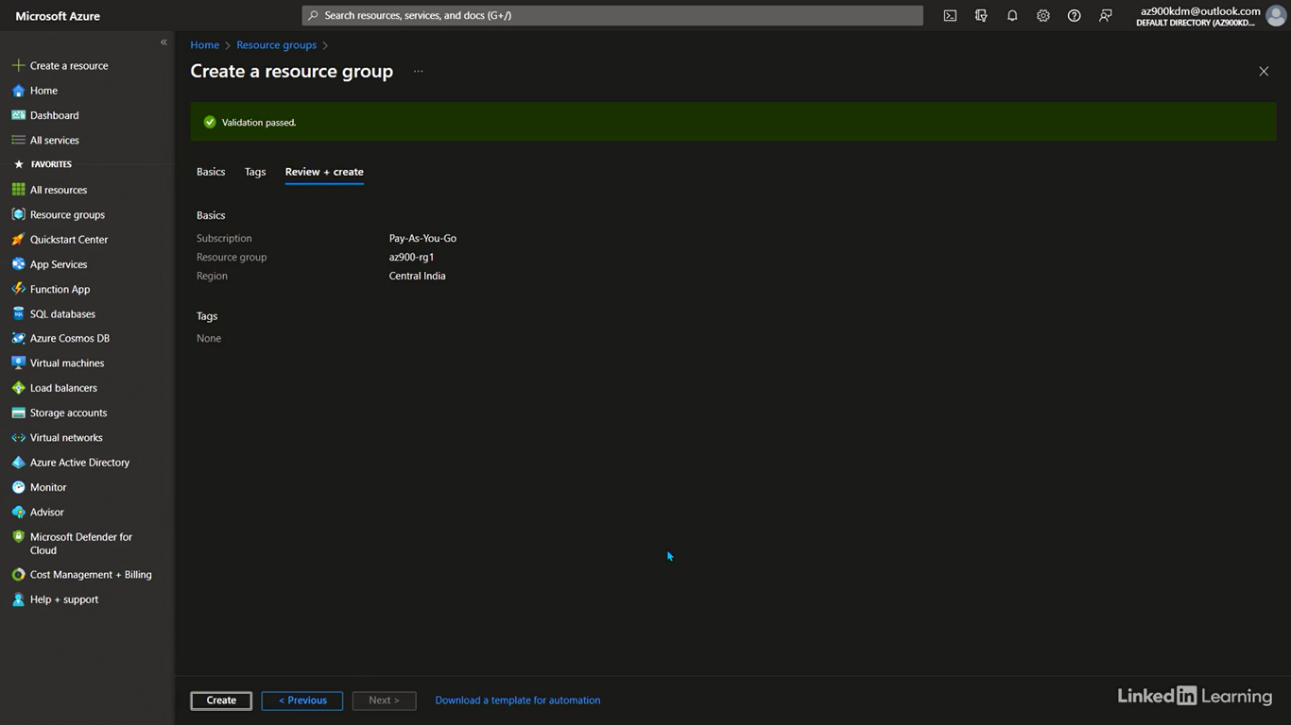

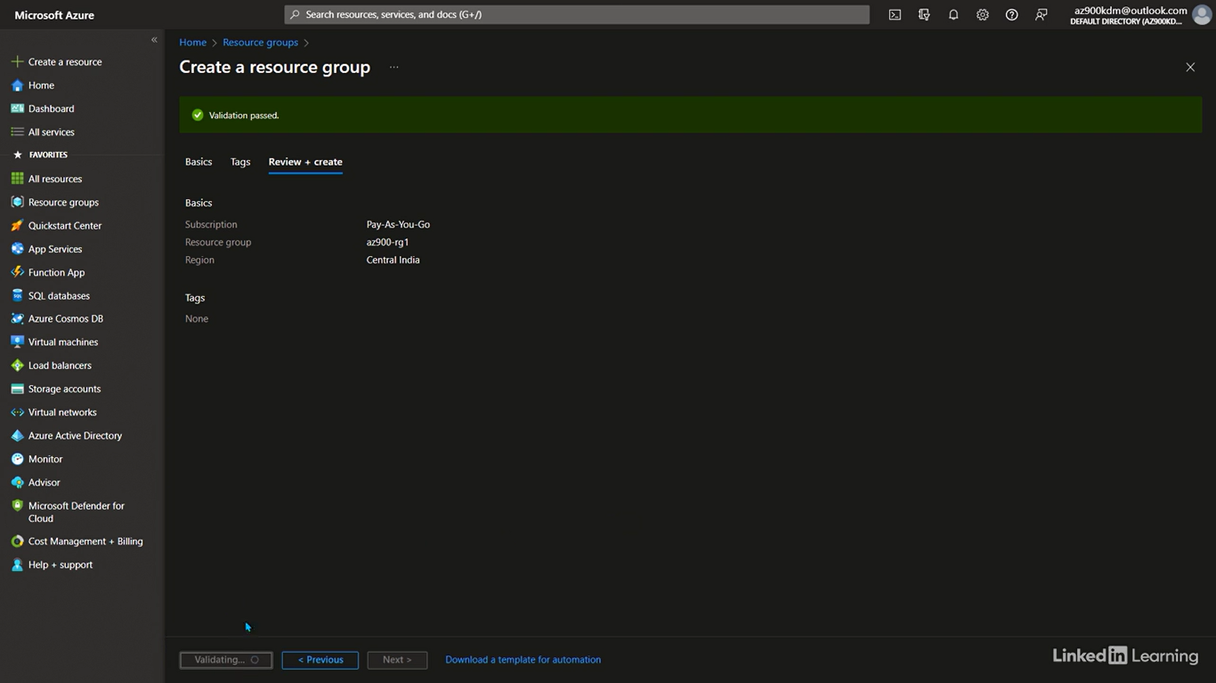

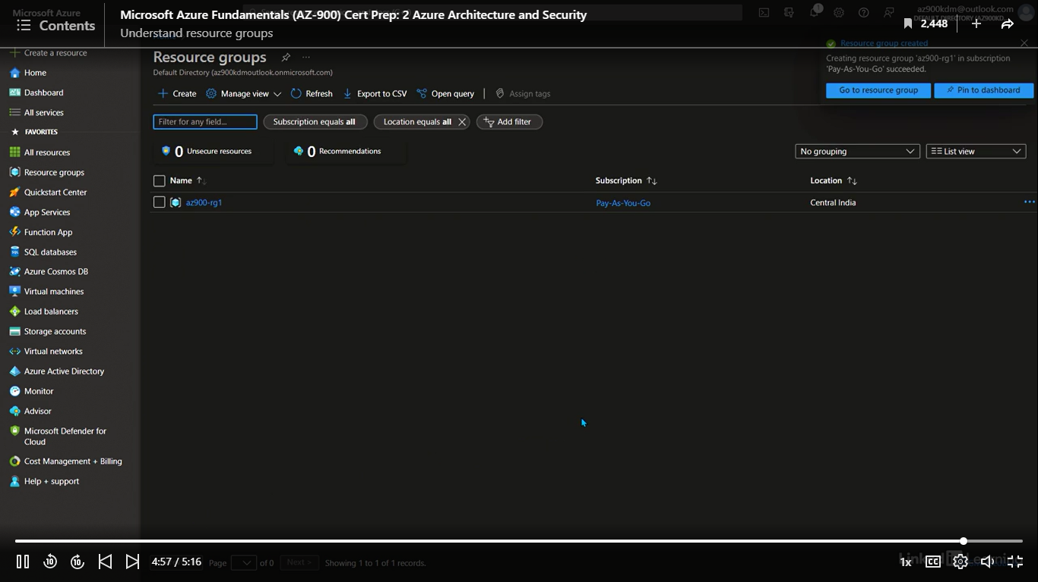

Understand resources

[Instructor] I have used the word resources a lot of times up until now. In general, we know what a resource is, an entity that serves a purpose, but what does it really mean in the context of the cloud? Let's understand that in a little more depth. Resources are the end objects in the Azure hierarchy. Management groups hold subscriptions. Subscriptions contain resource groups, and resource groups contain resources. A resource is an instance of a cloud service. When you choose a service to deploy, an instance of that service gets deployed to your subscription. This instance is called a resource. You probably remember there are three types of service models in the cloud, infrastructure, platform, and software as a service. A resource can be IaaS, PasS or a SaaS resource. Azure resources provide three main functions, compute, networking and storage. When you want to process information, you deploy a compute resource. When you want to move data between compute resources, you need a networking resource, and when you want to store information persistently, you use a storage resource. Enterprise applications use a combination of all compute, networking, and storage resources in application architectures. To create a resource, you'll need to give it a name, specify the subscription, it's resource group, and the region it needs to be placed in. Depending on the type of resource, there can be additional parameters required for its deployment. This is also the point where you start incurring charges. Resources are charged on type and configuration. There is no cost involved in creating management groups, subscriptions, or resource groups because they're simply used for administration. The resources are what perform actual tasks, and so they cost money. The charges for all resources in a subscription are billed monthly. In the shopping cart example, the actual items you put in the cart correspond to the resources in the cloud, and those are what you actually pay for at the checkout counter, not the cart nor the paper bags. Resources can also be moved across resource groups if you want to restructure them. It's quite flexible. Let's jump into a demo, and see what it looks like to create a resource. In this demo, we will not actually create a resource. Instead, we will try to understand how the architectural hierarchy, and the administrative hierarchy aligned in the process of creating a resource. I'll start by picking the most commonly used resource in the cloud, a virtual machine. Don't worry if you don't know what it is, we'll get to it later. I'll click on this virtual machine's icon or use the search bar on the top if the icon isn't here. On this page, you can see there are no virtual machines deployed yet. That's why it's empty. I'll click on the create button on the top to take me to the create a virtual machine page. Here first, I'll need to specify the subscription. That'll be pay as you go. That's the only one we have right now. Along with that, the resource group. I'll deploy this virtual machine inside the resource group we created in the previous demo. AZ900-RG1. Give the virtual machine a name. Let's call it AZ900-VM1. VM1 stands for virtual machine one. You can see the region by default is set to Central India. That's because our resource group, AZ900-RG1 was created in that region, but if I want, I can choose a different region for this virtual machine resource. Let's leave this as it is. In the availability dropdown, you'll see there are multiple options. The first option and the default one is no infrastructure redundancy required. You should choose this if you want zonal replication only. That is replication of the virtual machine only within one availability zone. The second option is availability zone. Choose this if you want zoned redundant replication. That is replication of the virtual machine across availability zones in the Central India region, this option is a little more expensive than the first because it offers better availability. Now, I'm not going to go through the entire process of creating a virtual machine because there are a lot of parameters we haven't covered yet. What's important at this point is to be absolutely clear about the architectural, and administrative hierarchy.

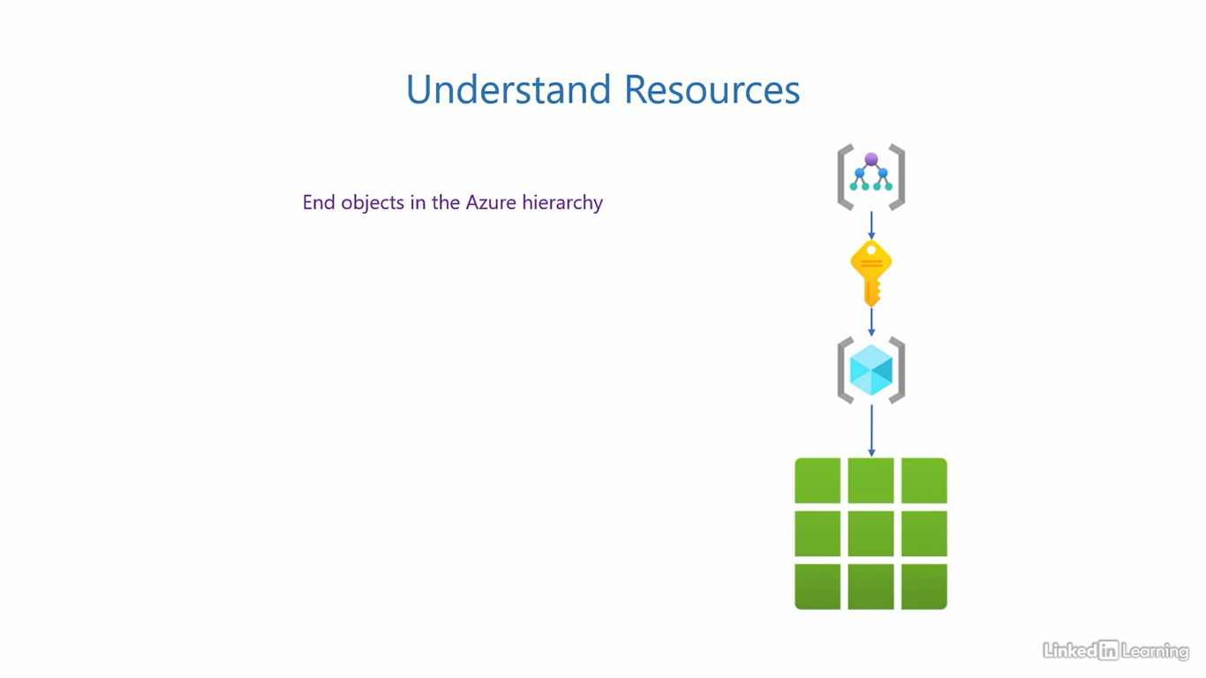

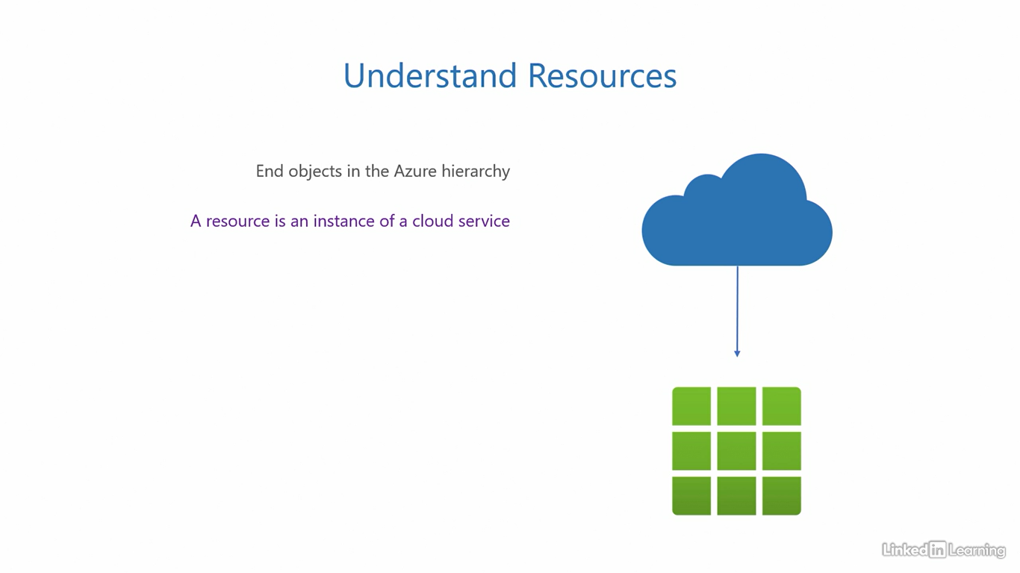

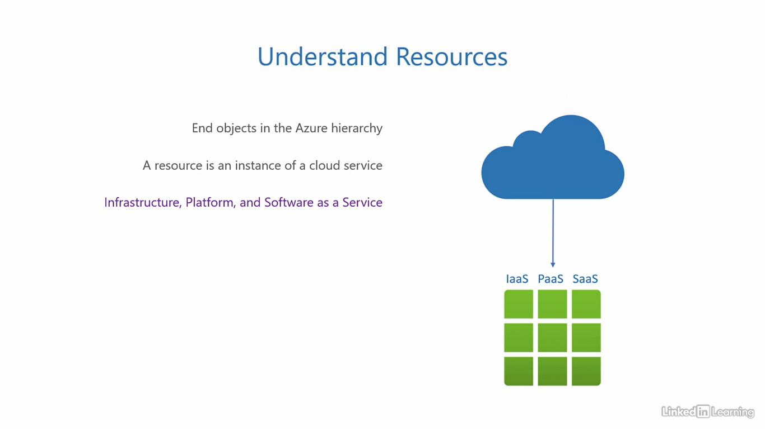

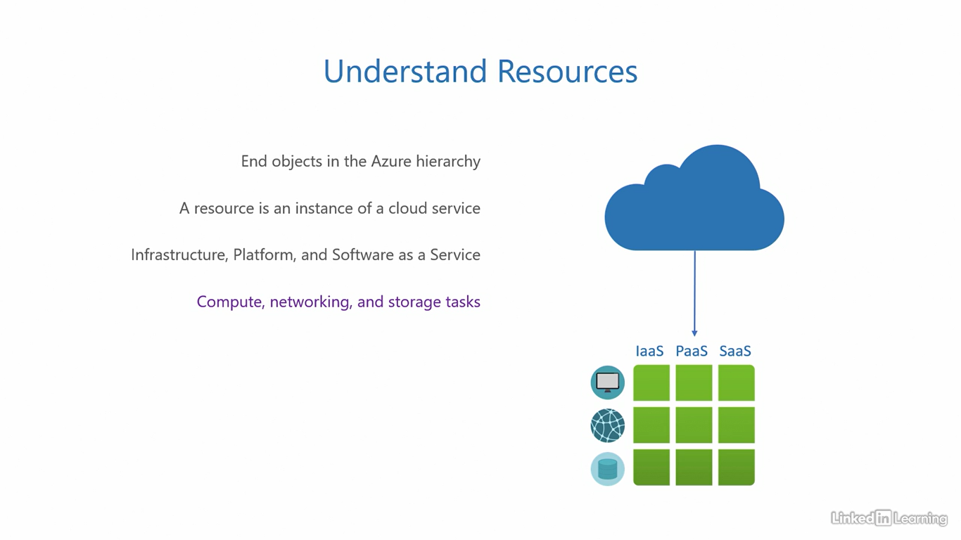

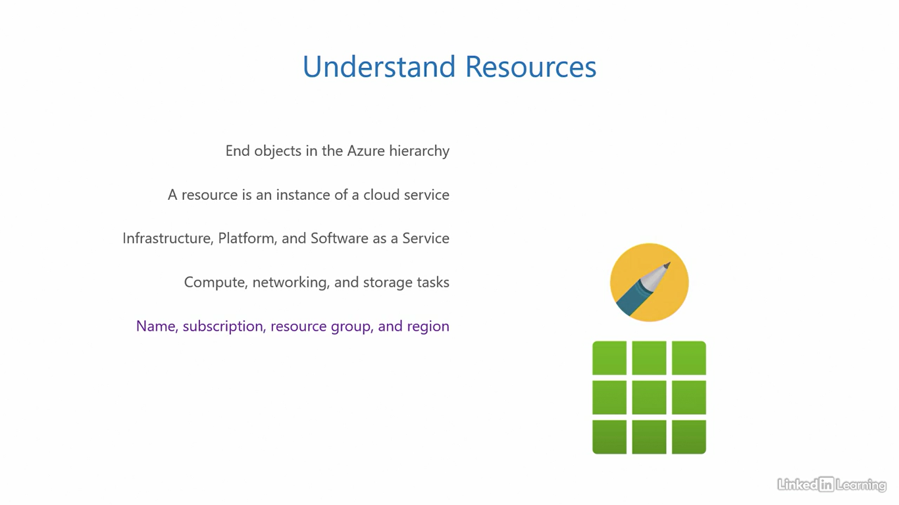

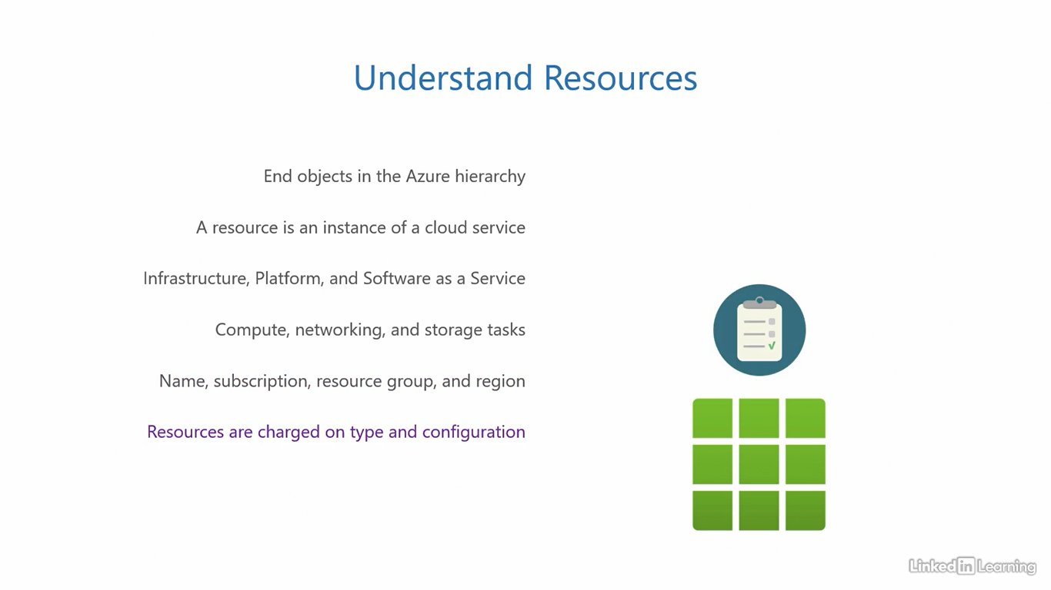

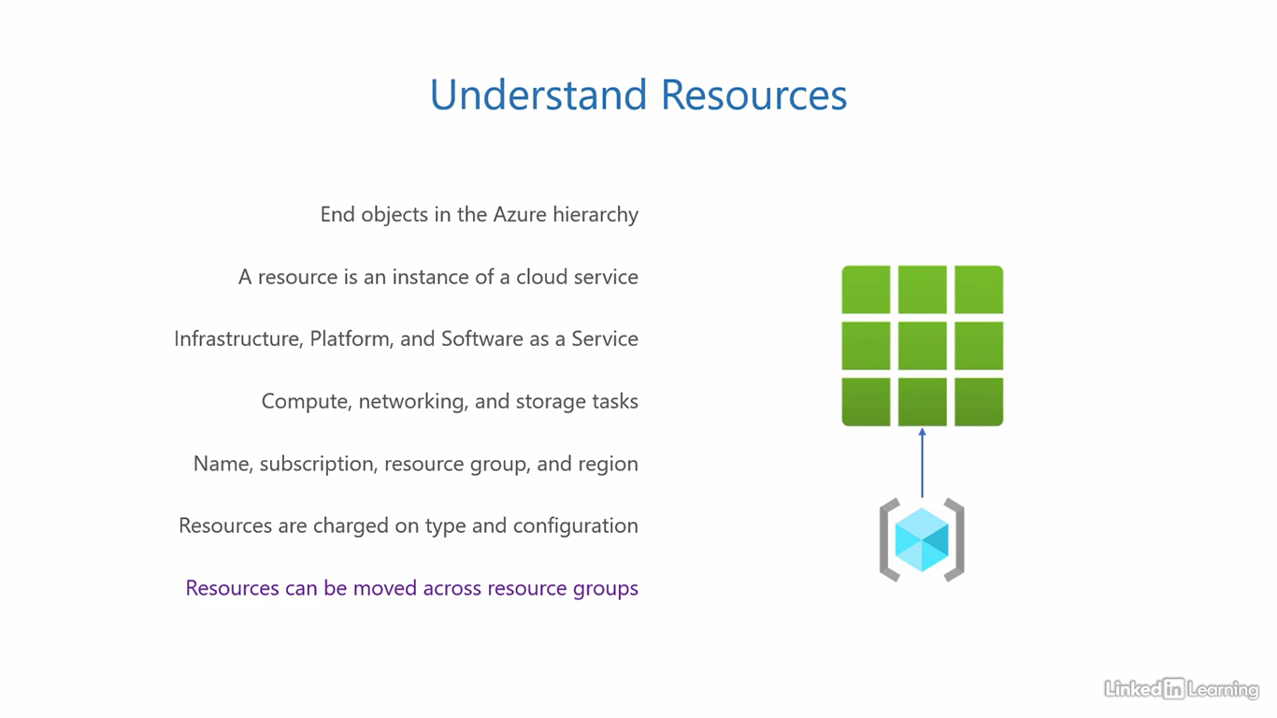

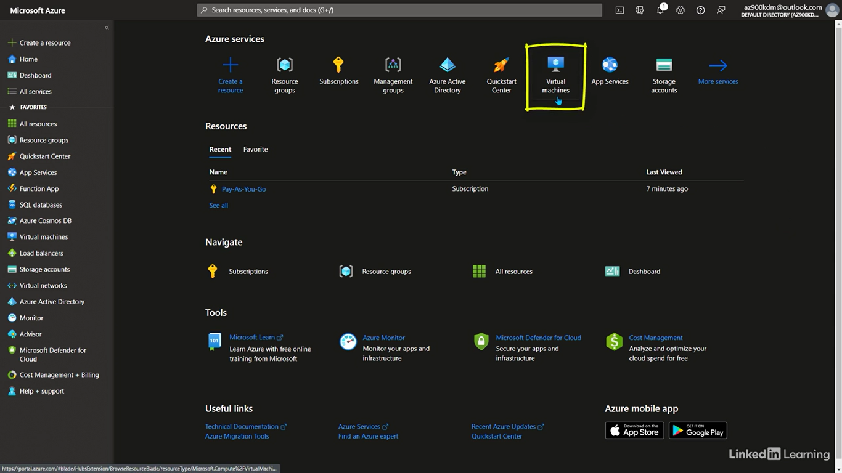

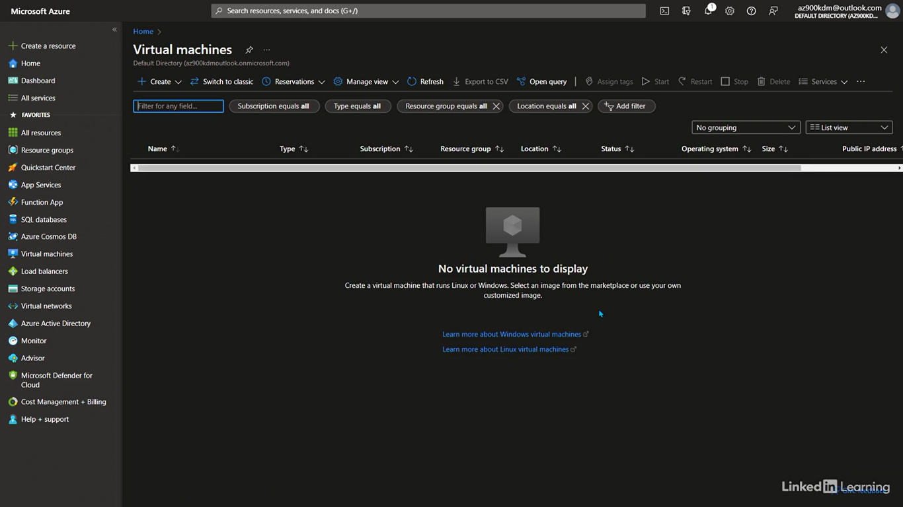

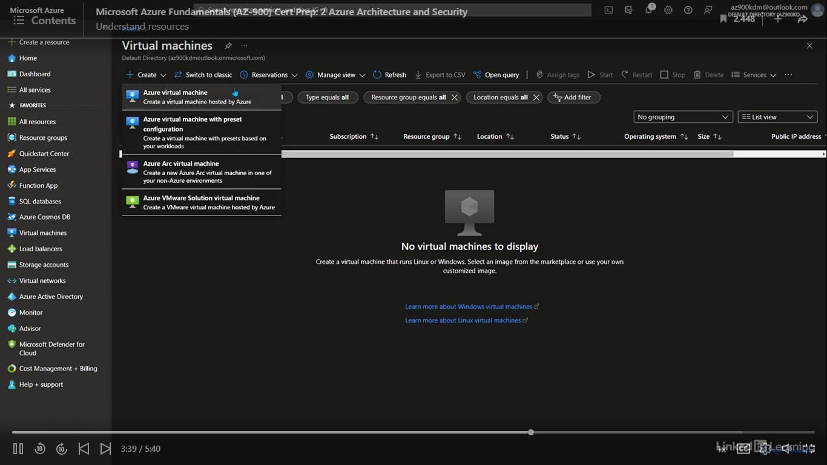

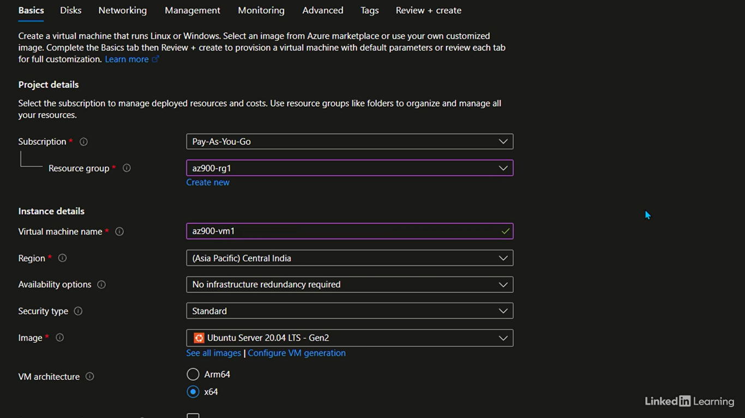

Exam trick #2

[Instructor] I do understand that as beginners, things can be difficult to remember. Things that are obvious for experienced professionals, can be what new learners struggle with, so to make this easy for you, I have our next trick. Management groups hold subscriptions, subscriptions contain resource groups, and resource groups contain resources. Take their first letters MG, S, RG and R and convert it to Mega Shopping Rage Returns, which as a happy coincidence, connects back to our shopping cart example. You can imagine me zooming past you in the supermarket with a shopping cart, if that helps.

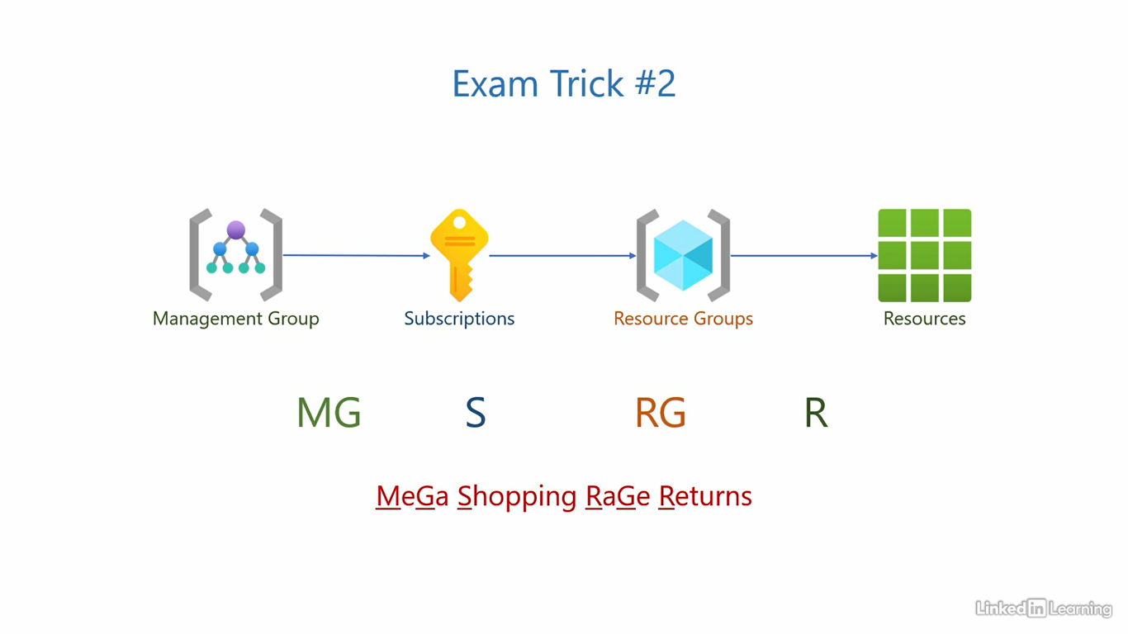

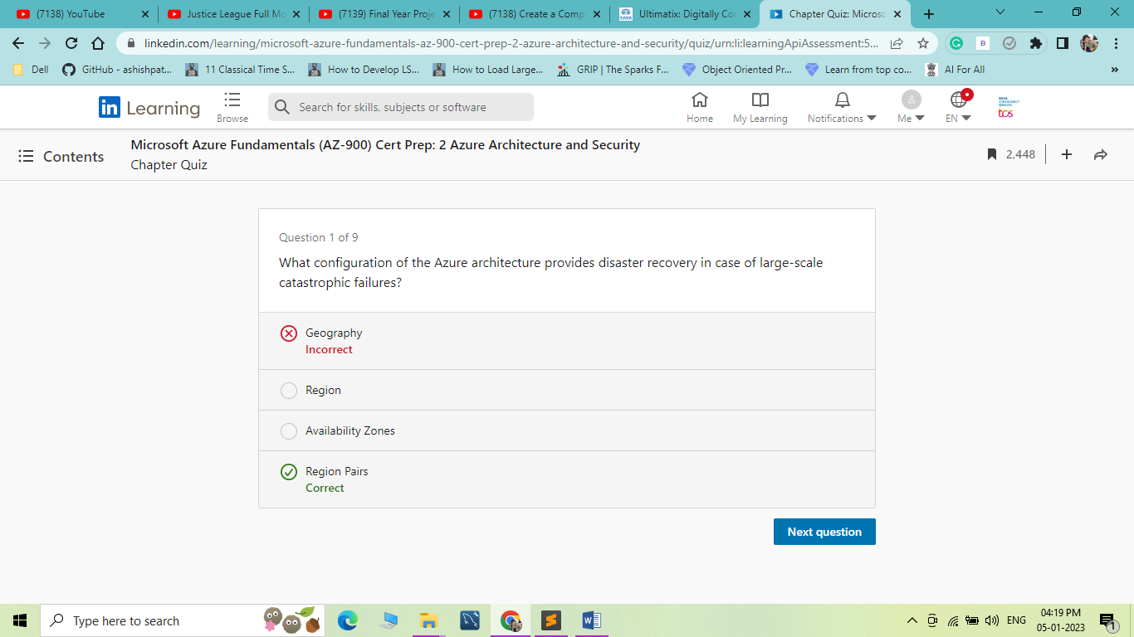

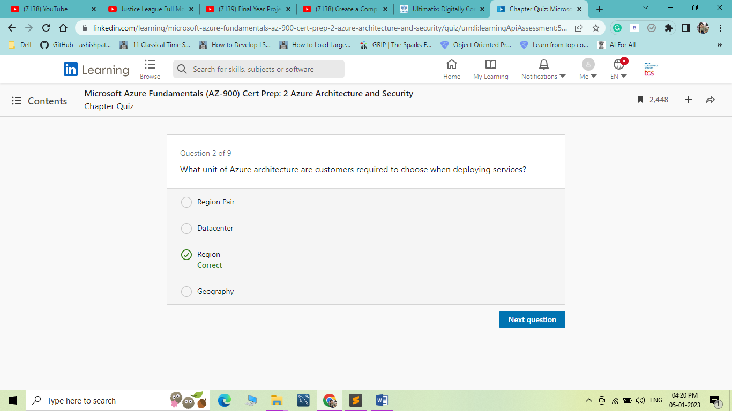

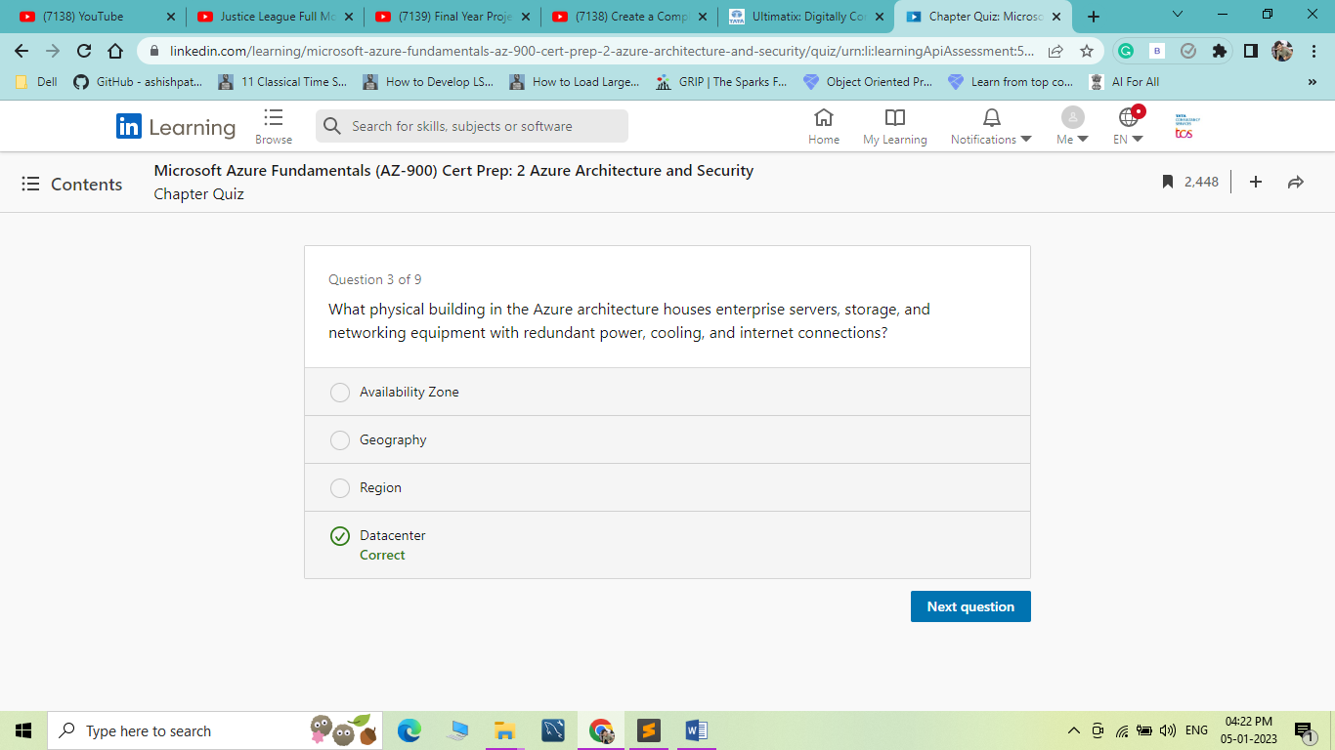

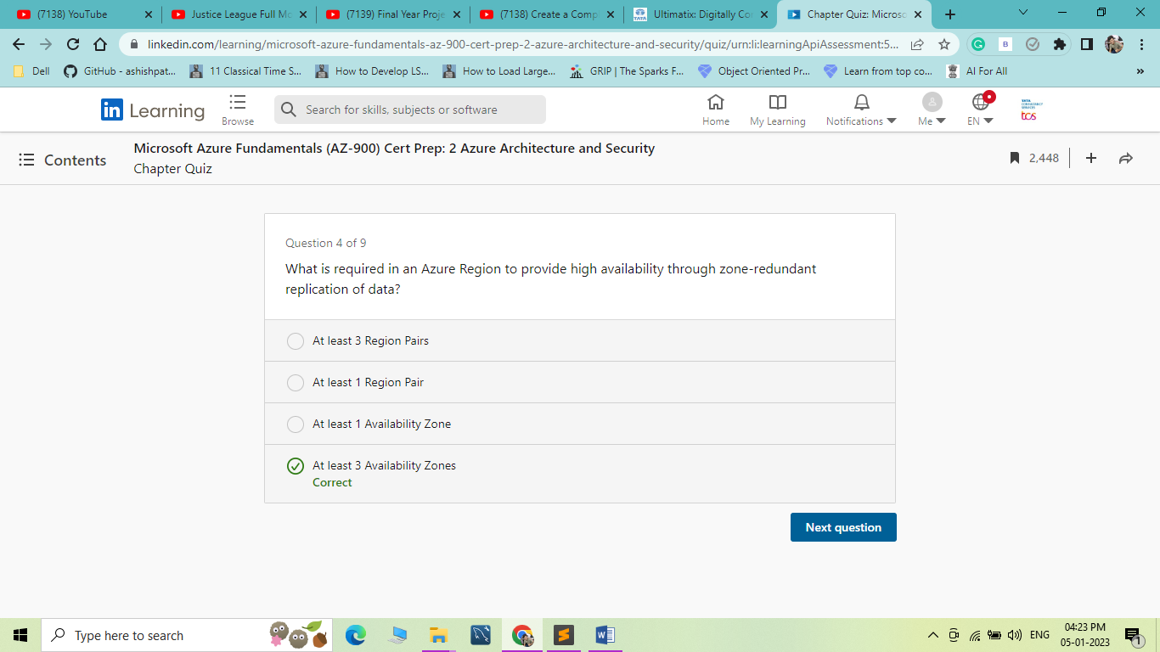

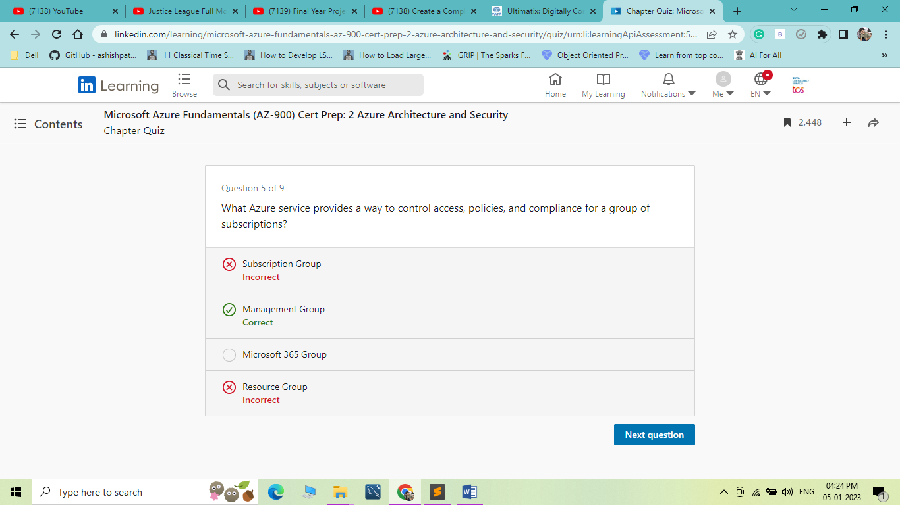

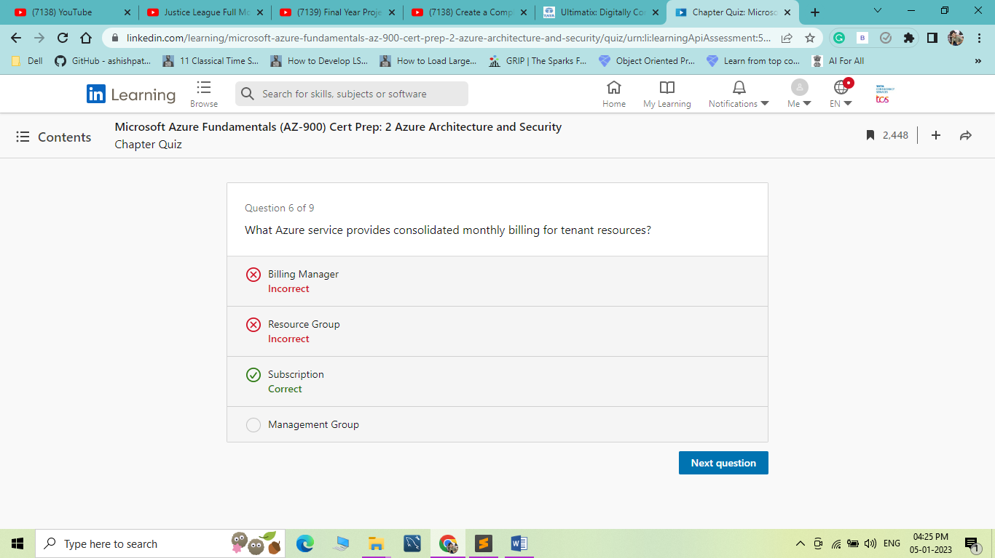

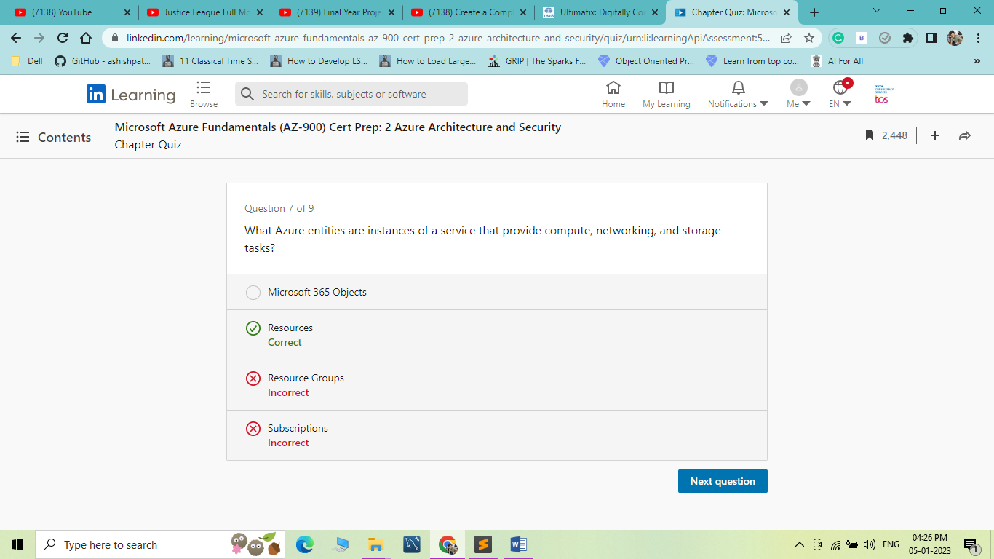

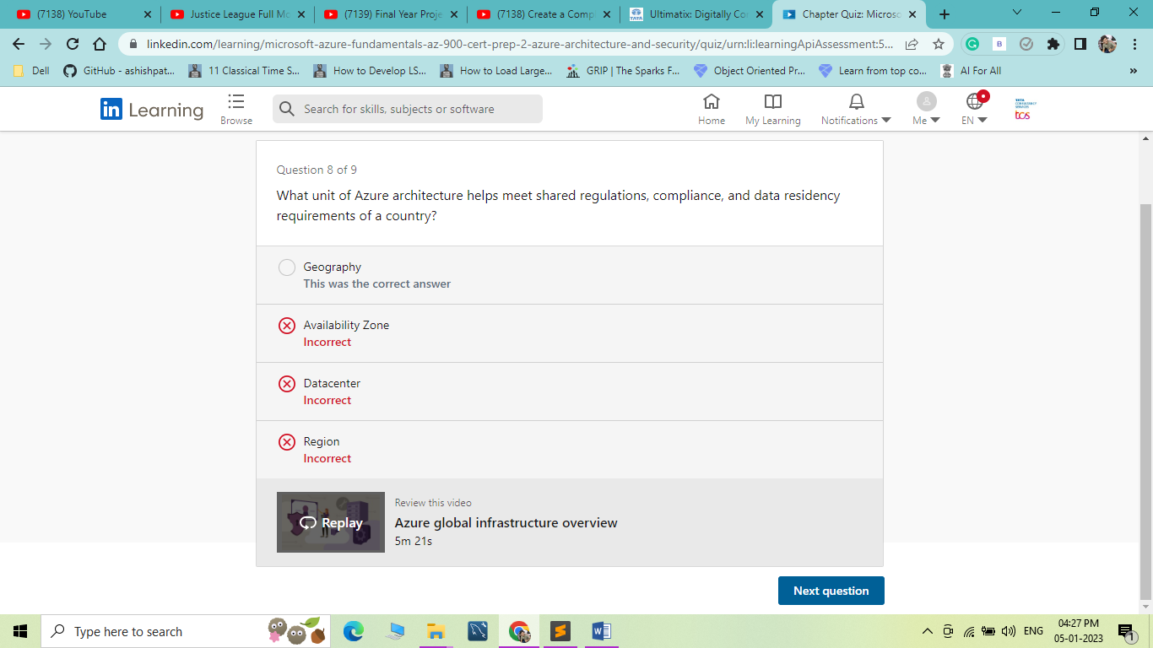

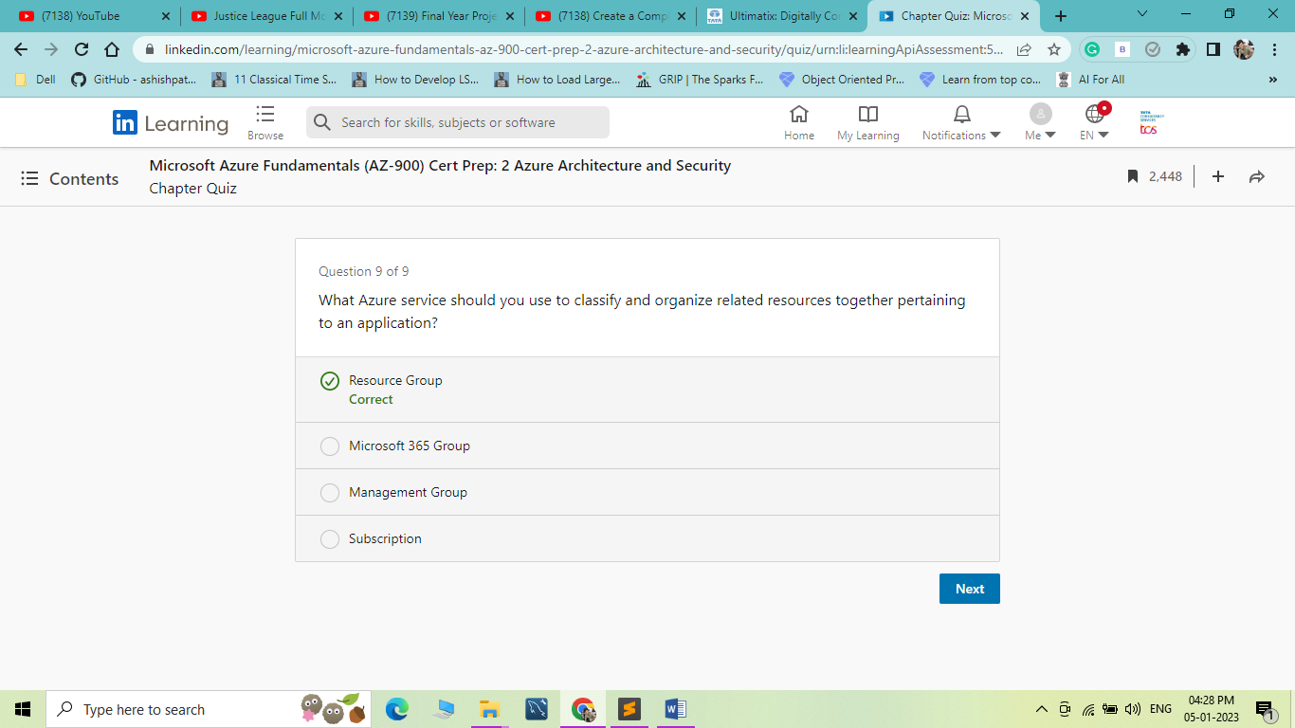

1. Understand Azure Active Directory

Identity and access

[Instructor] Welcome to the chapter Understand Azure Active Directory. This is an identity and access management solution for your entire cloud. This is our first layer of defense in cloud security, which makes it essential that you learn this before any other cloud service in Azure. Let's see what it is and what it does. Let's clearly define what we mean by identity and access. Imagine you are traveling internationally in a commercial airliner. What documents would you need to get through the airport, onto that plane, and enter your destination country? You'll mainly need a passport and a visa. The passport helps you prove your identity by validating if you really are who you claim to be. The visa controls your access by outlining what you can and cannot do in the destination country. If you are on a tourist visa, you can do tourism. If you have a business visa, you can do business. The immigration department checks both your passport and visa. If you get through both the hoops successfully, you get to take off. The steps are very similar in IT when you want to access an application or a resource. Instead of a passport, you have credentials, that is username and password that you use to prove your identity. The process of proving your identity is called authentication. Once successfully authenticated, you are given a list of actions you can and cannot perform on the application or resource. This process of controlling access is called authorization. In enterprise environments, the authority managing these checks is called a directory server. The study of managing users, their credentials, authentication, authorization, directory server, and its services is called identity and access management. We've been doing this for decades in our on-premises environment. This isn't a new concept. Then, why is identity and access suddenly gaining so much traction? In the past, managing identity and access was mostly confined to a closed corporate network. Users, their dedicated computers, directory server, and the applications were all on the local intranet. Simple and straightforward to manage. But now, we are moving towards modernization. Users are not restricted to their dedicated computers anymore. They want the freedom to use multiple devices and be productive: desktops, laptops, tablets, and mobile devices with different operating systems. It's not easy to enforce compliance across such a wide range of devices. Users also want the flexibility to work from anywhere: a coffee shop, their homes, from the beach sipping a cocktail, or from another country altogether. The implication of this being they will need to send their credentials over the internet for authentication. The internet, as we know it, can be a dangerous place. It's not easy to differentiate if a request is real or disguised as real. To add to those challenges, we now have a segregation of the environment. On one side, we have the traditional on-premises environment. And for modern applications, we have the cloud. Do we have two separate credentials for the two environments, or is there a way to use just one? How do we authenticate and authorize apps in the cloud? The number of such questions quickly piles up into a mountain. Let's see if we have a solution for all the challenges we just discussed.

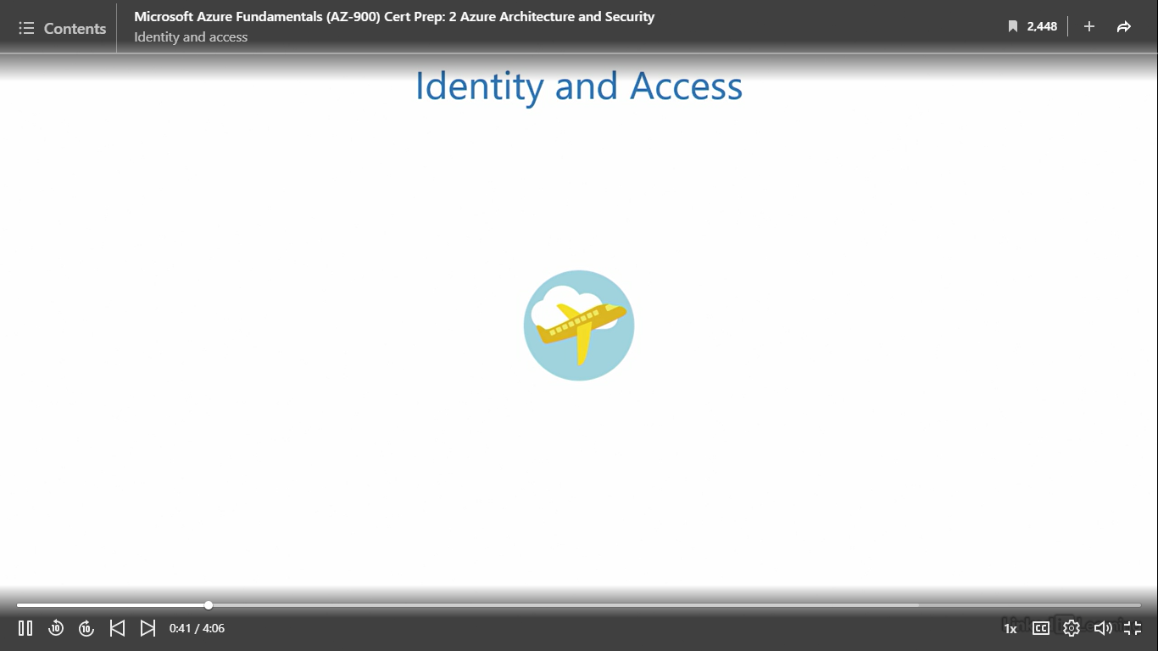

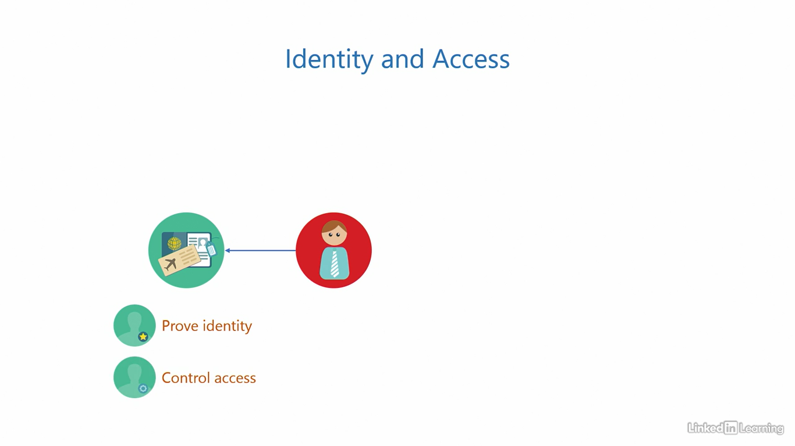

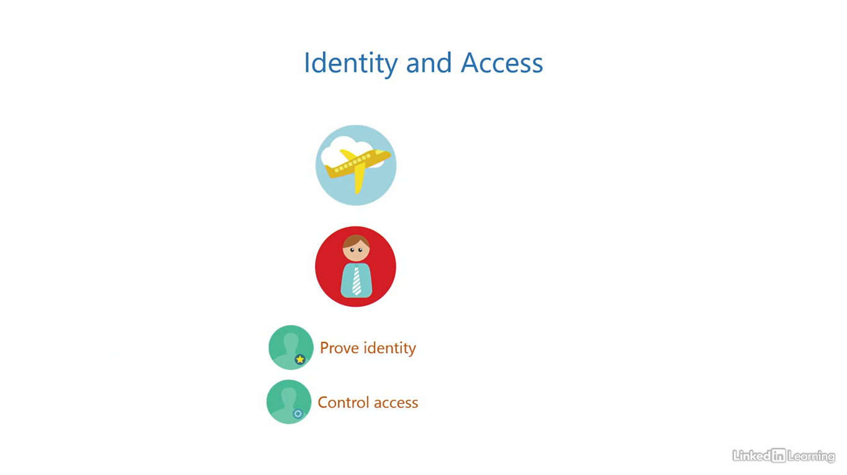

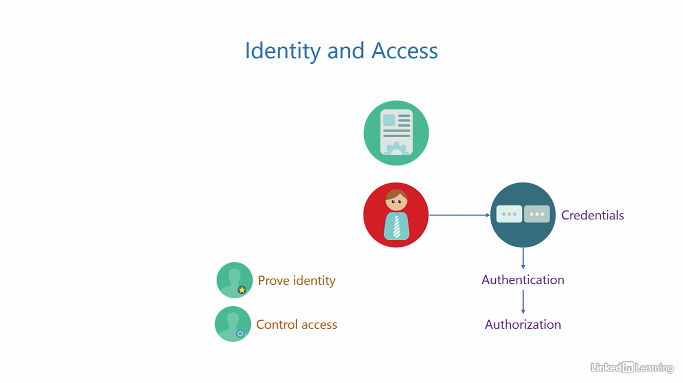

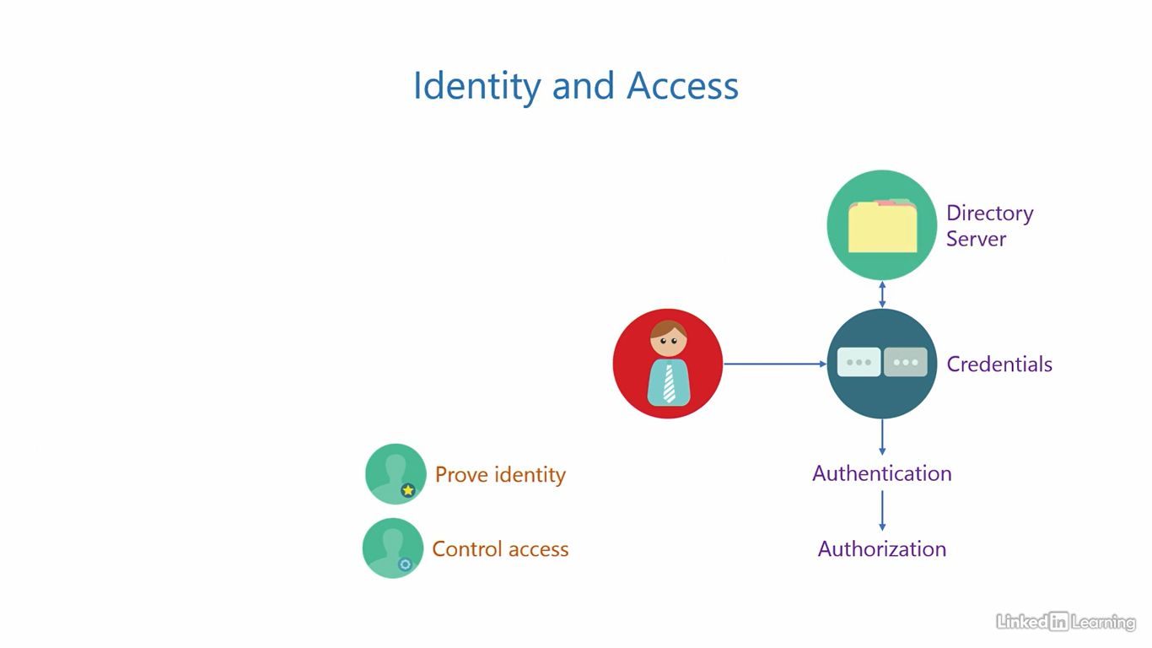

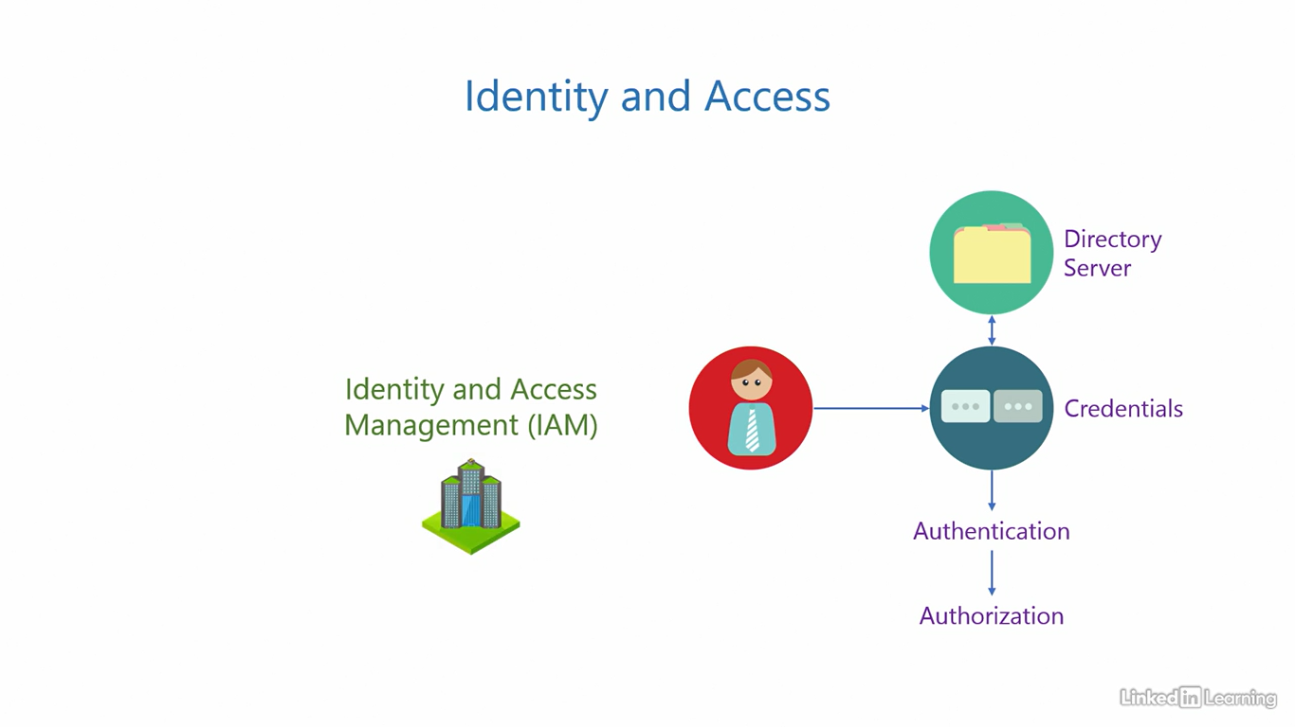

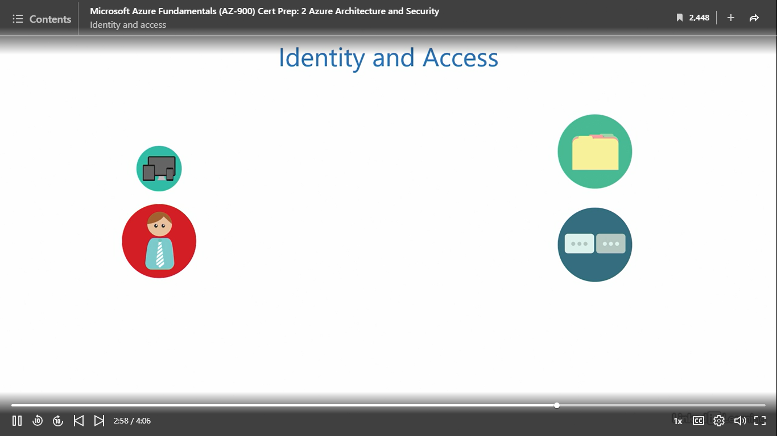

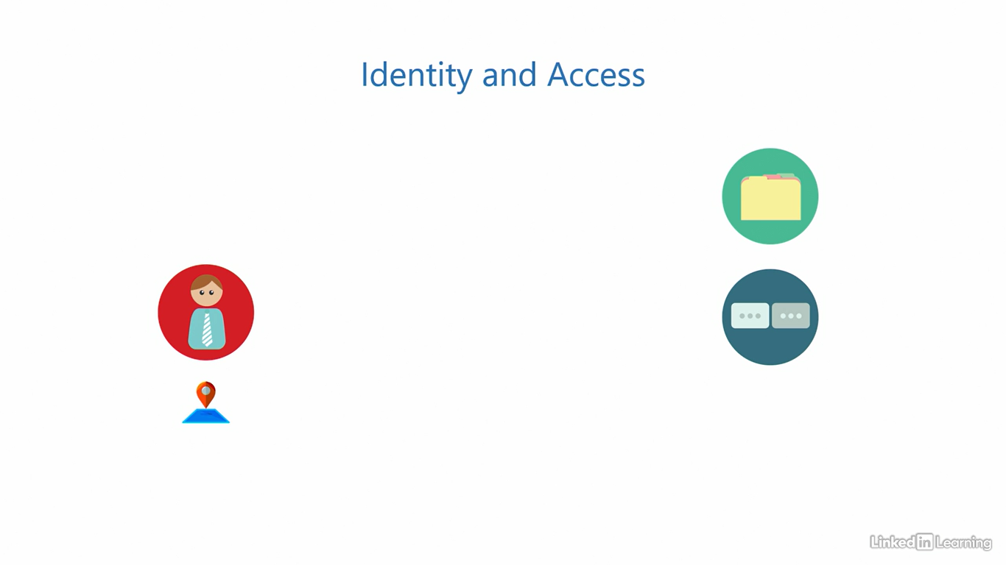

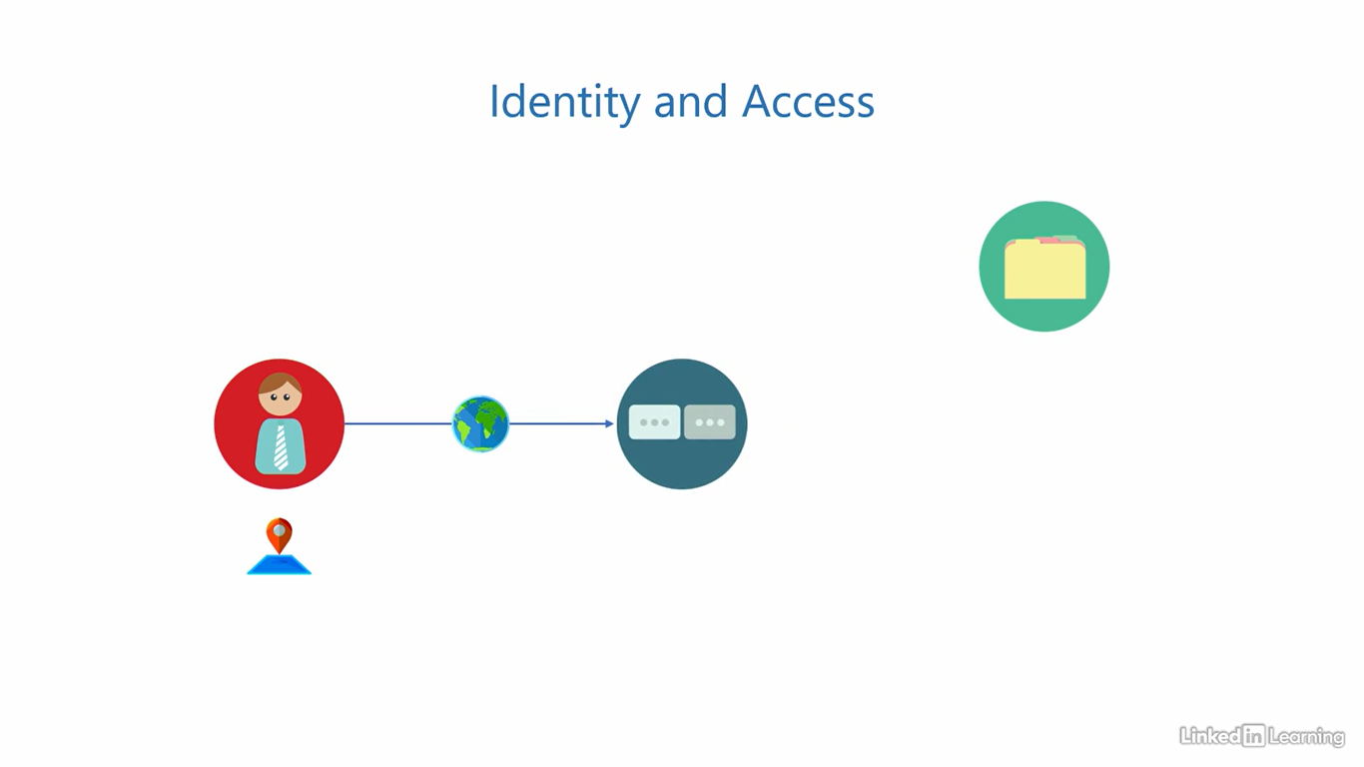

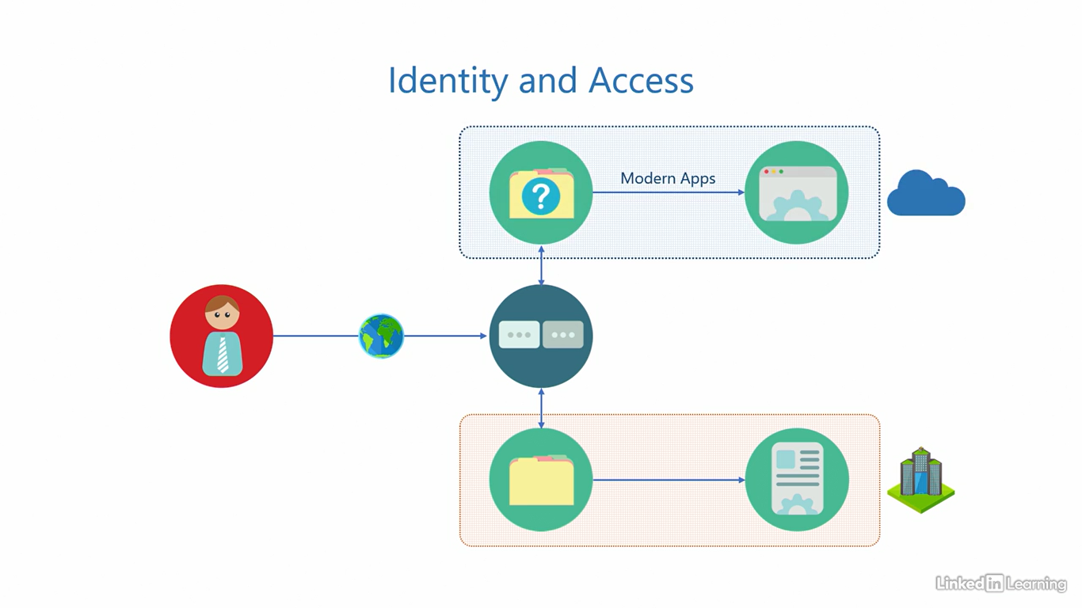

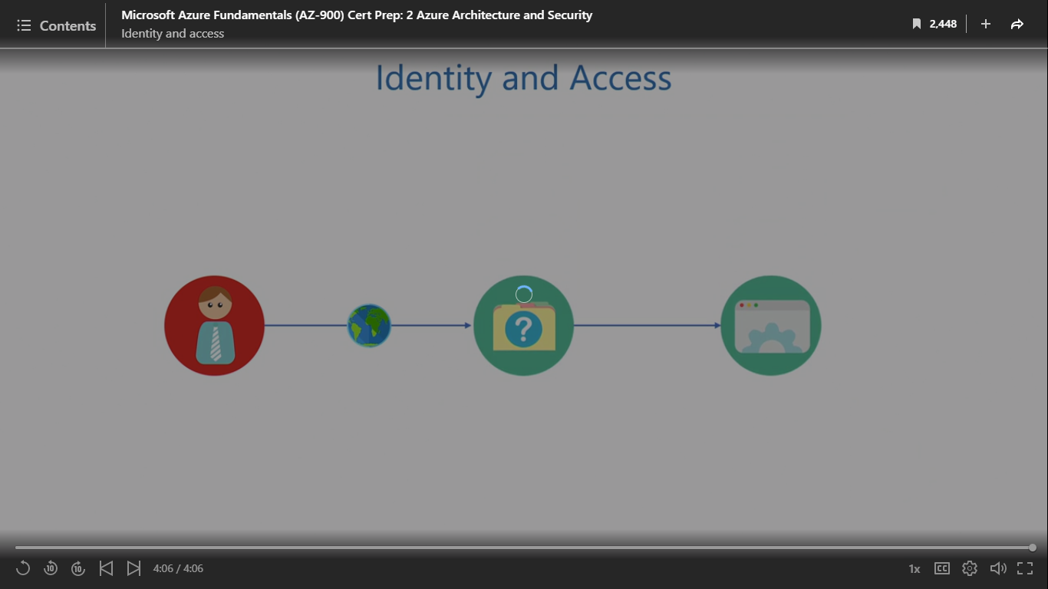

What is Azure Active Directory?

[Instructor] Azure Active Directory or Azure AD is a global Identity-as-a-Service solution. It's actually an umbrella of services supporting different identity and access scenarios. Identity-as-a-Service is basically a subset of SaaS, because Azure AD provides the software for the directory server as a service ready to use. So when we say Identity-as-a-Service, we are just being more specific about what type of service it offers. It is the first line of defense for all your cloud resources. It's job is to provide identity and access services for the modern day world. It has answers to all the challenges we discussed in the last video. That's how sophisticated it is. Azure Active Directory is the universal set for all Azure assets of an organization, kind of like a logical security boundary between your organization and other organizations in the cloud, because Azure is a public cloud, and this boundary is called an Azure Active Directory tenant or simply an Azure AD tenant. All organizations will ideally have only one Azure AD tenant with the exception of mergers and acquisitions. A default directory and domain are provisioned when you sign up for Azure. Remember I mentioned that when you sign up for an Azure subscription, a couple of its associated assets are also provisioned, one was the Root Management Group named the Root Tenant Group. The other asset is an Azure AD tenant. So during the signup process, Azure creates a default Azure AD tenant, creates the tenant root group and then places the subscription under the Root Management Group. The purpose of a domain in the tenant is to uniquely identify your Azure tenant on the internet. Just like families have a common surname, a tenant must have a unique domain name. That is what binds the resources of your organization together. You probably remember the domain from the Create a Subscription demo. Azure is built from the ground up to support today's modern day applications. These modern apps are built on today's modern architecture and use the latest new generation protocols. Azure AD also enables you to manage users and devices along with the applications. This helps organizations be up to date with technology, ensure that employees are productive, and maximize their revenues. Azure AD is powered by artificial intelligence and machine learning. So instead of you trying to figure out if a request is real or fake, you can let the cloud do that for you. It also has analytics and logs to get insights into existing sign-ins, activities, and actions performed by users. Deploying Azure AD does not mean the on-premises infrastructure is of no use anymore. In fact, they go better together and make a hybrid identity infrastructure. You can use a tool Azure AD Connect to integrate your on-premises Windows Server Active Directory and synchronize its data to Azure. Both of them can work hand in hand to support applications across both environments. Let's get into the portal and see whatever default Azure AD tenant looks like. To open our default directory, I'll click on this icon here that says Azure Active Directory. That will bring us to this page. As you can see on top, this is the Default Directory. It was automatically created when we signed up for our Azure subscription. The overview page gives you a summary of your tenant resources, including the name of the tenant. You can see it says Default Directory again, its ID, the domain it is using, and the current licensing level. On the right, you'll also see the total number of users, groups, applications, and devices that are a part of this tenant. I'm not a big fan of the name Default Directory, so what I'll do is click on Properties here and then go to the Name text box. I'll rename this directory to something more meaningful. Let's call this AZ 900 Directory. I'll have to hit the Save button at the bottom to confirm the name change. This can take anywhere from a few seconds to a few minutes depending on the number of resources in your tenant. My tenant over here is brand new with a very few resources, so this should be quick. I'll refresh the page to see if the name change has come into effect. Looks like this operation was successful. You can see the new name reflects on the overview page and here on top of the screen. I mentioned in the slides that Azure AD is the universal set for all Azure assets of an organization. That's why in the blade on the left, you'll see options to manage users, groups, enterprise applications, devices, and custom domains. The AZ 900 exam only requires you to have a high level understanding of Azure AD and its purpose in the Azure ecosystem. You are not expected to know how to configure it.

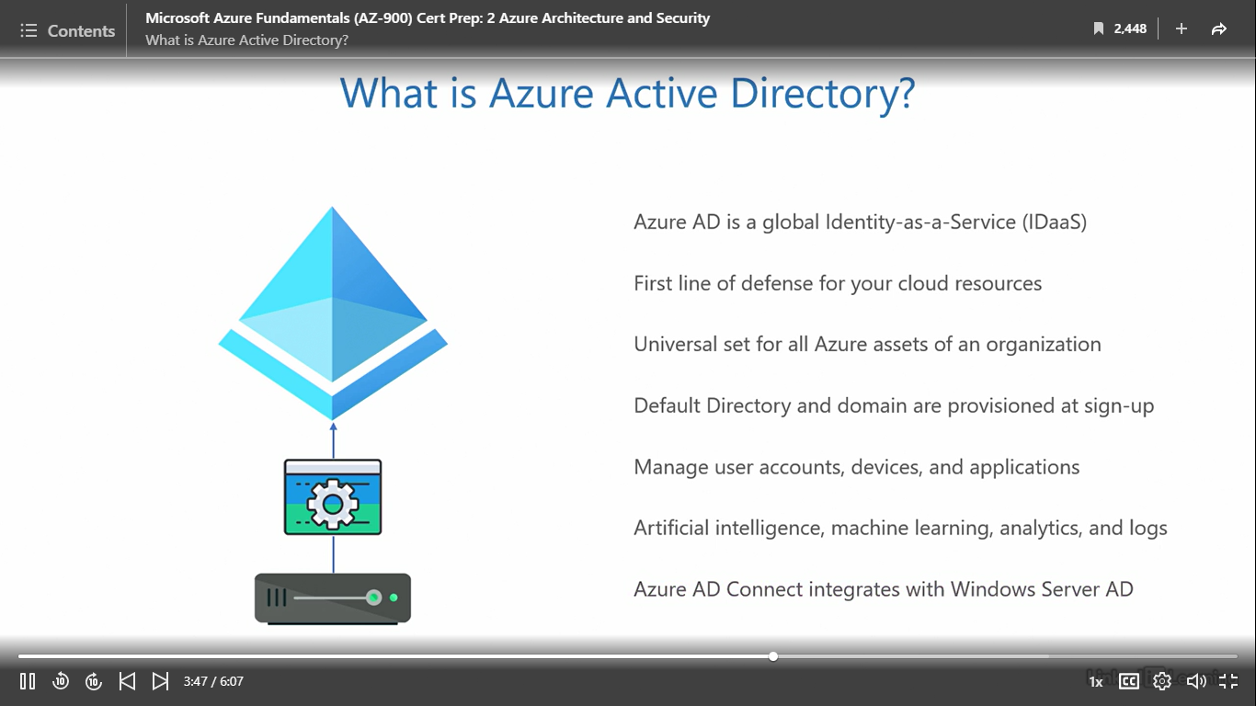

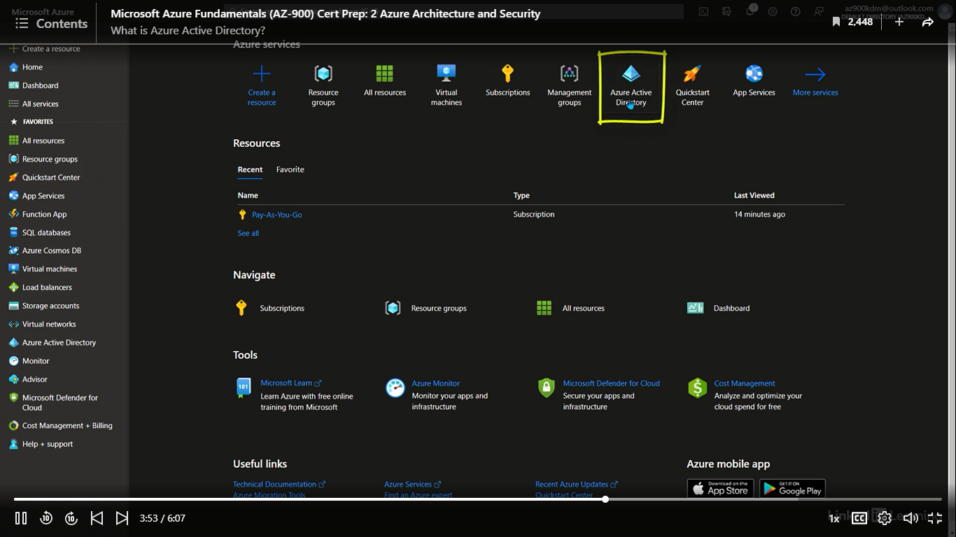

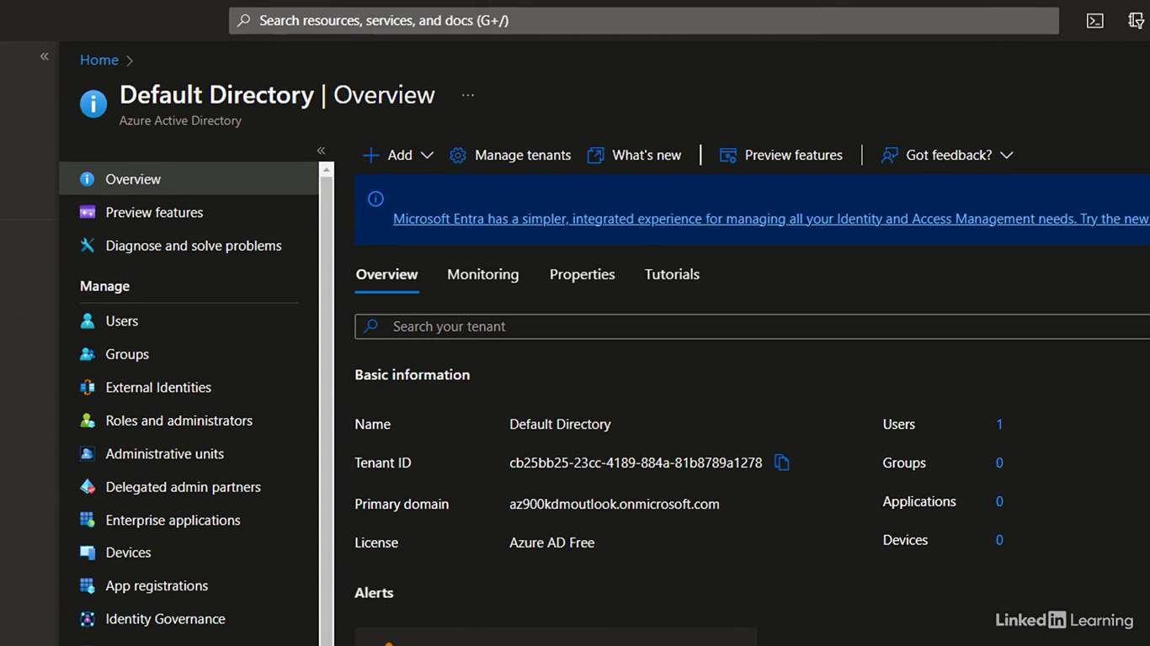

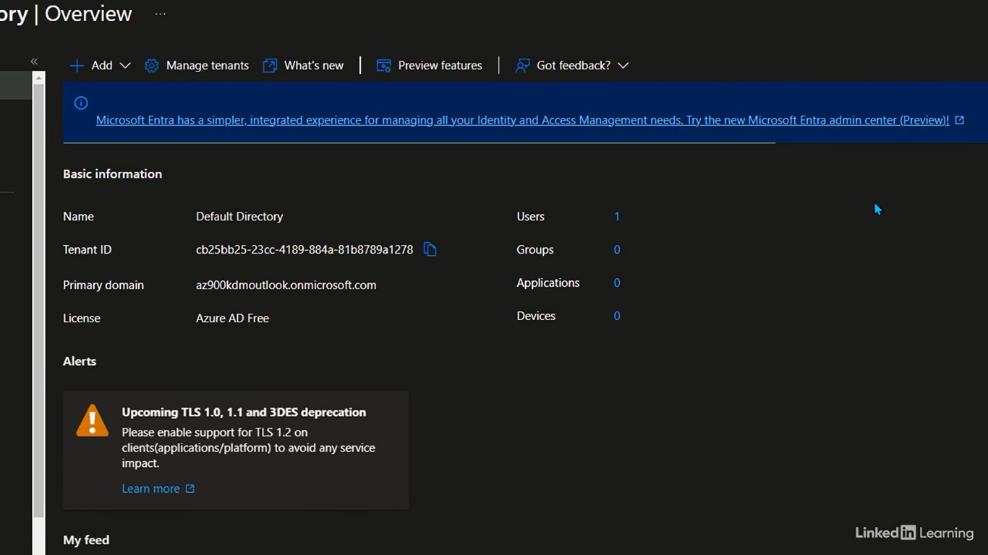

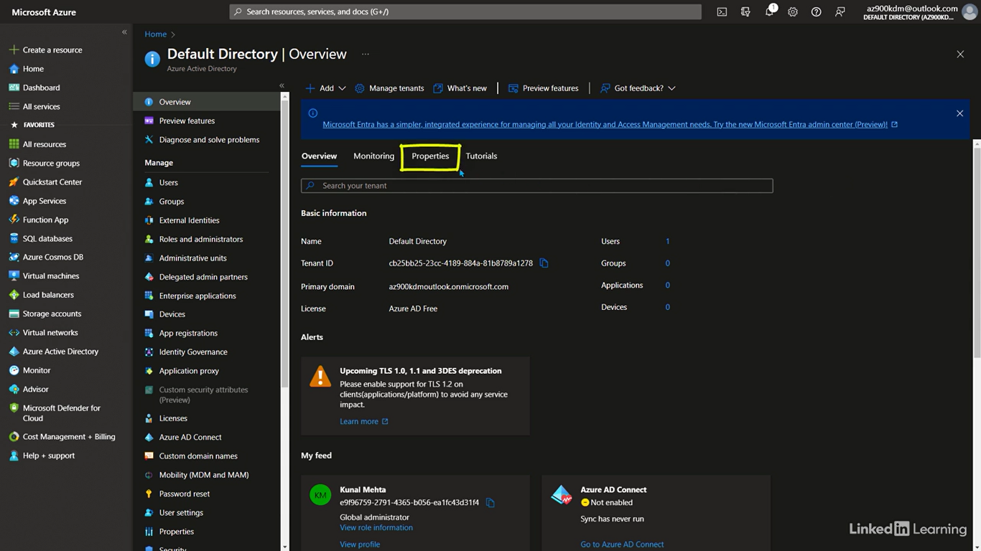

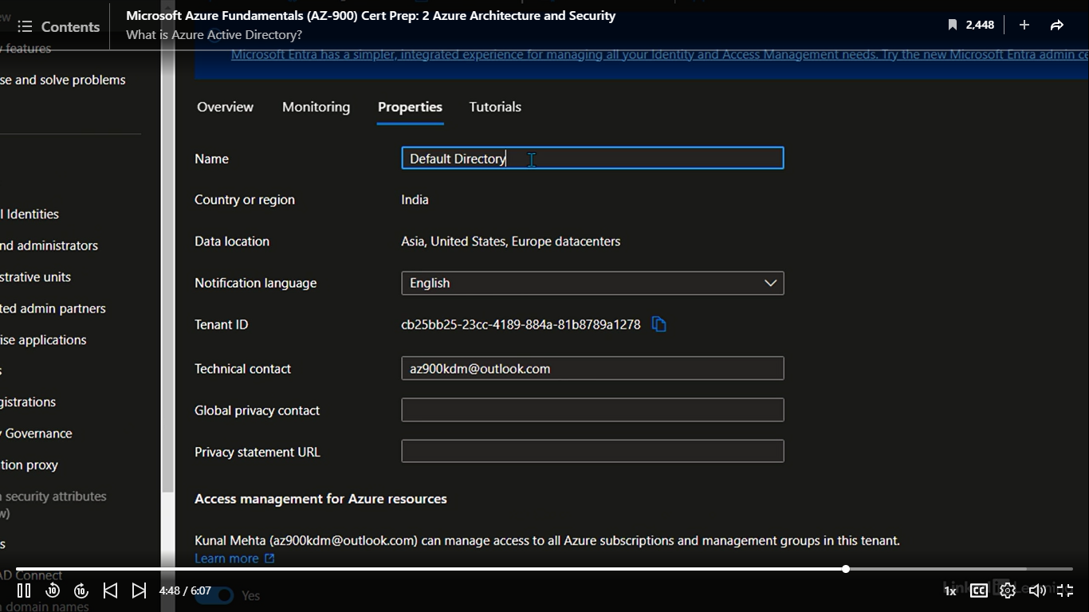

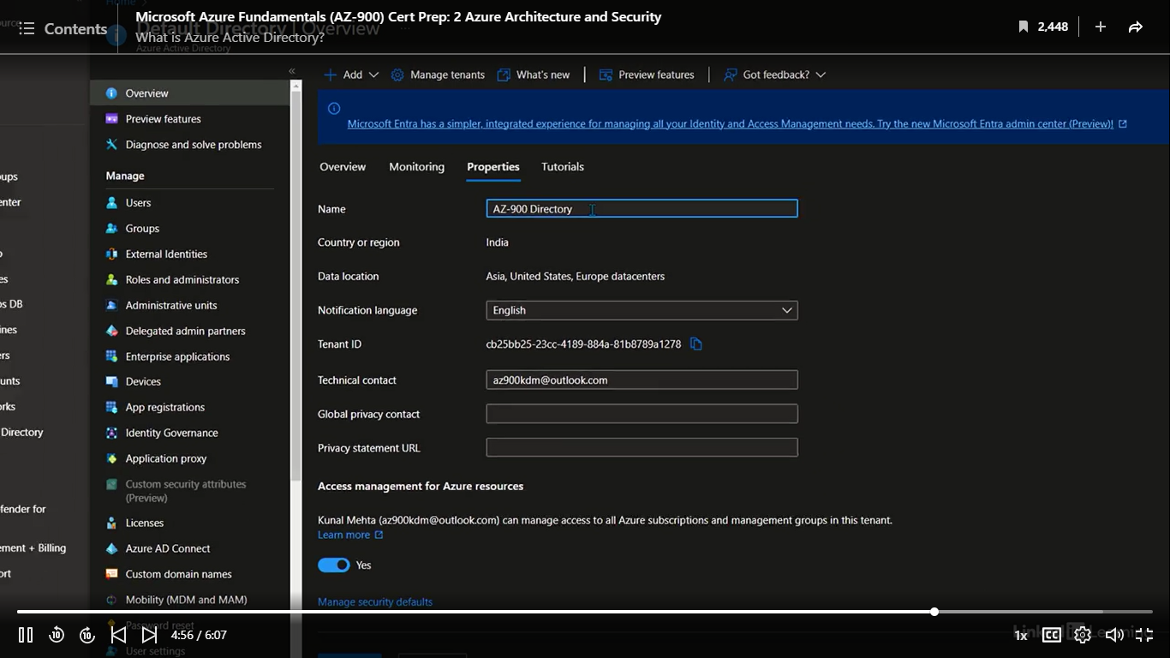

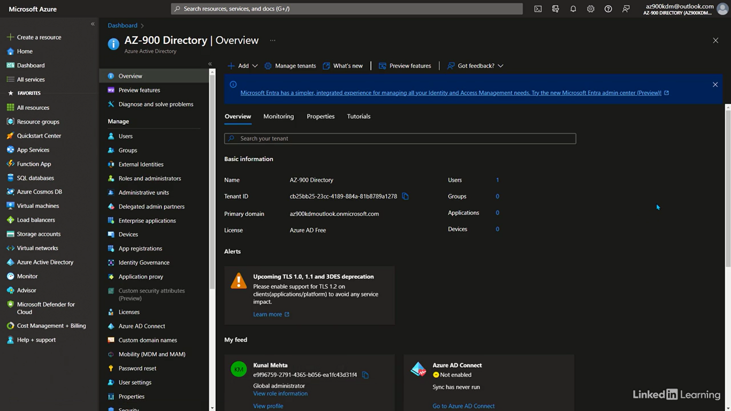

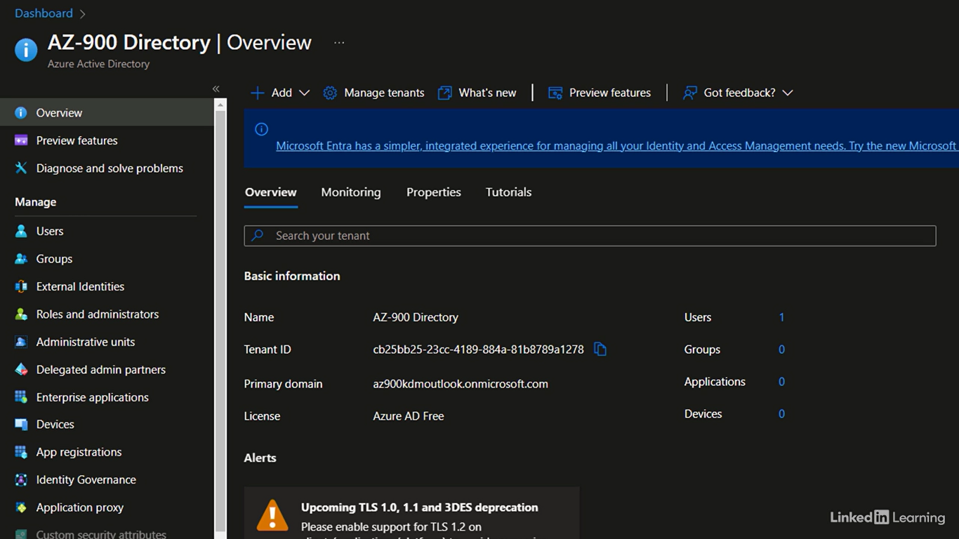

Understand users, devices, and applications

[Kunal] Users, devices and applications are three key pillars of any IT environment. Users use devices to build and deploy applications. Without any one of them, there's nothing to do. That makes them the most frequently used entities on a day-to-day basis and the most targeted by attacks. Let's see how Azure helps us protect them. Users created in Azure AD are called cloud-native users. They have all the modern cloud-enabled features and security attached to them. Their entire lifecycle is controlled within Azure, right from creating, modifying, and deleting these accounts. You can also have non-native user accounts that are synchronized from on-premises environment using AD Connect. By default, all users are created as standard users, meaning they have very few permissions, but if you want, user permissions can be elevated through Roles. Assigning them specific roles will allow them to perform tasks they're responsible for and help take the load off your shoulders. Then, just like you can put resources into a resource group for managing them collectively, you can do the same here. You can add users to groups: security groups and Microsoft 365 groups. These are the two types of groups in Azure AD. The first is purely used to assign permissions to users, whereas the second one is used to enable collaboration among the users, like users in the same department or working on the same project. You also have support for devices of multi-form factors and operating systems. Doesn't matter if your users have a Windows surface or a brand-new iPhone. They will be able to securely access applications and resources in the cloud. To manage these devices, you either need to join them to the corporate domain or register them with Azure. There are three methods to do that. Standalone Windows computers can be joined directly to the cloud using Azure AD Join. Windows computers that are already a part of an on-premises domain can be joined to Azure using Hybrid Azure AD Join. And to support bring your own device scenarios, also commonly known as BYOD, where users use their own devices instead of company-issued devices, you can implement Device Registration. This works for both Windows and non-Windows devices, like iOS, Android, and macOS. With Azure, you get native support for modern apps: SaaS, PaaS, IaaS, as well as legacy applications that use traditional architecture and protocols. For the modern apps, developers can choose any modern protocols, like OAuth, SAML, OpenID, and WS-Federation. If you don't know what these are, don't worry. Just remember that these are authentication and authorization protocols that Azure supports for modern applications. Let's switch to the Azure Portal and create a new user. In this demo, we will create a new user account. To do that, let me click on Users option in the left side menu. You can see there's only one user account in the entire tenant right now, the one with which we signed up for Azure. Here's the thing. The account we used to sign up should be kept aside safely for emergencies, preferably with a complex password. It is also recommended that you have at least two user accounts with full control of the tenant, so now we will create a new user account and start using that one from here on. Leave this account aside for safekeeping. I'll click on the New user button on top of the screen and select the first, Create new user, option. This is the Create New User page. Over here in the Select template, I'll leave the radio button on Create user because we want to create a new user in our Azure AD tenant, not invite an external user. Scroll down to the Identity section. Here, you'll need to enter the username for this new account. We'll leave the domain as it is for now. Next, I'll add the account holder's full name, first name, and last name. That is Kunal D Mehta, Kunal D, and the Mehta. Create an initial password for the account. Then, if we want, we can directly add this user to existing groups from right here, but we haven't created any groups yet, so I'll leave this as it is. In Roles, I'll assign this new account full control of this tenant. To do that, I'll search for global administrator and then mark the Global administrator checkbox. Any user who has this permission assigned will have full control of your Azure tenant. Use this with extreme caution. Only assign this to users who really need it. I'll then click on the Select button at the bottom to assign these permissions to the user. Down below, we also have the option to add additional information about the user in this section. I'm going to skip past that for now. And then, finally, click on the Create button. In a few seconds, you should see the confirmation on success of creating the new user account and assigning them global administrative permissions on the top right corner. I'll refresh the page. And there it is. From now on, I'll use this new user account and keep the older one aside safely for emergency use.

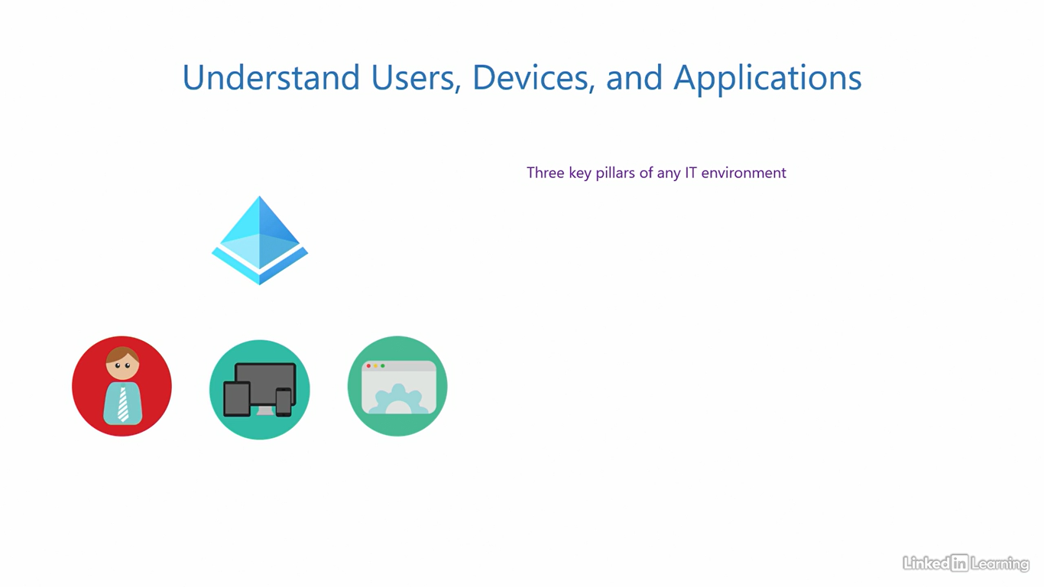

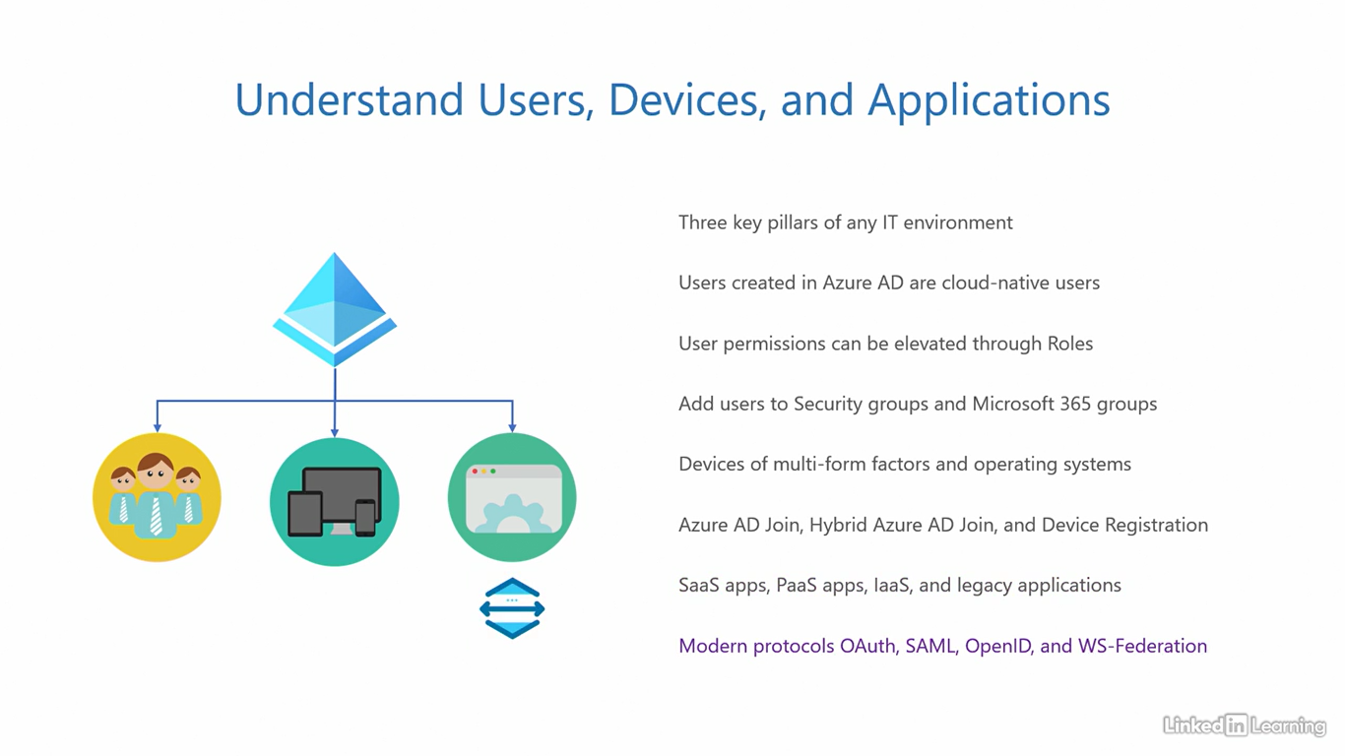

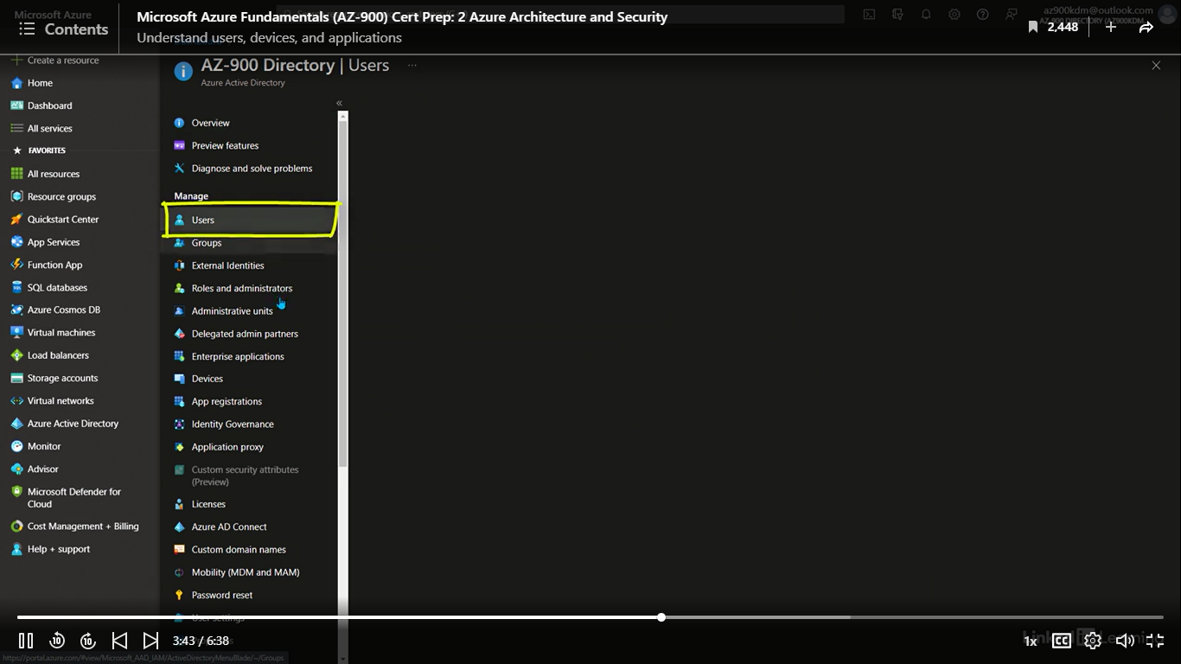

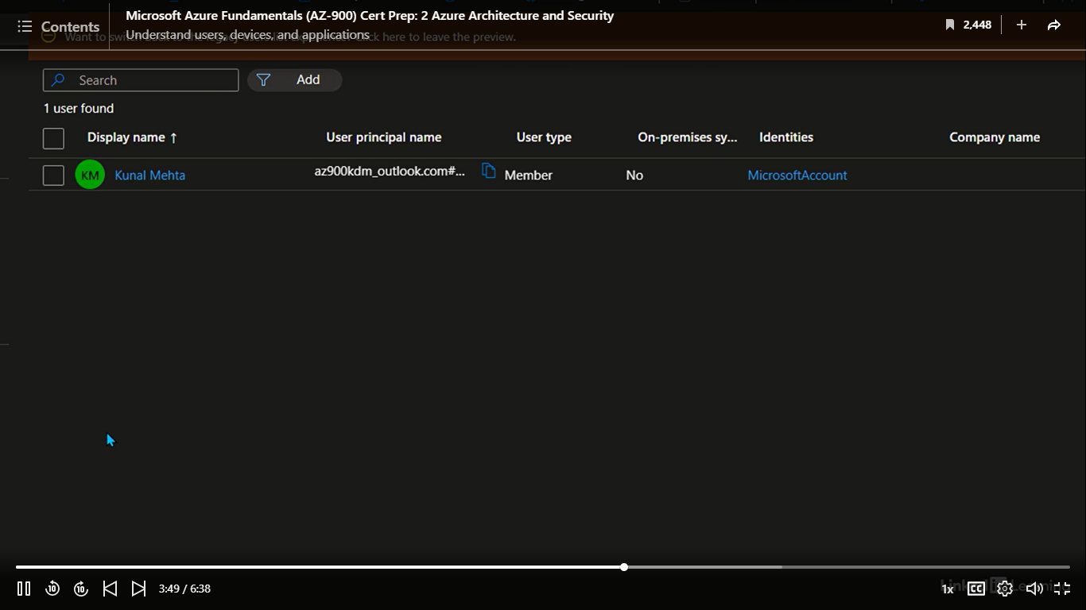

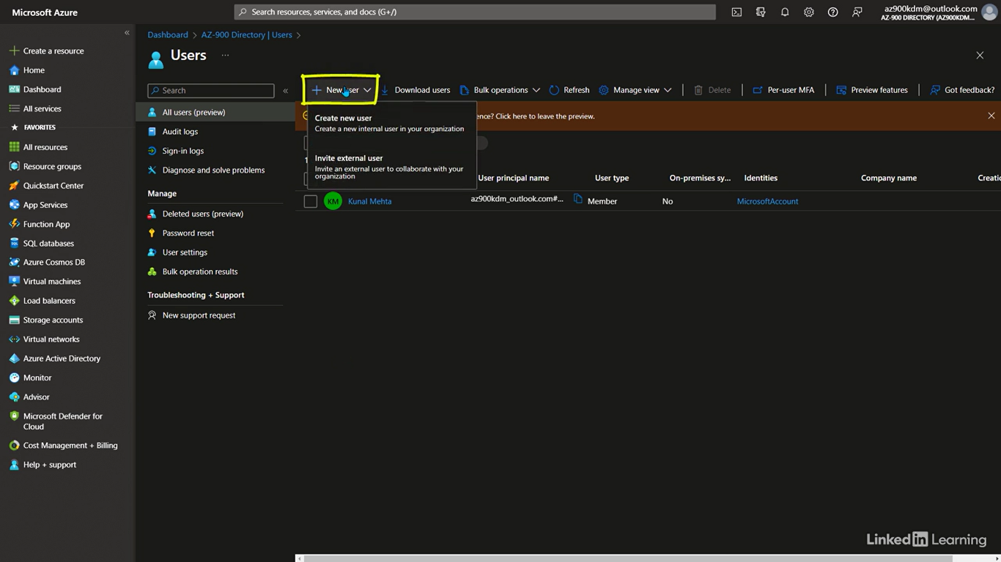

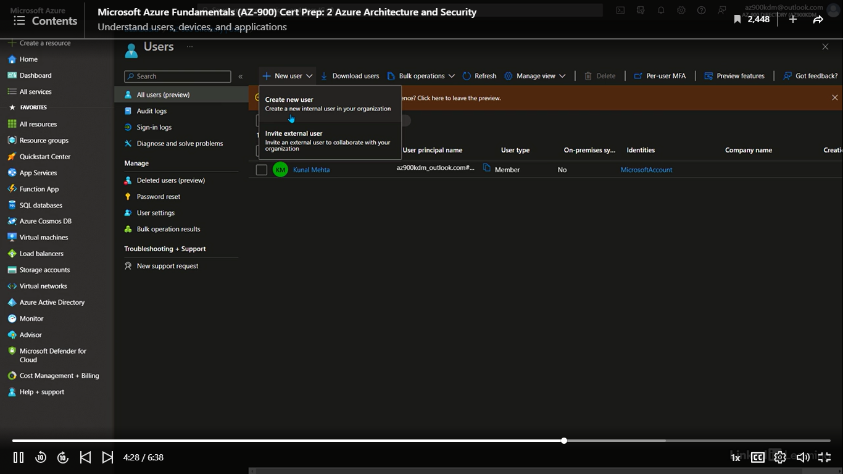

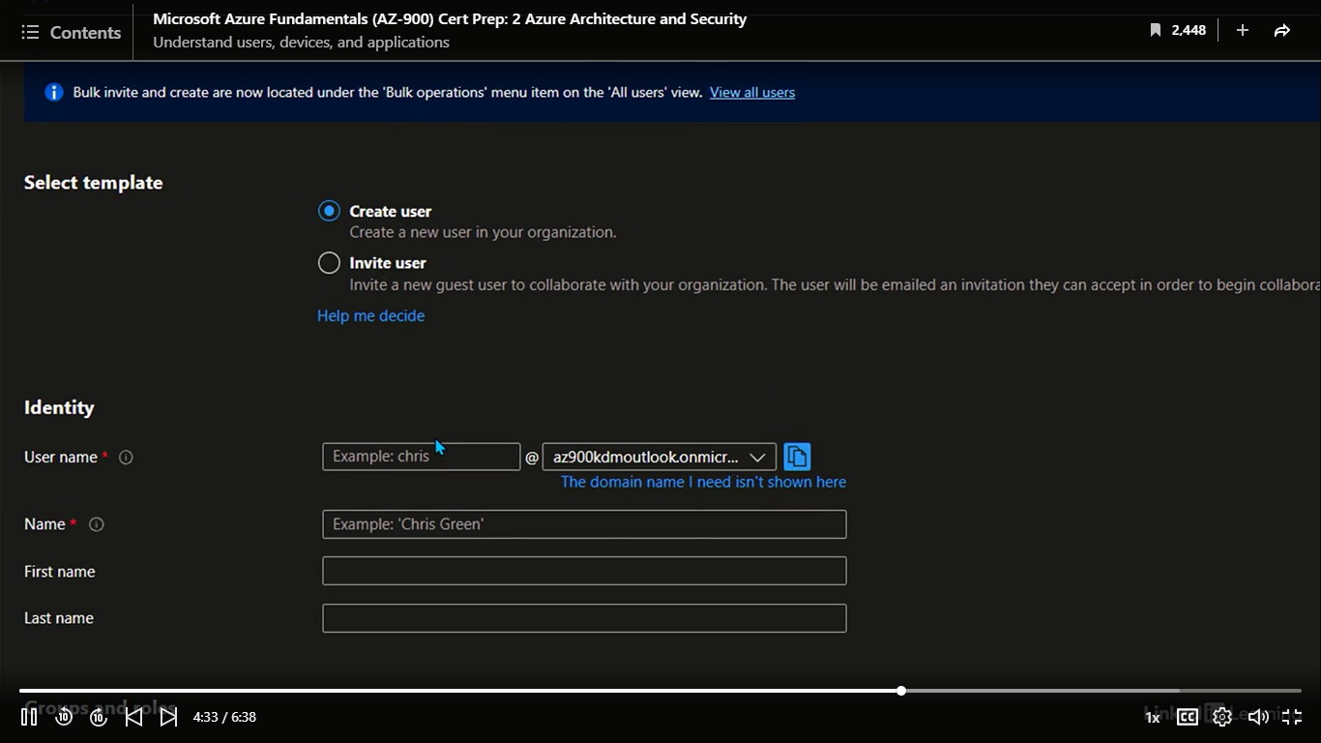

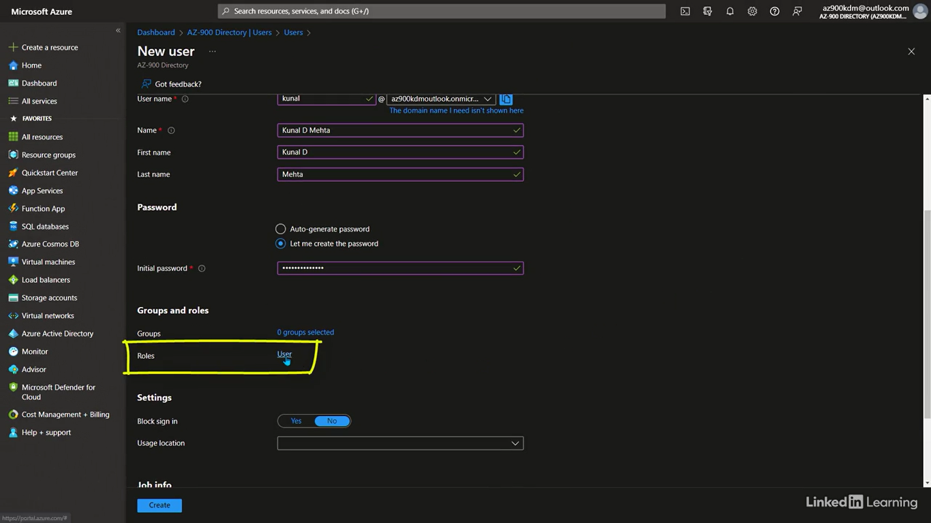

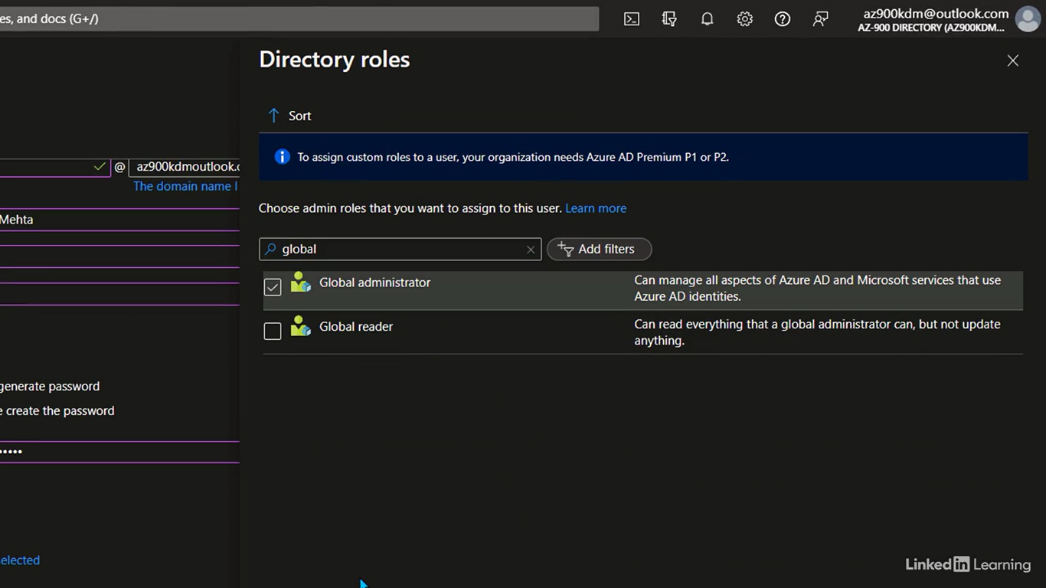

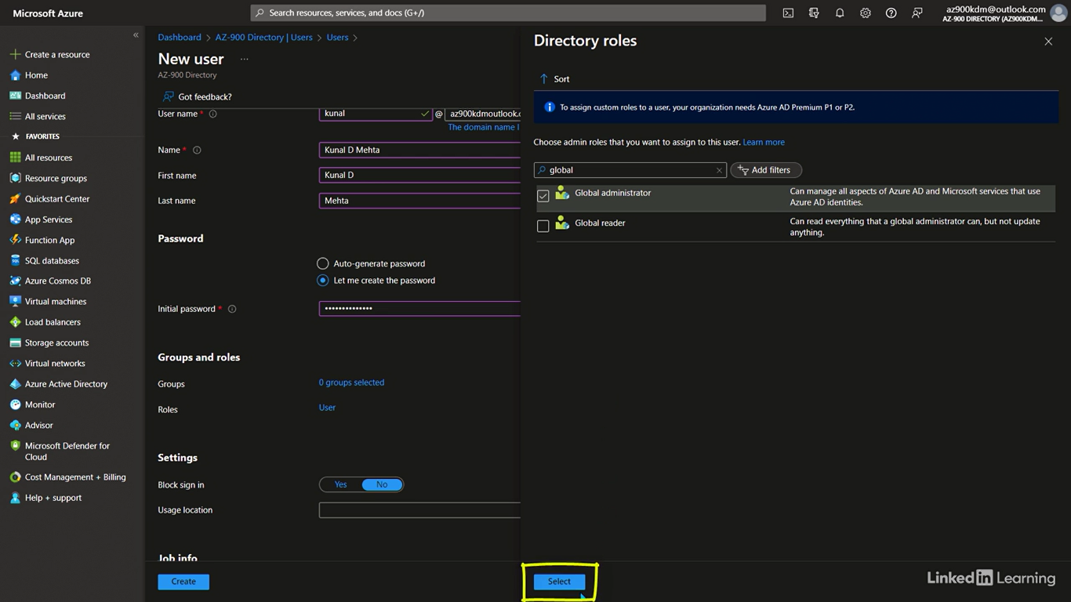

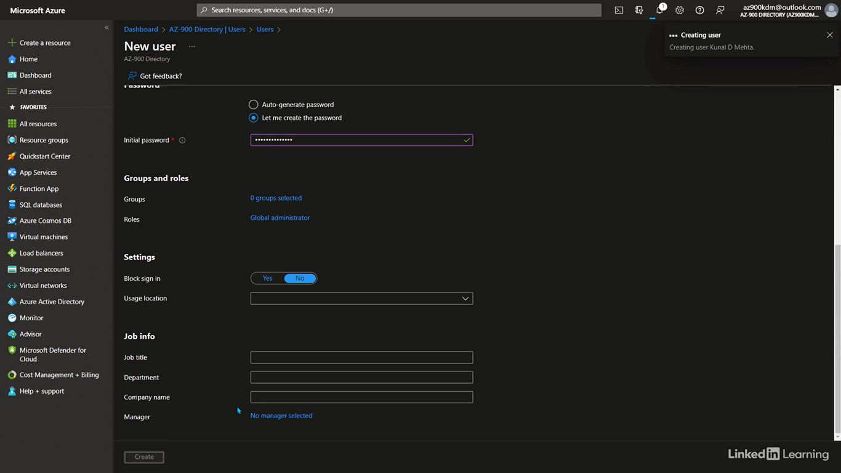

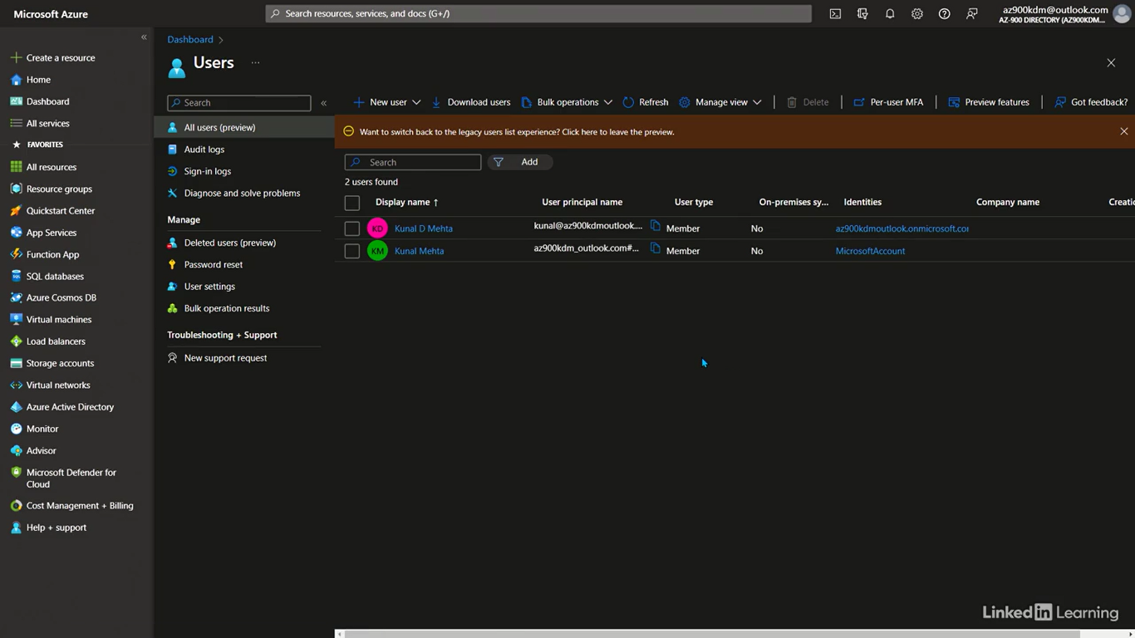

Understand Azure AD Domain Services

[Instructor] In the last video, I mentioned Azure AD enables developers to build modern applications using modern protocols. But how do we support traditional legacy applications? For that, we have Azure AD Domain Services. This service is specifically designed for applications that require traditional directory server services in the cloud. Directory-aware applications are those that require a directory server on-premises and the previous generation of protocols to function. When you migrate these legacy directory-aware applications to the cloud, Azure AD Domain Services offers those traditional dependencies to the application, but in the modern cloud environment. The ideal method would be to refactor or recode the application to use modern protocols that the cloud offers because they are better. But there are cases where refactoring the application to modern is not possible. Like if the application developers are no longer with the company, or you don't have access to the application source code, or the vendor who sold it to you no longer supports it. In such situations, you can use Azure AD Domain Services. It allows you to leverage the legacy AD protocols, such as Kerberos, NTLM, and LDAP in the cloud. These are the authentication and authorization protocols that legacy applications use. How Azure AD Domain Services works is that it provisions a standalone managed domain in Azure for these applications. This domain operates independently and is isolated from our primary Azure AD domain, so only for use by the legacy application. If you want to grant access to this application for users in the primary Azure domain, you can configure a one-way synchronization from Azure AD to Azure ADDS. So that's from your primary Azure AD domain to the standalone domain in Azure AD Domain Services.

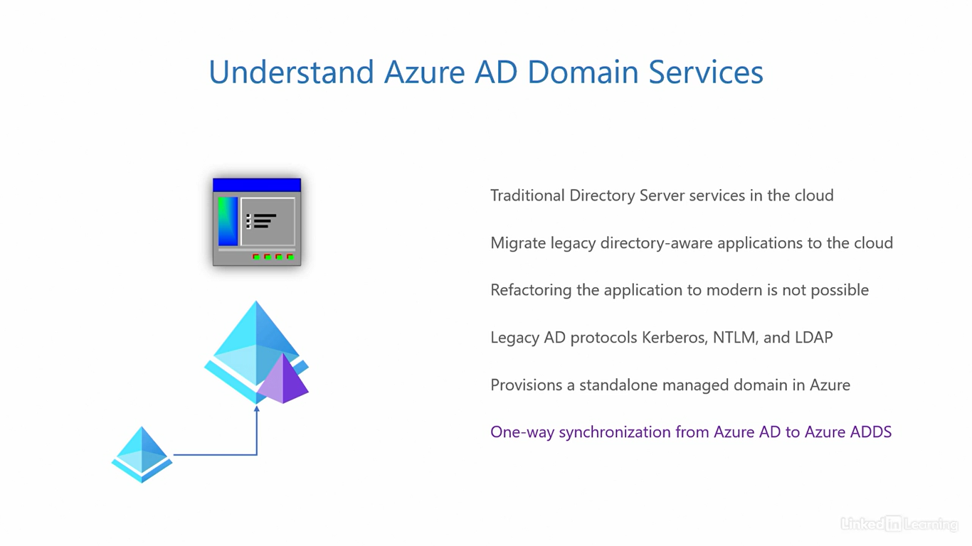

Understand Azure AD B2B and B2C

[Instructor] So far, we've discussed how Azure Active Directory supports users, groups, devices, and modern applications for an organization. We also talked about how it helps in the migration of legacy applications to the cloud. Now, let's talk about how it helps you manage the identities of external users, those who are not employees of your organization. The first solution we have is Azure AD Business-2-Business, or B2B. This is used when you want to facilitate collaboration with external organizations. For example, if your company is working on a project that requires the involvement of outside users, B2B can help you with that. It provides a secure channel for external users to access resources they need in your Azure environment. If you know, the traditional way to do this would be to deploy federation servers, but you don't have to go through that hassle in the cloud anymore. Because these are external users, their account lifecycle is controlled by the external organization, the organization that they belong to. Creating the account, modifying, deleting, all of that is done externally by them. Their directory authenticates their users and you simply trust their directory, but you control local authorization for your local tenant resources. This means what they do in your Azure tenant is completely under your control. Outside of that, not your responsibility. A B2B account lifecycle is generally managed by administrators. The next solution we have is Azure AD Business-2-Consumer, or B2C. This is intended for external users who are individual customers, not users from external organizations for collaboration. B2C is designed to support consumers using your public-facing applications at scale. If there is an application that you offer to the general public that anyone can sign up for, you can use B2C to manage their identities. When I say at scale, I mean the ability to handle hundreds, thousands, or millions of public accounts. You can use this for desktop applications, web, mobile and even single-page apps, the whole spectrum. What truly differentiates B2C from other tenants is the self-service for user account lifecycle management. The end users are free to sign up, create their profiles, make changes, or even delete their accounts if they wish to, all on their own without administrator intervention. For example, think of an airline app. I can install the app, sign up for their loyalty program, book flights, reschedule them, or delete my account altogether. The airline can use B2C in Azure to handle accounts of consumers like me and give me control to manage my account. A B2C account lifecycle is generally managed by the end customers or end users.

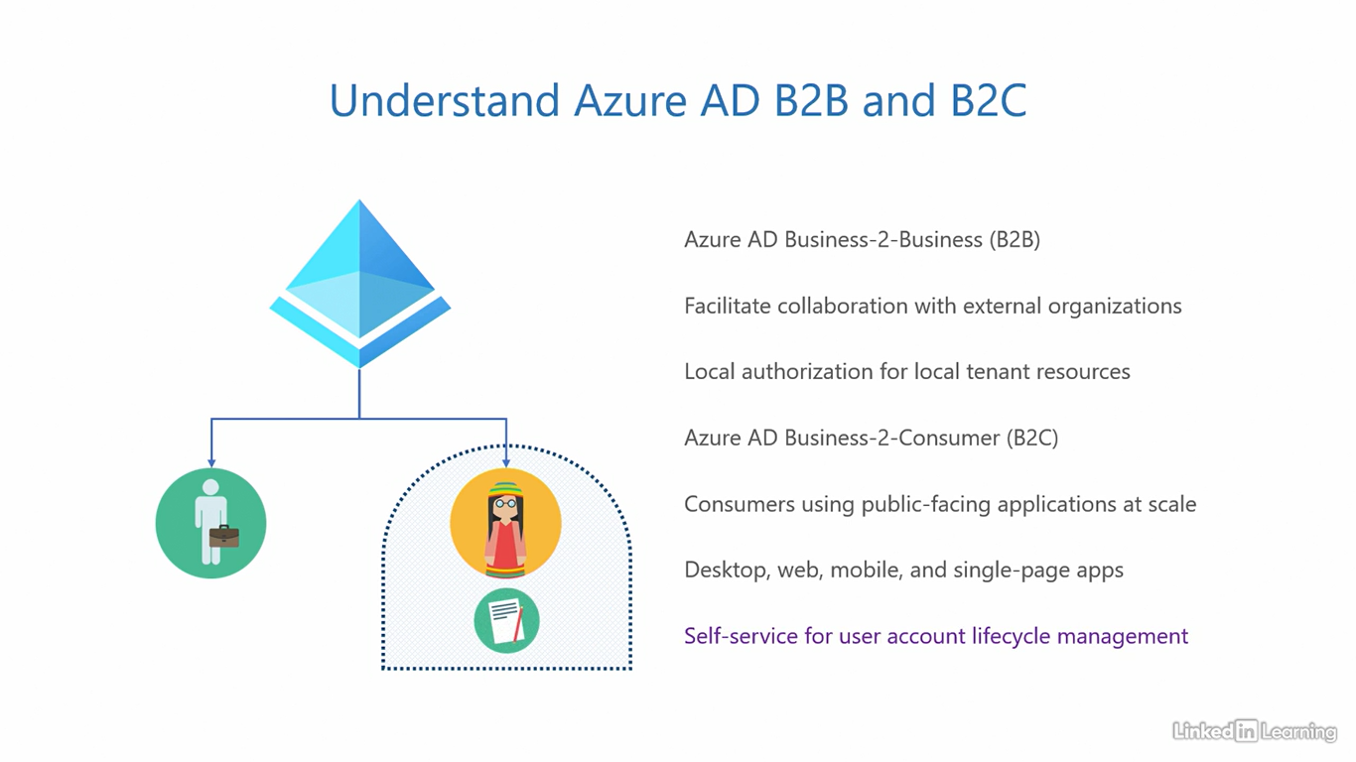

Understand multifactor authentication

[Instructor] We know that you need to provide your credentials to Azure AD for authentication, and in turn, get access to resources in the cloud. It's a simple one-step process, but what if someone somehow gets access to your credentials? Someone with not the best intent? It would be equally easy for them to access your resources, and perform unauthorized actions on your behalf. The consequence of that could be from bad to worse. Multifactor authentication can help prevent that from happening by creating an extra barrier to entry in addition to your password. Password is the first factor of authentication. If you add another factor of authentication, you get two factor authentication, password plus one more. Add another one, and you get three factor authentication, and so on. Whenever you have two or more factors, we refer to it as multi-factor authentication. A user must pass through all the factors successfully in order to gain access. The industry standard is to use two factors. This concept operates on three principles. Something you know. Something you have or something you are. Something you know is a piece of information that only you would know or remember. Something you have could be an object that only you possess, and something you are is an attribute that is unique to you. Something you know in the IT world is typically a password. We all know this one. Something you have can be an authenticator app on your mobile phone. A FIDO2 security key or an OATH hardware token. The authenticator app is installed on your mobile phone, and generates one-time codes that only work with your account. FIDO2 security key is a USB device, and OATH token is a little physical device that generates one-time codes just like the authenticator app. This means even if someone gets your password, they still won't be able to authenticate, and sign into your account unless they have one of these. There's also an option for cellular-based text messages and voice calls. You can use a one-time password or OTP delivered through an SMS or a voice call for authentication. Personally, I prefer the previous options because a SIM card can be spoofed easily and is less secure. These were something you have choices of authentication. For a choice of something you are based authentication, we have Windows Hello for Business. It uses facial recognition for authenticating users. You will need a webcam on a Windows computer for this to work. A face is an attribute unique to each user, and that's why this is a something you are choice of authentication. By default, when you enable multifactor authentication, it always prompts for the second factor after the first one completes successfully. While that's great for security, users can quickly get annoyed with it. To avoid that, Azure can trigger multifactor authentication based on signals of a sign-in attempt. That is depending on how risky a sign-in attempt appears to be. The big question is, does MFA really make a difference? Based on a Microsoft study, they say MFA can help prevent 99.9% of the attacks on corporate accounts, so it's definitely worth implementing. Let's take this for a spin. I want to reiterate that for the AZ-900 exam, you only need to know the concept of multifactor authentication in Azure. You do not need to know how to configure and implemented. For this demo, I've already configured multifactor authentication on my account, the new account we created in the last demo. My goal is to only show you what MFA looks like in action. I'm here on the sign-in page for the Azure portal. I'll first enter my password, which is the first factor. If the password is correct, the sign-in page will ask me to approve the sign-in request on the authenticator app on my smartphone. The authenticator app on my phone has already been linked to my Azure account. This is the screenshot of the notification I got on my smartphone. Once I tap the approved button on the phone, the sign-in page gets the green signal, and redirects me to the Azure portal. If any of the two factors are not completed successfully, the sign-in will fail. This ensures even if someone has your password, they cannot get access to your account without explicit approval from your phone. And if it happens that you get the notification when you're not expecting it, that's a hint that something suspicious is happening to your account Immediately change your password in such a situation.

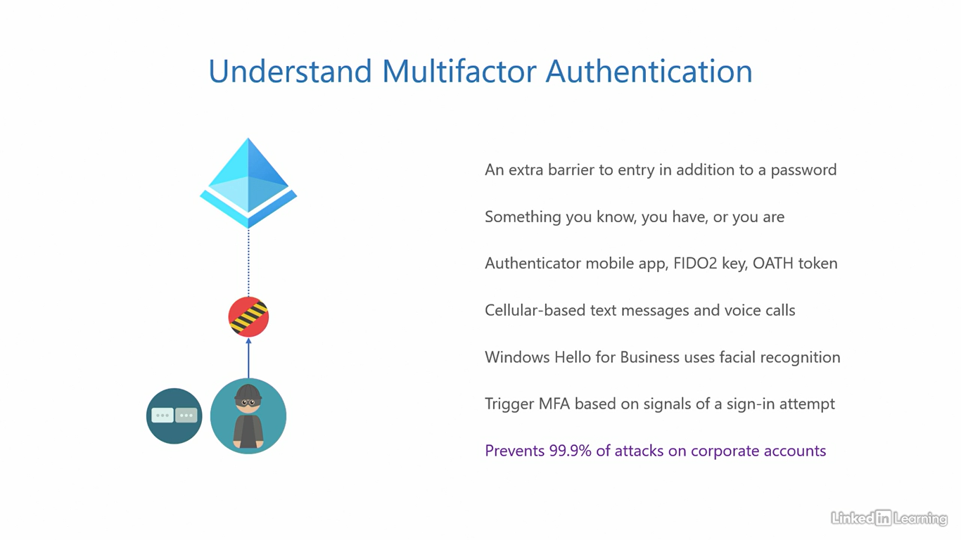

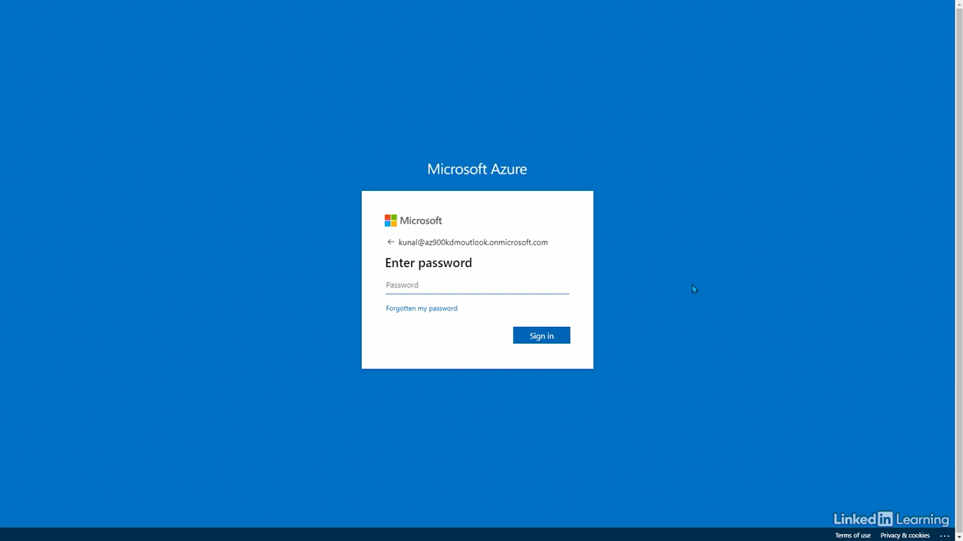

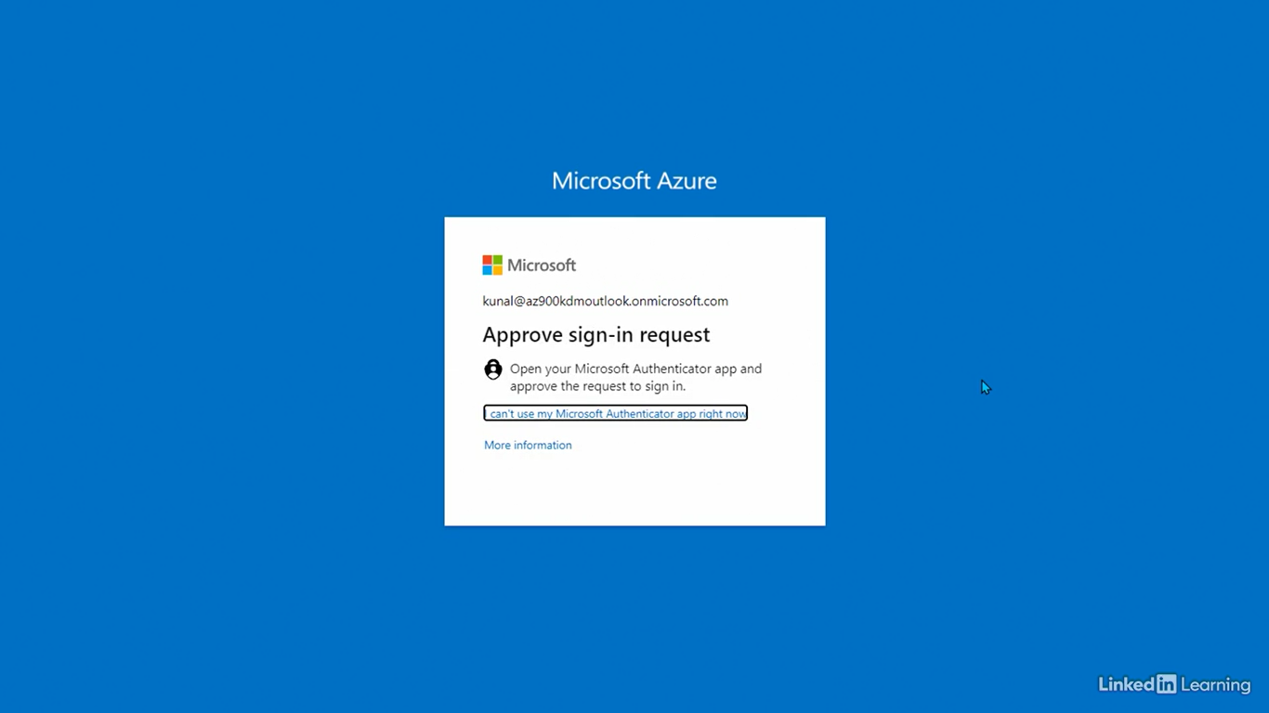

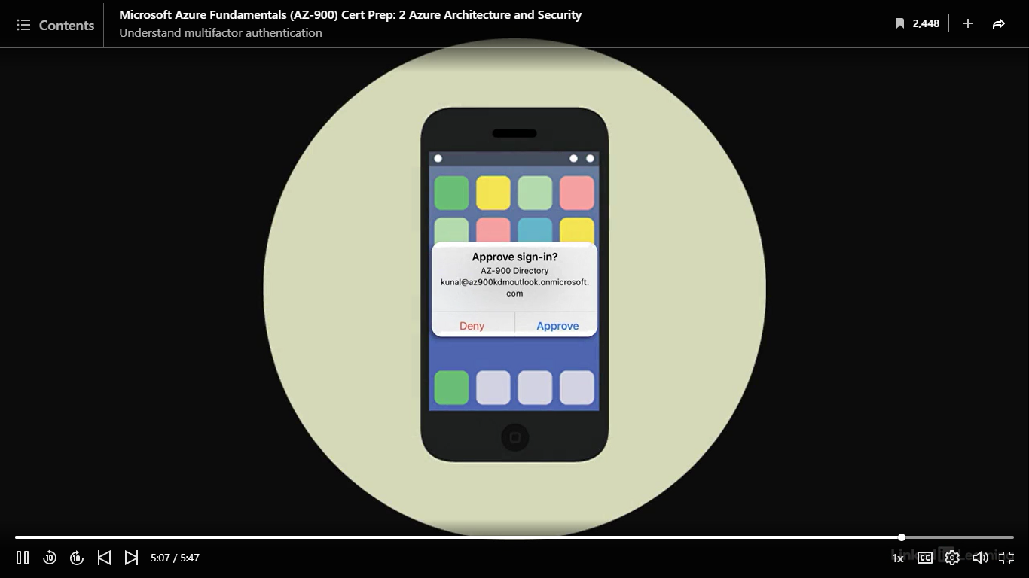

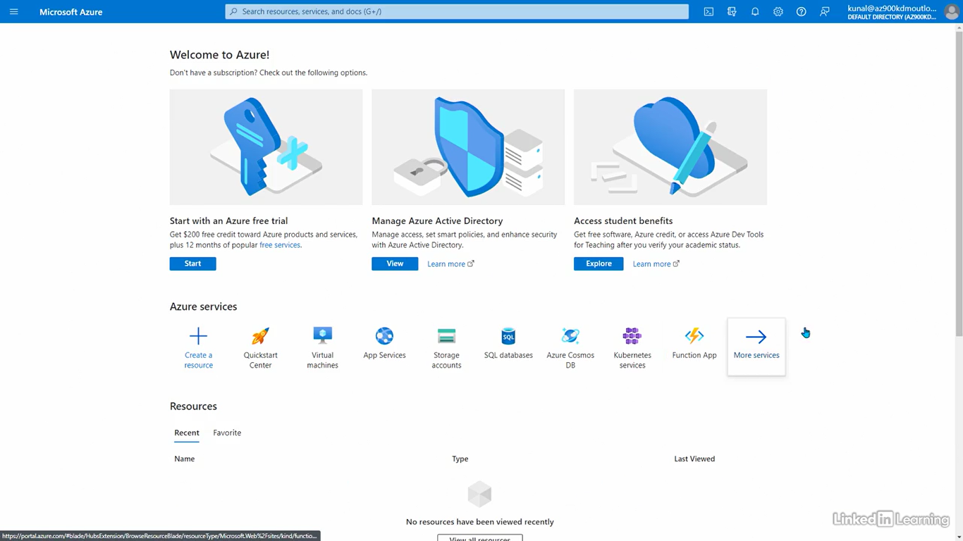

Understand passwordless authentication

[Instructor] The goal of passwordless authentication is to get rid of the need to use passwords in IT. The word passwordless is self-explanatory, but I know you are wondering, "Why do we need to get rid of passwords?" That is because using passwords has a lot of drawbacks, and in today's world where security is absolutely critical, passwords are not good enough. The two main problems are, simple passwords break easily, and complex ones are difficult to remember. You know what I'm talking about. With as many accounts as we have today, it is humanly not possible to remember unique strong passwords for all of them. So what do we do? We either use simple passwords that break easily or share a single complex passwords across all accounts. If not that, we write down the passwords on paper. Let the browser remember our passwords or user password manager to auto fill all our passwords. Any of those methods can leak your passwords, and compromise your accounts. So instead of going through all that pain, why not simply get rid of passwords? You have learned that in multi-factor authentication, we use a second factor for authentication in addition to passwords. If the other factors are stronger and more secure than passwords, why not make one of those our first factor or the primary mode of authentication? Our first step can be something you have, plus the next step could be something you know or something you are. Something you have can be a computer assigned to you, a smartphone or a security key. In addition to that, something you know can be a four to six-digit pin or something you are can be facial recognition. The good news is we have the solutions to implement passwordless authentication in the Microsoft ecosystem. You can have a Windows 10 computer, an authenticator app on the mobile, a FIDO2 security key, plus a Windows pin or Windows Hello for facial recognition. So you get two factors, but without having to use passwords. In fact, I get notifications on my Apple Watch to approve or deny a sign-in request. I can simply tap on approve and sign-in. That's how easy passwordless can be. Azure has built-in support for passwordless with seamless single sign-on. But before we do that, here's Passwordless authentication. Just like the previous demo, you don't need to know how to configure, and implement passwordless. My goal is to only show you what it looks like in action. I'm back on the sign-in page for Azure. This time I will not enter my password. Instead, I will click on this little link that says, "Use an app instead." This is the password alternative. The sign-in page will ask me to approve sign-in by entering a number into the authenticator app on my smartphone. That number over here is 86. Just a reminder, my app is already linked to my Azure account. This is the screenshot of the notification from my phone. I have to enter the number from the sign-in page into the text box on my phone. I type in 86 and then tap on the yes button to confirm it is me who's trying to sign in. Once done, I'm redirected to the Azure Azure portal. Try to comprehend how great this is for security. In the previous multifactor authentication demo, you had to enter the password, but here nothing except the email address, which is already public.

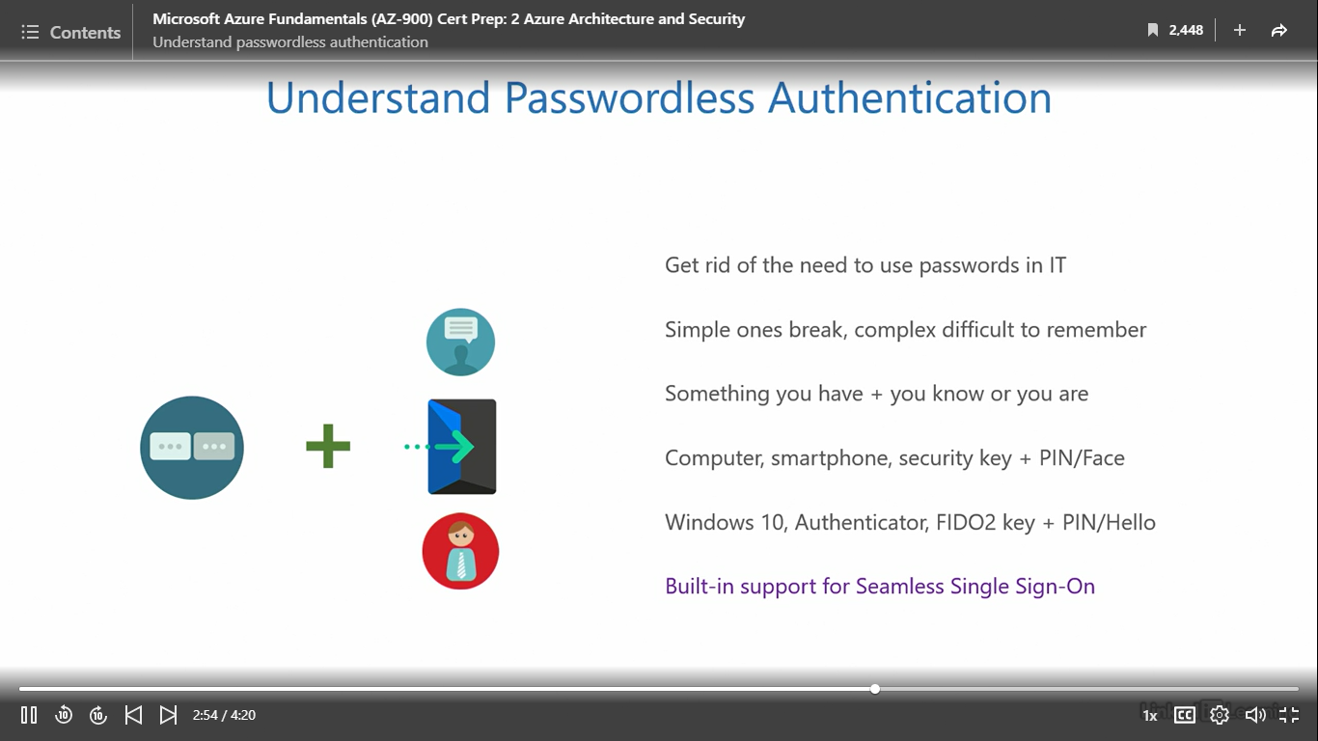

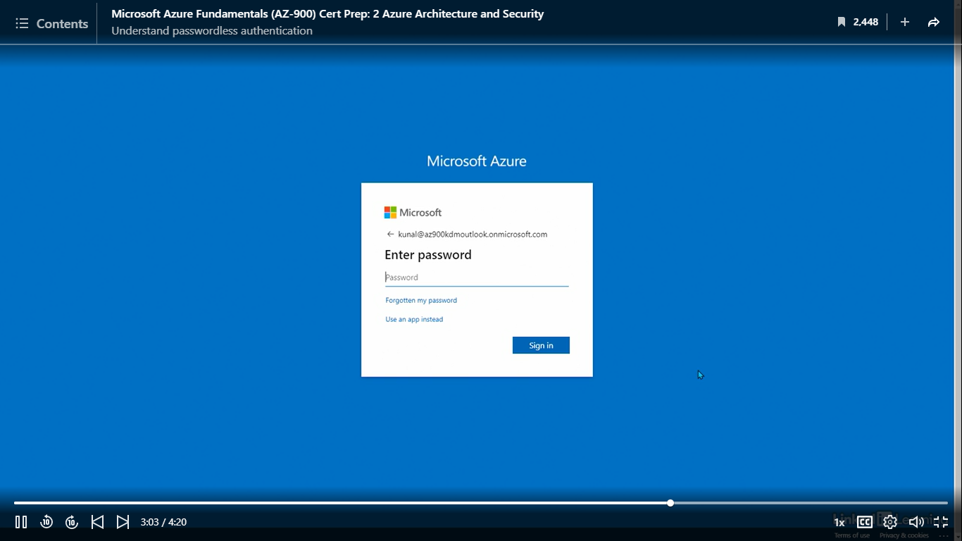

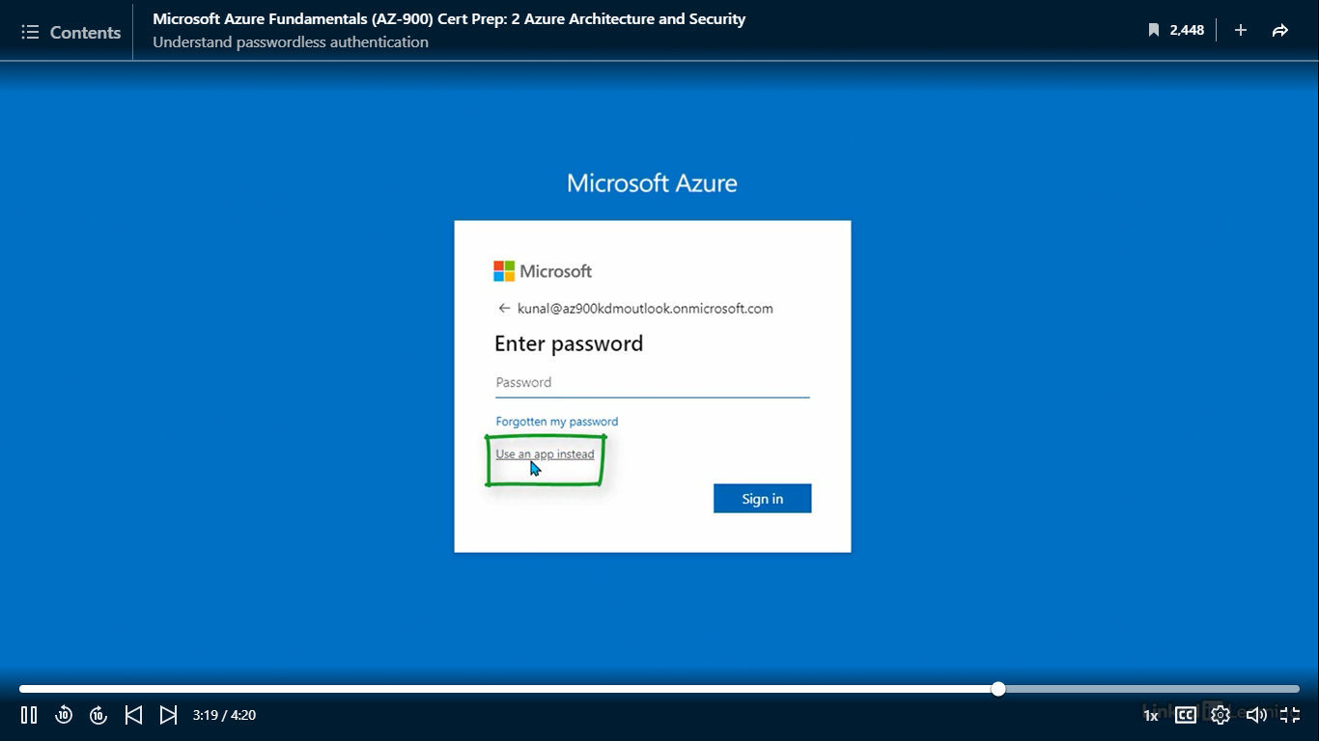

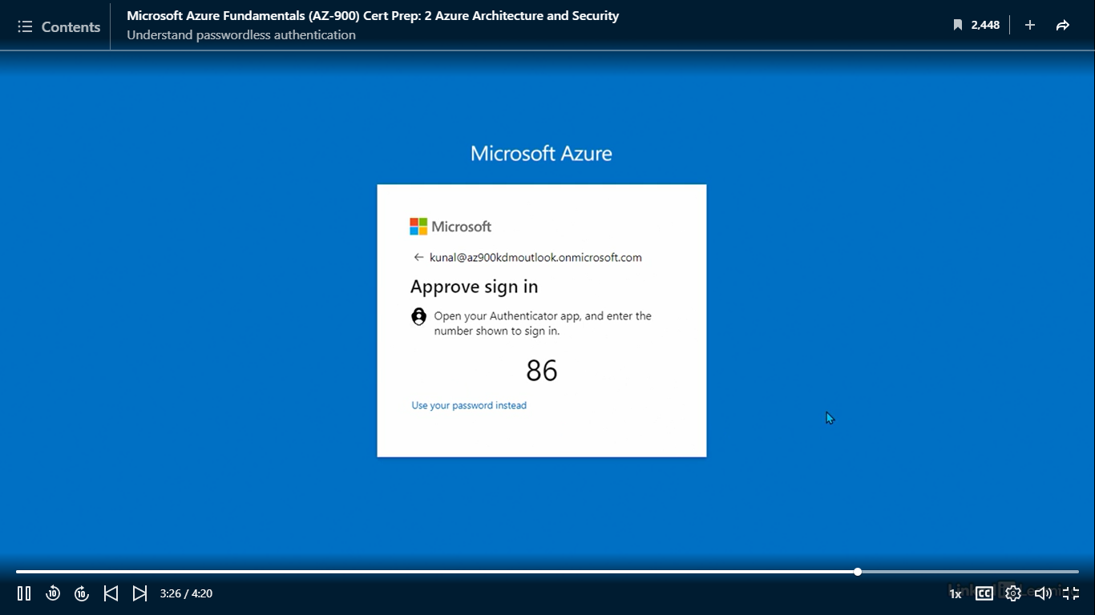

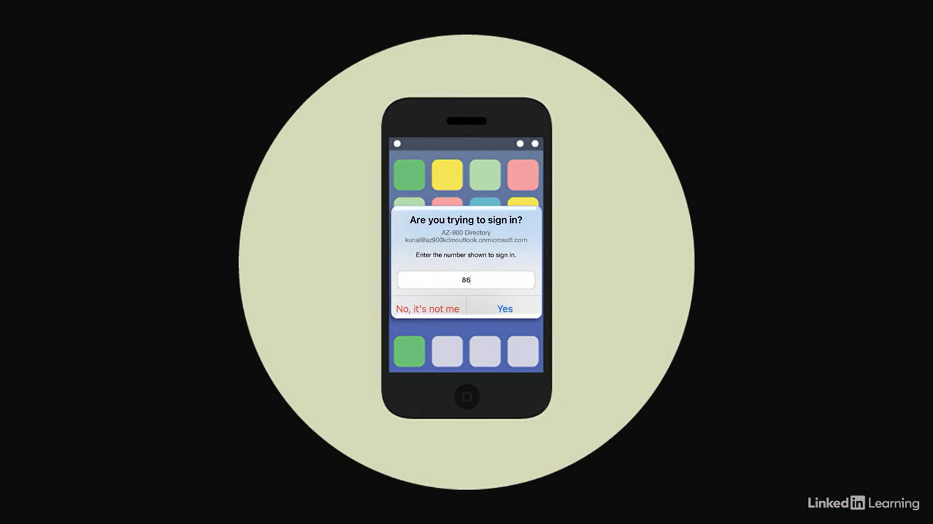

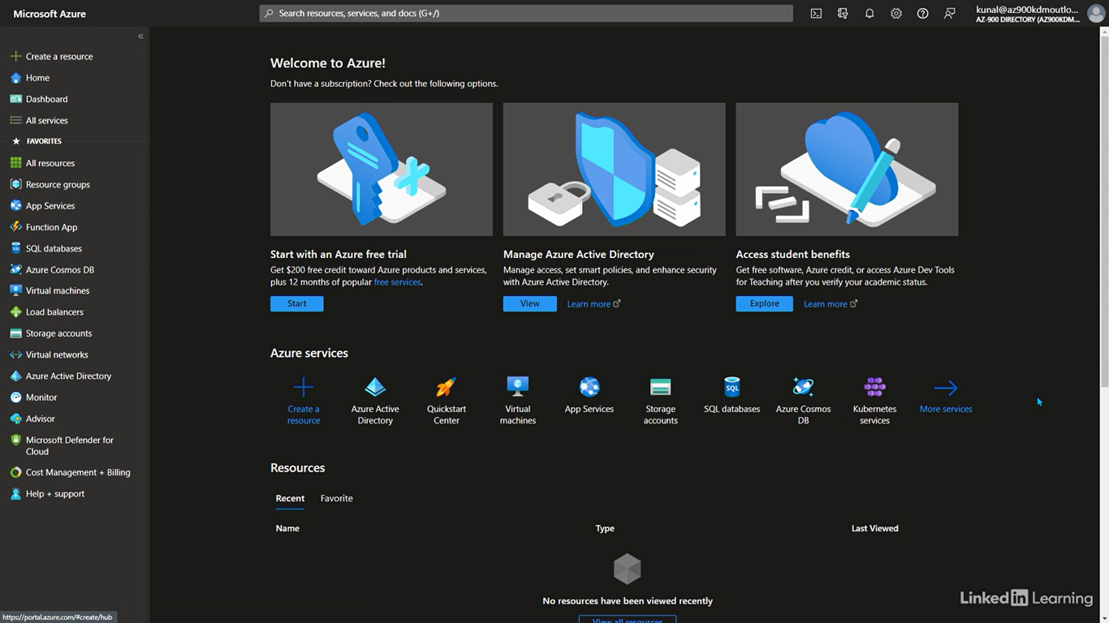

Understand single sign-on

[Instructor] Everything we discussed in this chapter so far has been around authentication. Single sign-on comes into the picture after all the factors of authentication are successfully completed. It helps simplify access for users across apps and resources. We know that you need credentials to authenticate and gain access to your Azure AD tenant resources. That's easy if we talk about one app or resource. But, what happens when there are multiple of them? Do you have to authenticate every single time? And if there's multifactor authentication, do you authenticate twice for every app or resource? This can become very cumbersome for users. It'll annoy them and affect their productivity. The answer to this problem is single sign-on. You authenticate just once to Azure Active Directory. If the sign-in is successful, it generates an authorization token. This token has details of what a user can access and what actions they're allowed to perform. That is a simplified version of what really happens. The next time a user needs access to an app or resource, their user account simply presents the token. No need to go type in credentials every single time. The token automatically grants access to the resources if the user is allowed to access them. All of this happens automatically behind the scene without user intervention. What's even better is that seamless sign-ins can happen across cloud and on-premises environments. Sign-in once and resources in both environments become accessible to you. This also makes the users more comfortable by blurring the line between on-premises and the cloud. At this point, single sign-on works the best for domain users using domain-joined Windows devices. This means the user has to be a part of the directory and use a Windows computer that is joined to the Active Directory domain.

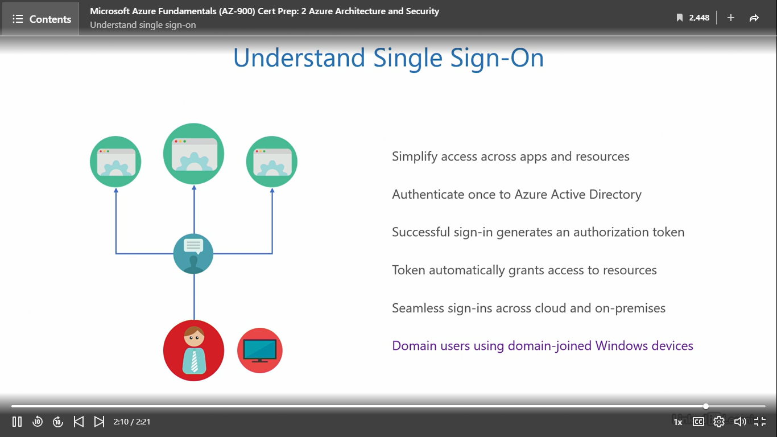

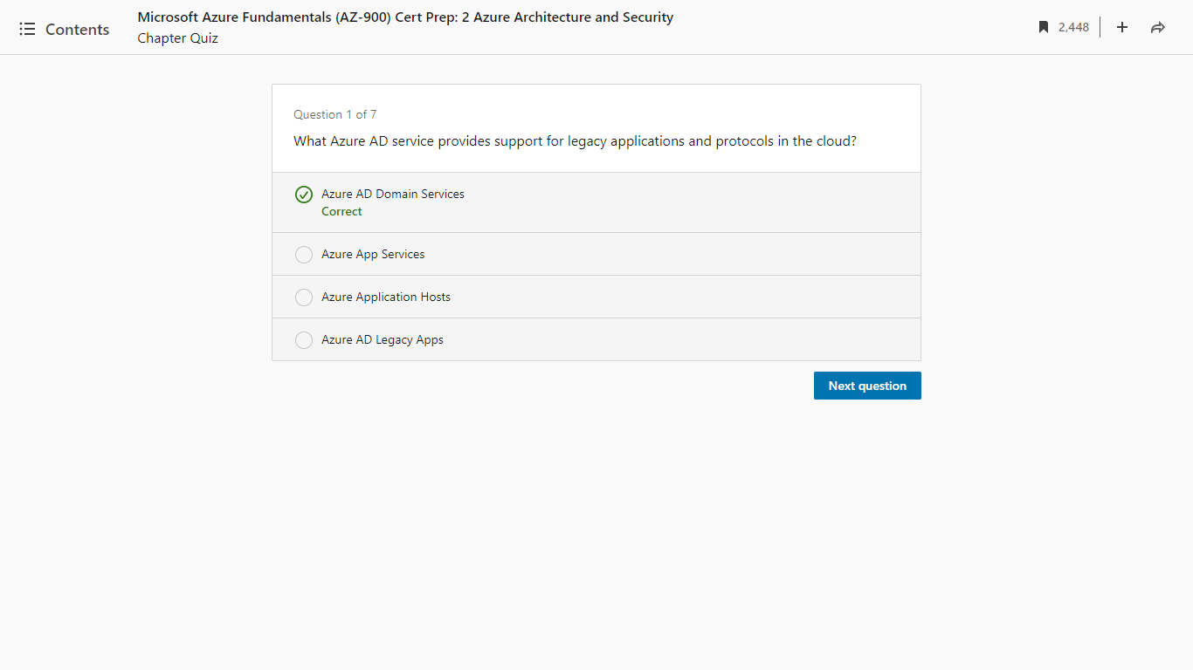

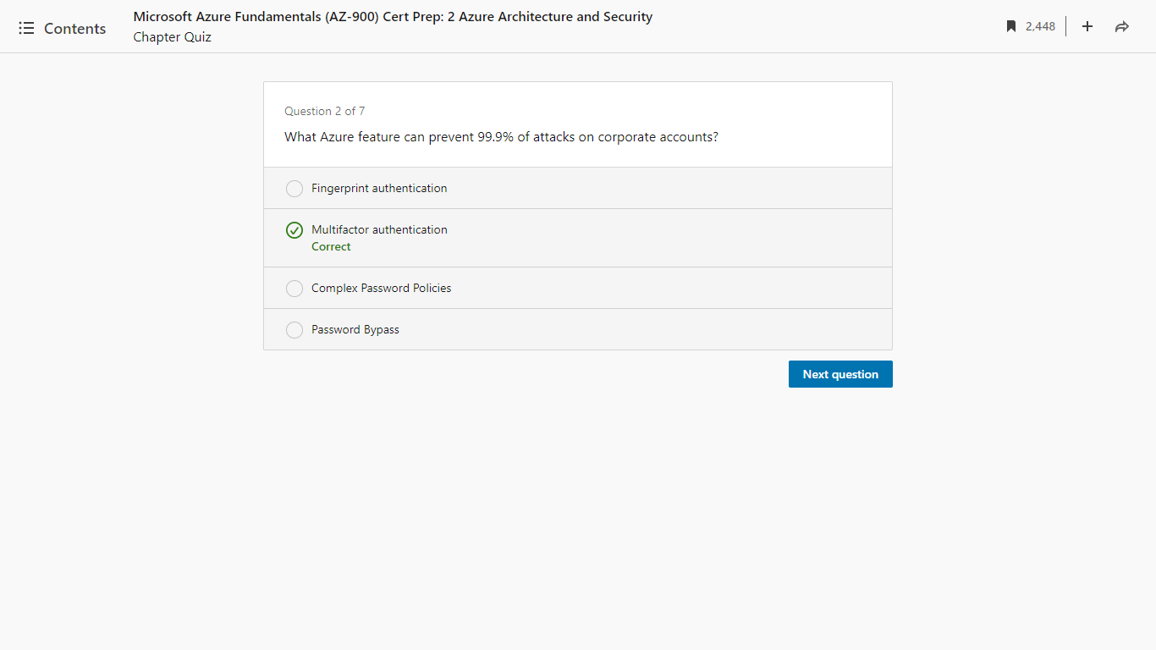

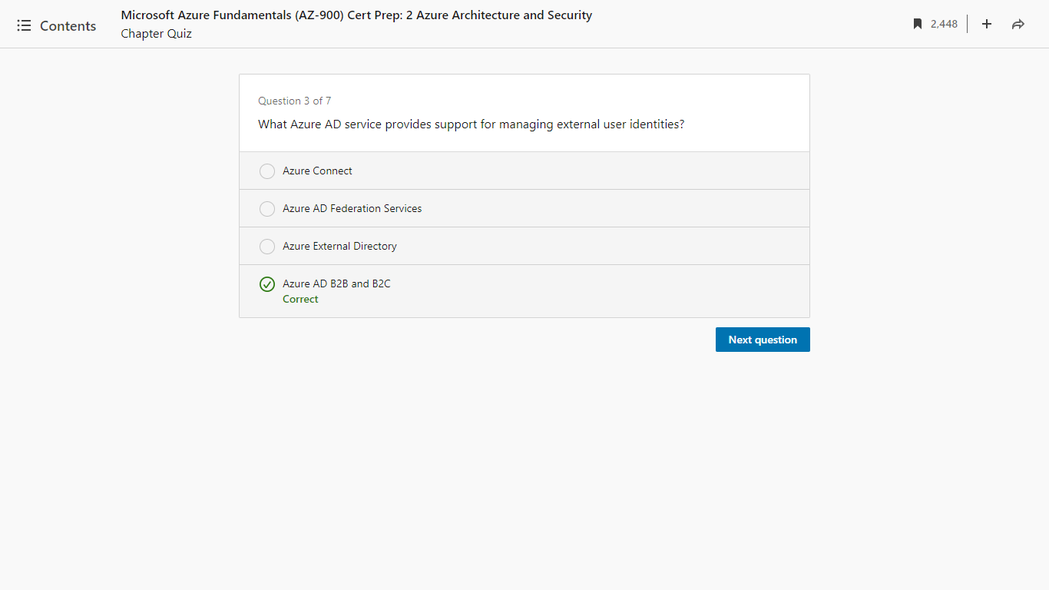

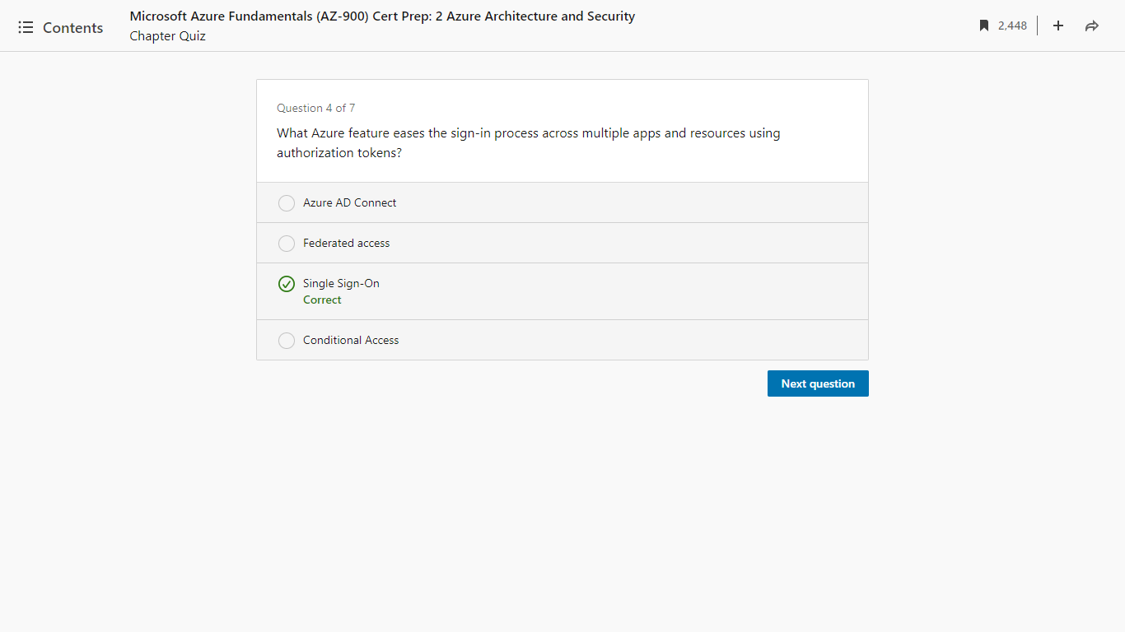

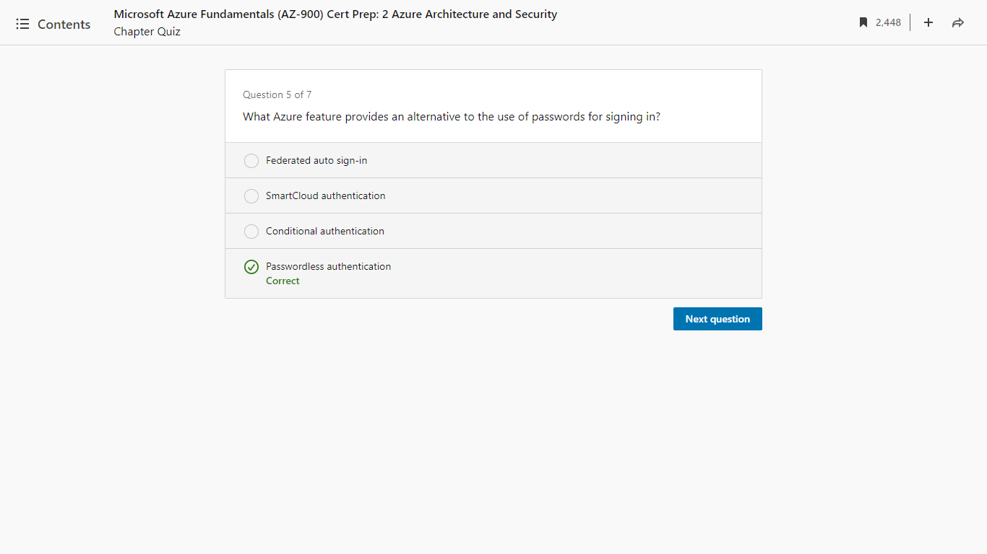

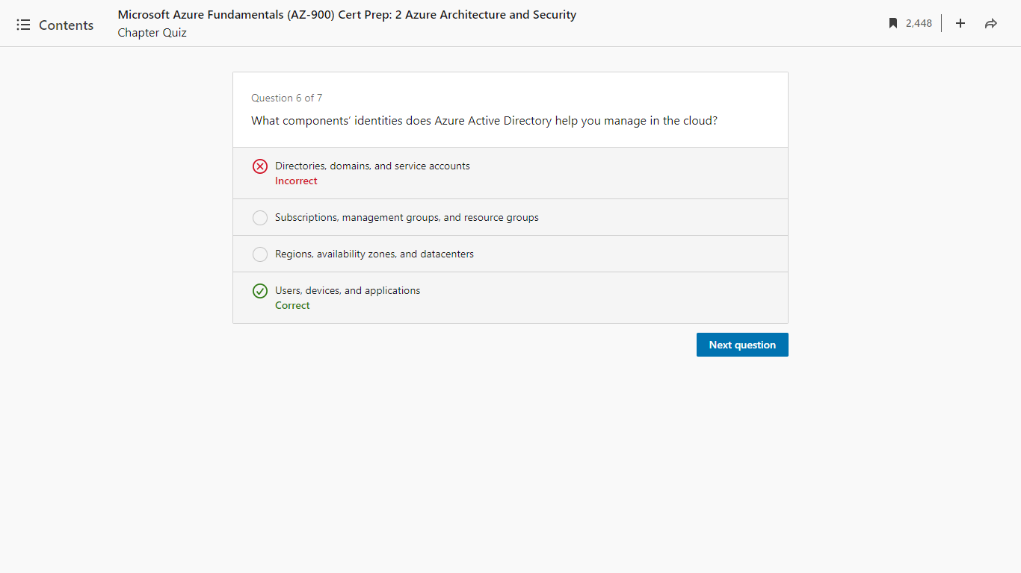

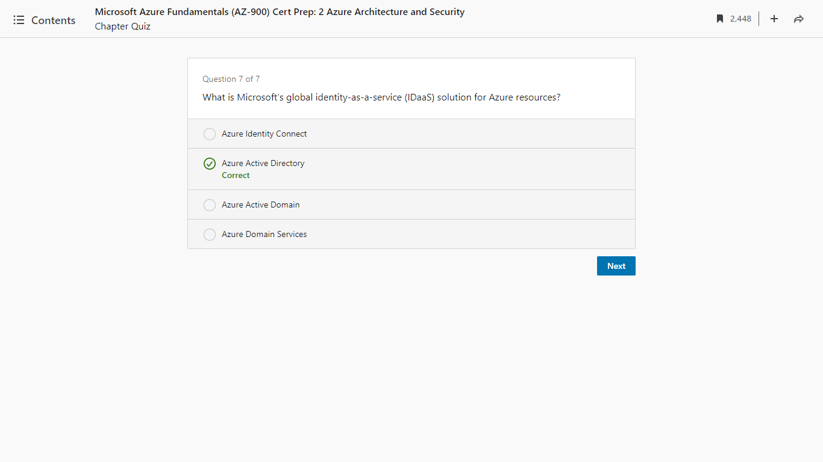

1. Understand Azure Security

Vulnerability and threat

[Instructor] Welcome to "Understand Azure Security". In this chapter, we'll discuss a few essential security products in Azure that everyone must know. When it comes to security, Azure has a whole plethora of solutions from basic to advanced. But for beginners, knowing how to respond to the most common events is important. The products you're about to learn in this chapter do exactly that. Security is all about the big picture. The more holistically you see, the more potential weak points you'll identify and fix. Here are the absolute basics of designing a security strategy. Imagine you have a nice house like the one you see here. Everything's great until you have an open window and a ghost waiting outside. The open window here is a vulnerability of the house and the ghost is a threat. A vulnerability alone without a threat or a threat alone without a vulnerability is not a problem. It's a problem only when these two meet. A threat exploits a vulnerability to cause a breach. This is a big problem. Of course, in my example, I'm assuming a ghost can't pass through walls. That's a debate for another time. Coming back to the point, what can we do to prevent a breach? First step, fix all known vulnerabilities. That'll be closing the window in our example. Second step would be to add a preventive barrier, making it difficult for the threat to reach a vulnerability. Like in our example, a fencing. Again, I'm assuming ghosts can't jump over fences. The third step would be to proactively assess and look for unknown vulnerabilities, like get a pet that guards your house in our example. Security in IT shares the same trajectory. Although a ghost may not be real, threats in our industry are very real. If there's a vulnerability in your application or network, a threat will find its way to it. And not to mention, you already know the stakes are very high. An organization's reputation, intellectual property, customer's personal information, financial data, one small breach and the losses could easily stagger into millions of dollars. So our top priority should be without an exception to fix vulnerabilities immediately. Then have preventive measures to avoid a breach and systems to proactively monitor our environments against known, unknown, or new threats. Vulnerabilities in IT are not always glaringly obvious. You will have to do a lot of digging to find them. You should understand that security is not a one-time implementation. It's a continuously ongoing process. Bad guys are coming up with new exploits every single day. We need to be constantly on the lookout for ways to assess and prevent a crisis even in the cloud because we, as customers, have a shared responsibility along with the cloud service provider.

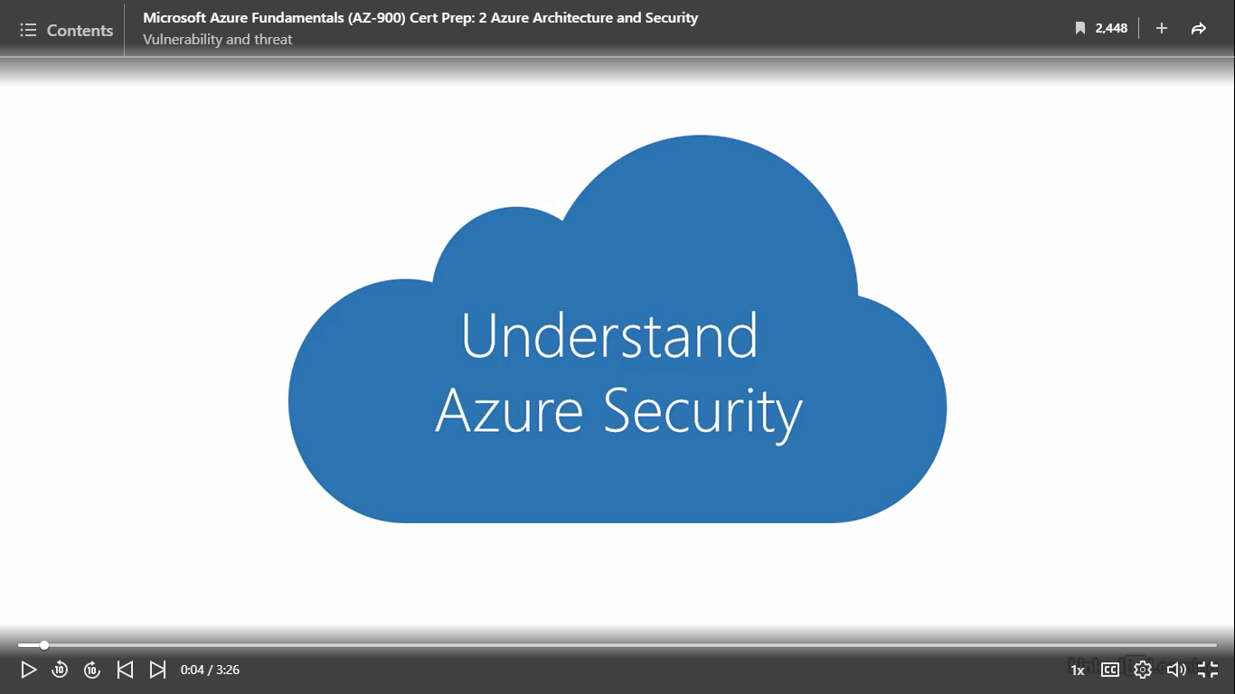

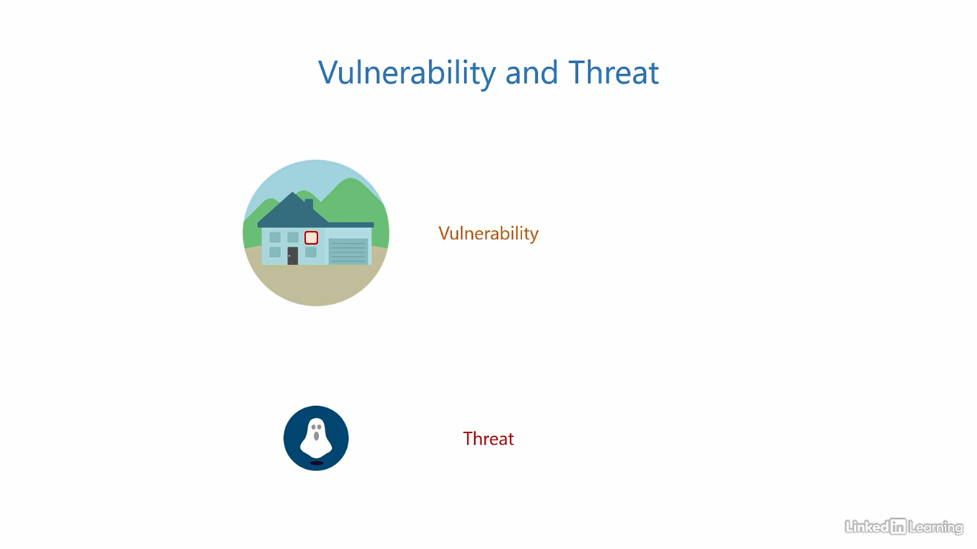

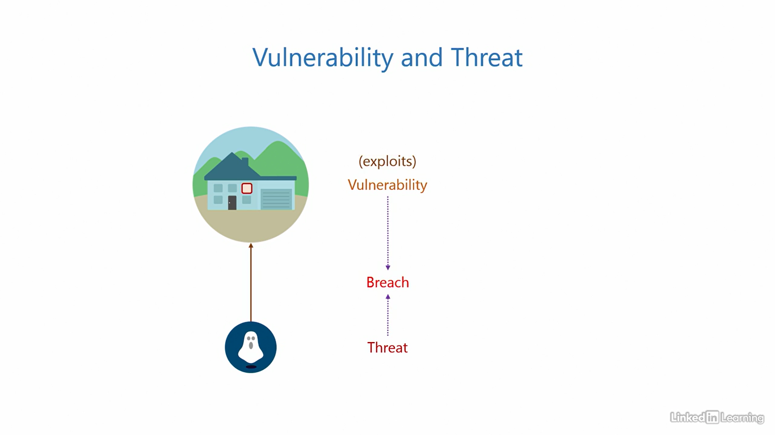

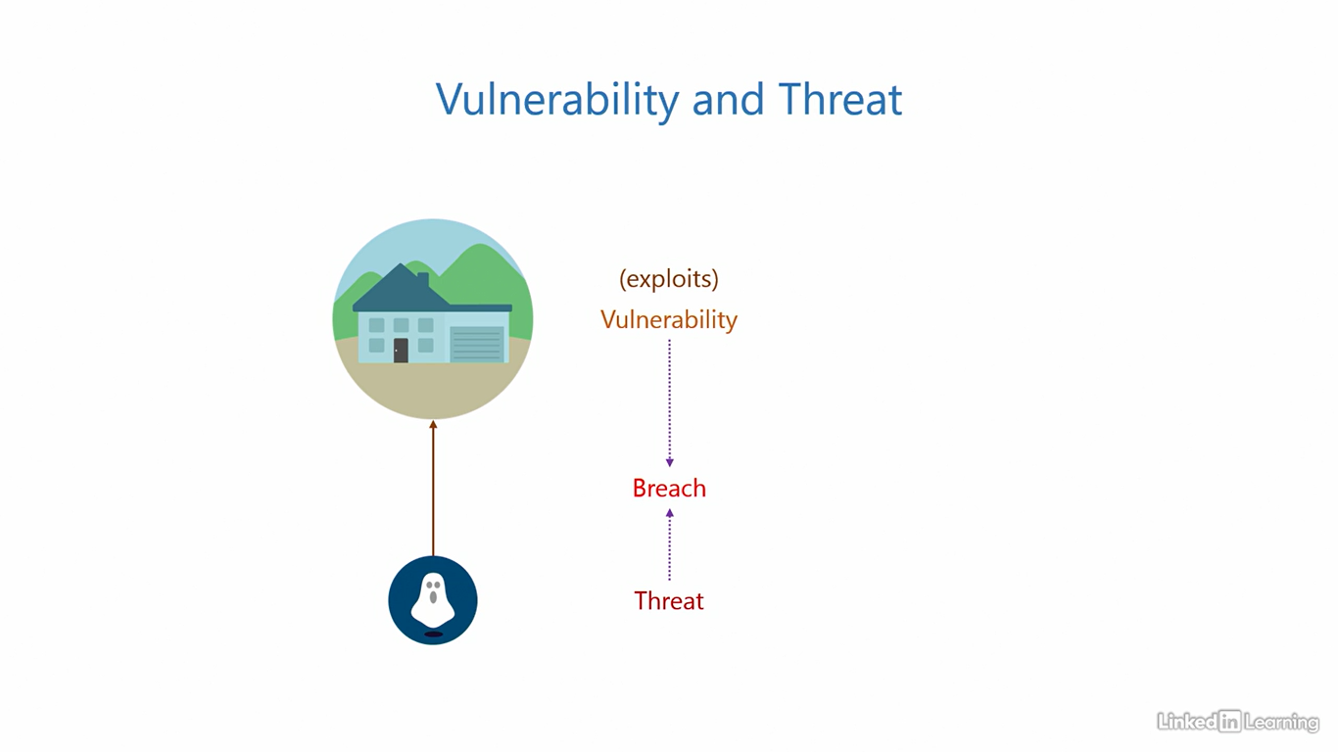

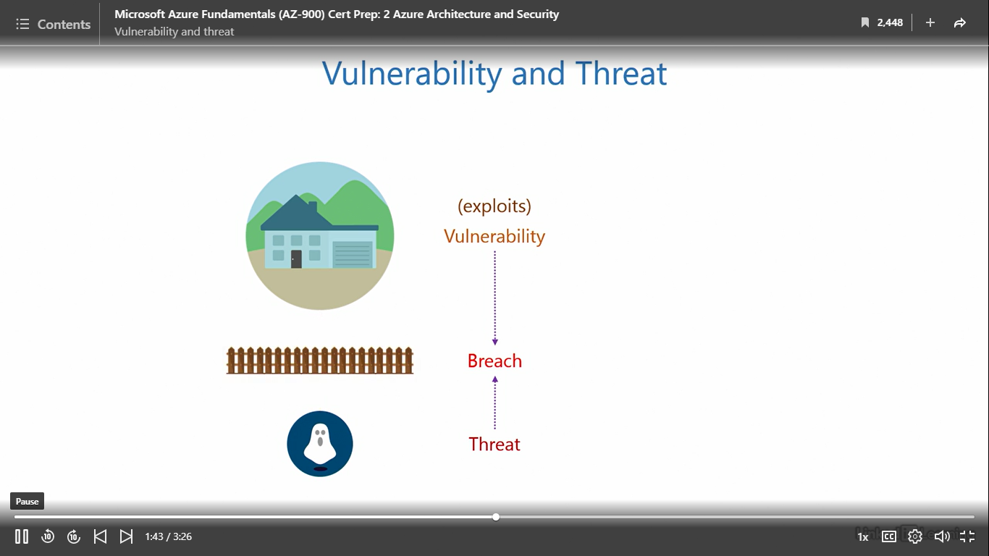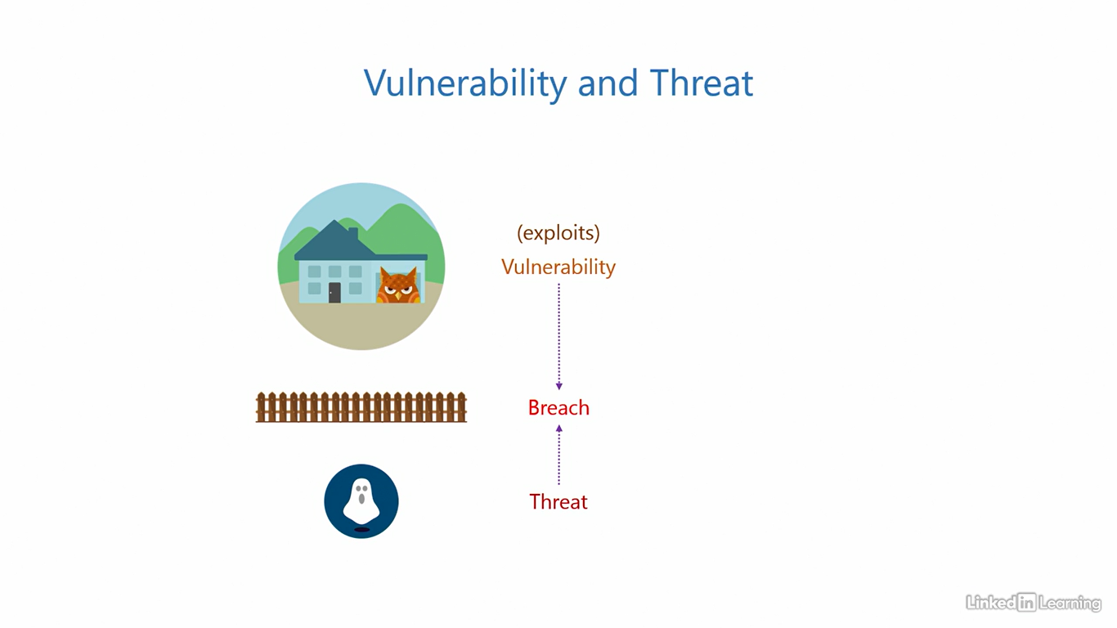

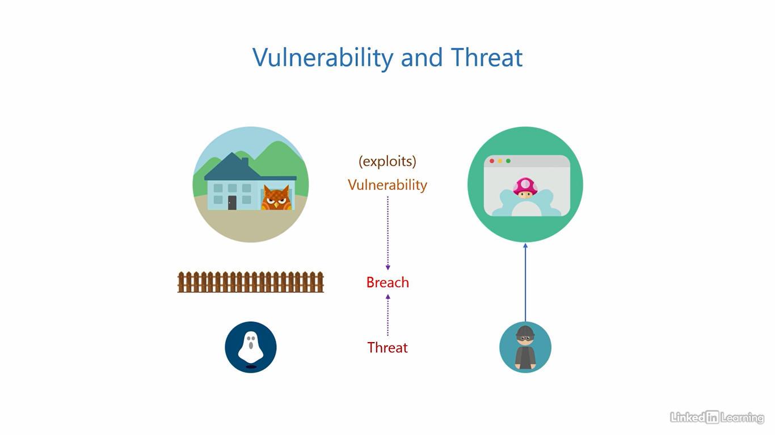

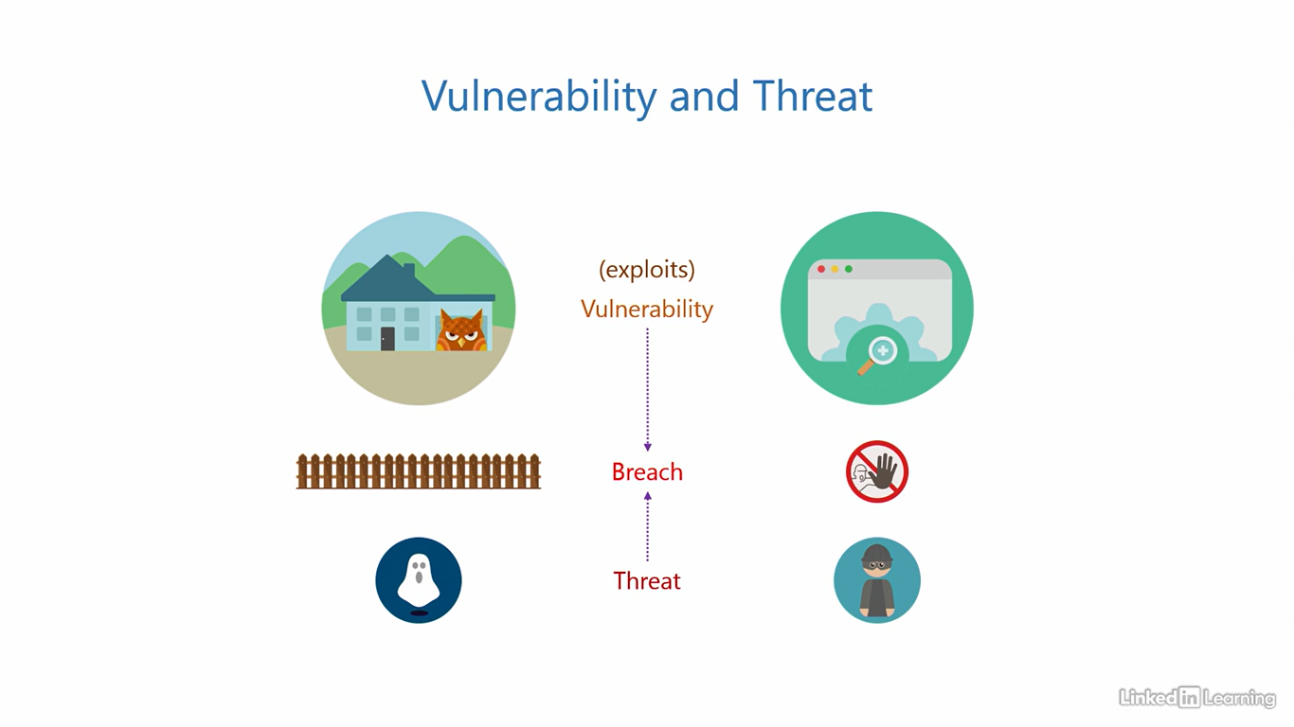

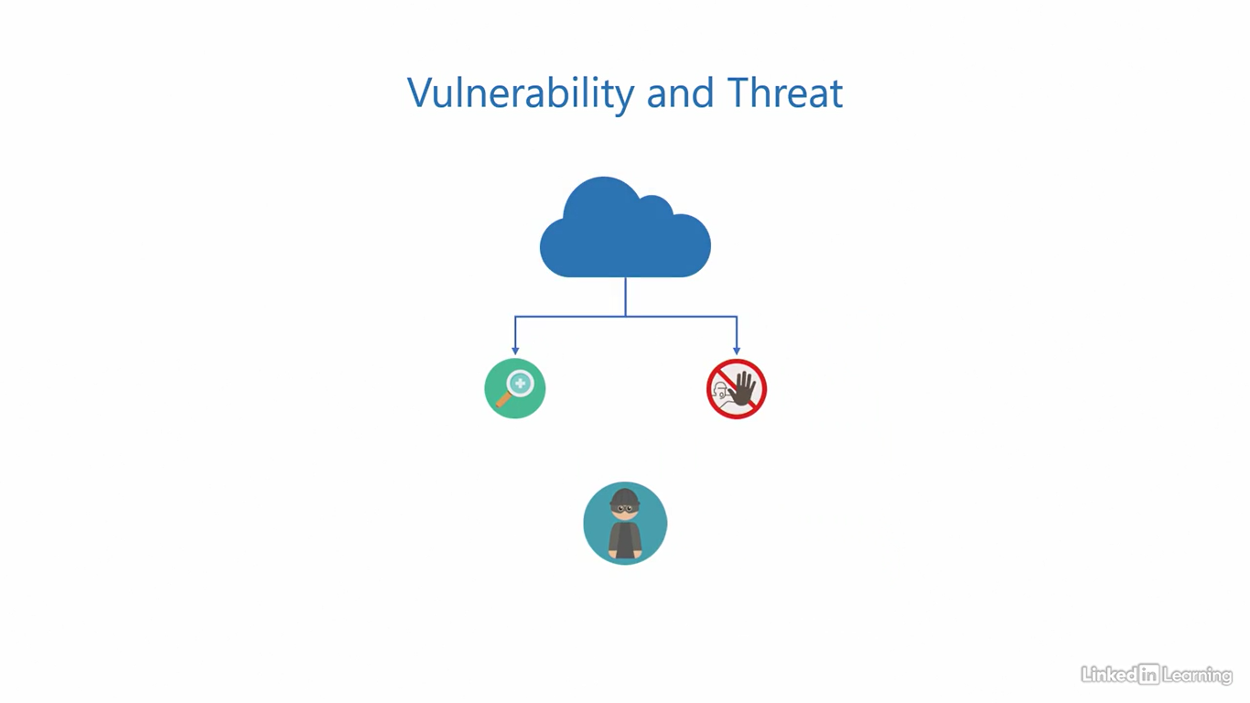

Understand the Zero Trust approach

[Instructor] Security products evolve from theories that security researchers conceptualize in order to prevent, reduce, and mitigate the impact of a breach. Let's look at one of those theories called the Zero Trust Approach. In the past, as I've mentioned, IT components were mostly confined to a closed corporate network: the directory server, applications, devices, users and other services. They were all housed in a physical location on premises in a closed, trusted network. The inherent trust here comes from the fact that most corporate networks are limited to the physical boundary of the location. We presume any person present physically in the office accessing the network has already undergone a security check at the building gate. We assume we can trust them. We don't double check, and that's okay. But as you know, modernization has changed everything. The physical boundary is gone, the security check at the gate is gone, and users are now accessing applications and resources over the public internet. And so as a result of that, we have to lose the trust we've had because the whole internet is an untrusted network. This is essentially why we need the Zero Trust Approach. There are three guiding principles to the Zero Trust Approach. First is verify explicitly. This states, you should always verify the authenticity of a request explicitly and using as many data points as you can. Don't just depend on credentials. Look beyond it. See if there's any other piece of information available to determine if a request is real or shady. Observe patterns and see if anything is out of the ordinary. Second is the principle of least privilege. This states you should always grant the least amount of privilege or permissions to a user account that is necessary for them to perform their job because the more privilege you assign, the more potential there is for damage, either unintentional or intentional. In recent times, we've taken this further. We now grant the least amount of privilege to a user for the least amount of time that's necessary. We've added a time dimension to it. For example, if there's a task that requires X amount of privilege but that task only happens once a year, should the user have those rights all year round or only when that task needs to be performed? Of course, only when it's needed. The third principle takes it to the next level. In traditional environments, we assume trust but here, you are supposed to assume a breach. We imagine anyone who gets onto the network is here to cause damage. We keep our defenses prepared for it accordingly and limit the damage to the smallest radius possible. This way, you're always active to respond to incidents instead of being passive. I know it may sound a bit pessimistic but that's how we have to be in this industry.

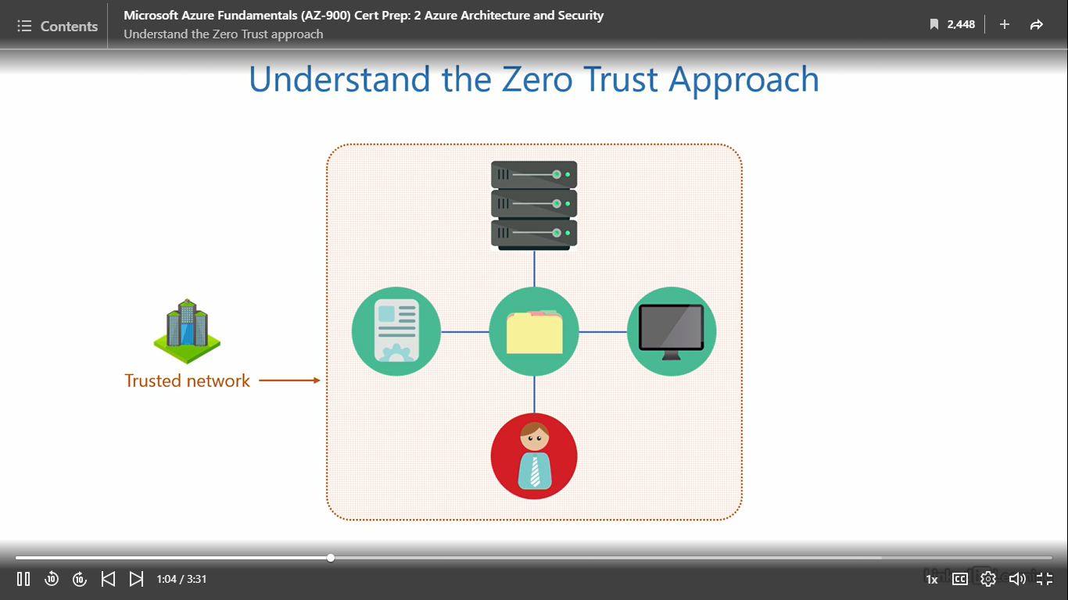

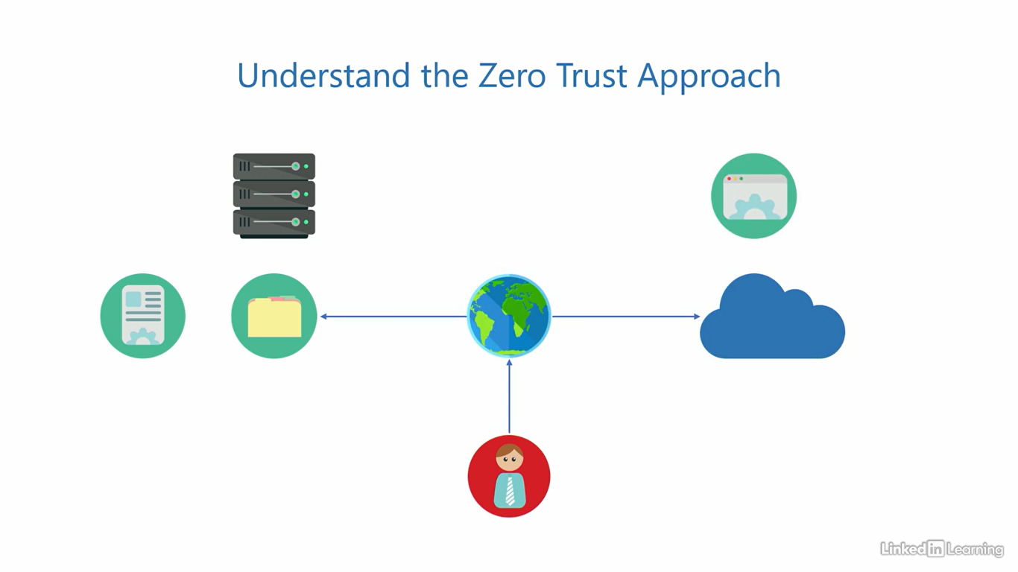

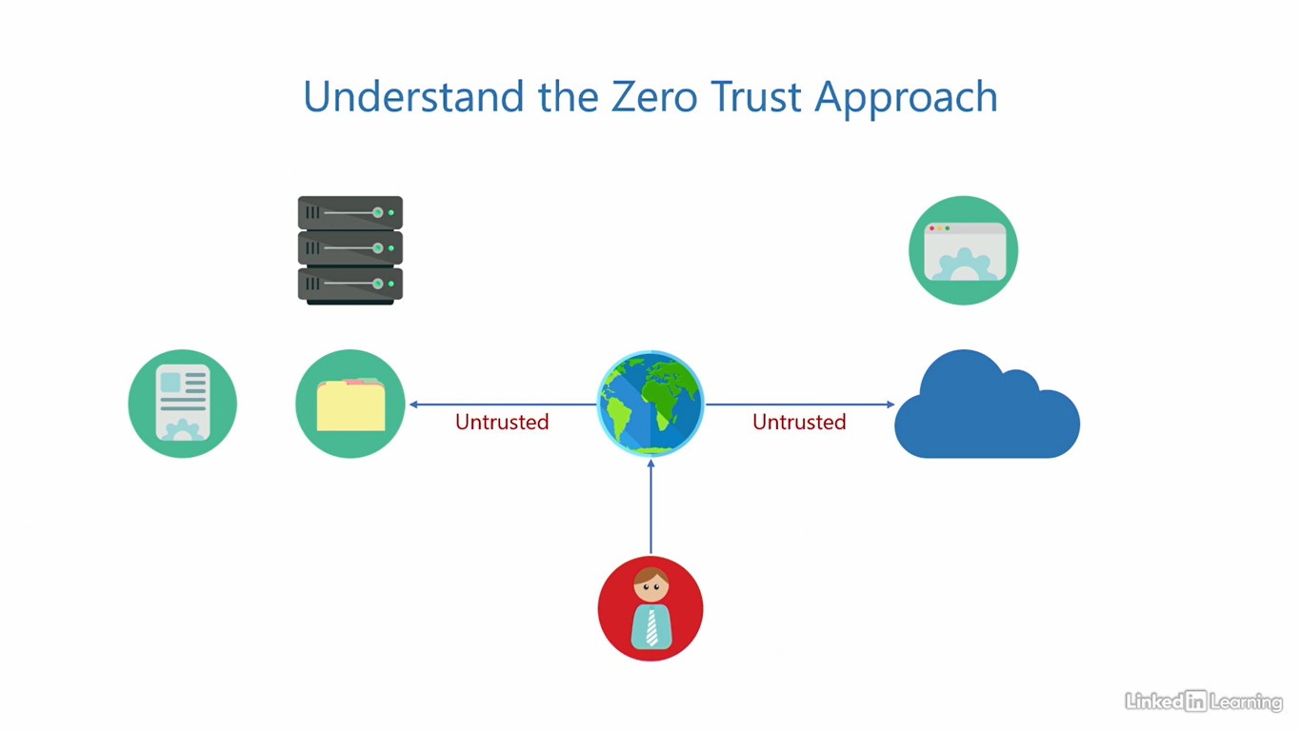

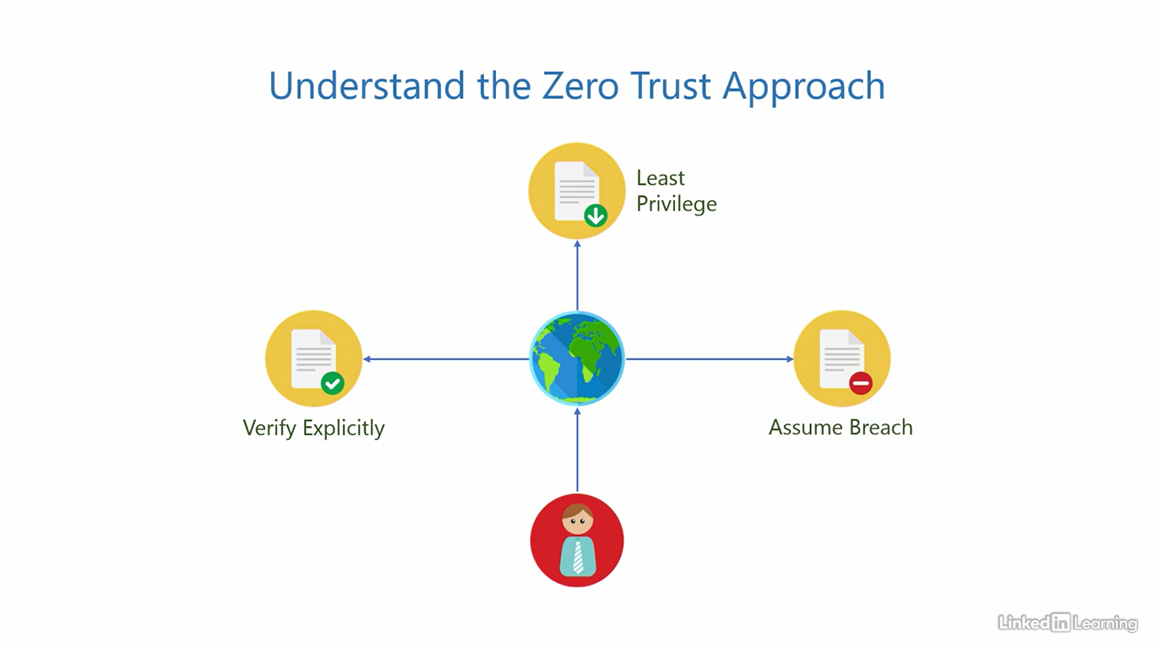

Understand the defense-in-depth model

[Instructor] When we hear the word breach, we typically think of unauthorized users stealing our confidential data and using it for their own benefit. The usual intent in such situations is to gain an unfair competitive advantage over your organization. While it's true that this is a breach, the definition of a breach is broader than that. A breach can also mean unauthorized people modifying or corrupting your data. Imagine if someone hacked into a bank and removed just one digit from the bank balances of its customers. Imagine removing just one digit or maybe made the bank balance database unreadable. The intent here can be to directly hurt the organization. A breach can also mean making a system non-responsive to legitimate users. This can be done by bombarding servers with so many fake requests that it gets overloaded and does not have the capacity to serve legitimate users. This is also categorized as a breach because it can result in extremely slow responses or complete downtime of an application. The intent here, usually in my experience that I've seen is to take revenge. There are specific terms we use to describe these breaches. Unauthorized people stealing data is a breach of confidentiality. To maintain confidentiality, you need to ensure only the right people can access your corporate resources. Then, modifying or corrupting data is a breach of integrity. To maintain integrity, you need to ensure data can only be modified by the right people, whether it's at rest or in transit. After that, making a system non-responsive is a breach of availability. To maintain availability, we need to design solutions that can sustain and handle denial of service attacks. These three are collectively called CIA and no, not the one from the movies. The defense in-depth model is designed to preserve confidentiality, integrity, and availability for the entire IT stack at every single layer, right from the physical space to the data. That explains why we call it defense in-depth. Let's quickly look at the layers and see what kind of defense should you implement at what layer. You have heard of the multi-layered approach to security. The defense in-depth model is a more conservative version of the multi-layered approach. We introduce layer after layer to slow down an attack as much as possible, just like layers of an onion. There's one layer after another, after another, and so on. That's how security should be. That's also how we need to design our security. At the topmost data layer, from a security perspective, we need to maintain confidentiality and integrity. Data is not something that runs, so the availability aspect does not really apply to it. For the application layer, we need to maintain confidentiality, integrity and availability. An application runs and provides an interface to read and write data, so all the three are important here. Similarly, if we were to extrapolate this frameworks, runtime, patches and hotfixes, would all require integrity and availability. For hardware and operating system, all three are important. Give it a little thought and you'll understand why. Then for power cooling and internet, because they're not really IT components, only the availability aspect applies. Finally, for the physical space, from a digital perspective, confidentiality matters. The defense in-depth model and the IT stack you see in this video is simplified and we are basing this on a general application. This may change on a case-to-case basis depending on the complexity of the application design.

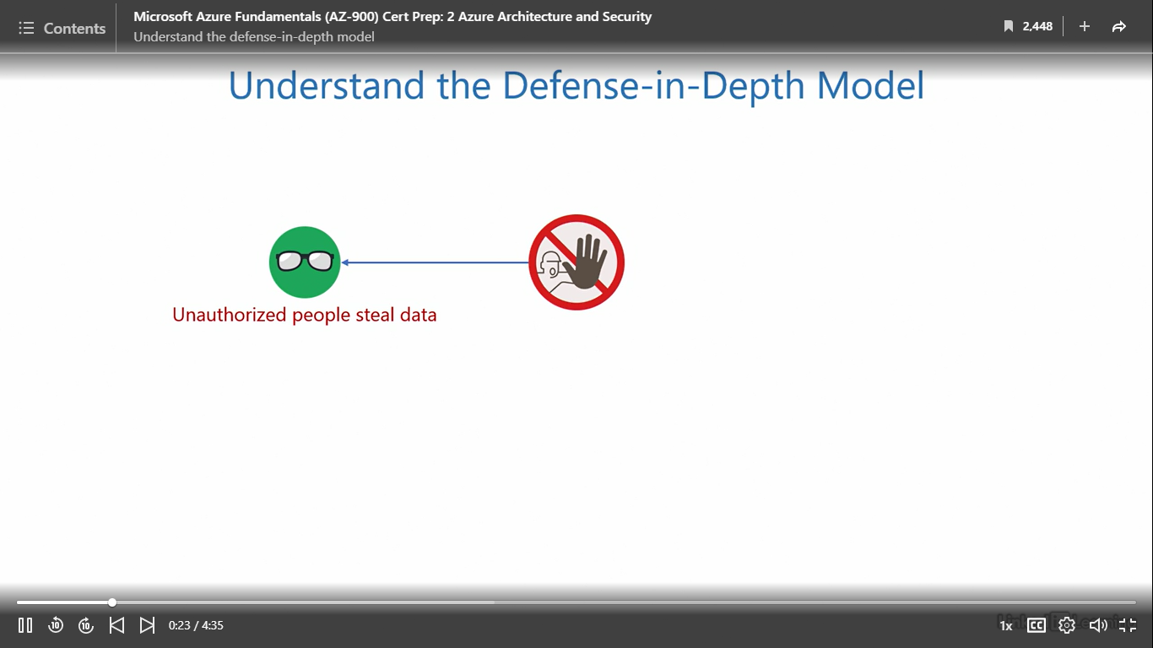

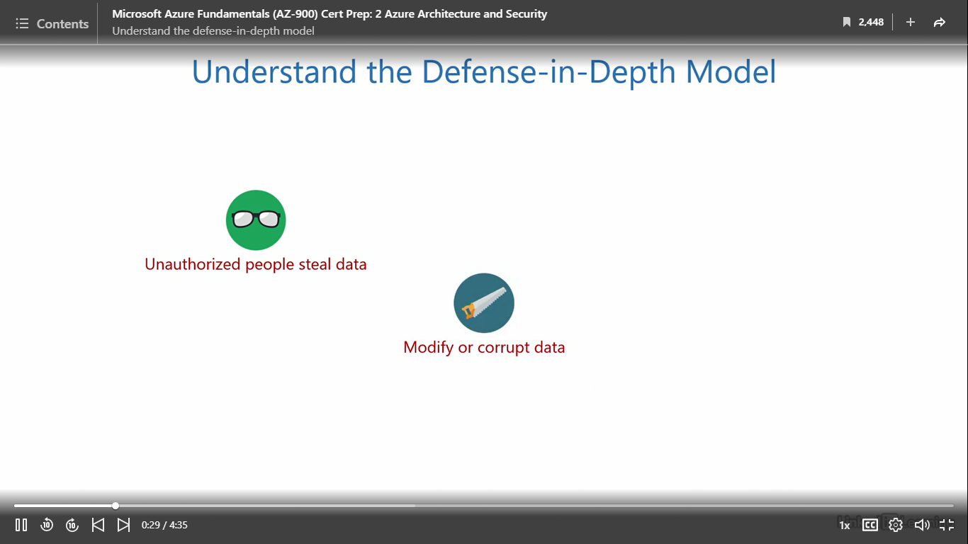

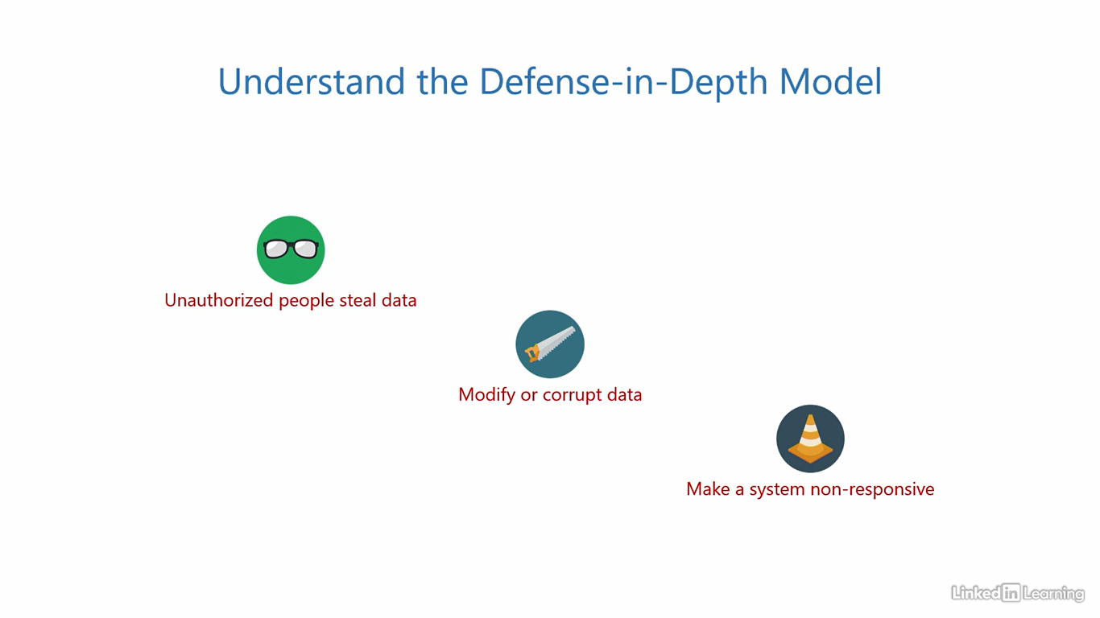

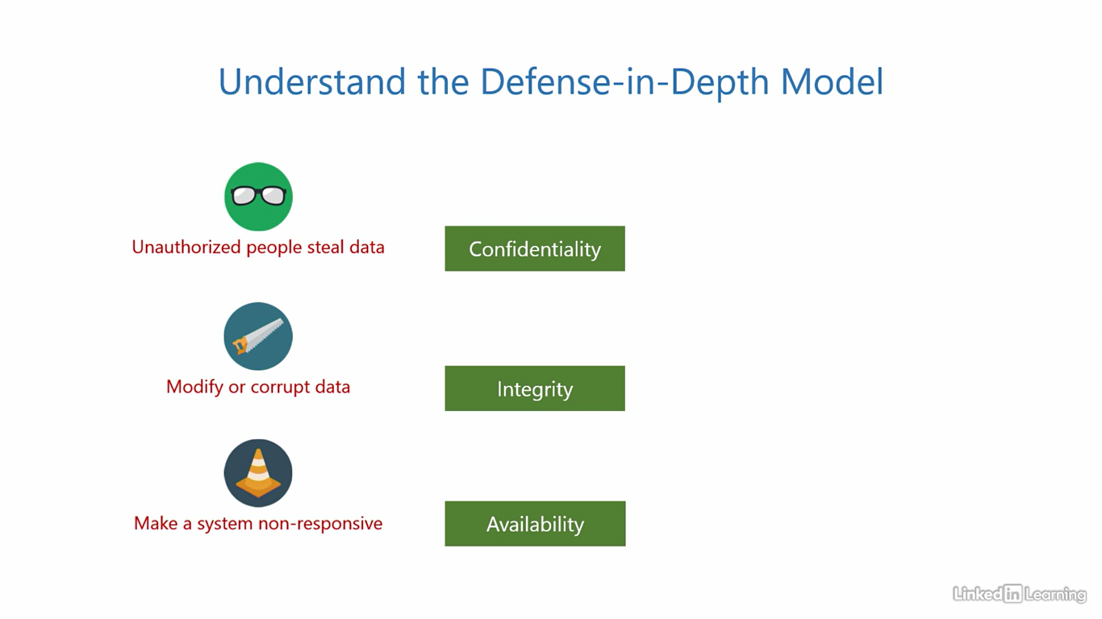

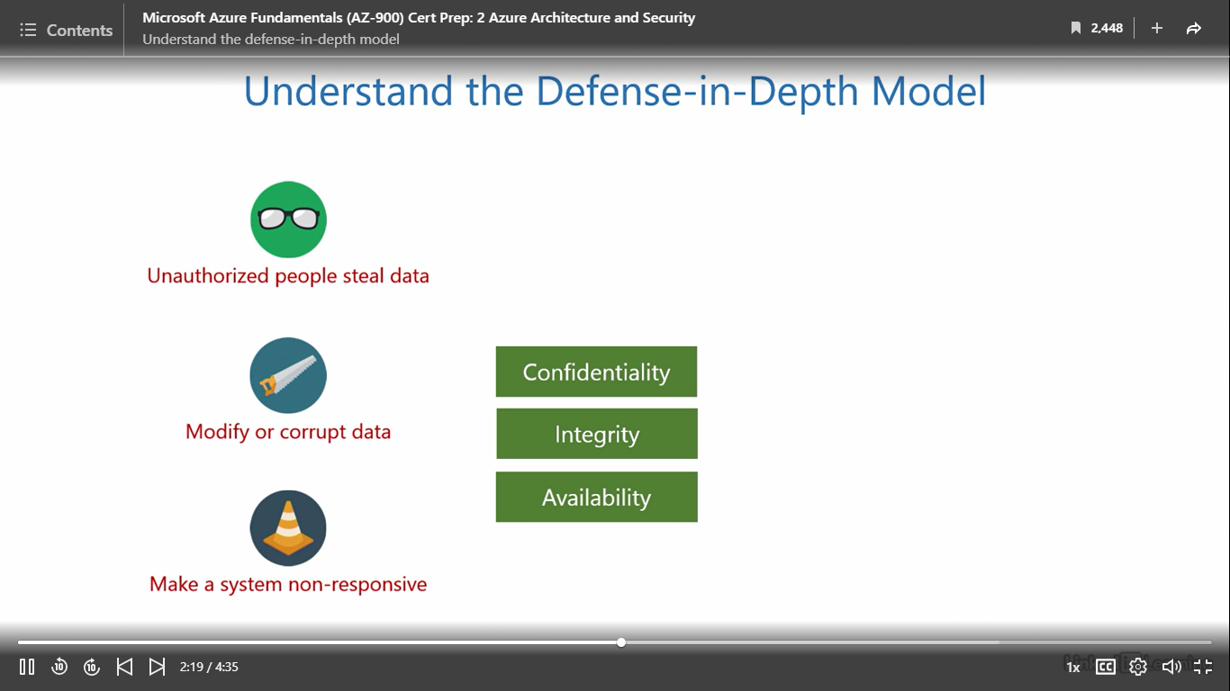

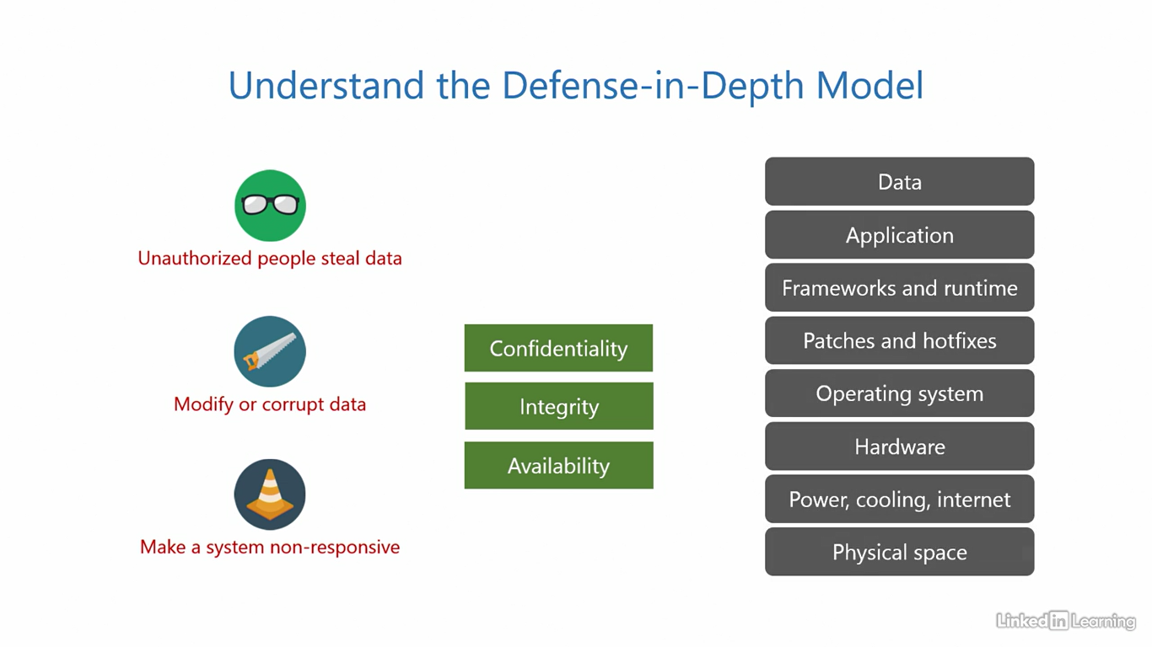

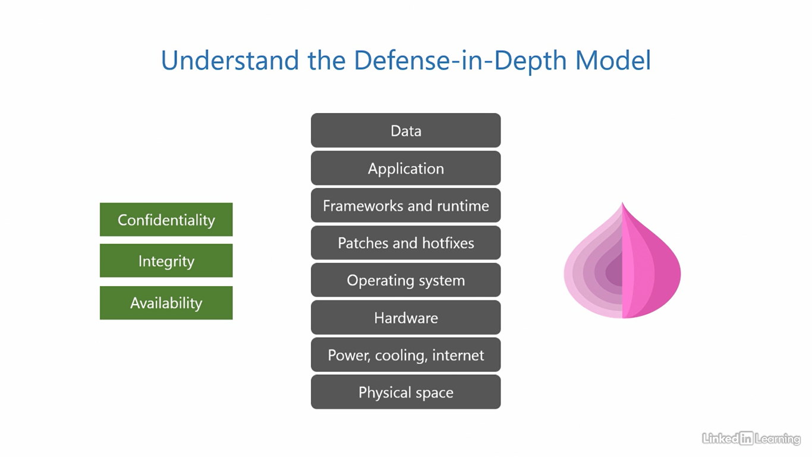

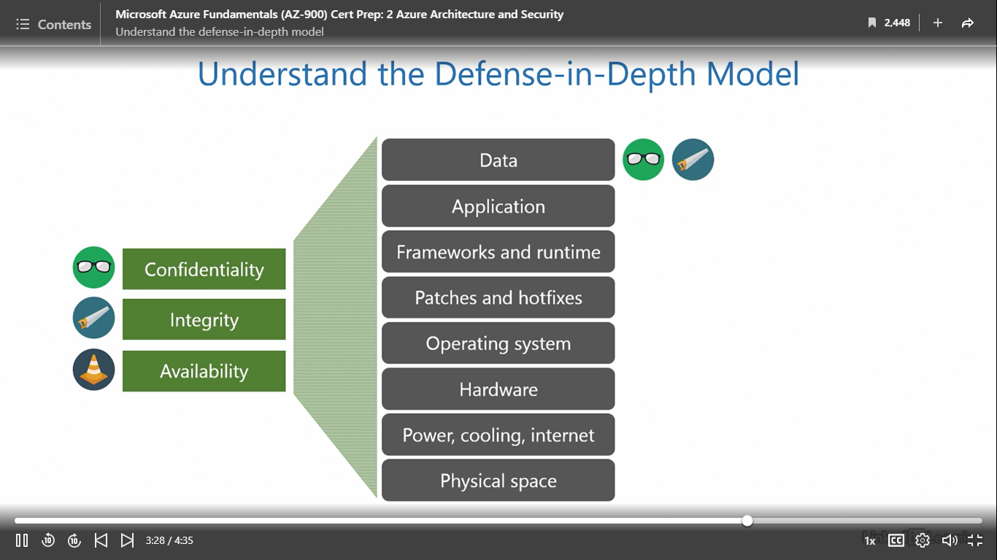

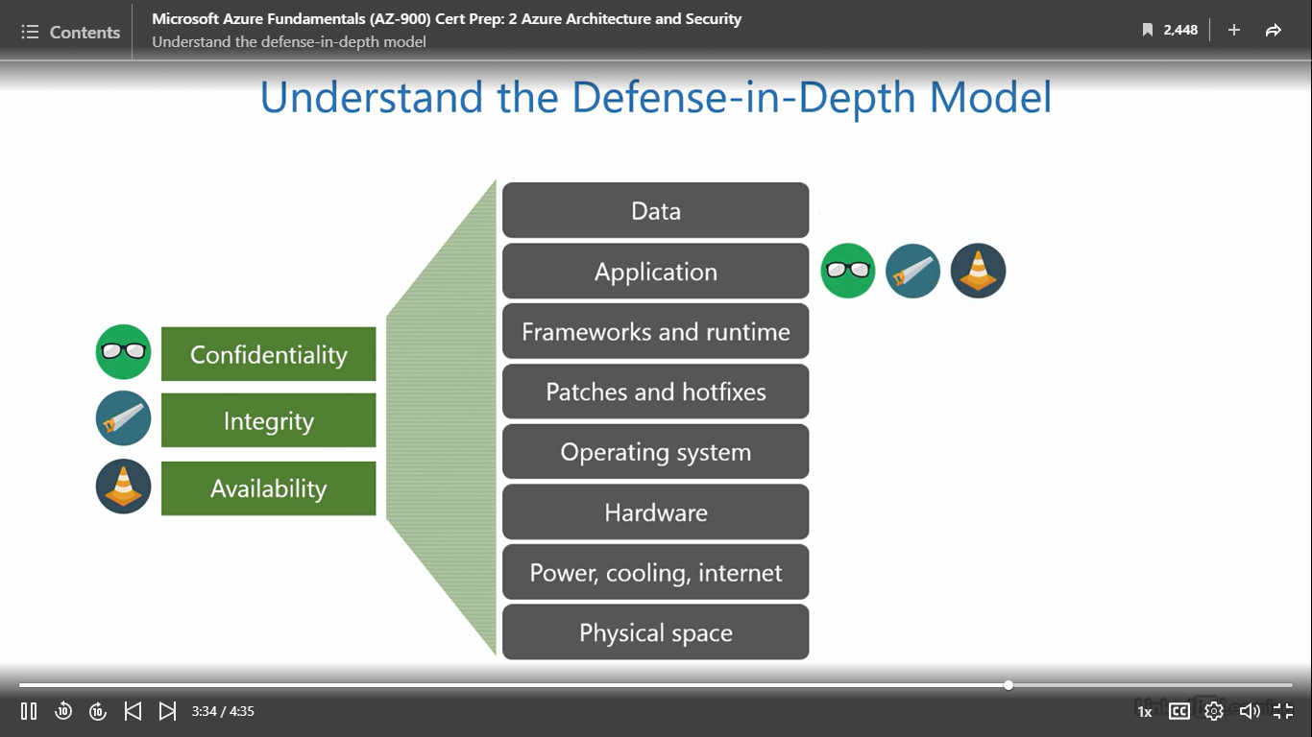

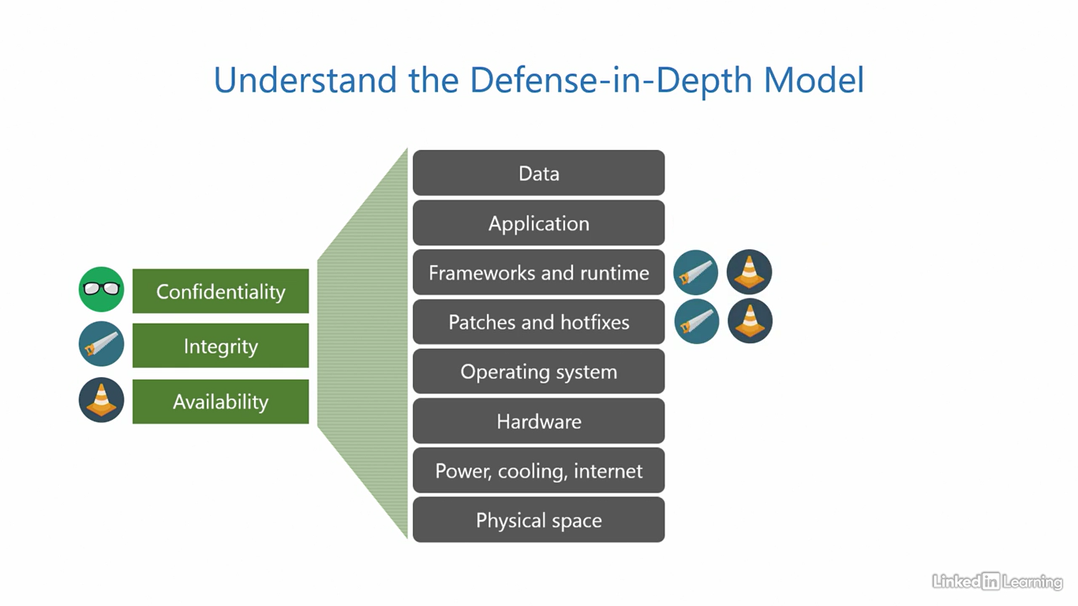

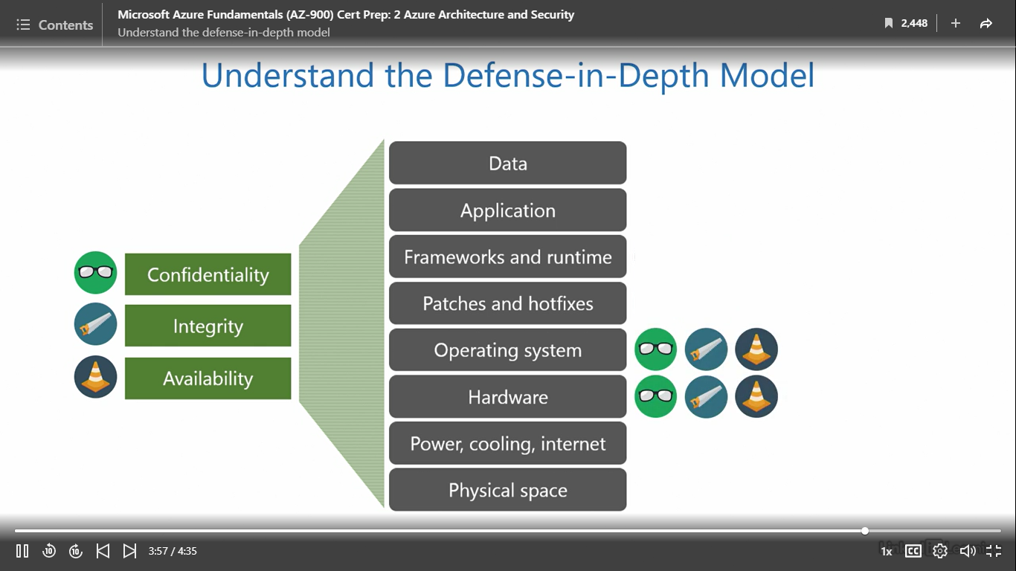

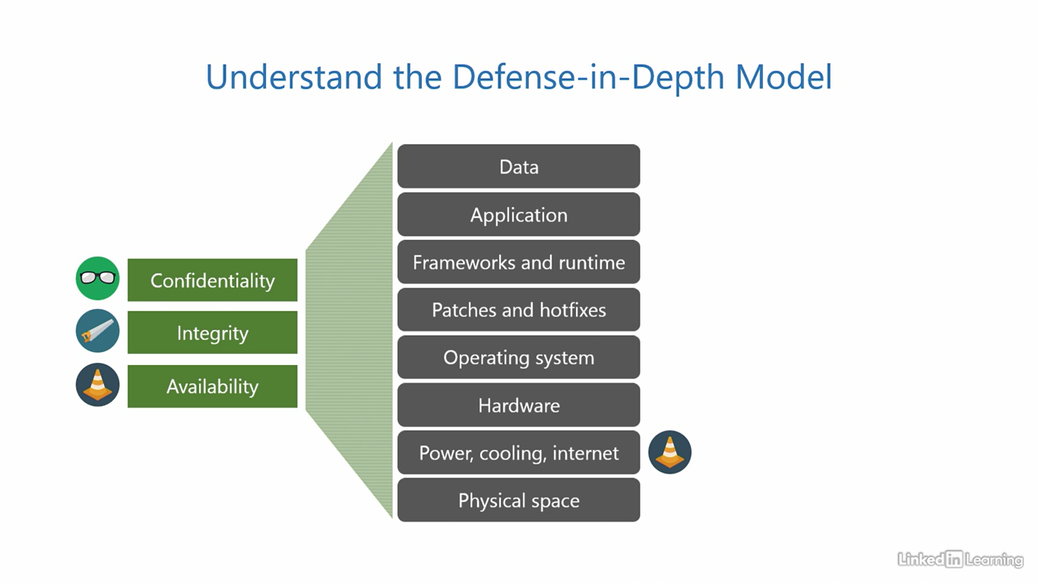

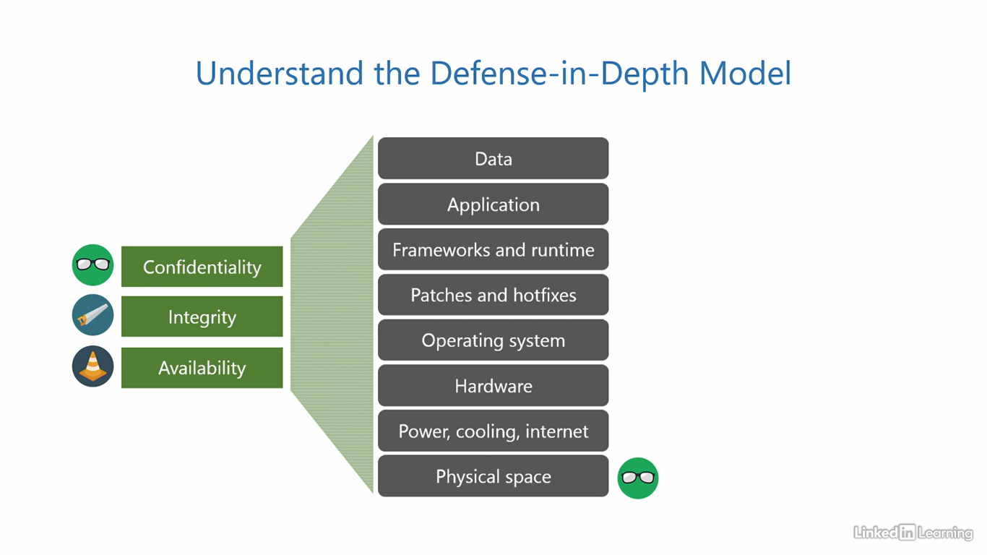

Understand Azure AD Conditional Access

[Instructor] We have already established we need credentials to access Azure resources and maybe an additional factor if we have implemented multi-factor authentication. This is great for security, but it's not really smart. You've learned that the zero trust approach requires us to verify explicitly using all data points. How do we go about this? We use Azure AD Conditional Access, which provides smart authentication capabilities for your tenant. It jumps into action at the first factor of authentication and uses additional data points to validate the sign-in request. The additional data points are called signals. Azure AD Conditional Access analyzes these signals, makes a decision, and performs enforcement of the decision. The signals consist of the following parameters: who the user is, what group do they belong to, what device and operating system they're using, and what application they're requesting access to. Azure AD Conditional Access also takes into account real-time risk. If it is known that there's a cyber attack going on in some part of the world, Azure will up its defenses for all its customers. Azure passes all this information into its Conditional Access engine, which is powered by artificial intelligence and machine learning. The algorithms analyze if this is the user's regular location, if it is their regular device, or if there's a history of them or their group requiring access to that particular application. Based on the result of all this data crunching, it'll either allow access, allow access after additional steps, or simply block access depending on how risky Azure thinks a sign-in attempt is. If it is low risk or not risky, allow access. If it is moderate risk, users may be required to perform additional steps, like going through multi-factor authentication or a password reset. If it is high risk, block access. Once you enable this feature, a set of default Conditional Access templates are automatically populated based on Microsoft recommendations. You can get started by enabling any one of them or customize and create a whole new Conditional Access policy using these templates as a baseline.

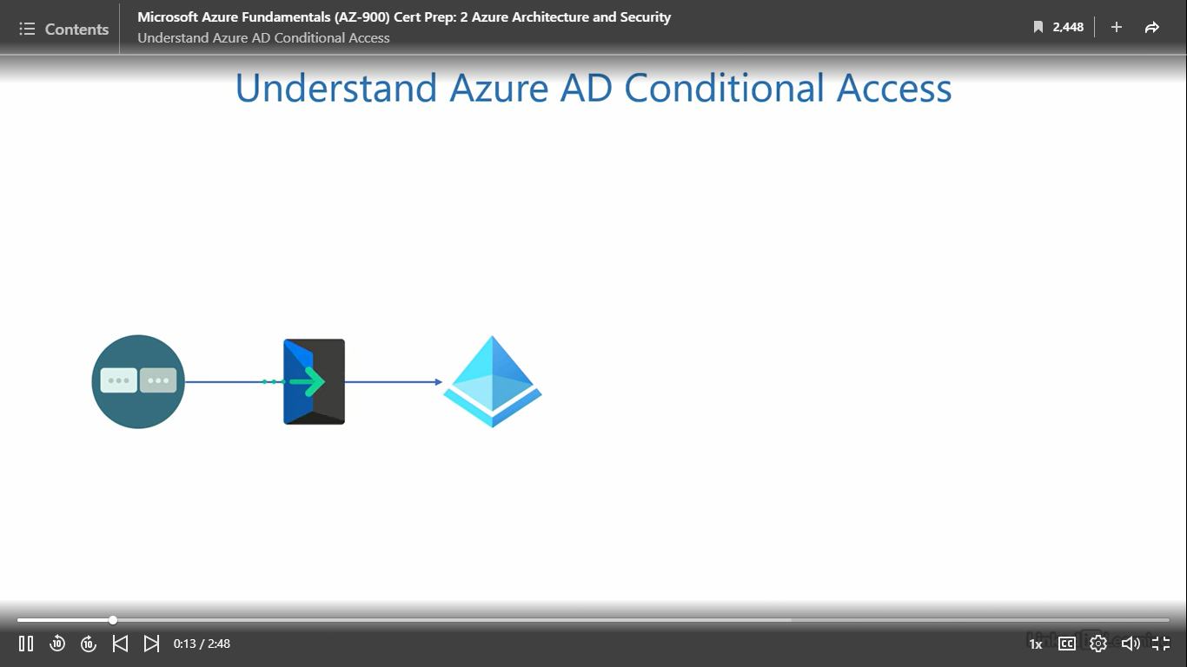

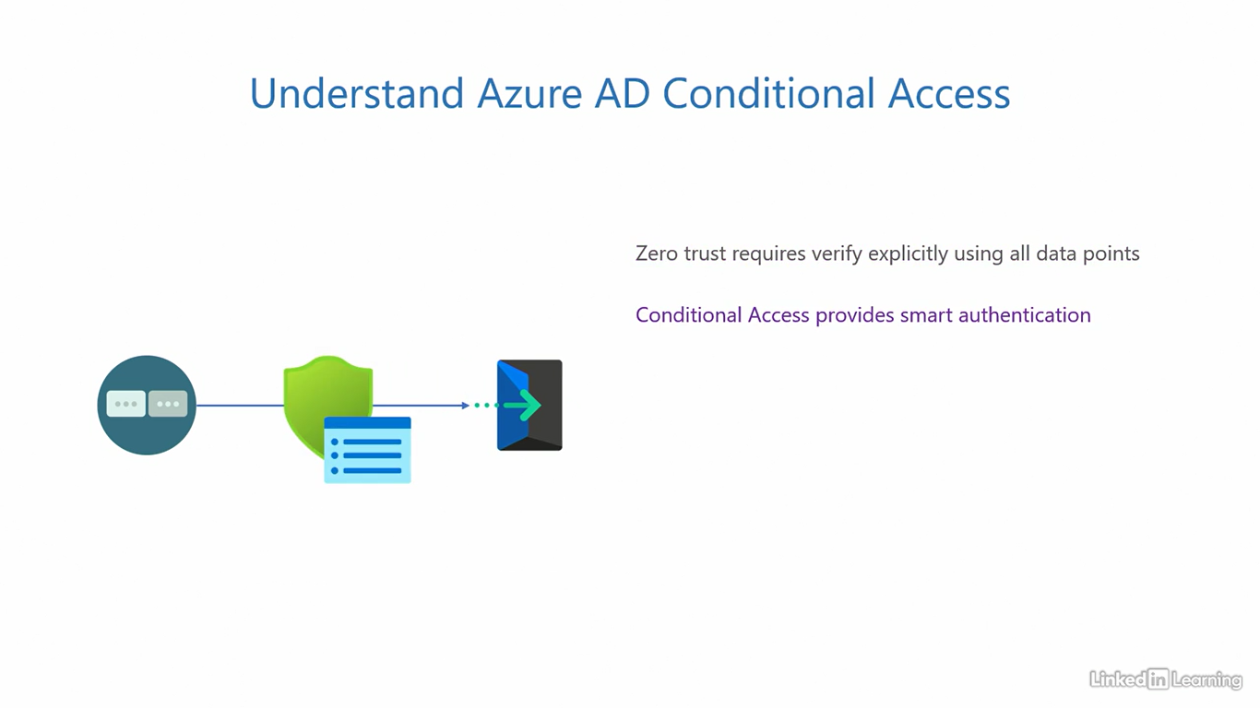

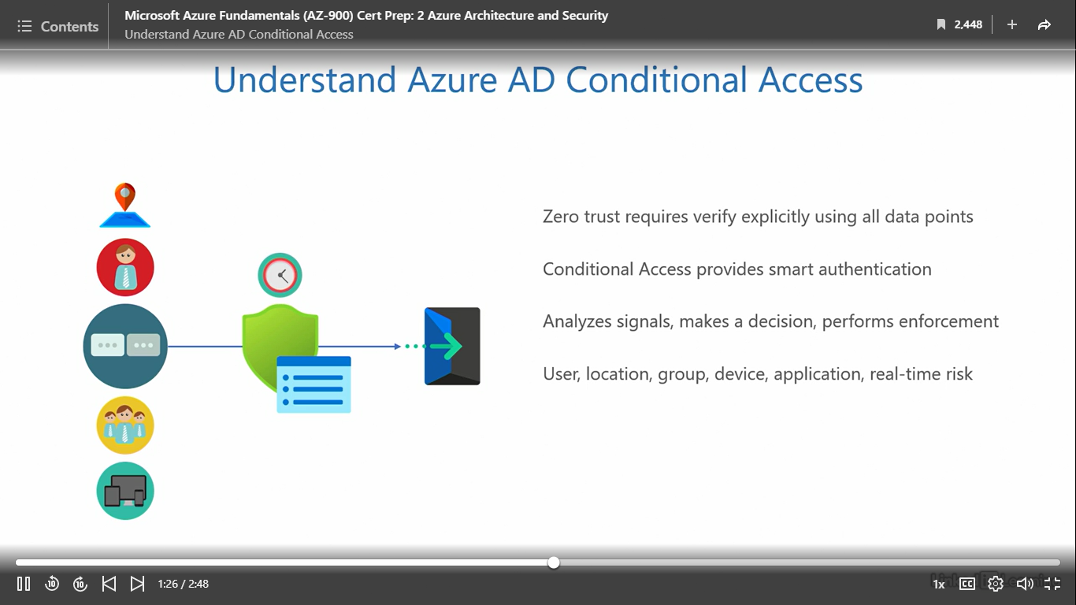

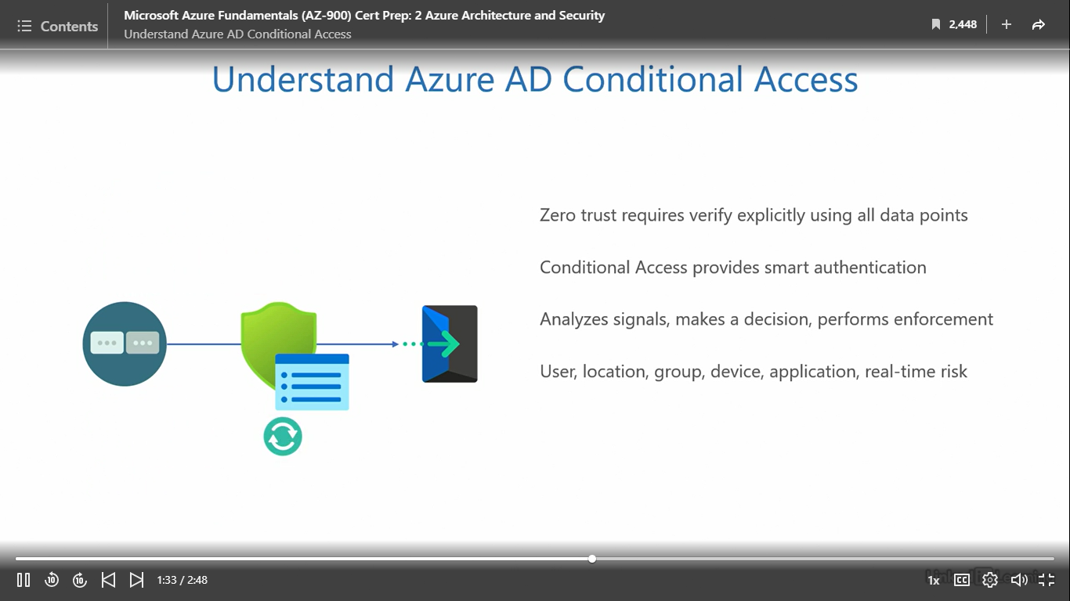

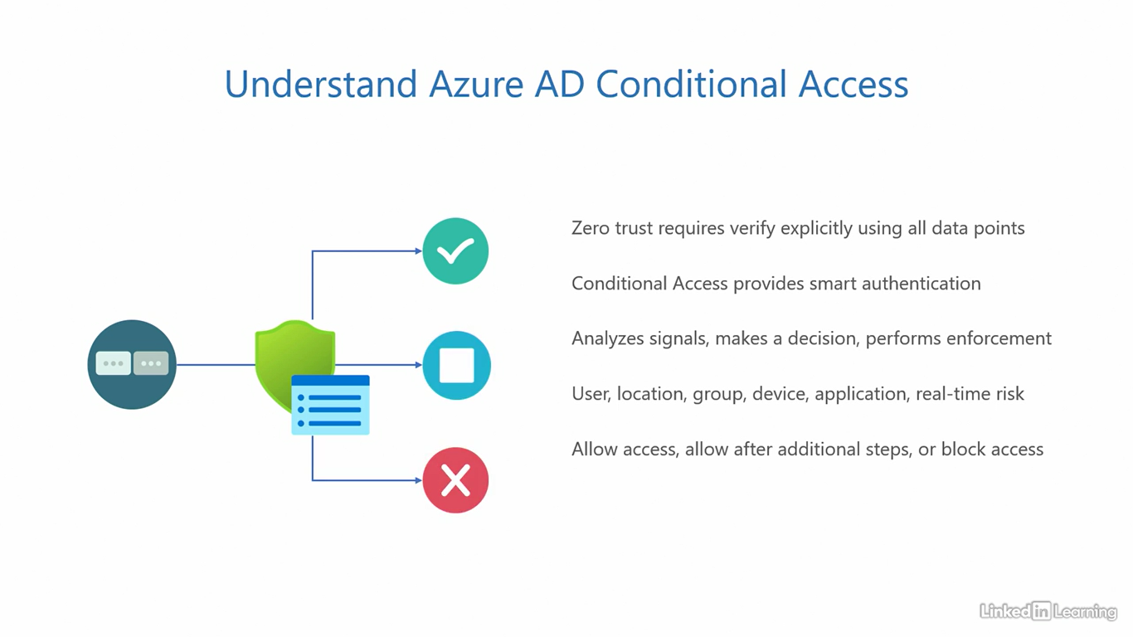

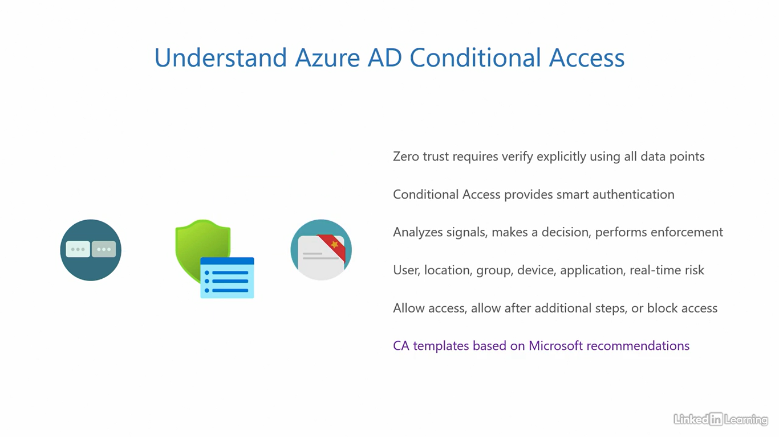

Understand role-based access control

[Instructor] So far, we've covered authentication in Azure. What follows after a successful authentication is authorization. Azure role-based access control, abbreviated as RBAC, provides smart authorization for Azure resources. It defines permissions for users based on their role in the organization. I call it smart authorization because it provides a very granular and fine-grained access control mechanism. Not only can you assign permissions for users at the topmost level in the hierarchy, you can also drill down to the smallest resource and precisely define what users can and cannot do to resources. There are three parts that make this work. First is a security principle. This can be a user account, a group, or any identity to which you want to grant permissions. Second is a rule definition. This part defines the role and the actions an identity is authorized to perform. To simplify it, the role can be an owner, contributor or a reader. And the actions can be a combination of create, read, update, and delete operations. This is a simplified description of the role definition. The third part is the scope. This is the target to which the permissions will apply. The scope can be a management group, a subscription, a resource group, an individual resource, or a very specific action on a particular resource. As I mentioned, from the largest entity to the smallest bit in the hierarchy, RBAC covers it all. Then, role assignment is the process of attaching role definitions to security principles. It essentially means taking the role along with its list of actions and linking it with an identity. Azure has many built-in roles that you can assign to users across services, but if none of those fit your requirement, you can also create your own custom role for assignment. You can go in depth and choose every little detail the way you want with custom roles. You also have the opposite of role assignments in Azure, they are called deny assignments. A role assignment is created with the intent of granting access, whereas a deny assignment is created with the intent of specifically denying access.

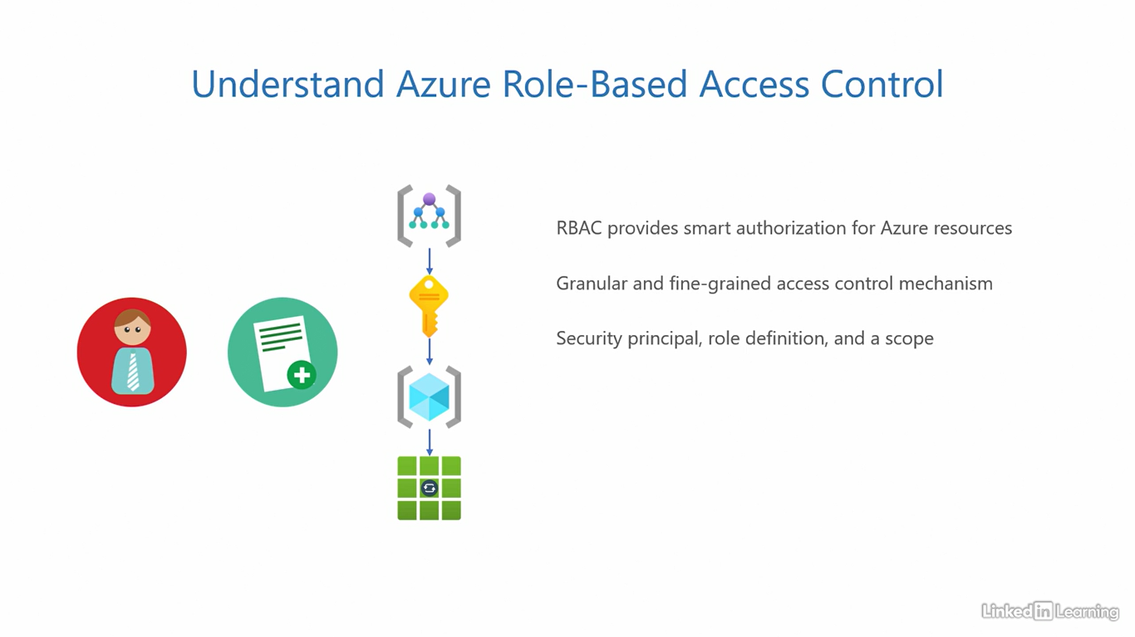

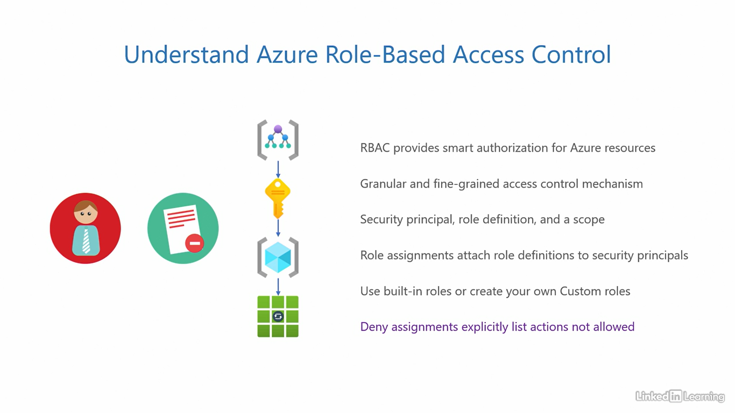

Understand Microsoft Defender for Cloud

[Instructor] Microsoft Defender for Cloud provides you with a single unified interface for all things security. It is the go-to product for end-to-end visibility into your resources. The unification here is helpful because it means you don't have to go through multiple consoles, and dashboards to view various security-related events. Defender for Cloud consolidates all of that in one single place. It is an on-premises and a multi-cloud solution. This means it can gather data from your on-premises environment, as well as other popular public clouds out there. That's Azure or even Amazon Web Services, AWS and Google Cloud Platform, GCP. The way it works is it installs a small piece of software called agents or extensions inside your resources. These agents and extensions can be automatically provisioned to your resources. What they do is they perform a verbose scan of the resources and report raw data back to Microsoft Defender for Cloud. Defender crunches all that raw data, and presents us with meaningful results. The assessment generates a secure score as a percentage, representing how secure your overall environment is. The higher the percentage, the better. Then for misconfigurations that are affecting your score, it provides recommendations with step-by-step procedures to comply and improve your score. If a misconfiguration can be easily resolved, sometime it'll also offer a quick fix where you just have to press a button and it'll go ahead, and fix the problem for you on your behalf. It also raises alerts in real time if it detects an anomaly on any protected resources. This way, you can take immediate action, and prevent a bad event from escalating. In industry jargon, this product provides cloud security, posture management, and cloud workload protection platform. That is in simple words, provides insights into the security posture of your cloud environment, and how well protected your workloads are. This product meets all the core requirements we listed in the vulnerability and threat video. Ability to actively assess the environment, help you fix vulnerabilities, and offer preventive measures to stop a breach.

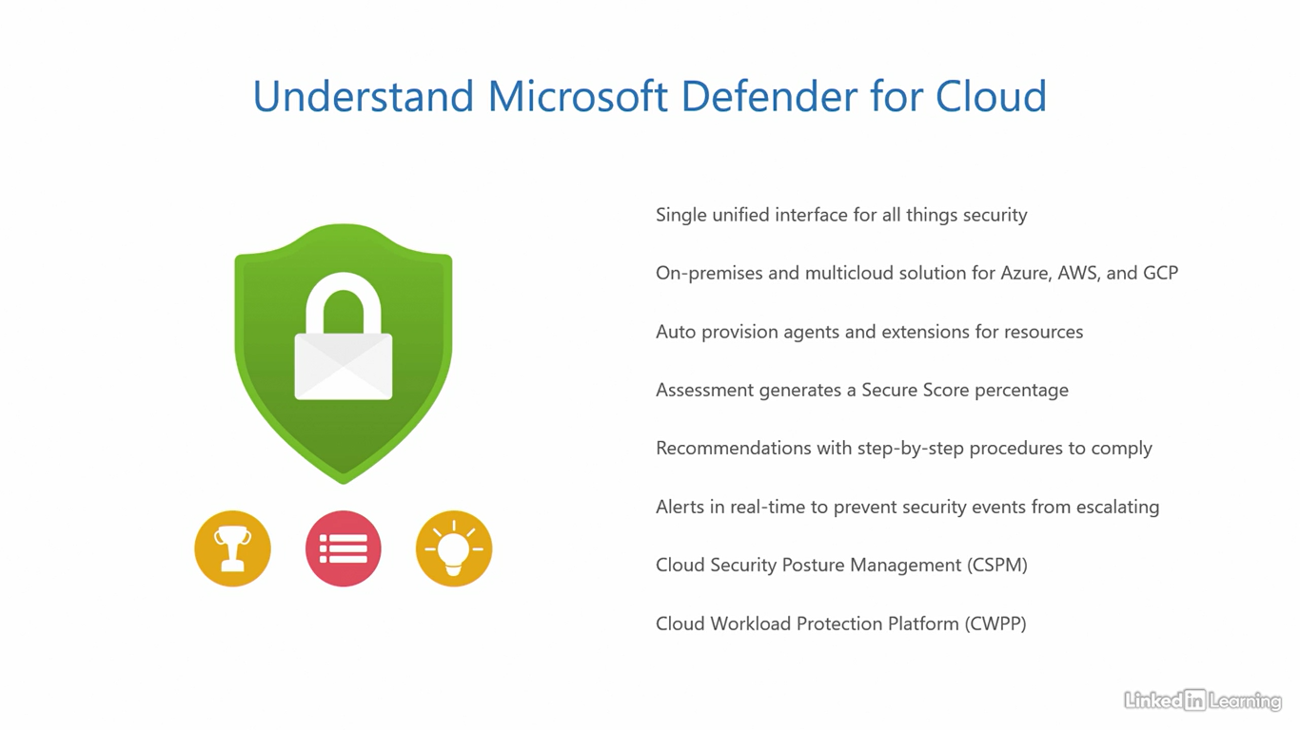

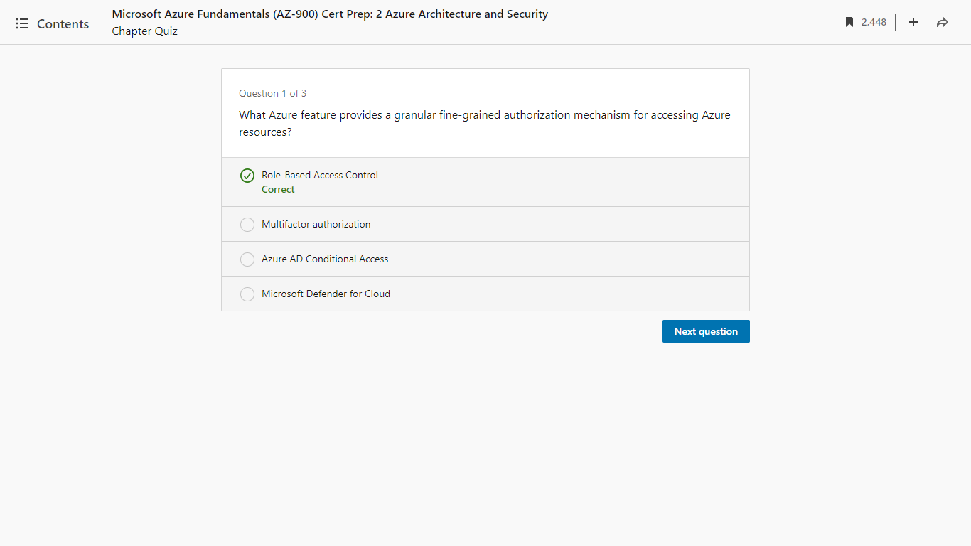

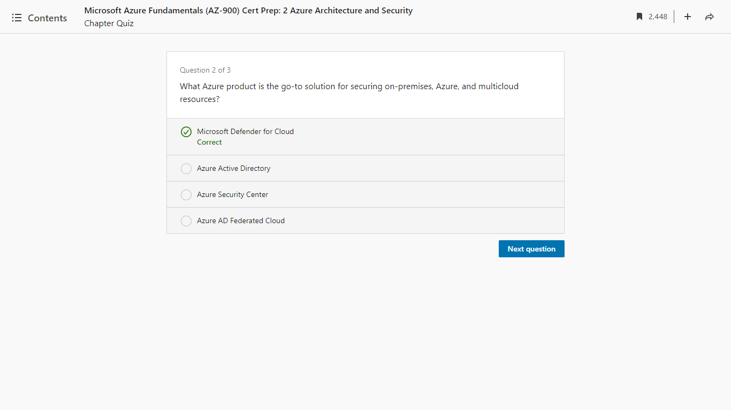

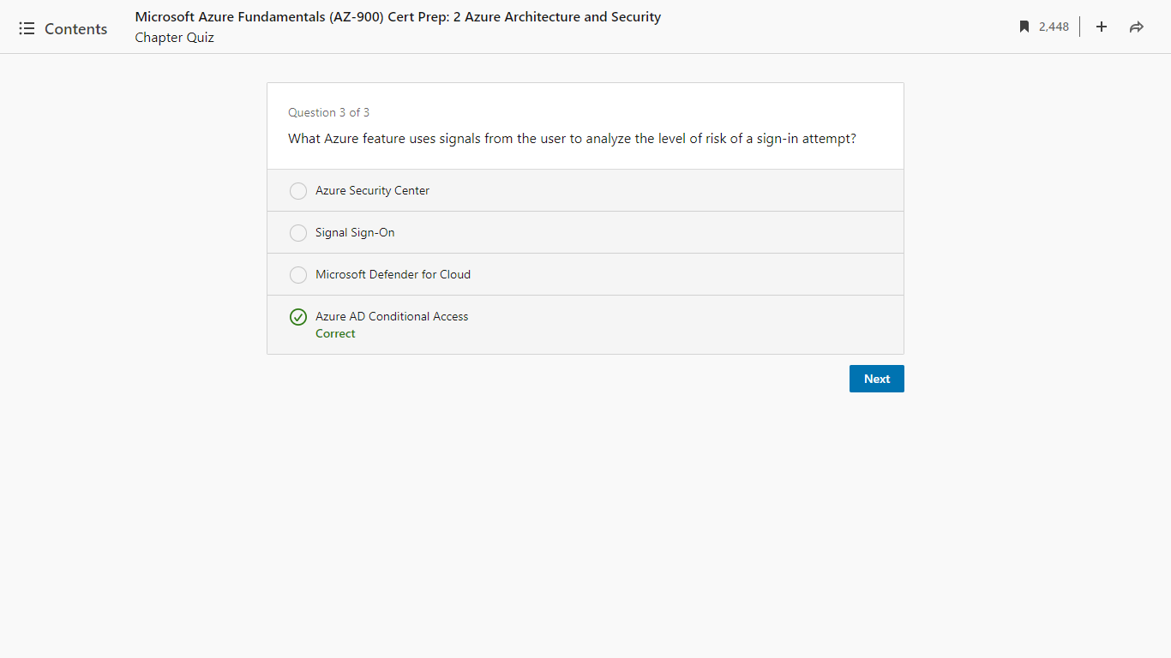

Course summary

[Kunal] We're almost towards the end of this course. I know we've covered a lot of things here. Azure Architecture, Identity, Access, and Security. In this chapter, the conclusion, I'll quickly recap the important topics covered and point you towards your next step. Here's a run through of everything we've learned so far. This was the second course in the learning path for AZ-900 on LinkedIn Learning. We covered half of the official exam objective, "Describe Azure Architecture and Services" in this course. We covered the Architecture and Security parts, but not Services. As I mentioned at the beginning of this course, I have split this section over two courses because this is a core objective with high weightage. We will cover Azure Services in the next course. In the first chapter, we got an overview of the Azure Global Infrastructure, including an Azure geography. We then learned about how geographies contain regions, regions contain availability zones, and availability zones contain datacenters. We then kicked off our Azure journey with a subscription, talked about management groups and how they hold subscriptions. Then, how a subscription contains resource groups and how a resource group contains resources. You also got a high-level understanding of what resources are and the tasks they help you accomplish. In the second chapter, we learned about Azure Active Directory, the identity and access management solution for your Azure Cloud environment. I also talked about how it enables you to manage users, groups, devices and modern applications. Then, I mentioned the use of Azure AD Domain Services for supporting legacy applications in the Cloud. We also got to know that for external business users, we use Azure AD B2B. And for external consumers using your public facing applications, we can use Azure AD B2C. After that, we covered multifactor authentication, passwordless authentication, and single sign-on. In the last chapter, we saw smart authentication and authorization with Azure AD Conditional Access and Role-Based Access Control. We finally wrapped up the chapter with a discussion about Microsoft Defender for Cloud.

